Descriptive statistics

Rapport package team @ https://github.com/aL3xa/rapport

2011-04-26 20:25 CET

## Description

This template will return descriptive statistics and frequency table of a categorical variable.

## *gender* ("Gender")

The dataset has *709* observations with *673* valid values (missing: *36*) in *gender* ("Gender"), which seems to be a qualitative variable.

### Base statistics

|  |  |  |  |  |
| --- | --- | --- | --- | --- |
| **gender** | **N** | **%** | **Cumul. N** | **Cumul. %** |
| male | 410 | 60.9212 | 410 | 60.9212 |
| female | 263 | 39.0788 | 673 | 100 |
| Total | 673 | 100 | 673 | 100 |

### Barplot

[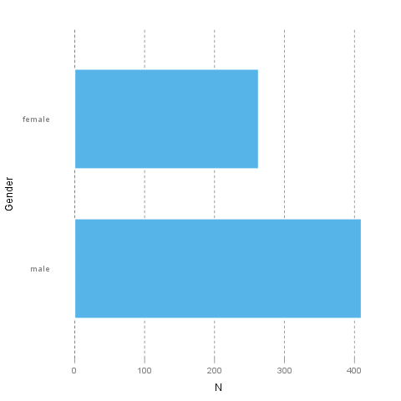](/tmp/RtmpI5pYwT/file646aca2-hires.png)

It seems that the highest value is *2* which is exactly 2 times higher than the smallest value (*1*).

The most frequent value is *male*.

## Description

This template will return descriptive statistics and frequency table of a categorical variable.

## *dwell* ("Dwelling")

The dataset has *709* observations with *662* valid values (missing: *47*) in *dwell* ("Dwelling"), which seems to be a qualitative variable.

### Base statistics

|  |  |  |  |  |
| --- | --- | --- | --- | --- |
| **dwell** | **N** | **%** | **Cumul. N** | **Cumul. %** |
| city | 599 | 90.4834 | 599 | 90.4834 |
| small town | 33 | 4.9849 | 632 | 95.4683 |
| village | 30 | 4.5317 | 662 | 100 |
| Total | 662 | 100 | 662 | 100 |

### Barplot

[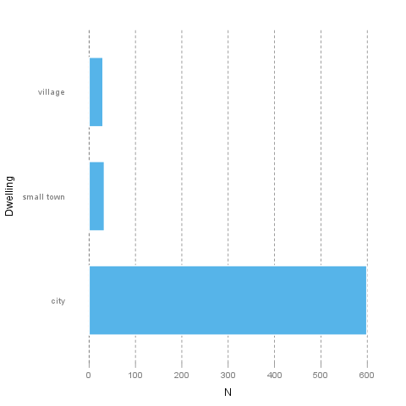](/tmp/RtmpI5pYwT/file5f30d780-hires.png)

It seems that the highest value is *3* which is exactly 3 times higher than the smallest value (*1*).

The most frequent value is *city*.

This report was generated with [R](http://www.r-project.org/) (2.14.0) and [rapport](http://al3xa.github.com/rapport/) (0.2) in 0.487 sec on x86_64-unknown-linux-gnu platform.

