Rapport package team

Descriptive statistics

2011-04-26 20:25 CET

## Description

This template will return descriptive statistics of a numerical or frequency table of a categorical variable.

### *gender* ("Gender")

The dataset has *709* observations with *673* valid values (missing: *36*).

|  |  |  |  |  |
| --- | --- | --- | --- | --- |
| gender | N | % | Cumul. N | Cumul. % |
| male | 410 | 60.92 | 410 | 60.92 |
| female | 263 | 39.08 | 673 | 100.00 |
| Total | 673 | 100.00 | 673 | 100.00 |

Frequency table: Gender

The most frequent value is *male*.

#### Charts

[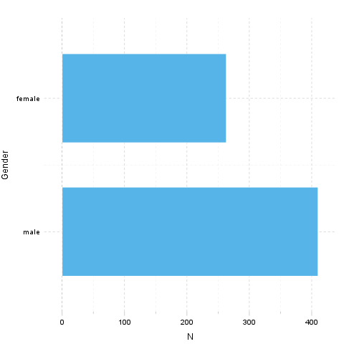](plots/descriptives-1-hires.png)

It seems that the highest value is *2* which is exactly *2* times higher than the smallest value (*1*).

## Description

This template will return descriptive statistics of a numerical or frequency table of a categorical variable.

### *age* ("Age")

The dataset has *709* observations with *677* valid values (missing: *32*).

#### Base statistics

|  |  |  |  |
| --- | --- | --- | --- |
| Variable | mean | sd | var |
| Age | 24.57 | 6.849 | 46.91 |

Descriptives: Age

The standard deviation is *6.849* (variance: *46.91*). The expected value is around *24.57*, somewhere between *24.06* and *25.09* with the standard error of *0.2632*.

#### Charts

[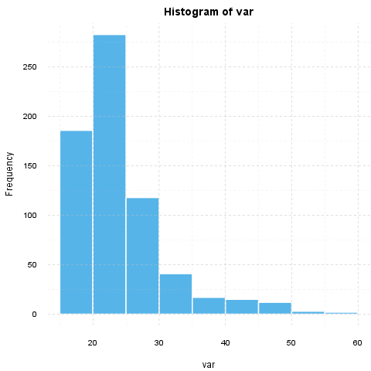](plots/descriptives-2-hires.png)

It seems that the highest value is *58* which is exactly *3.625* times higher than the smallest value (*16*).

If we *suppose* that *Age* is not near to a normal distribution (skewness: *1.925*, kurtosis: *4.463*), checking the median (*23*) might be a better option instead of the mean. The interquartile range (*6*) measures the statistics dispersion of the variable (similar to standard deviation) based on median.

## Description

This template will return descriptive statistics of a numerical or frequency table of a categorical variable.

### *hp*

The dataset has *32* observations with *32* valid values (missing: *0*).

#### Base statistics

|  |  |  |  |
| --- | --- | --- | --- |
| Variable | mean | sd | var |
| hp | 146.7 | 68.56 | 4701 |

Descriptives: hp

The standard deviation is *68.56* (variance: *4701*). The expected value is around *146.7*, somewhere between *122.9* and *170.4* with the standard error of *12.12*.

#### Charts

[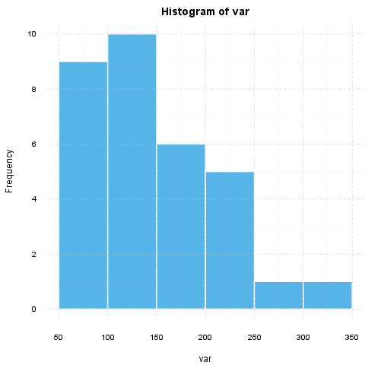](plots/descriptives-3-hires.png)

It seems that the highest value is *335* which is exactly *6.442* times higher than the smallest value (*52*).

If we *suppose* that *hp* is not near to a normal distribution (skewness: *0.726*, kurtosis: *-0.1356*), checking the median (*123*) might be a better option instead of the mean. The interquartile range (*83.5*) measures the statistics dispersion of the variable (similar to standard deviation) based on median.

This report was generated with [R](http://www.r-project.org/) (2.15.1) and [rapport](http://rapport-package.info/) (0.4) in *1.258* sec on x86_64-unknown-linux-gnu platform.

