Example template

Rapport package team @ https://github.com/aL3xa/rapport

2011-04-26 20:25 CET

## Description

This template demonstrates the basic features of rapport. We all hope you will like it!

## Début

Hello, world!

I have just specified a *Variable* in this template named to **leisure**. The label of this variable is "Internet usage in leisure time (hours per day)".

And wow, the mean of *leisure* is *3.1994*!

### Descriptive statistics

|  |  |  |  |  |  |  |
| --- | --- | --- | --- | --- | --- | --- |
| **Min.** | **1st Qu.** | **Median** | **Mean** | **3rd Qu.** | **Max.** | **NA's** |
| 0.000 | 2.000 | 3.000 | 3.199 | 4.000 | 12.000 | 37.000 |

The 5 highest values are: *12*, *12*, *10*, *10* and *10*.

## Description

This template demonstrates the basic features of rapport. We all hope you will like it!

## Début

Hello, world!

I have just specified a *Variable* in this template named to **leisure**. The label of this variable is "Internet usage in leisure time (hours per day)".

And wow, the mean of *leisure* is *3.1994*!

**For more detailed statistics, you should have set desc=TRUE!**

## Description

This template demonstrates the basic features of rapport. We all hope you will like it!

## Début

Hello, world!

I have just specified a *Variable* in this template named to **leisure**. The label of this variable is "Internet usage in leisure time (hours per day)".

And wow, the mean of *leisure* is *3.1994*!

**For more detailed statistics, you should have set desc=TRUE!**

### Histogram

[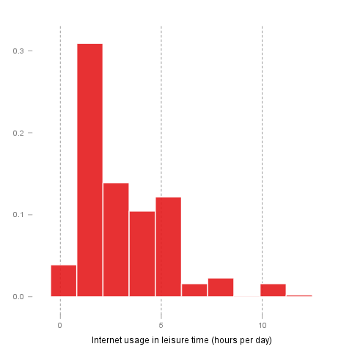](/tmp/RtmpeIwHkw/filef3bde6c-hires.png)

## Description

This template demonstrates the basic features of rapport. We all hope you will like it!

## Début

Hello, world!

I have just specified a *Variable* in this template named to **leisure**. The label of this variable is "Internet usage in leisure time (hours per day)".

And wow, the mean of *leisure* is *3.1994*!

**For more detailed statistics, you should have set desc=TRUE!**

### Histogram

[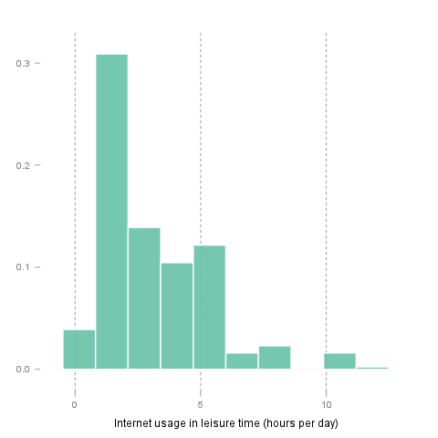](/tmp/RtmpeIwHkw/file4657af68-hires.png)

This report was generated with [R](http://www.r-project.org/) (2.14.0) and [rapport](http://al3xa.github.com/rapport/) (0.1) in 0.651 sec on x86_64-unknown-linux-gnu platform.

