Outlier tests

Rapport package team @ https://github.com/aL3xa/rapport

2011-04-26 20:25 CET

## Description

This template will check if provided variable has any outliers.

## Boxplot

[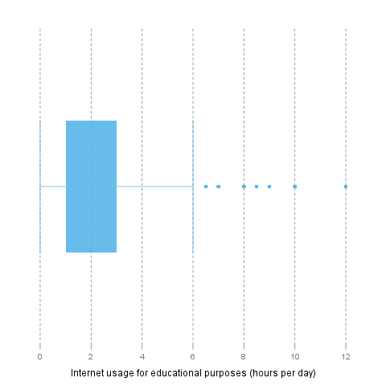](/tmp/RtmpeIwHkw/file524b5128-hires.png)

## Lund test

It seems that *4* extreme values can be found in "Internet usage for educational purposes (hours per day)". These are: 10, 0.5, 1.5, 0.5.

### Explanation

The above test for outliers was based on *lm(1 ~ edu)*:

|  |  |  |  |  |
| --- | --- | --- | --- | --- |
|  | **Estimate** | **Std. Error** | **t value** | **Pr(>|t|)** |
| (Intercept) | 2.0481 | 0.078 | 26.2677 | 0 |

### References

* Lund, R. E. 1975, "Tables for An Approximate Test for Outliers in Linear Models", Technometrics, vol. 17, no. 4, pp. 473-476.
* Prescott, P. 1975, "An Approximate Test for Outliers in Linear Models", Technometrics, vol. 17, no. 1, pp. 129-132.

## Grubb's test

Grubbs test for one outlier shows that highest value 12 is an outlier (p=0.0002).

### References

* Grubbs, F.E. (1950). Sample Criteria for testing outlying observations. Ann. Math. Stat. 21, 1, 27-58.

## Dixon's test

chi-squared test for outlier shows that highest value 12 is an outlier (p=0).

### References

* Dixon, W.J. (1950). Analysis of extreme values. Ann. Math. Stat. 21, 4, 488-506.

## Description

This template will check if provided variable has any outliers.

## Boxplot

[](/tmp/RtmpeIwHkw/file62de4e18-hires.png)

## Lund test

It seems that *4* extreme values can be found in "Internet usage for educational purposes (hours per day)". These are: 10, 0.5, 1.5, 0.5.

### Explanation

The above test for outliers was based on *lm(1 ~ edu)*:

|  |  |  |  |  |
| --- | --- | --- | --- | --- |
|  | **Estimate** | **Std. Error** | **t value** | **Pr(>|t|)** |
| (Intercept) | 2.0481 | 0.078 | 26.2677 | 0 |

### References

* Lund, R. E. 1975, "Tables for An Approximate Test for Outliers in Linear Models", Technometrics, vol. 17, no. 4, pp. 473-476.
* Prescott, P. 1975, "An Approximate Test for Outliers in Linear Models", Technometrics, vol. 17, no. 1, pp. 129-132.

## Grubb's test

Grubbs test for one outlier shows that highest value 12 is an outlier (p=0.0002).

### References

* Grubbs, F.E. (1950). Sample Criteria for testing outlying observations. Ann. Math. Stat. 21, 1, 27-58.

## Dixon's test

chi-squared test for outlier shows that highest value 12 is an outlier (p=0).

### References

* Dixon, W.J. (1950). Analysis of extreme values. Ann. Math. Stat. 21, 4, 488-506.

## Description

This template will check if provided variable has any outliers.

## Boxplot

[](/tmp/RtmpeIwHkw/file31d6ac2a-hires.png)

## Lund test

It seems that *4* extreme values can be found in "Internet usage for educational purposes (hours per day)". These are: 10, 0.5, 1.5, 0.5.

### Explanation

The above test for outliers was based on *lm(1 ~ edu)*:

|  |  |  |  |  |
| --- | --- | --- | --- | --- |
|  | **Estimate** | **Std. Error** | **t value** | **Pr(>|t|)** |
| (Intercept) | 2.0481 | 0.078 | 26.2677 | 0 |

This report was generated with [R](http://www.r-project.org/) (2.14.0) and [rapport](http://al3xa.github.com/rapport/) (0.1) in 1.026 sec on x86_64-unknown-linux-gnu platform.

