**Project Title -** Tiffin Management System

**Group No -** 34

**Group Members** - Deepali Vyas (223045)

Mohd Hammad(223114)

**Document -**UML

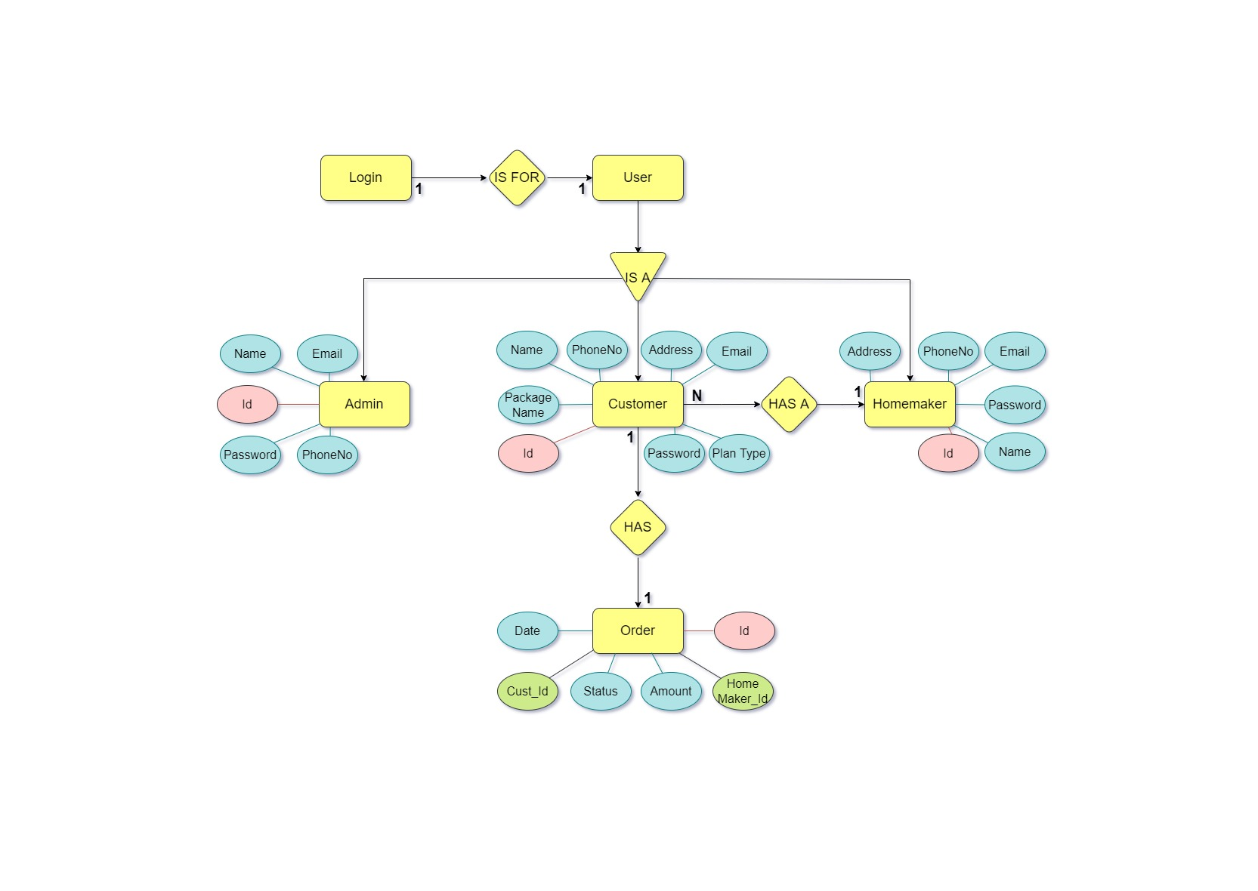

**ER DIAGRAM**

**DFD DIAGRAM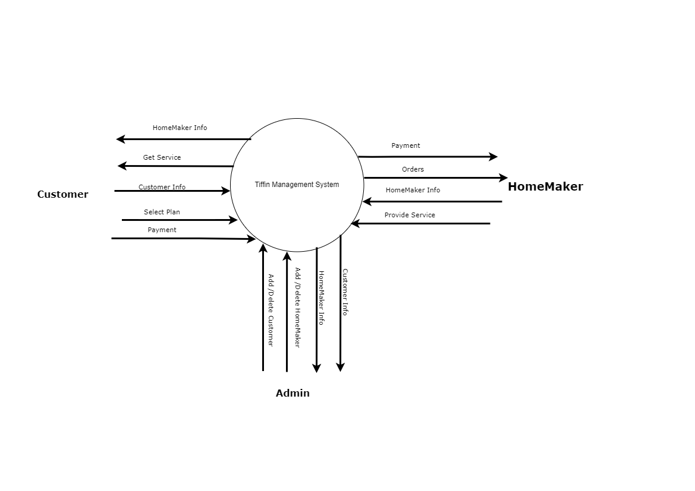DFD-0**

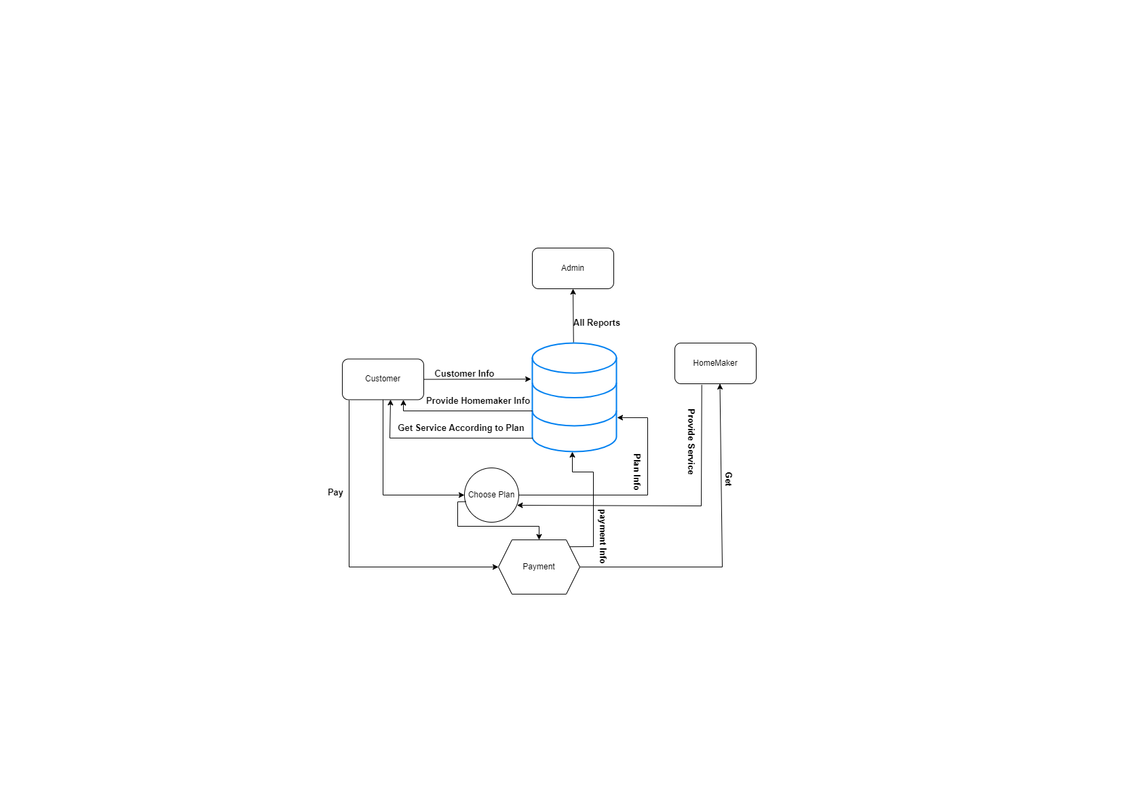

**DFD-1**

**CLASS DIAGRAM**

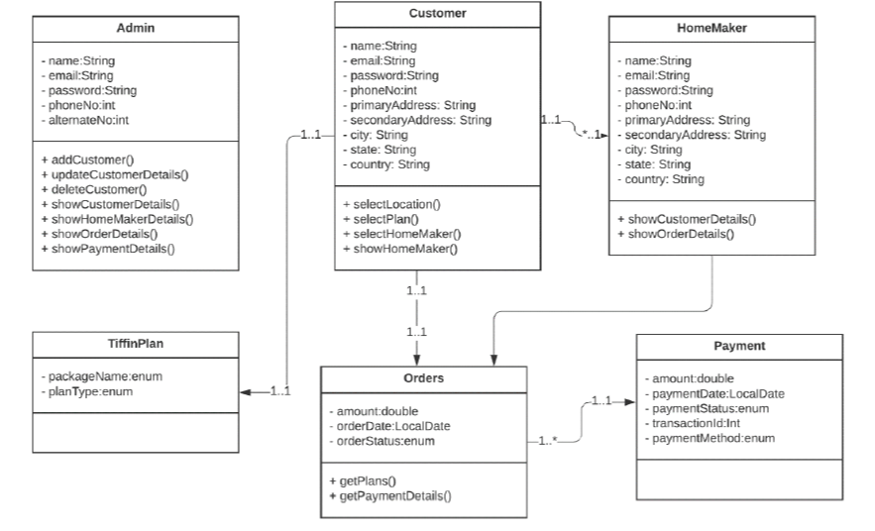

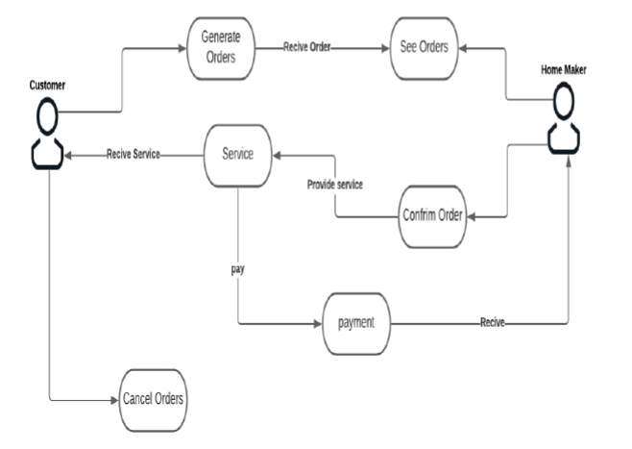

**USE CASE DIAGRAM**

**TABLES**

**ADMIN TABLE:**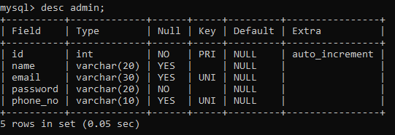

**CUSTOMER TABLE:**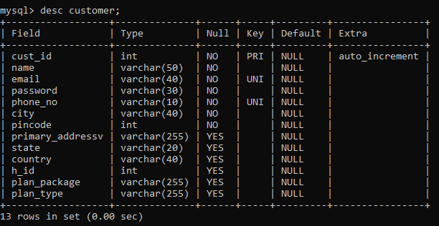

**HOME_MAKER TABLE:**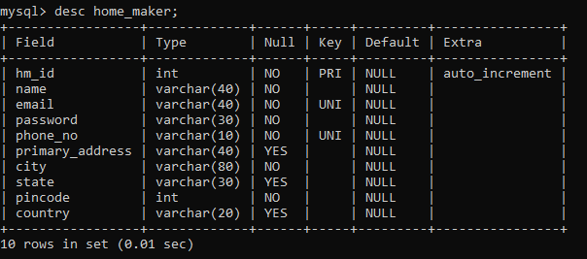

**ORDER TABLE:**