Online Education E-Commerce

1. Shoog Mansour
2. Reem Alomar
3. Reem Alsalem
4. Saja Alshahrani
5. Dalal Alzunaidi
6. Home Screen

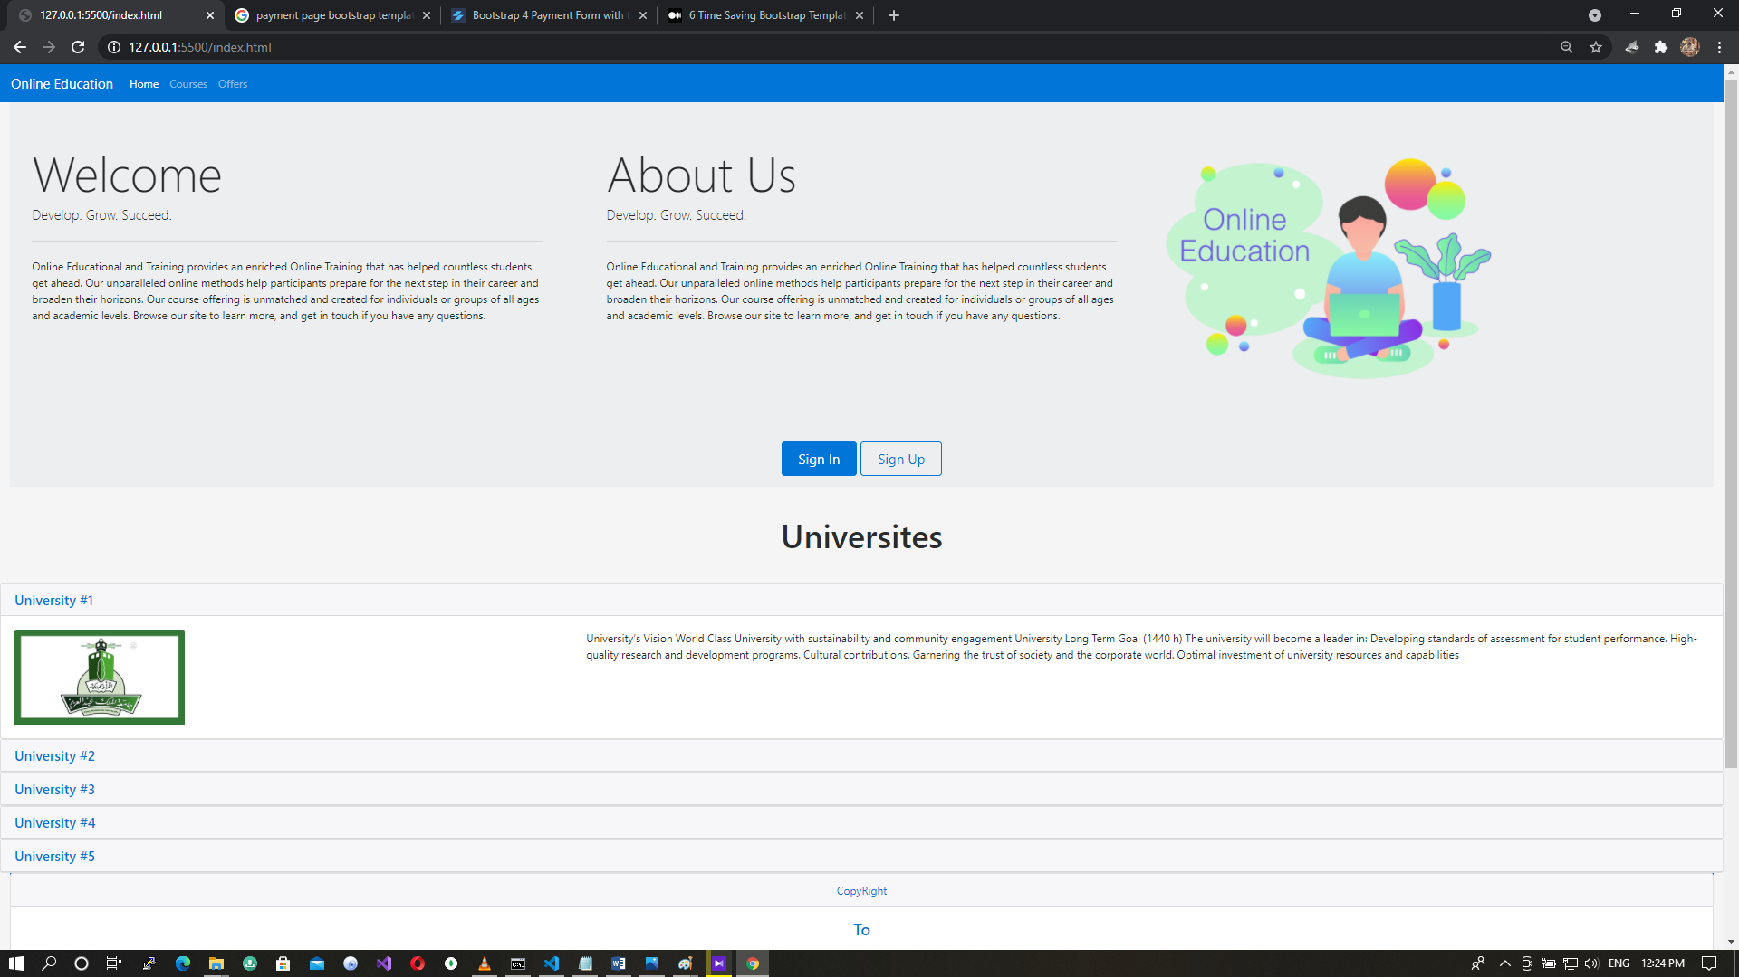

1. Courses Screen

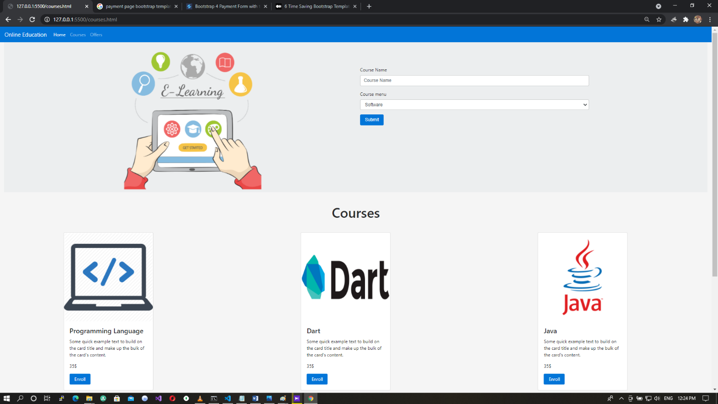

1. Offer Screen

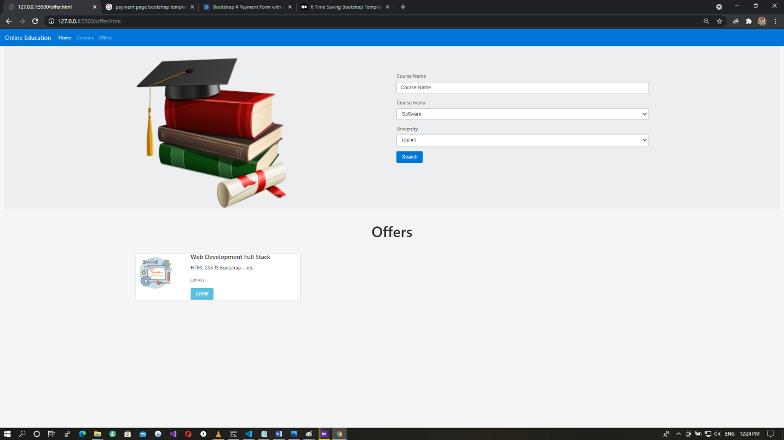

1. Payment Screen

