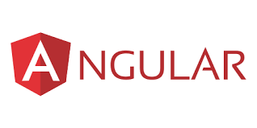

* **Installing Angular CLI**

Npm install -g @angular/cli

* **To check Angular version**

ng version

* **To create new application**

Ng new nameOfTheApplication

* **Development Server**

Required for HTTP requests

Angular comes with a server

Monitor files for changes

Not suitable for production

Command – npm start or ng serve (both does the same work)