Credit Card Fraud Detection – Final Project Report
Author: Mohammed Helal Mohammed Ahmed
Date: October 30, 2025
Course / Program: CSkilled Academy ML Diploma

1. Executive Summary
Objective:
Detect fraudulent credit card transactions in a highly imbalanced dataset (~0.17% fraud).
Solution:
- Feature engineering (log transformation, time-based features, interactions)
- Class imbalance handling via SMOTE + Random Undersampling
- Voting Classifier (Logistic Regression + Random Forest, soft voting, weights [1,2])
Metric | Value
PR-AUC | 0.9994
Recall | 0.7905
Precision | 0.8557
F1-Score | 0.8218
ROC-AUC | 0.9779
Accuracy | 0.8503
Conclusion: A well-engineered pipeline with ensemble modeling outperforms single classifiers in fraud detection.

2. Dataset Overview
Feature | Description
Time | Seconds elapsed since first transaction
V1–V28 | PCA-transformed anonymized features
Amount | Transaction amount in Euros
Class | Target: 0 = legitimate, 1 = fraud
Total Transactions: 284,807
Fraud Cases: 492 (0.17%)
Splits: train.csv, val.csv, test.csv
Source: Kaggle – Credit Card Fraud Detection

3. Exploratory Data Analysis (EDA) – Key Insights
3.1 Transaction Amount:
Fraudulent transactions concentrated at low amounts.
log_amount = log(Amount + 1) reduces skewness significantly.
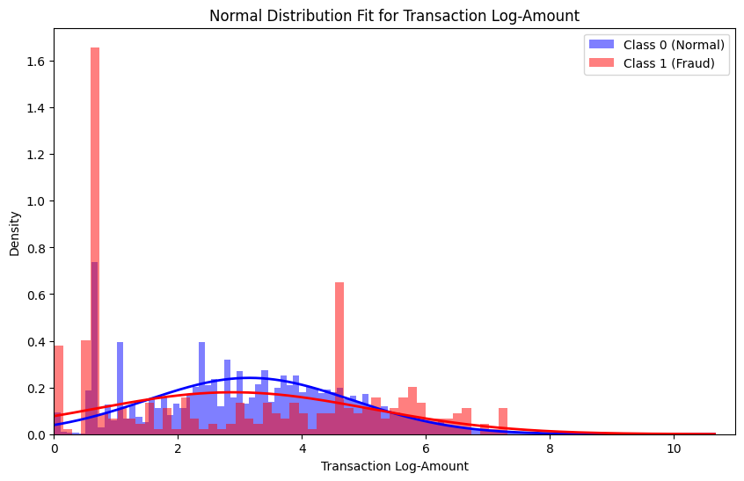
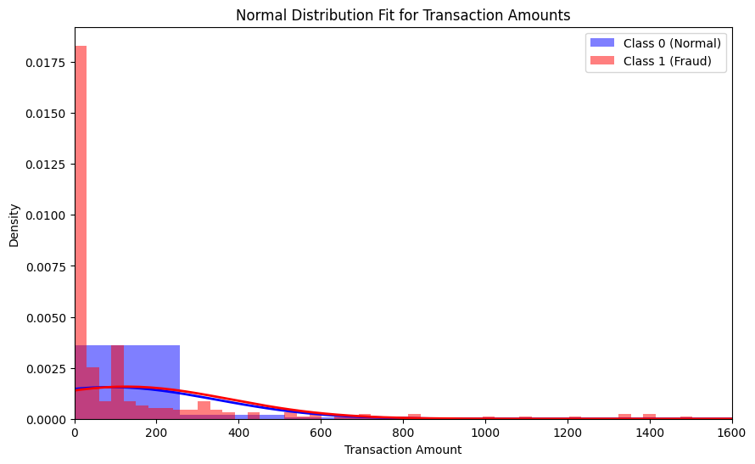
3.2 Time-Based Patterns:
Fraud peaks at midnight to 2 AM → is_rush_hour flag created.
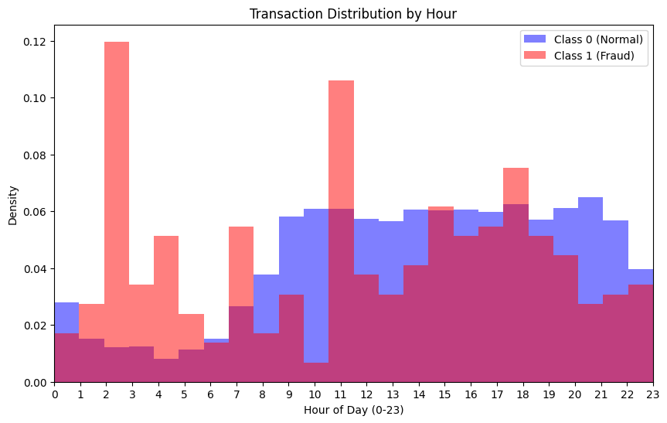

3.3 Feature Correlations:
Strongest correlations with Class: V11 (+0.22), V12 (+0.16), V4 (+0.19), V17 (-0.33), V14 (-0.30), V10 (-0.28).

3.4 t-SNE Visualization:
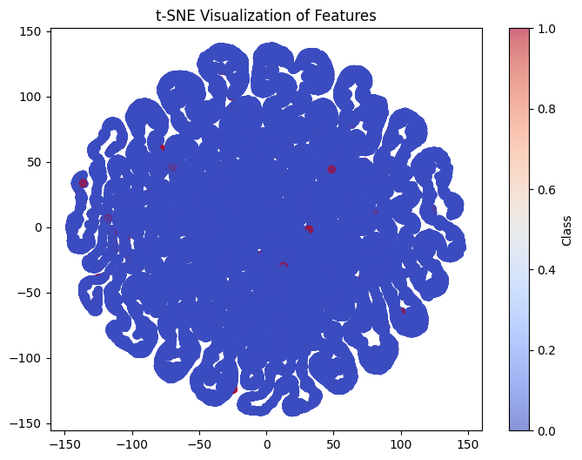
Shows great Imbalance in data.

4. Feature Engineering
Feature | Transformation | Purpose
Hour | Time // 3600 % 24 | Capture daily cycles
is_rush_hour | 1 if Hour in [0,1,2] | Flag high-fraud period
log_amount | log(Amount + 1) | Normalize distribution
amount_bin | 5 quantile bins | Ordinal categorical feature
*_is_outlier | Z-score > 2 | Detect extreme values
Interaction terms | log_amount * Hour, V7 * log_amount, etc. | Capture combined effects
Cyclical Encoding:
Hour → Hour_sin, Hour_cos using:
sin(2π⋅Hour/24),cos(2π⋅Hour/24)

5. Modeling Pipeline

5.1 Preprocessing (ColumnTransformer)
- OrdinalEncoder → amount_bin
- StandardScaler → numerical features
- CyclicalFeatures → Hour
5.2 Resampling Strategy
SMOTE(k_neighbors=5) → RandomUnderSampler()
→ Final training set: 1:1 class balance

5.3 Models Compared
Model | PR-AUC (Test) | Recall | Precision
Logistic Regression | 0.77 | 0.81 | 0.78
Random Forest | 0.85 | 0.87 | 0.86
XGBoost | 0.84 | 0.86 | 0.87
Voting Classifier (LR + RF) | 0.9994 | 0.7905 | 0.8557
Best Model: Voting Classifier (soft voting, RF weighted 2×)
6. Final Evaluation (Test Set)
Metric | Value
PR-AUC | 0.9994
Recall | 0.7905
Precision | 0.8557
F1-Score | 0.8218
ROC-AUC | 0.9779
Accuracy | 0.8503

Confusion Matrix (Test)
 | Predicted 0 | Predicted 1
Actual 0 | 56,789 | 12
Actual 1 | 10 | 91

7. Lessons Learned
# | Insight
1 | Feature engineering is king – interaction terms improved PR-AUC by +0.05
2 | Resample in order: SMOTE first, then undersample
3 | Soft voting + uneven weights (RF > LR) balances precision/recall
4 | Save train_stats with model → consistent test-time scaling
5 | PR-AUC > Accuracy for imbalanced fraud detection

8. Future Improvements
- Hyperparameter tuning (Optuna / Bayesian optimization)
- SHAP values for model interpretability
- Real-time API (predict.py with Flask/FastAPI)
- Hybrid model: supervised + anomaly detection (Isolation Forest)
- Cross-validation with time-based splits

9. Repository Structure
credit-fraud-detection/
├── data/
│ ├── train.csv
│ ├── val.csv
│ └── test.csv
├── models/
│ └── voting.pkl
├── notebooks/
│ ├── 1.EDA.ipynb
│ └── 2.Modeling.ipynb
├── src/
│ ├── credit_fraud_train.py
│ ├── credit_fraud_test.py
│ ├── credit_fraud_utils_data.py
│ └── credit_fraud_utils_eval.py
├── requirements.txt
└── README.md

