ABASYN UNIVERSITY ISLAMABAD CAMPUS



“Mobile Application Development”
“CS375”
“Assignment:4”

“Muhammed Hamza”
“8628 - B”
“Dep: BSSE-{Software Engineering}”

“Submitted to:
Dr. Sadaf Tanvir”

- The product has been successfully published on gumroad:

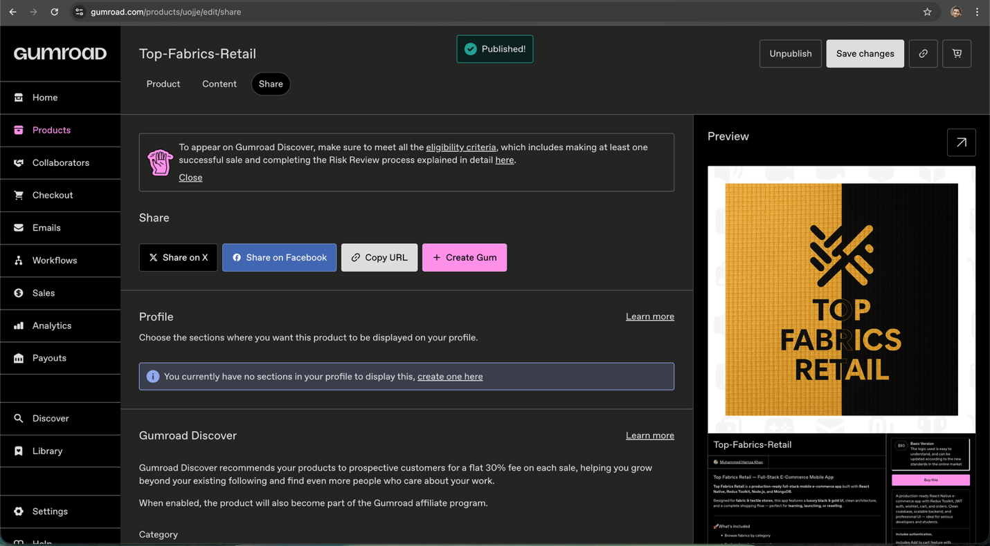

- Mobile application of A2 has been successfully uploaded and published on the Gumroad platform.
- The product status shows “Published”, confirming that the listing is now live and publicly accessible.
- This verifies successful deployment of the application on a digital marketplace.

- Payoneer has been successfully integrated as a payment or payout option

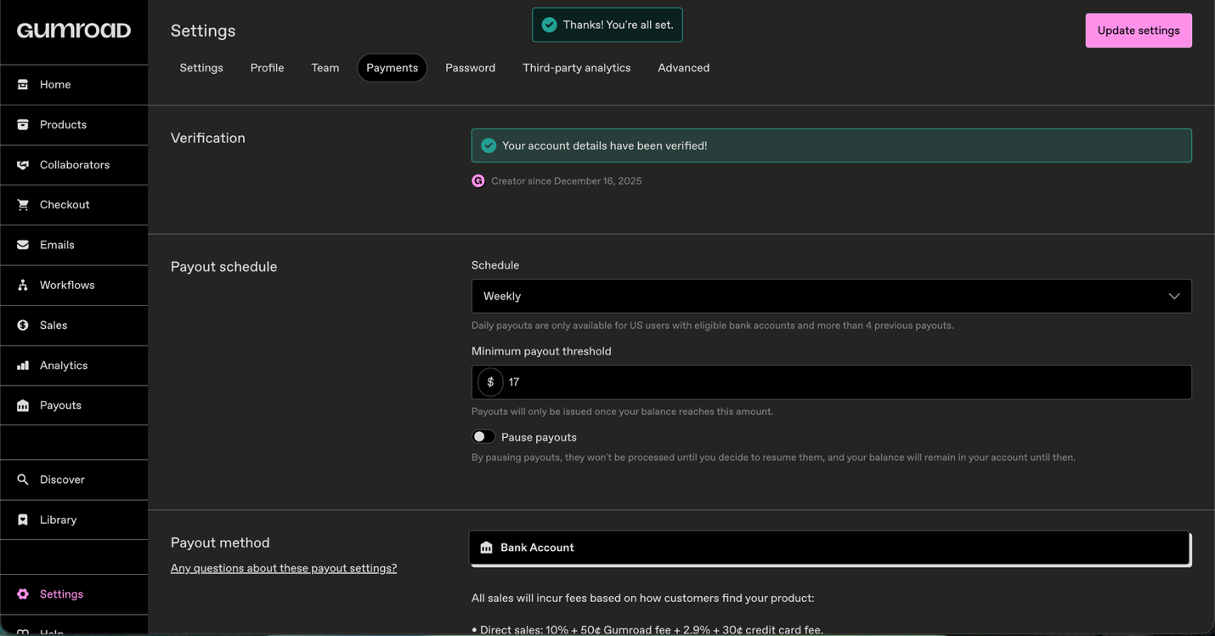

- The payment and payout settings have been successfully verified on Gumroad.
- The account verification status confirms that payouts are enabled and ready to be processed.
- Earnings from product sales will be received through the linked bank account according to Gumroad’s payout policy

- Link
