Complete Guide: Installing xv6 from Scratch
This guide starts from a fresh Windows PC and walks through every step until xv6 is running.

Step 1: Install VMware Workstation
- Download VMware Workstation Pro.
- Run the installer.
- Finish installation and restart the PC if prompted.

Step 2: Download Ubuntu ISO
- Download the Ubuntu Desktop LTS ISO (22.04 or 24.04). Save the .iso file.

Step 3: Create a New Virtual Machine
- Open VMware.
- Click Create a New Virtual Machine.
- Select the Ubuntu ISO.
- Allocate at least 7 GB RAM, 4 CPU cores, and 40 GB disk.
- Finish the wizard.

Step 4: Install Ubuntu
- Start the VM.
- Choose Install Ubuntu.
- Select keyboard and timezone.
- Choose Normal Installation.
- Erase disk (inside VM only).
- Create username and password.
- Wait for installation to finish and reboot.

Step 5: Update Ubuntu
- Open Terminal and run:
sudo apt update
sudo apt upgrade -y

Step 6: Install Required Packages
- Run:
sudo apt install -y git build-essential make gdb gcc-riscv64-linux-gnu binutils-riscv64-linux-gnu qemu-system-misc

Step 7: Download xv6
- Run:
git clone https://github.com/mit-pdos/xv6-riscv.git
cd xv6-riscv

Step 8: Build xv6
- Run:
make

Step 9: Run xv6
- Run:
make qemu
- If successful, the xv6 shell will appear.
- 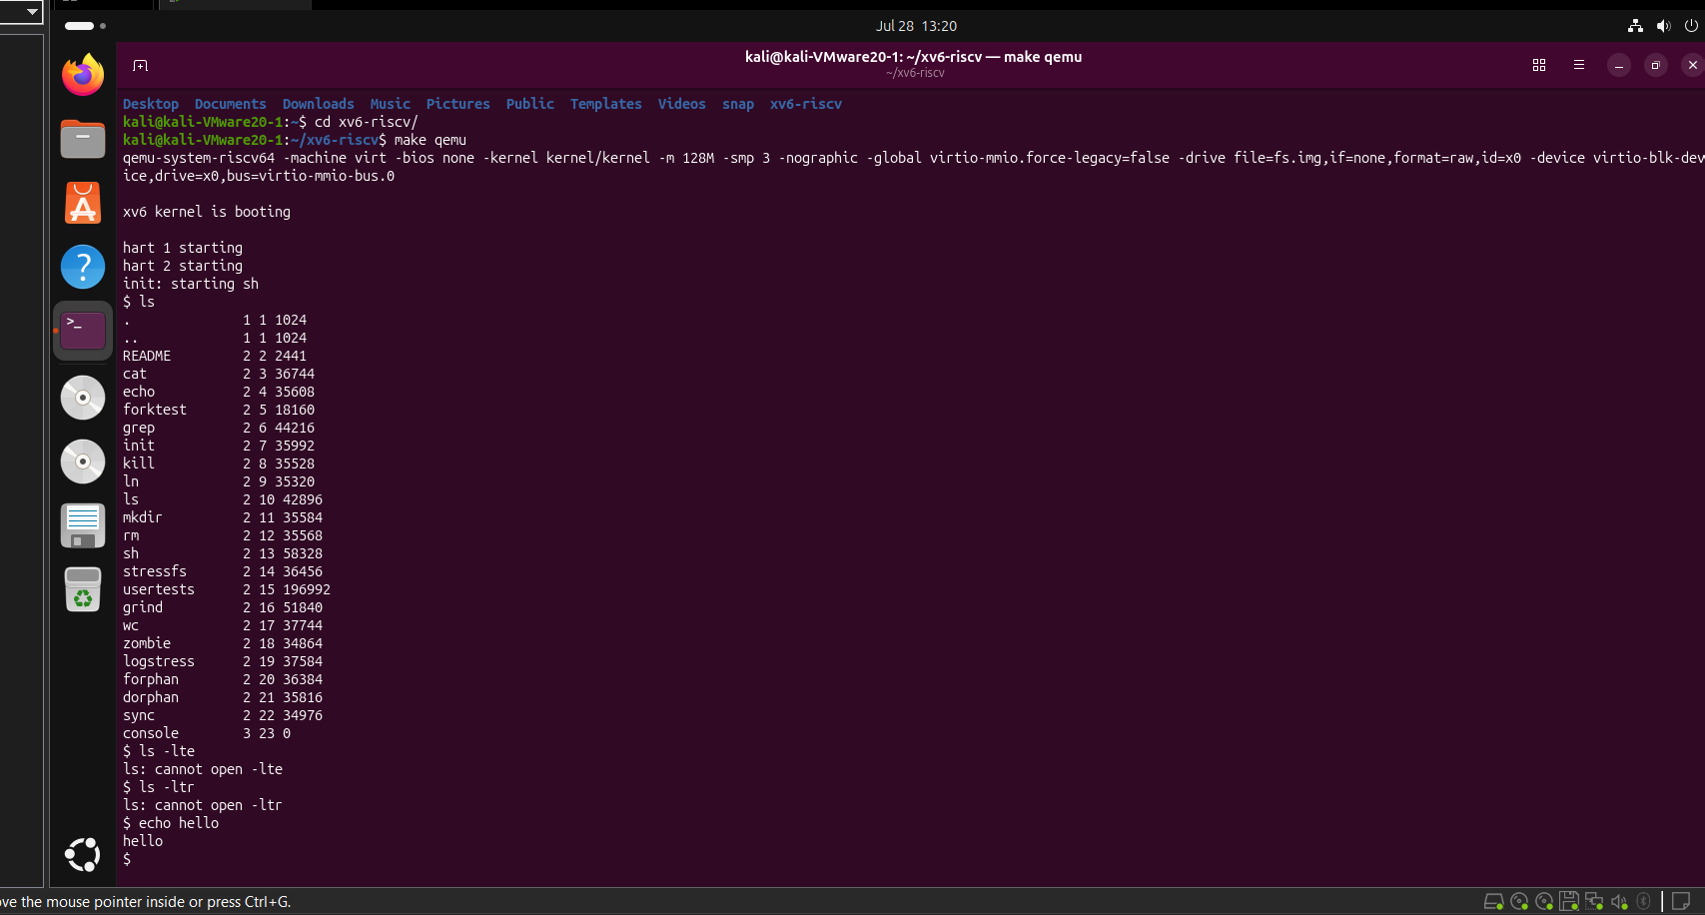

Step 10: Exit xv6
- Press Ctrl + A, then X to exit QEMU.

Checklist
- VMware installed
- Ubuntu installed
- Ubuntu updated
- Required packages installed
- xv6 downloaded
- xv6 compiled
- xv6 running successfully

