**Analysis of lidar-derived snow depth over Fortress Basin**

**Goal:** Determine the accuracy of lidar-derived snow depth (in comparison to manually collected snow depth)

**Methods:**

1. Processed lidar point clouds into 1 m resolution tifs (Figure 1)
2. Subtracted the bare ground survey (October 19, 2022) from all snowy surveys to retrieve snow depth rasters
3. Used GNSS point locations of manual snow depth measurements to extract lidar-derived snow depth for comparison

**Results:**

* Fortress Ridge lidar snow depths are in agreement with manually measured snow depth (bias of 0.00m, Table 1)
* Fortress Ridge South lidar snow depths have the largest disagreement with manual measurements (lidar depths are 14.6 cm lower than manual measurements)
  + This is displayed clearly in Figure 2, where FRS is the site with the largest discrepancy between manual and lidar snow depths
  + Largest discrepancies between manual and lidar snow depths appear within the first half of the transect (Figure 3)
* For all survey points across Fortress, for all days, lidar snow depth is biased 6.8 cm shallower than manual measurements

Table 1. Comparison of manual snow depth measurements and lidar-derived snow depths.

|  |  |  |
| --- | --- | --- |
| **Site** | **Lidar Snow Depth Bias (m)** | **Lidar Snow Depth R2** |
| Bonsai | -0.055 | 0.946 |
| Canadian Ridge | -0.071 | 0.934 |
| Fortress Ridge | 0.000 | 0.666 |
| Fortress Ridge South | -0.146 | 0.682 |
| Basin-wide | -0.068 | 0.939 |

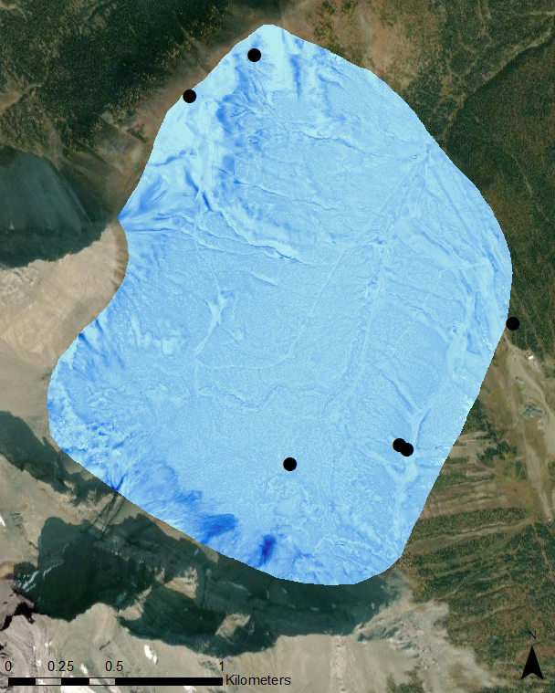

Lidar snow depth (m)

Figure 1. Example of lidar-derived snow depth (retrieved 20 April 2023). Location of meteorological stations displayed as a black dot.

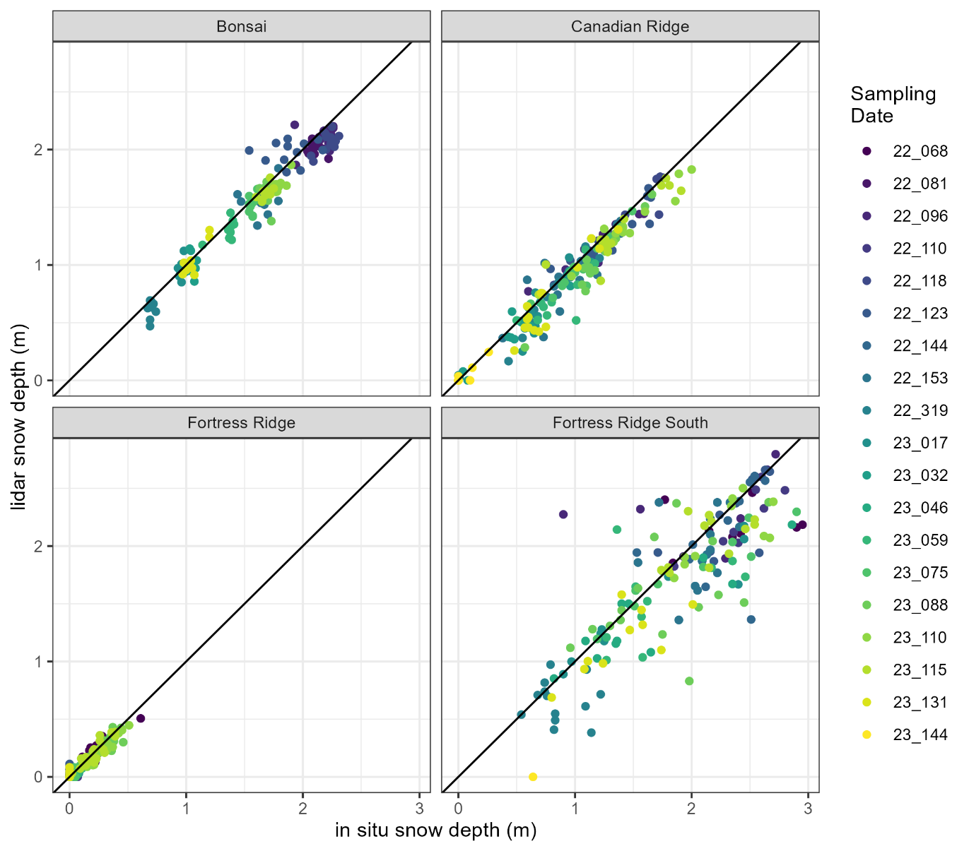

Figure 2. Manually measured snow depth vs lidar-derived snow depth, coloured by date of retrieval.

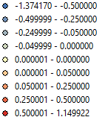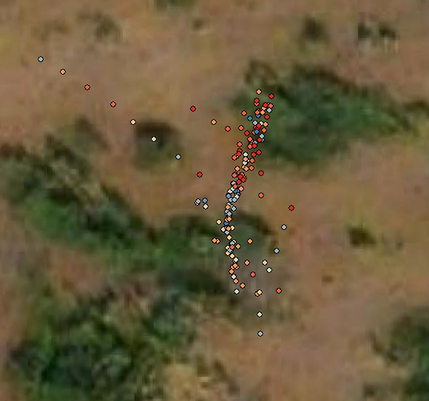

In situ – lidar snow depth (m)

Figure 3. GPS locations of manual snow depth measurements at Fortress Ridge South, coloured by discrepancy between manually measured and lidar-derived snow depths (blue = manual > lidar, red = manual < lidar).

**Appendix**

Dates used for analysis

