**Lidar-derived SWE over Fortress Basin**

**Goal:** calculate snow water equivalent (SWE) for the entirety of Fortress Basin using lidar-derived snow depths and manual measurements of snow density

**Methods:**

1. Processed lidar points clouds of Fortress Basin into 1 m resolution rasters, and subtracted bare ground elevations (October 19, 2022) to derive snow depth for all dates
2. Regression between manually measured snow depth and snow density was calculated (whole basin, Figure 1), regression was used to calculate basin-wide SWE for dates meeting R2 threshold (Figure 2)
   * Threshold of >10 survey points and R2 > 0.5
   * This applied to three dates: 9 March 2022, 16 March 2023, 20 April 2023
3. Dates not meeting the regression threshold -> Fortress Basin divided into 7 Hydrological Response Units (HRU) (Figure 3), mean snow density for each HRU (for each date) was used to calculate SWE (Figure 4)
   * HRUs manually created using optical satellite imagery (2023) of Fortress, in combination with reference to HRUs provided by Logan (Alberta Biosphere Monitoring Institute)

**Notes:**

* Depth/density regression works well for mid-winter snowpacks (March/April)
  + Should R2 cutoff for using/not using regressed SWE be changed?
  + Does it make sense to use regressed SWE, or should the method of SWE calculation be kept consistent?
* Extremely high SWE values (>7000 mm) are found around the headwall, likely influenced by avalanches (clear avalanche path visible in Figure 5)
  + This means that this one area is the predominant source for a large amount of meltwater for Bonsai and Fortress Creek
* Missing densities for cat roads and artificial clearings on ski runs – leaves big gaps in mean density SWE maps (Fig 4)

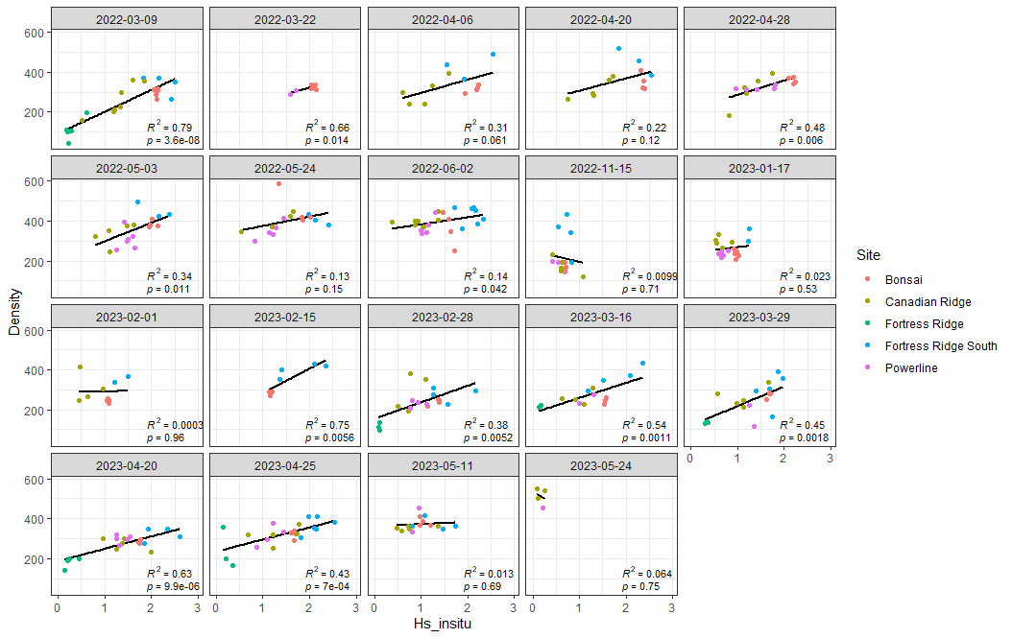

Figure 1. Regression between in situ snow depth and snow density. Dates meeting the regression threshold include 9 March 2022, 16 March 2023, and 20 April 2023.

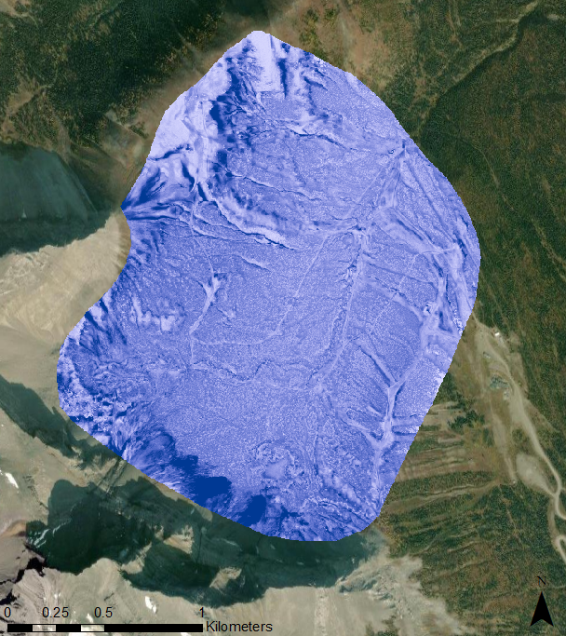

SWE (mm)

Figure 2. Basin-wide SWE derived from depth/density regression on 20 April 2023. Highest SWE found in areas near headwall where triggered avalanches occur.

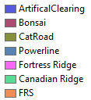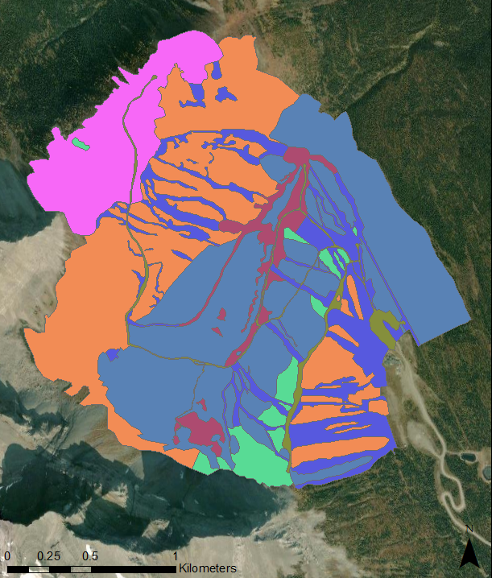

Figure 3. Fortress HRUs created from HRUs provided by Alberta Biosphere Monitoring Institute and from 2023 satellite imagery.

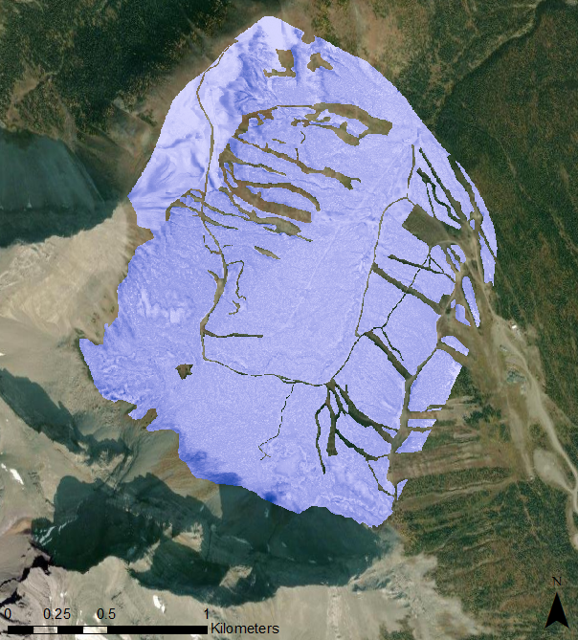

SWE (mm)

Figure 4. Basin-wide SWE derived from average density within HRU regions for 25 April 2023.

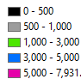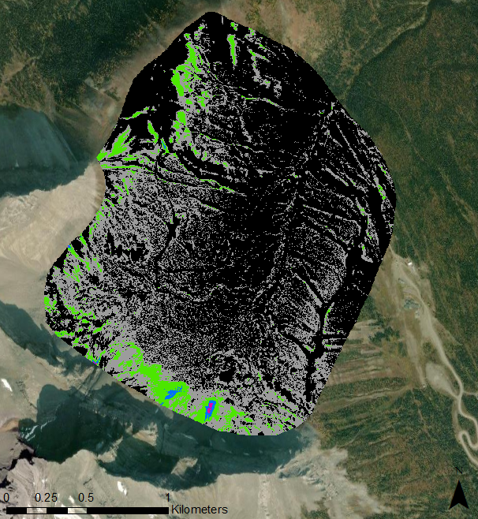

SWE (mm)

Figure 5. Regressed SWE displayed with a classified colour ramp to display areas with the highest SWE for 20 April 2023. SWE is predominately between 0 – 1000 mm across the basin, with pockets of high SWE being found in drifts around Fortress Ridge and near the headwall.