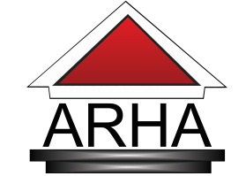

MEDIA ADVISORY Contact: McKenya Dilworth
FOR IMMEDIATE RELEASE 703.549.7115 ext.420

ARHA celebrates its 75th Anniversary as leader in Housing

ALEXANDRIA, VA., May 30, 2014. This summer, the Alexandria Redevelopment and Housing Authority (ARHA) celebrates 75-years of service in the community. From its inception in 1939, the organization has provided affordable and low-income housing and services, to thousands of families and spearheaded millions of dollars in redevelopment projects in the city of Alexandria. ARHA will celebrate its anniversary with resident success stories and highlight past and current projects throughout June.

ARHA were established on June 27, 1939 by City Ordinance and Mayoral appointment of a five member Board of Commissioners, in accordance with Virginia enabling legislation. The first low-rent housing units were occupied in 1941. ARHA is a public agency that preserves affordable housing opportunities for Alexandria’s low-income residents by providing safe and sanitary living conditions. The agency also provides educational and career advancement opportunities to residents through various social and resident service programs.

For the last 75-years, the Alexandria Redevelopment and Housing Authority have provided adequate and affordable housing, economic opportunities, and a suitable living environment, free from discrimination, for the citizens of Alexandria.

ARHA’s mission is to be an industry leader in the development and management of model mixed income communities that provide the opportunity for residents to achieve self-sufficiency and to participate in economic opportunities that are made possible through this model.

For more information about events related to the 75th Anniversary contact McKenya Dilworth at 703.549.7115 ext.420 and visit ARHA’s website at www.arha.us.

