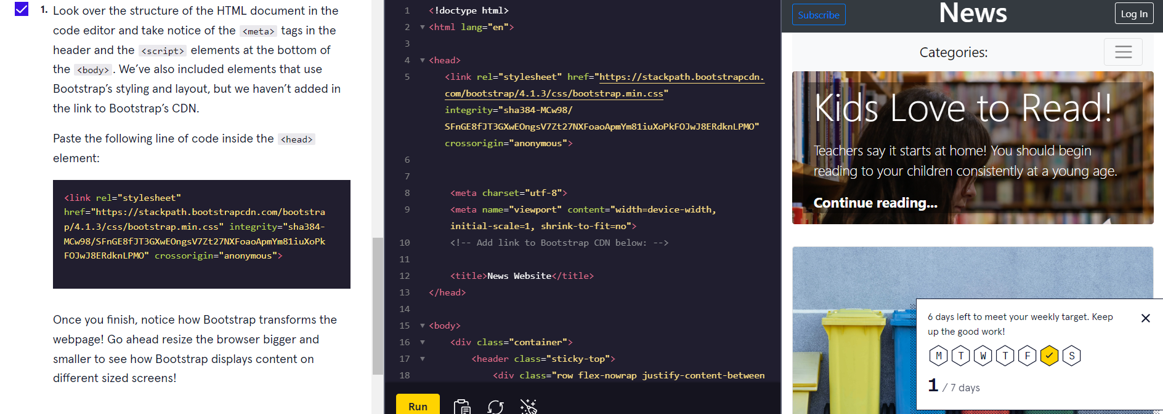

<div class="container">

<div class="row">

<div class="col">

<!-- A column inside a row inside a container! -->

</div>

</div>

</div>

We can adjust the size of the appear output in the screen :

<div class=”container”>

<div class="container-fluid”></div>

This container-fluid take up the entire width of the screen