Php is not a case sensitive, can be used Echo or echo, both can be run

<?PHP

>

DO COMMENT WITH //

IF IN HTML <!---- -->

/* */

<?php

require 'vendor/autoload.php';

# This logic handles connecting to the database, where we store our todo status

$pdo = new \PDO("sqlite:" . "db/sqlite.db");

# This PHP logic handles user actions

# New TODO

if (isset($_POST['submit']))

{

  $description = $_POST['description'];

  $sth = $pdo->prepare("INSERT INTO todos (description) VALUES (:description)");

  $sth->bindValue(':description', $description, PDO::PARAM_STR);

  $sth->execute();

}

# Delete TODO

elseif (isset($_POST['delete']))

{

  $id = $_POST['id'];

  $sth = $pdo->prepare("delete from todos where id = :id");

  $sth->bindValue(':id', $id, PDO::PARAM_INT);

  $sth->execute();

}

# Update completion status

elseif (isset($_POST['complete']))

{

    $id = $_POST['id'];

    $sth = $pdo->prepare("UPDATE todos SET complete = 1 where id = :id");

    $sth->bindValue(':id', $id, PDO::PARAM_INT);

    $sth->execute();

}

# Here is the HTML:

?>

<!DOCTYPE HTML>

<html lang="en">

<head>

  <title>Todo List</title>

</head>

<body class="container">

  <h1>Todo List</h1>

  <form method="post" action="">

    <input type="text" name="description" value="">

    <input type="submit" name="submit" value="Add">

  </form>

  <h2>Current Todos</h2>

  <table class="table table-striped">

    <thead><th>Task</th><th></th><th></th></thead>

    <tbody>

<?php

  # Entering PHP mode,

$sth = $pdo->prepare("SELECT * FROM todos ORDER BY id DESC");

$sth->execute();

foreach ($sth as $row) {

  # Exiting PHP Mode

    ?>

<tr>

  <td>

      <!-- This is PHP shorthand for inserting dynamic text into HTML -->

      <?=htmlspecialchars($row['description'])?></td>

  <td>

    <?php # Here we are mixing HTML and PHP to get the desired document

if (!$row['complete']) {

        ?>

    <form method="POST">

      <button type="submit" name="complete">Complete</button>

      <input type="hidden" name="id" value="<?=$row['id']?>">

      <input type="hidden" name="complete" value="true">

    </form>

    <?php

} else {

        ?>

    Task Complete!

    <?php

}

    ?>

  </td>

  <td>

    <form method="POST">

      <button type="submit" name="delete">Delete</button>

      <input type="hidden" name="id" value="<?=$row['id']?>">

      <input type="hidden" name="delete" value="true">

    </form>

  </td>

</tr>

<?php

}

?>

    </tbody>

  </table>

</body>

</html>

Using dot operator

Echo”my name is: ” . “ Haziq”; == my name is: Haziq

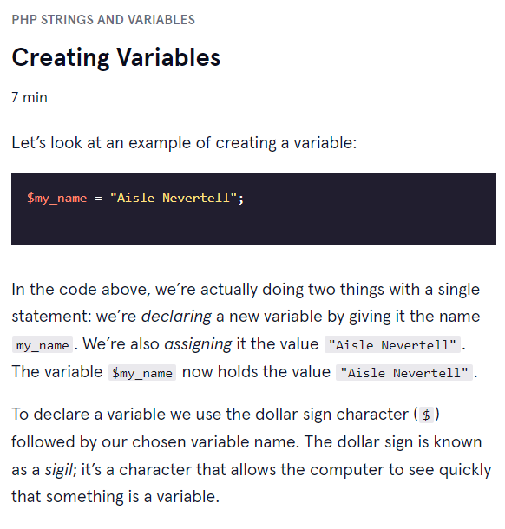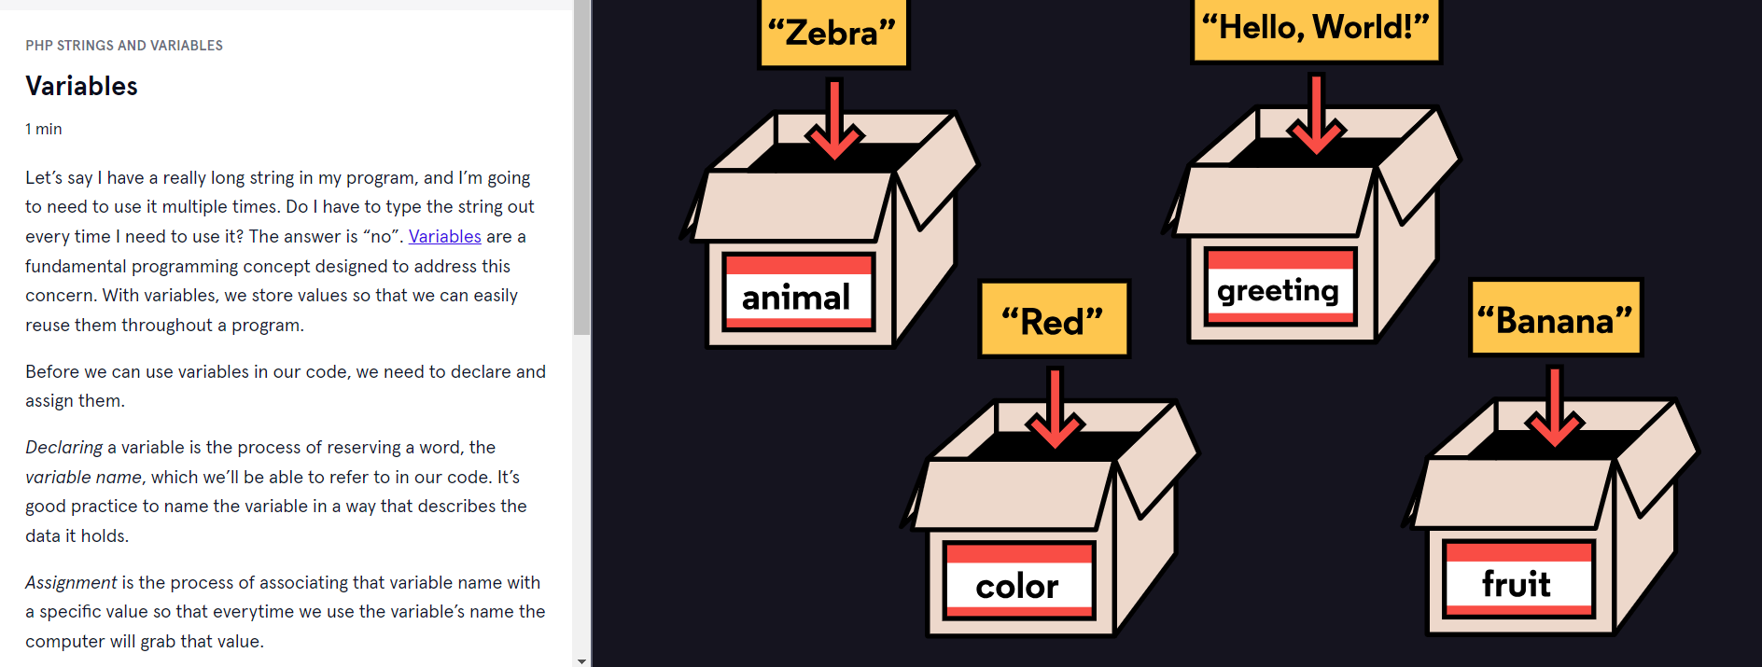

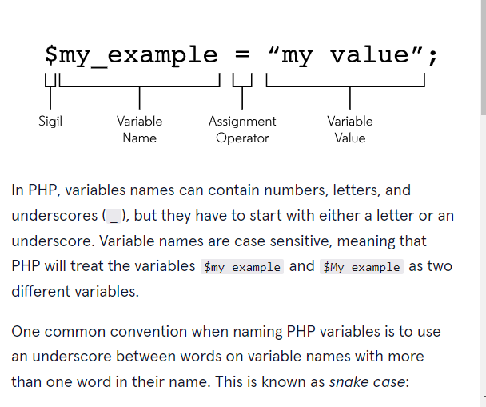

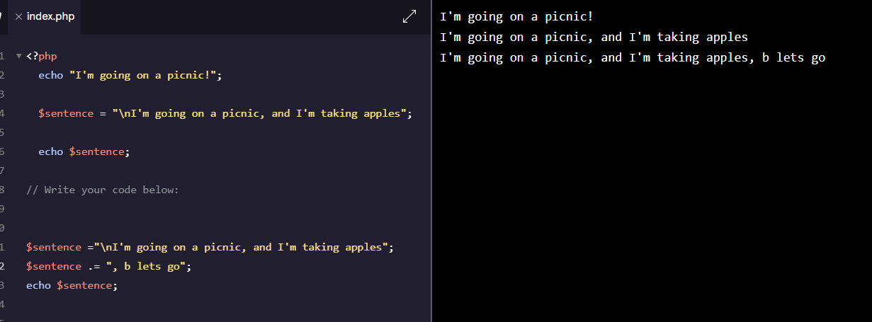

7/09/2024

