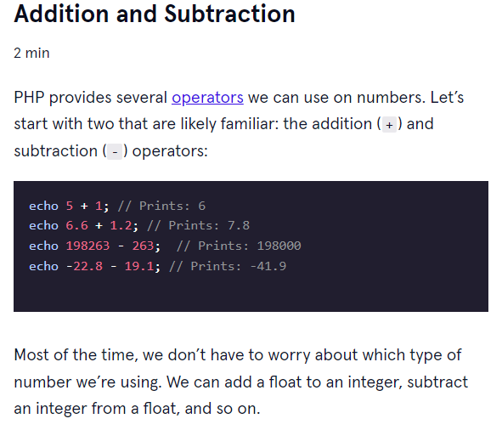

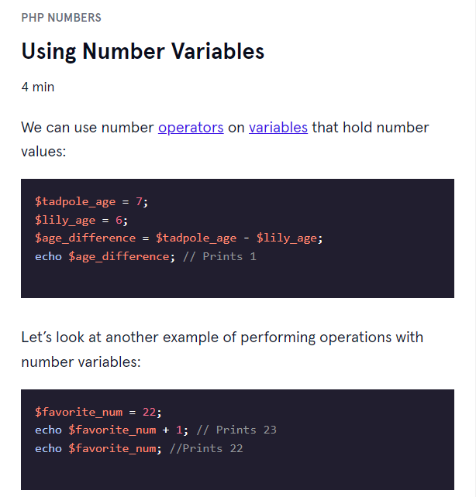

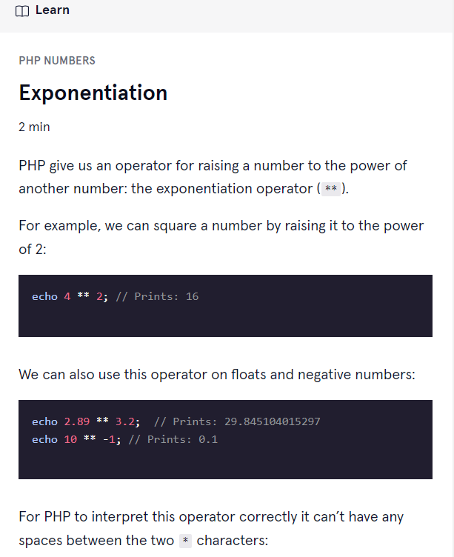

Modulos

It happens when no whole number to calculate.

<?php

// Write your code below:

$my_num=21;

$answer =$my_num;

$answer +=2;

$answer *=2;

$answer -=2;

$answer /=2;

$answer -=$my_num;

 echo $answer;