    <div class="nav">

      <div class="container">

        <ul>

          <li>Register</li>

          <li>Schedule</li>

          <li>Sponsors</li>

          <li>About</li>

          <li>Contact</li>

        </ul>

      </div>

    </div>

<h6 id=’publish-time’>Published : 3 days ago</h6>

In css, we can color the h6 by using

#publish-time{

Color:gray;

}

Kalau guna class:

<h2 class=’destination’> johor</h2>

Dalam css,

.destination{

Color:blue;

}

 <h5 class='author-class' id='author-id'>By: Stacy Gray</h5>

  <p style='color:green; font-size:20px;'>The world is full of fascinating places. Planning the perfect vacation involves packing up, leaving home, and experiencing something new.</p>

Internal stylesheet when there are many to styling and just use at between the <head> tags

div{

  color:orange;

}

TYPE SELECTOR:

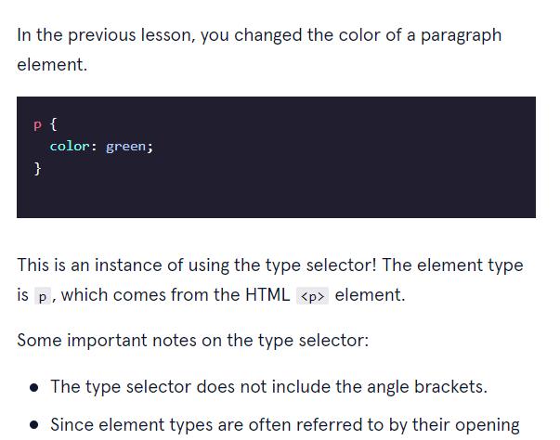

UNIVERSAL ; ALL FONT IS CHANGED TO VERDANA

Place the stylesheet in between the head tags

Kalau dia dah declare as id, kita akan guna # di file css.

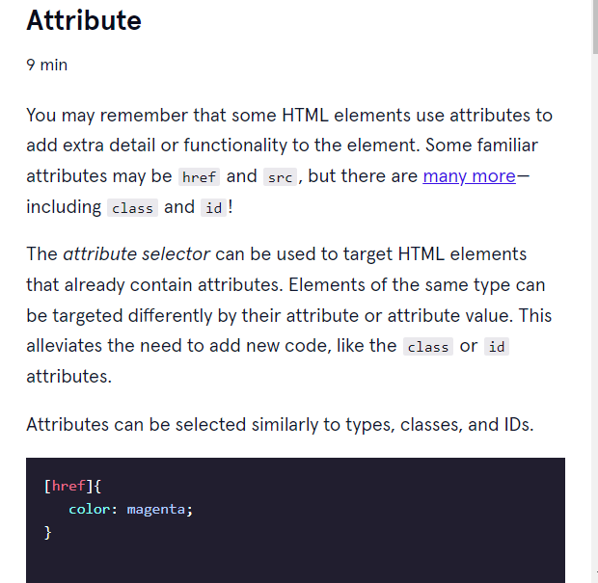

On the keyword that contain Florence and Italy, the link will be turn it colors to the one that is being declared.

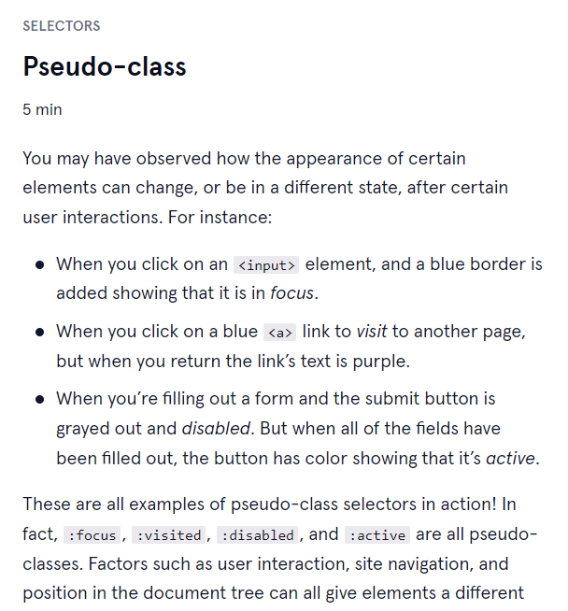

We have added a selector psedo-class{

a:hover{

color:darkorange;

}

In html >

  <h2 class='destination heading-background'>1. Florence, Italy</h2>

We applied a ruleset for it by

.heading-background{

Background-color:aqua;

}