Glass Box

Kinetic energy
Big Back wheels

Front Triple-wheels
F
Motors

Power
Ascends curbs

Power
Batteries

Information
Heat

Sound

Kinetic energy
Hind legs

Front legs
F
Motors

Power
Storage Unit
Movement
Carries Packages
Power
Batteries

Information
Package
Processing Unit
Sensors
Heat

Sound

DELETE ABOVE THIS

- Brainstorming
  - Morphological chart
Table 10 - Morphological chart
Function | Means
Function | 1 | 2 | 3 | 4 | 5
1. Traversal of the campus | Wheels | Propellers | Continuous wheel track | Quadruped/Biped | Conveyer belt
2. Carrying the package | Wagon | Carried Box | Pneumatic tubes
3. Navigation | GPS | Predefined path | Pilotage ^{[i]}
4. Maintain the safety of the package | Digital lock | Combination Lock | 2-step verification
Feature | Means
Feature | 1 | 2 | 3 | 4 | 5
1. Fast | Motors power | Mechanic | Lightweight
2. Long battery life | Energy consumption | Capacity | Recharge time

[i] navigating by reference to visible landmarks
- Alterative A: Quadruped robot with a wagon attached to it, navigates using pilotage, the packages are secured using a 2-step verification system (2FA)
- Alternative B: Conveyer belt where the packages are put in a plastic box and placed on it, the conveyer belt spans the campus on a predefined path, the packages are secured using a combination lock.
- Alternative C: Ground robot that uses wheels to traverse the campus, the package is loaded on the robot (carried box), it navigates using GPS, the packages are secured using a Digital lock

Ideas from initial brainstorming:
- Alternative D: Robot Train
- Alternative E: Pneumatic System
- Alternative F: Drone delivery

Alternatives analysis
  - Ground Robot
A ground robot with a built-in storage cart uses four wheels to move between buildings within the university campus. The robot needs to be able move safely using obstacle avoidance techniques to avoid objects around it. It uses battery, to supply enough power for a complete back and forth trip. To be able to move between buildings, the ground robot needs a navigation algorithm to guide the robot through the whole trip.
Pros :
- Free movement? Flexible path? No pre-defined stop points(NO NO)?
- No need for special roads (it uses our normal daily roads) // No infrastructure needed
- Battery powered (works even when electric power off? No need?)
Cons:
- Needs to be carefully trained to avoid obstacles
- Higher probability of getting stuck
- Easily tampered with
- Training phase is required
Movement

Batteries

Controller
Motors

rear wheels
F
Kinetic energy
commands
Power
Heat

Sound

Figure 6 - Glass box

Cost analysis
ITEM | Expected Price | Quantity | Total
Jetson nano | $75.00 | 1 | $75.00
Stereo Camera Module Compatible with Jetson Nano | $45.00 | 1 | $45.00
motor driver | $12.00 | 4 | $48.00
Platform | $100.00 | 1 | $100.00
battery | $20.00 | 1 | $20.00
Wheels | $12.00 | 4 | $48.00
Motors | $15.00 | 4 | $60.00
Total cost |  |  | $336.00

  - RoboDog
This alternative is a quadruped robot. It uses two front legs and two hind legs to move just like an animal would. Furthermore, it can traverse at acceptable speeds and carry a heavy load. This alternative can also walk on the campus and roads.

Pros:
- Innovative
- Can climb stairs
- Can drag or carry the packages
Cons:
- Complex
- Easily tampered with (pushing, vandalizing, etc…).
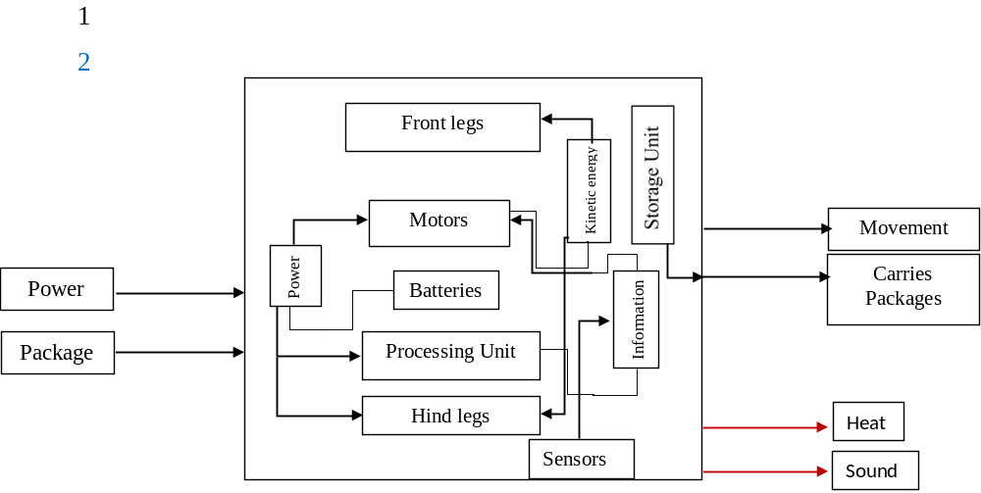
ITEM | Expected Price | Quantity | Total
Jetson nano | $75.00 | 1 | $75.00
Stereo Camera Module Compatible with Jetson Nano | $45.00 | 1 | $45.00
LIDAR sensor | $100.00 | 1 | $100.00
Gyroscope sensor | $15.00 | 1 | $15.00
Wagon | $60.00 | 1 | $60.00
battery | $20.00 | 1 | $20.00
Artificial limbs (3D printed) | $40.00 | 2 | $80.00
Servo motors | $20.00 | 8 | $160.00
Total cost |  |  | $555.00

  - Robot train tracks
To be able to use a mini train within campus, we need train tracks that connect the buildings we want to deliver to and from. By having different stops at different faculty buildings, and smart train junctions that can save time by switching to shorter routes the user can drop off the packages at 1 of the stops and then the receiver would take the package at the stop nearest to him/her.
Pros
- Eliminates the need for navigation algorithms.
- If pedestrians avoid the tracks, no need for obstacle avoidance.
- Can be fast?
Cons
- Requires train tracks to function.
- Sub-optimal routes
- Limited to set of stops

Heat

Batteries

Controller
Train Tracks
Motors

Train
Power
Kinetic energy
Information
Power
Deliver packages
Sound

Figure 6 – Train’s Glass box

ITEM | Expected Price | Quantity | Total
Arduino uno | $40.00 | 1 | $40.00
Wagon | $60.00 | 3 | $180.00
Battery | $20.00 | 1 | $20.00
Traction motor | $450.00 | 1 | $450.00
Total cost |  |  | $690.00

- Choosing Baseline Design
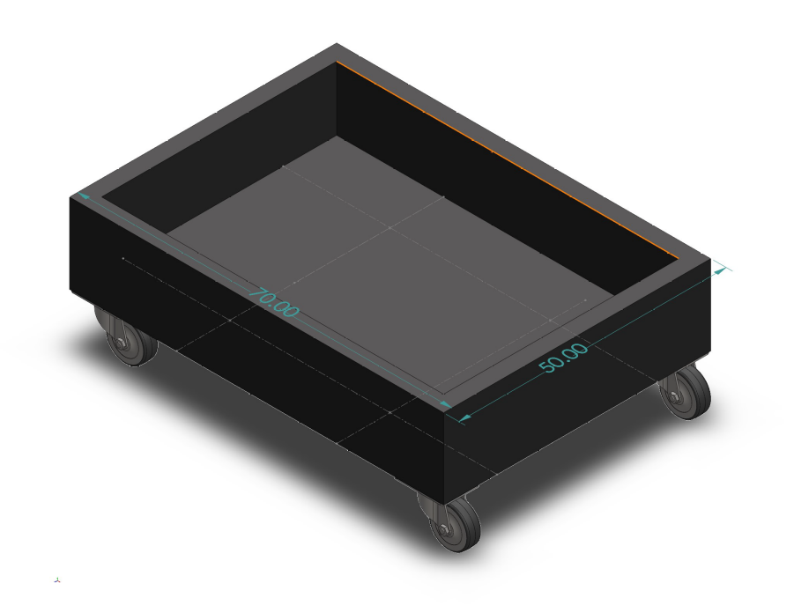
After analyzing the alternatives, we chose the Ground Robot to be our baseline design. Due to it having the lowest cost, balanced complexity, and the availability of the parts. We modeled our idea using SolidWorks to be able to imagine our baseline design.

To further improve our base model, we started thinking of things we could change. We thought of reusing a hoverboard instead of buying the different motors and motor drivers. Hoverboards contain powerful motors that could carry people (~100 kg) which makes the design sturdier. Furthermore, wheel encoders are included in the hoverboard eliminating the need to buy them. In addition to that, the hoverboards have a recharging capability that is simple to use. We also thought of adding ventilation slits to the wagon to improve thermal dissipation. In addition to that, one idea was to add a hole in the wagon for cable management to eliminate the possibility of unwanted friction of the wires with the ground.

  - Morphological chart
Table 10 - Morphological chart
Function | Means
Function | 1 | 2 | 3 | 4 | 5
1. Traversal of the campus | Wheels | Propellers | Continuous wheel track | Quadruped/Biped | Conveyer belt
2. Carrying the package | Wagon | Carried Box | Pneumatic tubes
3. Navigation | GPS | Predefined path | Pilotage ^{[i]}
4. Maintain the safety of the package | Digital lock | Combination Lock | 2-step verification
Feature | Means
Feature | 1 | 2 | 3 | 4 | 5
1. Fast | Motors power | Mechanic | Lightweight
2. Long battery life | Energy consumption | Capacity | Recharge time

[i] navigating by reference to visible landmarks
- Alterative A: Quadruped robot with a wagon attached to it, navigates using pilotage, the packages are secured using a 2-step verification system (2FA)
- Alternative B: Conveyer belt where the packages are put in a plastic box and placed on it, the conveyer belt spans the campus on a predefined path, the packages are secured using a combination lock.
- Alternative C: Ground robot that uses wheels to traverse the campus, the package is loaded on the robot (carried box), it navigates using GPS, the packages are secured using a Digital lock

KTDA
Musts/Alternative | A: Quadruped Robot | B: Conveyer Belt | C: Ground Robot | D: Robot Train | E: Golf Cart | F: Drone
- The ability to move within 2 km range of the Engineering building autonomously on paved roads.  - Ensures the safety of the packages.  - Includes a storage unit for the shipments.  - Tamper proof electronic components.  - Made from durable material.  - Operate within 5 km/h.  - Can carry weight within (80kg). | GO / NO GO  GO / NO GO  GO / NO GO  GO / NO GO  GO / NO GO  GO / NO GO  GO / NO GO | GO / NO GO  GO / NO GO  GO / NO GO  GO / NO GO  GO / NO GO  GO / NO GO  GO / NO GO | GO / NO GO  GO / NO GO  GO / NO GO  GO / NO GO  GO / NO GO  GO / NO GO  GO / NO GO | GO / NO GO  GO / NO GO  GO / NO GO  GO / NO GO  GO / NO GO  GO / NO GO  GO / NO GO | GO / NO GO  GO / NO GO  GO / NO GO  GO / NO GO  GO / NO GO  GO / NO GO  GO / NO GO | GO / NO GO  GO / NO GO  GO / NO GO  GO / NO GO  GO / NO GO  GO / NO GO  GO / NO GO

Wants | Weight | Rating | Score | Rating | Score | Rating | Score | Rating | Score | Rating | Score | Rating | Score
- All the parts for the project can be found in Jeddah | 7 | 10 | 70 | 10 | 70 | 10 | 70 | No go
- The project can be done in 5 weeks | 10 | 10 | 100 | 8 | 80 | 0 | 0
- The project combines all our fields (mechanical, electrical) | 6 | 5 | 30 | 10 | 60 | 10 | 60
- The artifact could be water and dust resistant | 3 | 10 | 30 | 10 | 30 | 10 | 30
- The project implements material learnt in class | 8 | 10 | 80 | 7 | 56 | 8 | 64
- The Project could be made using eco-friendly materials | 3 | 4 | 12 | 0 | 0 | 0 | 0
- Doesn’t require payment for transportation | 10 | 10 | 100 | 10 | 100 | 9 | 90
- Could be made using less than 5 electric circuits | 8 | 10 | 80 | 7 | 56 | 3 | 24
- The project can be easily fixed in case of a malfunction | 10 | 7 | 70 | 8 | 80 | 3 | 30
- The project use pieces we can find in our homes. | 3 | 5 | 15 | 8 | 24 | 0 | 0
 |  | Total A = 587 |  | Total B = 556 |  | Total C = 368 |  | Total D = NO GO |  | Total E = NO GO |  | Total F = NO GO

- Intro+ musts+ wants + objectives (from project charter)
- Control System's Objective: Discuss all components (Acutators: motors, power electric circuits, sensors, microelectric devices, controllers) //individual
- Generate alternatives using morphological chart
- Compare alternatives using KTDA (Kepner Tregoe decision analysis)
- Analysis of alternatives that pass the KTDA (Glass box (describe the systems), pros cons, cost analysis of components)
- Select an alternative
- Further analysis of selected alternative (short paragraph)
- Maturing chosen baseline design (buying motors, wasting time etc. -> Reusing a hoverboard and adding a cart to it)
- Add 3D model of baseline design
- Specification (dimensions and updated SLDW), updated cost analysis // updated cost from old excel file.
- Discuss impact of components on economy, enviroment, society. //individual

Next meeting:
Tentative date: Fri 8:00 PM 12/11/2021
- Analysis of alternatives that pass the KTDA (Glass box (describe the systems), pros cons, cost analysis of components
- Assign black tasks + deadlines

Upcoming deadline:
Thursday 11:00 PM 18/11/2021

Mohanned: Actuators, power electric circuits, Economy
Suliman: Sensors, Enviroment
Wael: Microelectric devices, controllers, Socially

- Submit individual taks
- Formatting
- Send draft to Dr. Mohammed
- Final submission by 23rd of November

