بسم الله الرحمن الرحيم

King Abdulaziz University - Faculty of Engineering – EE-499

Senior Design Project
Report #5
Alternative Designs: On Campus Delivery Robot
Team#3
Advisor: Dr. Muhammed Bilal
No. | Member
1 | Muhannad Saeed Alghamdi | F21_T03_M1_1846525
2 | Sulaiman Abdullah Abbas | F21_T03_M2_1845862
3 | Wael Rabah Aldhaheri | F21_T03_M3_1846987
Table of Contents
Introduction 3
Project Objectives 3
Musts & Wants 3
Actuators: 4
A) Torque 4
B) Speed 4
C) Energy efficiency 4
1) Brushless DC Motor 5
2) Brushed DC Motor 5
3) Servomotor 6
Power Electronics Circuits: 7
1) H-Bridge 7
2) DC Motor Driver 9
3) DC to DC convertor 10
Sensors: 10
1-LIDAR sensor 11
2-Ultrasonic sensor 11
3-IR sensor 12
Controllers 12
1-Arduino 12
2-Raspberry Pi 13
Alternatives: 13
1.1. Morphological chart 13
Alternative analysis 14
1. Ground Robot 14
2. RoboDog 15
3. Robot train tracks 17
Choosing Baseline Design 18
Societal Impacts 19
Stereo camera 19
Motors 19
Economics Impact 20
Environmental Impact: 20
Lithium-Ion Battery: 20
Rubber wheels: 21
References 21

Introduction
Robotics are an important part of the future, and with that we have decided to implement a robot that will automate the process of delivery inside the KAU campus. Before that, the project goes through the design process where it will fulfill the project objectives and musts. All of whichare included in this report.
The design process will start off with discussing the core elements of the project. To add on, these elements are categorized into a few groups;
- Actuators
- Controllers
- Micro-electronic circuits
- Sensors
- Power electronics
All of these parts work together to create a unified robot. For example, the sensors retrieve data from the outside world to the micro-electronic circuits which send them to the controller, the brain of the robot, which then relays these to the motors and power electronics. Everything works together to fulfill the objectives.

Project Objectives
The objectives of the project are categorized into two levels, lower and higher levels. To start off, the lower-level objectives is what directly affects the smaller scope. The project will aim to connect the whole university buildings into a single automated delivery network. This network is important because it can be accessed by whoever needs it inside the campus. Moreover, another lower-level objective is to improve productivity of employees/students by saving their time. This is an important one due to the wastage of time whenever someone needs something delivered inside the vast areas of the campus. And finally, reduce the use of fuel and manpower in the delivery process.
The higher-level objectives are also not to be neglected, the first one is to increase development in the tech field industry in Saudi Arabia. Furthermore, raise awareness to decrease the carbon emission, by providing an electrical alternative to gasoline-based vehicles. And finally, encourage upcoming generations to research & develop autonomous solutions.

Musts & Wants
Part of the design process is finding out the musts and wants, these are important guidelines that the project needs to have or a bonus if it succeeds it doing. Below is the list for the musts and wants
Musts | Wants
The ability to move within 2 km range of the Engineering building autonomously on paved roads. | The ability to move around the whole campus autonomously on paved roads.
Ensures the safety of the packages. | Neat design.
Includes a storage unit for the shipments. | Can carry weight within (120kg).
Tamper proof electronic components. | Can charge using charging stations.
Made from durable material. | Costs less than 2500 SAR.
Operate within 5 km/h.

Can carry weight within (80kg).
Table 1 Musts & Wants

Actuators:
Actuators are simply motors; they are used to convert one shape of energy to a mechanical energy. The mechanical energy produced or simply the motion could be in linear or rotary motion. As the names suggests linear actuators responsible of producing the linear movements. While the rotary actuators are responsible of rotary motions through a circular path. There are three main measurements associated with actuator we will discuss, as follows:

A) Torque
The torque is a measurement of how much rotational force this actuator can produce. There two commonly used measurement units for torque, one is the newton meters (N.m) which is physically defined as the torque produced by a one-newton perpendicular force applied to a one meter long arm. Another unit used is the (Kg-cm) which is defined as the torque required for holding a 1 Kg mass at a radical distance of 1 cm. generally, the higher the torque is describes the higher abilities of the motor to push, pull or move heavier objects.

B) Speed
The speed of the actuator is defined as the rotation rate of the motors. A common unit to measure the speed of an actuator is by using the counts of revolutions per minutes known as (RPM). The speed of the actuator is highly dependent on the carried load's weight, a very high weight reduces the actuator speed. However, It is known that the speed measurement is done one the actuator when no load is carried.

C) Energy efficiency
Energy efficiency is one of the main concerns of any engineering tool. For actuators, it is basically a measurement of the amount of the used energy to perform a certain. The lesser amount of energy used to perform the same task is better than a higher amount with same mechanical performance.
As discussed above, actuators can be classified into categories based on certain set of classification criteria. However, we will discuss some commonly used actuators especially in the robotics field, they are as follows:

Brushless DC Motor
Brushless DC motors are considered to be of the highly efficient motors in producing higher torque. As Fig.1 shows, the brushless motor is simply a DC motor with no brushes. It has a permeant magnet. This permeant magnet called Rotor, as it rotates through the changes in the magnetic field around it caused by the coils known as stators. In order to control the rotation, we simply have to control flow and the direction of the current passing through these coils.
A brushless DC motor, as the one shown in Fig.1 uses three coils for each coil to wires are required for the flow of the current through that wire. Thus, for the brushless DC motor with only three wires it requires six wires. But, usually in many brushless DC motors it is designed that three of those six wires are internally connected. And we simply have the other three motors.
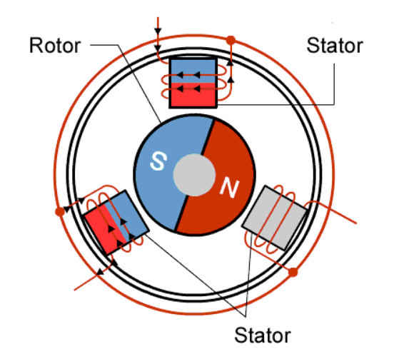
Figure 1 - Brushless DC motor internal connection

Brushed DC Motor
In the Brushed DC motor, instead of a rotary magnet we have a fixed permanent magnet it is called stator. The Coils rotates instead of the magnet through the current flowing through what we call brush. Fig.2 shows a brushed DC motor, note that the permanent magnet is fixed while the coils are the rotatory part resulted from the current flow through the brush.
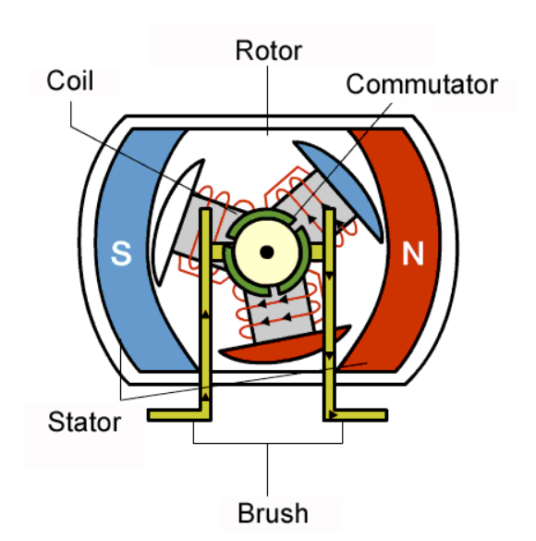
Brushed DC motor not only has a simpler design, it also easier to control using the current flow that passes through the brush to create magnetic field causing the coils to rotary as a result of the force produce by the magnetic field between the permanent magnetic and the coils on the rotor.

Servomotor
Servomotors are commonly used in robotics field. It is provide a control of the angular position through controlling a motor with an internal controller and feedback position. There are different types of the servomotors, one frequently used type a servomotor with maximum shaft rotation of 180º. This rotation is powerful in robotics applications as it could be used for pulling, pushing or rotation actions. Fig.3 shows the internal diagram of a servomotor.
Although we discussed the 180º rotation only, there are another type of the servomotors called a 360º continuous rotation servomotor used for applications where a full rotation is required. It is similar to the regular servomotor we discussed above but the shaft used here can spins continuously instead for the narrower range.

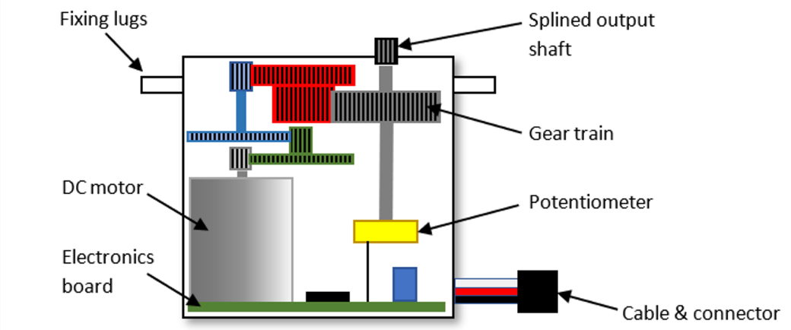
Figure 3 servomotor with its internal components

Power Electronics Circuits:
We have already discussed the actuators but one thing to be mentioned is the actuators has specific voltage and current requirement. Also, driving those actuators require specific electronic circuits. In this section, we will discuss some commonly used power electronic circuits, as follows:

H-Bridge
As we have discussed, the DC motors can rotate in two directions. If the motor plus pin connect to the V_{cc} and the minus was grounded it will spin differently than if we reversed the connections. one way to control the spinning direction without the need to plug and unplug the pins is done using H-Bridge. An H-bridge circuits shown in Fig.4, allows the current to flow in both directions by controlling the switches shown in the figure.
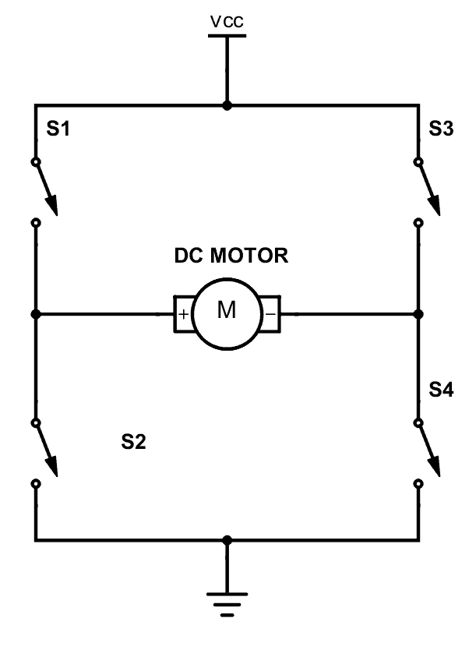
Figure 66 H-Bridge internal connection

To control the spinning direction of the motor we can close the switches s1 and s4 so the current flows from V_{cc} through s1 passing through the motor toward the ground. The current flow path is shown in Fig.5a. This will make the motor rotate in a certain direction.
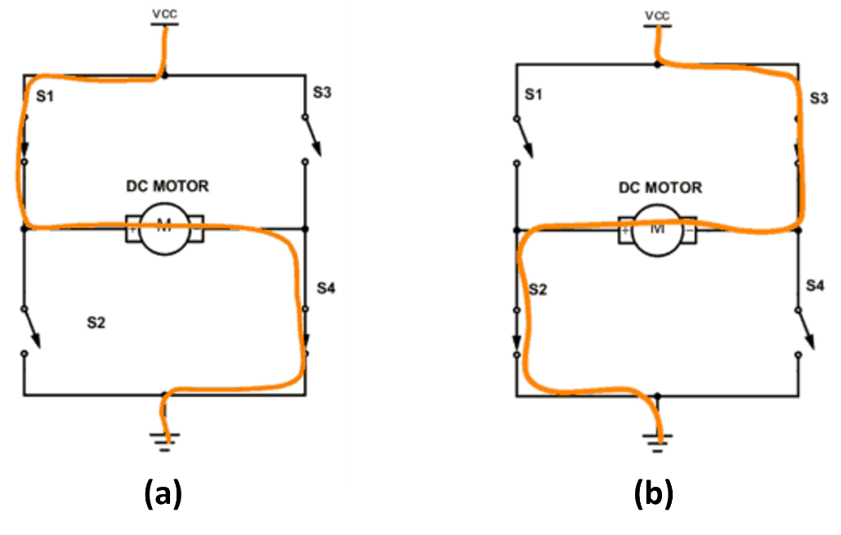
Figure 7(a) the current flow path when s1 and s4 are closed (b) the current flow path when s2 and s3 are closed

To make the motors spins to the other direction, we can close the switches s2 and s3 to force the current flow through from the minus pin of the motor to the positive pin making the motor spinning in the opposite direction. Fig.5b shows the current flow when s2 and s3 are closed.
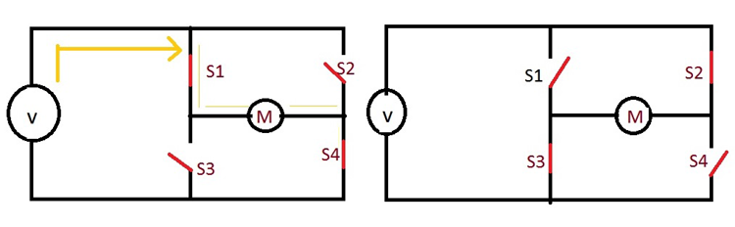
Figure 8 – A simple implementation a motor driver

DC Motor Driver
The H-Bridge circuit discussed above will take a part in the design of the motor driver. Fig.6 shows a simple implementation of the motor driver for illustration purposes with its internal connections. From the figure, we notice the H-bridge is works exactly as discussed above. The switches shown in the figure for sure are not mechanical switches. In many implementations, the switches used are transistor that are able to handle enough current and have a low V_{j} to reduce the drop in the voltage between the collector and emitter of the transistor.
Figure 9 a simple implementation a motor driver
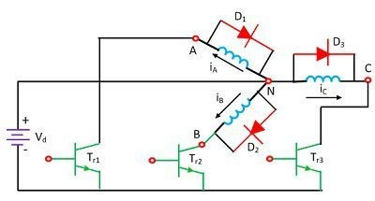
The implementation show in Fig.7 is used for three phase brushless DC motor. When a 120º positive current is supplied then the motor spins in the counter-clockwise direction. There are other motor driver implementation as the one shown in Fig.8 is a single phase brushless DC motor driver.
Figure 10 Three phase brushless DC motor driver circuit
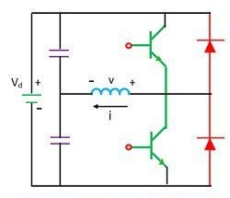
Figure 11 Single Phase Brushless DC motor drive circuit

DC to DC convertor
A DC-to-DC convertor is used to convert the source voltage level to another specified voltage level. In short, it takes the voltage coming from the input pins and output a lower or higher voltage level based on the design requirements. Both input and output signals are DC. Fig.9 shows the principle of the DC-to-DC convertor.
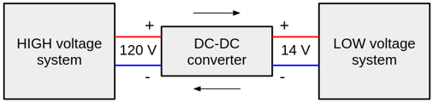
Figure 12 the principal block diagram of the DC-to-DC convertor

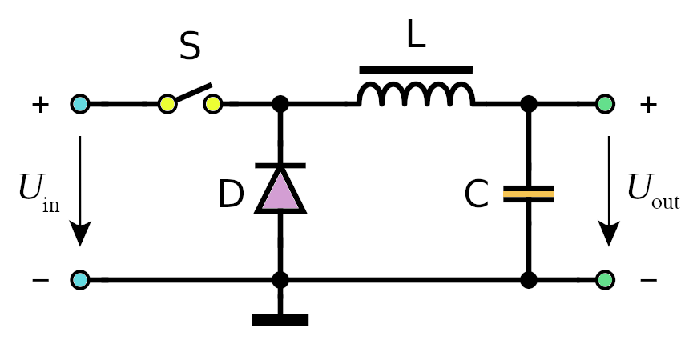
There are multiple implementations of the DC-to-DC convertor circuit. However, for illustration we used an implementation shown in Fig.10 for the DC-to-DC convertor. This implementation is based on switching frequency of the switch S.
Figure 13 a switching DC-to-DC convertor

Sensors:
Sensors are an important part of any robot; they can retrieve information that is easily accessible to us humans. Temperature, distance, oxygen levels to name a few are converted into an electrical reading that can be processed by the brains of the robot. Furthermore, they can be used as a way to give important parameters to a robot in order to function properly. Below you will find a few sensors that could be used to further enhance our project idea.

1-LIDAR sensor
Light Detection and Ranging is a very interesting remote sensor that measures the exact distance of an object. The LIDAR sensor uses a pulsing technique where it pulses light to determine the exact location of whatever the sensor is aimed at. Since the LIDAR technology uses light, we can calculate the distance by the following formula:
$$D=\frac{C*T}{2}$$
Where “D” is the distance of the object, C is the speed of light (299,792,458 m/s) and T is the time it takes to return to the LIDAR source.

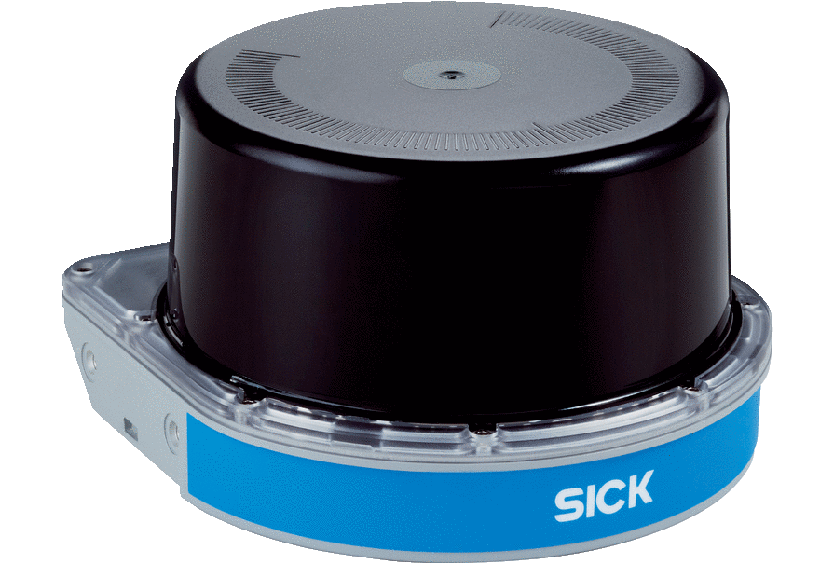
Figure 114 Showcasing a LIDAR sensor
https://www.geospatialworld.net/blogs/what-is-lidar-technology-and-how-does-it-work/

2-Ultrasonic sensor
Ultrasonic sensor is a very interesting sensor that shoots ultrasonic waves to calculate the distance. Much like the LIDAR sensor, it waits for the waves to return back and from there we can calculate the distance. Furthermore, it uses a transducer to send and receive high frequency pulses to determine the location. The equation below is used with the specific model HC-SR04
$$D=\frac{S*T}{2}$$
Where D is the distance, S is the speed of sound (340m/s) and T is the time.
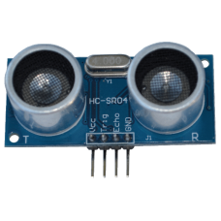
Figure 115 Showcasing an Ultrasonic Sensor
https://www.maxbotix.com/articles/how-ultrasonic-sensors-work.htm

3-IR sensor
These sensors work by emitting and receiving infrared radiation. The radiation hits objects nearby while the receiver waits for the bounce-back of the signal. It can detect movement and distance of the object. There are three types of infrared ranges;
- Near-infrared - from 0.75 to 3 3µm
- Mid-infrared - from 3 to 6µm
- Far-infrared - higher than 6µm

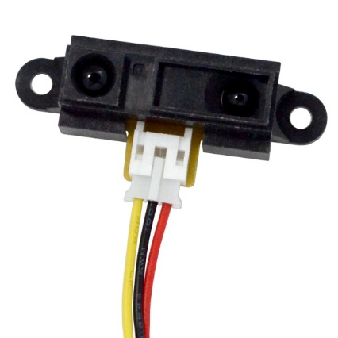
Figure 116 Showcasing the IR sensor
https://www.getkisi.com/guides/infrared-sensors

Controllers
Perhaps one of the most important parts of the robot is the controller. Which is the brain of the system. Granted, to be able to fully utilize the controller, sensors and actuators are also needed. Controllers are able to interface the sensors with the actuators. Which allows us to control the outputs of the actuators based on inputs of the sensors. Controllers vary in complexity, efficiency, and ease of use.

1-Arduino
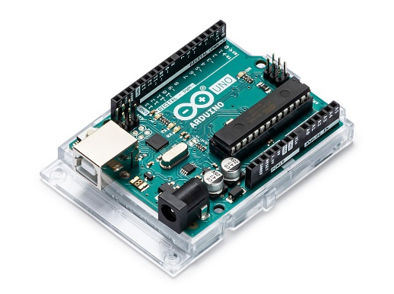
Arduino boards are one of the most popular boards in DIY projects used by both hobbyists and professionals. An Arduino board is a microcontroller board containing many different things including RAM, IO ports, and the microcontroller itself. There are different types of Arduino boards that differ in both size and capabilities. The most popular type might be the Arduino uno which is based on the ATmega328P microcontroller. Arduino boards also contains a part of the integrated development enviroment (IDE) that is used to program it. The Arduino IDE uses a basic version of C++. [1]
Figure 174 - Arduino uno board

2-Raspberry Pi
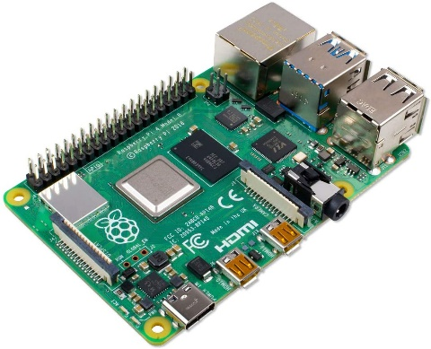
Raspberry Pi is called a single board computer (SBC) it functions basically like a full computer, an operatic system can be installed on it and the user can connect a monitor, mouse and keyboard to it. Raspberry Pi(s) are Linux based computers although different a different operating system like android can be installed on it. A Raspberry Pi has a clock speed that is much higher than even an Arduino mega (1.2 GHz vs 16 MHz). [2]
Figure 15 - Raspberry Pi 4

Alternatives:
  - Morphological chart

Function | Means
Function | 1 | 2 | 3 | 4 | 5
1. Traversal of the campus | Wheels | Propellers | Continuous wheel track | Quadruped/Biped | Conveyer belt
2. Carrying the package | Wagon | Carried Box | Pneumatic tubes
3. Navigation | GPS | Predefined path | Pilotage ^{[i]}
4. Maintain the safety of the package | Digital lock | Combination Lock | 2-step verification
Feature | Means
Feature | 1 | 2 | 3 | 4 | 5
1. Fast | Motors power | Mechanic | Lightweight
2. Long battery life | Energy consumption | Capacity | Recharge time
Table 2 - Morphological chart
[i] navigating by reference to visible landmarks
- Alterative A: Quadruped robot with a wagon attached to it, navigates using pilotage, the packages are secured using a 2-step verification system (2FA)
- Alternative B: Conveyer belt where the packages are put in a plastic box and placed on it, the conveyer belt spans the campus on a predefined path, the packages are secured using a combination lock.
- Alternative C: Ground robot that uses wheels to traverse the campus, the package is loaded on the robot (carried box), it navigates using GPS, the packages are secured using a Digital lock
Ideas from initial brainstorming:
- Alternative D: Robot Train
- Alternative E: Pneumatic System
- Alternative F: Drone delivery

Alternative analysis
  - Ground Robot
A ground robot with a built-in storage cart uses four wheels to move between buildings within the university campus. The robot needs to be able move safely using obstacle avoidance techniques to avoid objects around it. It uses battery, to supply enough power for a complete back and forth trip. To be able to move between buildings, the ground robot needs a navigation algorithm to guide the robot through the whole trip.
Pros:
- Dynamic stop points
- Flexible pathfinding
- Doesn’t require special roads
- Moderate complexity
Cons:
- Requires obstacle avoidance algorithms
- Higher probability of getting stuck
- Easily tampered with
- Training phase is required
Movement

Batteries

Controller
Motors

Rear wheels
F
Kinetic ergy
Commands
Power
Heat

Sound

Figure 16- Glass box

Cost analysis
ITEM | Expected Price | Quantity | Total
Jetson nano | $75.00 | 1 | $75.00
Stereo Camera Module Compatible with Jetson Nano | $45.00 | 1 | $45.00
Motor driver | $12.00 | 4 | $48.00
Platform | $100.00 | 1 | $100.00
Battery | $20.00 | 1 | $20.00
Wheels | $12.00 | 4 | $48.00
Motors | $15.00 | 4 | $60.00
Total cost |  |  | $336.00
Table 3 – Cost analysis
  - RoboDog
This alternative is a quadruped robot. It uses two front legs and two hind legs to move just like an animal would. Furthermore, it can traverse at acceptable speeds and carry a heavy load. This alternative can also walk on the campus and roads.

Pros:
- Innovative
- Can climb stairs
- Can drag or carry the packages
Cons:
- Complex
- Easily tampered with (pushing, vandalizing, etc…).

Cost analysis
ITEM | Expected Price | Quantity | Total
Jetson nano | $75.00 | 1 | $75.00
Stereo Camera Module Compatible with Jetson Nano | $45.00 | 1 | $45.00
LIDAR sensor | $100.00 | 1 | $100.00
Gyroscope sensor | $15.00 | 1 | $15.00
Wagon | $60.00 | 1 | $60.00
Battery | $20.00 | 1 | $20.00
Artificial limbs (3D printed) | $40.00 | 2 | $80.00
Servo motors | $20.00 | 8 | $160.00
Total cost |  |  | $555.00

Table 4 – Cost analysis

  - Robot train tracks
To be able to use a mini train within campus, we need train tracks that connect the buildings we want to deliver to and from. By having different stops at different faculty buildings, and smart train junctions that can save time by switching to shorter routes the user can drop off the packages at 1 of the stops and then the receiver would take the package at the stop nearest to him/her.
Pros
- Eliminates the need for navigation algorithms.
- If pedestrians avoid the tracks, no need for obstacle avoidance.
- Can be fast
Cons
- Requires train tracks to function.
- Sub-optimal routes
- Limited to set of stops

Heat

Batteries

Controller
Train Tracks
Motors

Train
Power
Kinetic energy
Information
Power
Deliver packages
Sound

Figure17 – Train’s Glass box

Cost analysis
ITEM | Expected Price | Quantity | Total
Arduino uno | $40.00 | 1 | $40.00
Wagon | $60.00 | 3 | $180.00
Battery | $20.00 | 1 | $20.00
Traction motor | $450.00 | 1 | $450.00
Total cost |  |  | $690.00
Table 5 – Cost analysis

Choosing Baseline Design
Musts/Alternatives | A: Quadruped Robot | B: Conveyer Belt | C: Ground Robot | D: Robot Train | E: Pneumatic tube system | F: Drone
The ability to move within 2 km range of the Engineering building | GO |  | GO | GO
Ensures the safety of the packages. | GO | GO | GO | GO | GO | GO
Includes a storage unit for the shipments. | GO | GO | GO | GO | GO | GO
Tamper proof electronic components | GO | GO | GO | GO | GO | GO
Made from durable material. | GO | GO | GO | GO | GO | GO
Operate within 5 km/h. | GO | NO GO | GO | GO | GO | GO
Can carry weight within (80kg). | GO |  | GO | GO | NO GO | NO GO
Constraints
The cost of the project must not exceed 5000 SAR. | GO |  | GO | GO
Project must be completed before the end of Term-2. | GO |  | GO | GO
Causes no harm to the surroundings. | GO |  | GO | GO
Battery life lasts for at least one complete trip (2 km). | GO |  | GO | GO
Guarantees the privacy of the packages. | GO |  | GO | GO
The artifact should withstand normal heat (36° C) for the duration of the trip (2 km) | GO |  | GO | GO

After analyzing the alternatives, we chose the Ground Robot to be our baseline design. Due to it having the lowest cost, balanced complexity, and the availability of the parts. We modeled our idea using SolidWorks to be able to imagine our baseline design.
Figure 18 - SolidWorks model
To further improve our base model, we started thinking of things we could change. We thought of reusing a hoverboard instead of buying the different motors and motor drivers. Hoverboards contain powerful motors that could carry people (~100 kg) which makes the design sturdier. Furthermore, wheel encoders are included in the hoverboard eliminating the need to buy them. In addition to that, the hoverboards have a recharging capability that is simple to use. We also thought of adding ventilation slits to the wagon to improve thermal dissipation. In addition to that, one idea was to add a hole in the wagon for cable management to eliminate the possibility of unwanted friction of the wires with the ground.

Societal Impacts

Stereo camera
Although using a stereo camera can facilitate obstacle avoidance and navigation, some people might be opposed to it due to privacy concerns. People might be bothered by seeing a robot equipped with a camera roaming around campus thinking that they are being recorded. To mitigate that effect, we could put notes that state that no camera footage would be published anywhere unless necessary by law.

Motors
Motors are crucial in any type of robot that is expected to move. Nevertheless, it might cause some disturbance to students and faculty members due to the noise. Although according to a survey done as a part of a research project, most people are only mildly annoyed by electric scooter noise in comparison to combustion scooters.

Economics Impact
Many on-campus businesses have their own apps, where the user can order some food, coffee or any deliverable item online. But however, the user will need to go and take the purchases from the market although the ordering stage was easy but leaving the building and wasting time just for coffee for example is not desirable in some cases especially when the users are on-campus, where people are busy working, studying and having lectures to attend. Having a lecture on a certain building and needing a coffee from a market in the other direction the result is settled for attending the lecture. The business on-campus suffer from this in daily basis. The customer and businesses are close, but no one can reach the other. Although, there are delivering companies provide delivering options, but does it make sense to have that cup of coffee the next day? Or to pay double the price? For businesses paying a price of $419.00 for a robot that can meet their customer at specific building entrance instead of him coming would not be a problem.
Although, this is the price of the expected purchases list. The improvement of the design later on will add other components to the list and may increase the price. But, generally the benefits on-campus business are getting from these robots will improve the amount of money spent within the campus and attract other business to get into the campus market.

Updated list:
ITEM | Expected Price | Quantity | Total
Jetson nano | $75.00 | 1 | $75.00
Stereo Camera Module Compatible with Jetson Nano | $45.00 | 1 | $45.00
motor driver | $12.00 | 2 | $24.00
Platform | $100.00 | 1 | $100.00
battery | $20.00 | 1 | $20.00
Wheels | $12.00 | 4 | $48.00
Motors | $25.00 | 2 | $50.00
Arduino uno | $20.00 | 1 | $25.00
GPS | $27.00 | 1 | $27.00
Wifi adapter | $5.00 | 1 | $5.00
Total cost |  |  | $419.00
Table 6 – Cost analysis

Environmental Impact:

Lithium-Ion Battery:
Regular batteries contain lead acid and nickel cadmium, these standard batteries are a big issue since they run out of juice quickly and are thrown away. The USA alone throws away around 3 billion batteries a year. Here is where the Nobel prize winner lithium batteries come into play. They provide a rechargeable alternative to regular cadmium batteries that are thrown yearly. These batteries are not thrown away and can theoretically be less harmful to the environment. Consequently, mining for the resources of these batteries is an issue. A river in Tibet was polluted due to the excess mining and bad regulations from the Tibetans. Lithium-Ion batteries are not perfect but are a better alternative to regular batteries.

Rubber wheels:
Everyday people use tires and specifically, rubber tires. These tires are used often and degrade over time to an unusable state in vehicles. Tire manufacturers strive to create tires that last longer and have better grip while using high quality materials. When a tire finishes its lifespan, it is often than not thrown into a land-fill where it sits there. These land-fills can cause tire fires or be breeding grounds for mosquitoes. Thankfully, rubber is a recyclable material that can be re-produced into many objects for our daily use.

References
[1] "Is the lithium-ion battery having a positive impact on the environment?", Nsenergybusiness.com, 2021. [Online]. Available: https://www.nsenergybusiness.com/features/lithium-ion-battery-environmental-impact/. [Accessed: 21- Nov- 2021]
[2] "Environmental Impact of used tires", Rerubber.com, 2021. [Online]. Available: https://www.rerubber.com/environmental-impact/. [Accessed: 21- Nov- 2021]
[3] "What is the Difference Between Speed Versus Torque?", Power Electric, 2021. [Online]. Available: https://www.powerelectric.com/motor-resources/motors101/speed-vs-torque. [Accessed: 21- Nov- 2021]
[4] https://www.electrical4u.com/brushless-dc-motors, 2021. [Online]. Available: https://www.electrical4u.com/brushless-dc-motors. [Accessed: 21- Nov- 2021]
[5] "What are Brushless DC Motors | Renesas", Renesas.com, 2021. [Online]. Available: https://www.renesas.com/us/en/support/engineer-school/brushless-dc-motor-01-overview. [Accessed: 21- Nov- 2021]
[6] "Servos for Robots", Rs-online.com, 2021. [Online]. Available: https://www.rs-online.com/designspark/servos-for-robots. [Accessed: 21- Nov- 2021]
[7] build electronics, 2021. [Online]. Available: https://www.build-electronic-circuits.com/h-bridge/. [Accessed: 21- Nov- 2021]
[8] "What is Brushless DC Motor Drive? Definition & Types - Circuit Globe", Circuit Globe, 2021. [Online]. Available: https://circuitglobe.com/brushless-dc-motor-drives.html. [Accessed: 21- Nov- 2021]
[9] "What is a DC-DC converter ? – x-engineer.org", X-engineer.org, 2021. [Online]. Available: https://x-engineer.org/dc-dc-converter/. [Accessed: 21- Nov- 2021]
[10] “Types of Arduino Boards : Working and Their Comparision.” https://www.elprocus.com/different-types-of-arduino-boards/ (accessed Nov. 19, 2021).
[11] “What are the differences between Raspberry Pi and Arduino?” https://www.electronicshub.org/raspberry-pi-vs-arduino/ (accessed Nov. 19, 2021).
[12] A. Fiebig, P. Marla, and R. Sottek, “Noise of electric and combustion-powered scooters and resulting annoyance,” Proc. - Eur. Conf. Noise Control, pp. 1069–1074, 2012.

