# **Actuators:**

Actuators are simply motors; they are used to convert one shape of energy to a mechanical energy. The mechanical energy produced or simply the motion could be in linear or rotary motion. As the names suggests linear actuators responsible of producing the linear movements. While the rotary actuators are responsible of rotary motions through a circular path. There are three main measurements associated with actuator we will discuss, as follows:

## **A) Torque**

The torque is a measurement of how much rotational force this actuator can produce. There two commonly used measurement units for torque, one is the newton meters (N.m) which is physically defined as the torque produced by a one-newton perpendicular force applied to a one meter long arm. Another unit used is the (Kg-cm) which is defined as the torque required for holding a 1 Kg mass at a radical distance of 1 cm. generally, the higher the torque is describes the higher abilities of the motor to push, pull or move heavier objects.

## **B) Speed**

The speed of the actuator is defined as the rotation rate of the motors. A common unit to measure the speed of an actuator is by using the counts of revolutions per minutes known as (RPM). The speed of the actuator is highly dependent on the carried load's weight, a very high weight reduces the actuator speed. However, It is known that the speed measurement is done one the actuator when no load is carried.

## **C) Energy efficiency**

Energy efficiency is one of the main concerns of any engineering tool. For actuators, it is basically a measurement of the amount of the used energy to perform a certain. The lesser amount of energy used to perform the same task is better than a higher amount with same mechanical performance.

As discussed above, actuators can be classified into categories based on certain set of classification criteria. However, we will discuss some commonly used actuators especially in the robotics field, they are as follows:

## **Brushless DC Motor**

Brushless DC motors are considered to be of the highly efficient motors in producing higher torque. As **Fig.1** shows, the brushless motor is simply a DC motor with no brushes. It has a permeant magnet. This permeant magnet called Rotor, as it rotates through the changes in the magnetic field around it caused by the coils known as stators. In order to control the rotation, we simply have to control flow and the direction of the current passing through these coils.

A brushless DC motor, as the one shown in **Fig.1** uses three coils for each coil to wires are required for the flow of the current through that wire. Thus, for the brushless DC motor with only three wires it requires six wires. But, usually in many brushless DC motors it is designed that three of those six wires are internally connected. And we simply have the other three motors.

Figure 1 a brushless DC motor internal connection

## **Brushed DC Motor**

In the Brushed DC motor, instead of a rotary magnet we have a fixed permanent magnet it is called stator. The Coils rotates instead of the magnet through the current flowing through what we call brush. **Fig.2** shows a brushed DC motor, note that the permanent magnet is fixed while the coils are the rotatory part resulted from the current flow through the brush.

Brushed DC motor not only has a simpler design, it also easier to control using the current flow that passes through the brush to create magnetic field causing the coils to rotary as a result of the force produce by the magnetic field between the permanent magnetic and the coils on the rotor.

Figure 2 a brushed DC motor internal connection

## **Servomotor**

Servomotors are commonly used in robotics field. It is provide a control of the angular position through controlling a motor with an internal controller and feedback position. There are different types of the servomotors, one frequently used type a servomotor with maximum shaft rotation of 180­­o. This rotation is powerful in robotics applications as it could be used for pulling, pushing or rotation actions. **Fig.3** shows the internal diagram of a servomotor.

Although we discussed the 180o rotation only, there are another type of the servomotors called a 360o continuous rotation servomotor used for applications where a full rotation is required. It is similar to the regular servomotor we discussed above but the shaft used here can spins continuously instead for the narrower range.

Figure 3 servomotor with its internal components

# **Power Electronics Circuits:**

We have already discussed the actuators but one thing to be mentioned is the actuators has specific voltage and current requirement. Also, driving those actuators require specific electronic circuits. In this section, we will discuss some commonly used power electronic circuits, as follows:

## **H-Bridge**

As we have discussed, the DC motors can rotate in two directions. If the motor plus pin connect to the Vcc and the minus was grounded it will spin differently than if we reversed the connections. one way to control the spinning direction without the need to plug and unplug the pins is done using H-Bridge. An H-bridge circuits shown in **Fig.4**, allows the current to flow in both directions by controlling the switches shown in the figure.

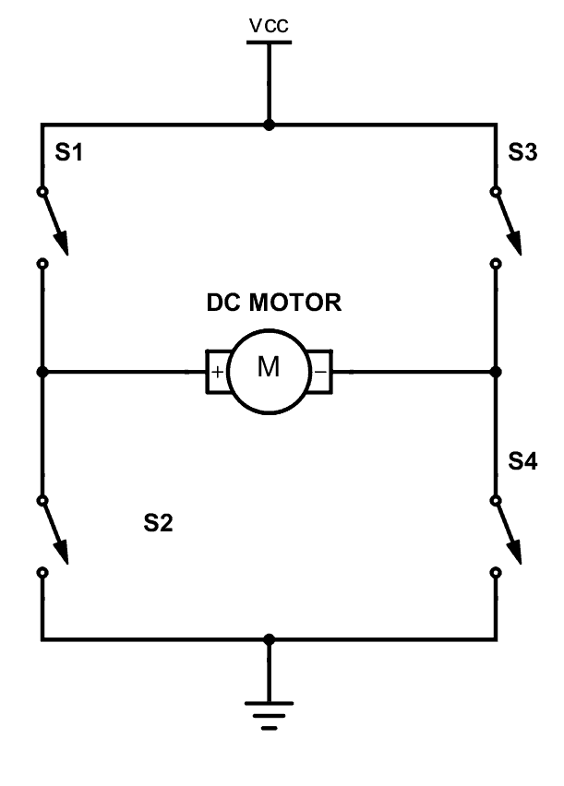

Figure 4 H-Bridge internal connection

To control the spinning direction of the motor we can close the switches s1 and s4 so the current flows from Vcc through s1 passing through the motor toward the ground. The current flow path is shown in **Fig.5a**. This will make the motor rotate in a certain direction.

Figure 5(a) the current flow path when s1 and s4 are closed (b) the current flow path when s2 and s3 are closed

To make the motors spins to the other direction, we can close the switches s2 and s3 to force the current flow through from the minus pin of the motor to the positive pin making the motor spinning in the opposite direction. **Fig.5b** shows the current flow when s2 and s3 are closed.

## **DC Motor Driver**

The H-Bridge circuit discussed above will take a part in the design of the motor driver. **Fig.6** shows a simple implementation of the motor driver for illustration purposes with its internal connections. From the figure, we notice the H-bridge is works exactly as discussed above. The switches shown in the figure for sure are not mechanical switches. In many implementations, the switches used are transistor that are able to handle enough current and have a low Vj to reduce the drop in the voltage between the collector and emitter of the transistor.

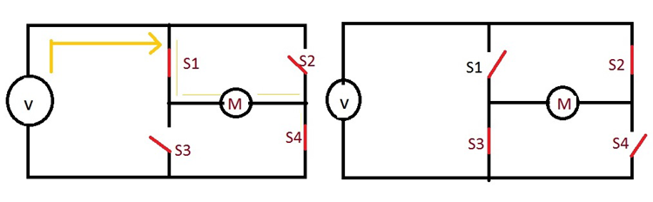

Figure 6 a simple implementation a motor driver

The implementation show in **Fig.7** is used for three phase brushless DC motor. When a 120o positive current is supplied then the motor spins in the counter-clockwise direction. There are other motor driver implementation as the one shown in **Fig.8** is a single phase brushless DC motor driver.

Figure 7 Three phase brushless DC motor driver circuit

Figure 8 Single Phase Brushless DC motor drive circuit

## **DC to DC convertor**

A DC-to-DC convertor is used to convert the source voltage level to another specified voltage level. In short, it takes the voltage coming from the input pins and output a lower or higher voltage level based on the design requirements. Both input and output signals are DC. **Fig.9** shows the principle of the DC-to-DC convertor.

Figure 9 the principal block diagram of the DC-to-DC convertor

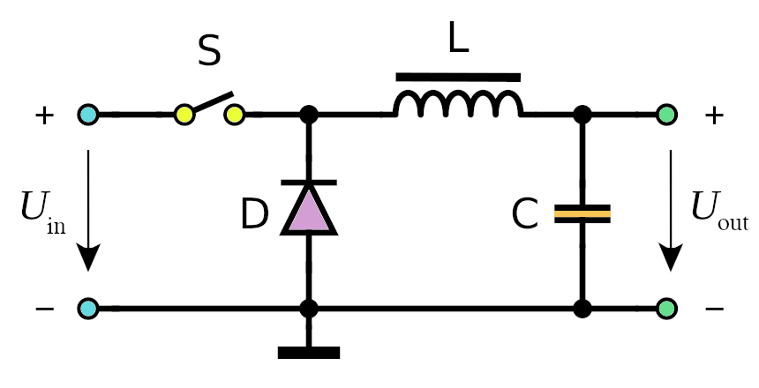There are multiple implementations of the DC-to-DC convertor circuit. However, for illustration we used an implementation shown in **Fig.10** for the DC-to-DC convertor. This implementation is based on switching frequency of the switch S.

Figure 10 a switching DC-to-DC convertor

# **Design Economics Impact**

Many on-campus businesses have their own apps, where the user can order some food, coffee or any deliverable item online. But however, the user will need to go and take the purchases from the market although the ordering stage was easy but leaving the building and wasting time just for coffee for example is not desirable in some cases especially when the users are on-campus, where people are busy working, studying and having lectures to attend. Having a lecture on a certain building and needing a for coffee from a market in the other direction the result is settled for attending the lecture. The business on-campus suffer from this in daily basis. The customer and businesses are close, but no one can reach the other. Although, there are delivering companies provide delivering options, but does it make sense to have that cup of coffee next day? Or to pay double the price? For businesses paying a price of $419.00 for a robot that can meet their customer at specific building entrance instead of him coming would not be a problem.

Although, this is the price of the expected purchases list. The improvement of the design later on will add other components to the list and may increase the price. But, generally the benefits on-campus business are getting from these robots will improve the amount of money spent within the campus and attract other business to get into the campus market.

**Updated list :**

|  |  |  |  |
| --- | --- | --- | --- |
| **ITEM** | Expected Price | Quantity | Total |
|  |
| Jetson nano | $75.00 | 1 | $75.00 |  |
| Stereo Camera Module Compatible with Jetson Nano | $45.00 | 1 | $45.00 |  |
| motor driver | $12.00 | 2 | $24.00 |  |
| Platform | $100.00 | 1 | $100.00 |  |
| battery | $20.00 | 1 | $20.00 |  |
| Wheels | $12.00 | 4 | $48.00 |  |
| Motors | $25.00 | 2 | $50.00 |  |
| Arduino uno | $20.00 | 1 | $25.00 |  |
| GPS | $27.00 | 1 | $27.00 |  |
| Wifi adapter | $5.00 | 1 | $5.00 |  |
| Total cost |  |  | $419.00 |  |

Srcs:

<https://www.powerelectric.com/motor-resources/motors101/speed-vs-torque>

<https://www.electrical4u.com/brushless-dc-motors>

https://www.renesas.com/us/en/support/engineer-school/brushless-dc-motor-01-overview

https://www.rs-online.com/designspark/servos-for-robots

https://www.build-electronic-circuits.com/h-bridge/

<https://circuitglobe.com/brushless-dc-motor-drives.html>

https://x-engineer.org/dc-dc-converter/

Figs:

1 & 2: <https://www.renesas.com/us/en/support/engineer-school/brushless-dc-motor-01-overview>

3: <https://www.rs-online.com/designspark/servos-for-robots>

4 & 5: <https://www.build-electronic-circuits.com/h-bridge>

6 : https://www.build-electronic-circuits.com/h-bridge/

7,8 : <https://circuitglobe.com/brushless-dc-motor-drives.html>

9,10: https://x-engineer.org/dc-dc-converter/