1. Circuit Schematic

The green arrows represent the flow of data from the sensors. As shown in the figure the sensors data flow from the hoverboard to a Wi-Fi module and then to the Jetson Nano. The data is then processed by the Jetson nano and using the algorithms for navigation and obstacle avoidance it sends the commands though the chain to the hoverboard

Figure - Data flow schematic

1. Mechanical specification of the cart

The figure below shows a SolidWorks model of the cart after adding the changes discussed in maturing the baseline design. The cart is a rectangular prism with the dimensions (L×W×H) (70×50×20 cm)

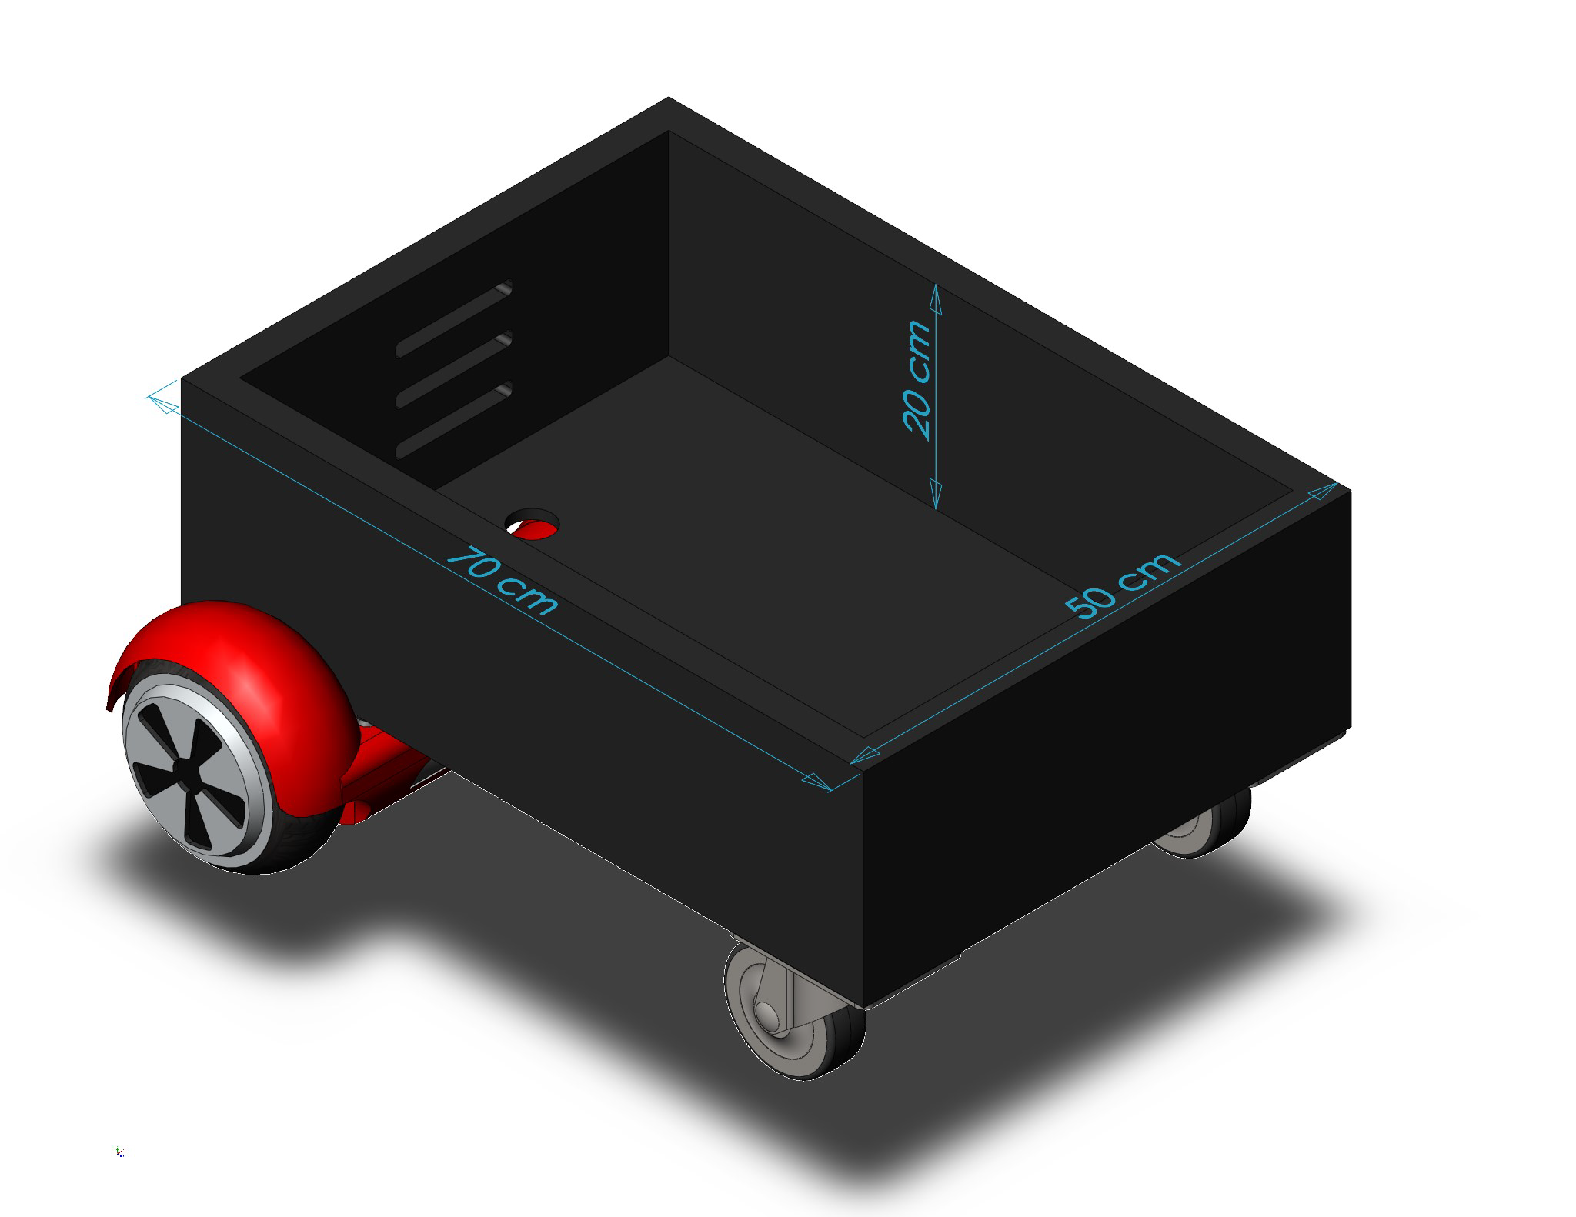

Figure 2 - SolidWorks model of matured design

1. Technical Aspects

Perhaps the most critical musts for our project are the ability to carry a weight within **80 kg** and that the artifact must be able to operate within **5 km/h**. To be able to satisfy those conditions we need powerful motors. Different hoverboards might have slightly different specifications but generally, the motors have a power of about **350 W** at **36 V** and can speed at speeds of up to **700 rpm** at higher voltages. For the speed requirement, hoverboards can operate at about **9.6 km/h** to **16 km/h** in faster models which is more than enough in our case. The wheels used in hoverboards have a diameter of about **15-25** **cm**. [1]

1. Simulation Results

Text