Technical Analysis using R – Preliminary Stage

Item | Details
Student Name | Mohamad Barakat
Course | BDA400 – Data Science Tools and Techniques
Assignment | Assignment 2 – Technical Analysis using R, Preliminary Stage

GitHub Repository Link: https://github.com/[your-username]/TechnicalAnalysis
Folder Assignment 2: https://github.com/Mhd-barakat/TechnicalAnalysis/tree/d67402411e5087f0eb4d0cab5f752eda03285b83/Assignment2

1. Setting up a GitHub Account and Repository
What is required: Create a GitHub account (or use an existing one), install and configure Git on the local PC, create a new repository named TechnicalAnalysis to store all assignments of this course, create a subfolder for this assignment, and document the entire setup process with screenshots.

Step 1.1 – Create a GitHub Account
A free GitHub account was created at github.com by entering an email address, a password and a username, completing the verification puzzle, and confirming the email with the launch code sent by GitHub.
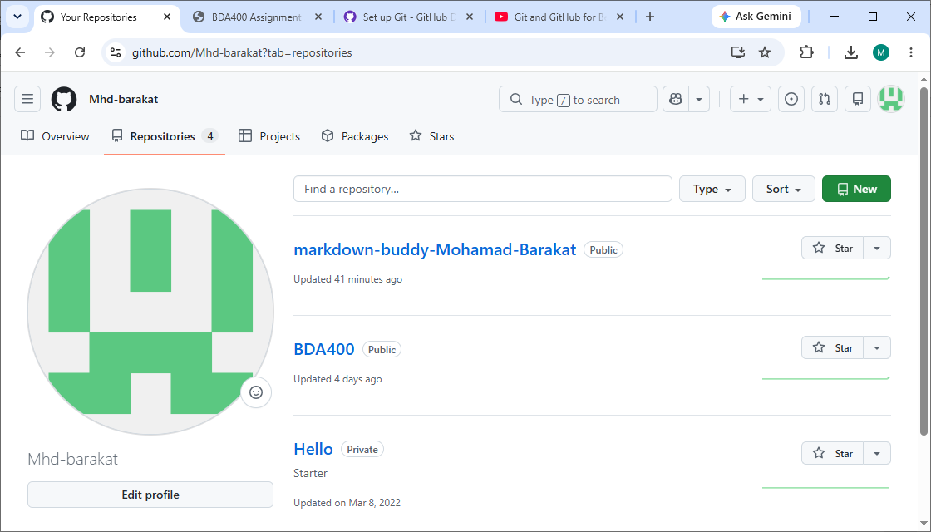
Figure 1: GitHub account sign-up / account dashboard
Explanation: This screenshot shows the GitHub account used for this course. The account was created through the GitHub sign-up page and verified by email; the dashboard confirms a successful sign-in with the chosen username.

Step 1.2 – Install Git on the Local PC
Following the GitHub installation guide (https://github.com/git-guides/install-git), the Git installer for Windows was downloaded and run with the default options.
[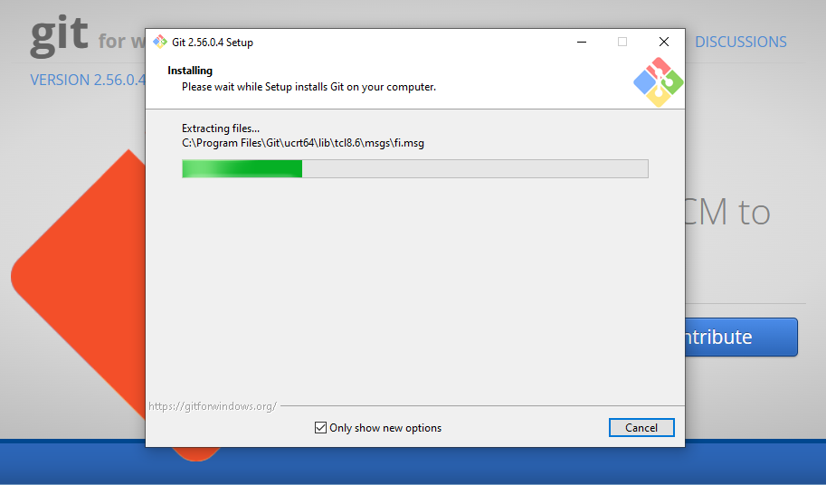
Figure 2: Git installation wizard
Explanation: This screenshot shows the Git Setup wizard on Windows. Git was installed with the default components and settings, which add Git Bash and the git command to the system so it can be used from the command line.

Step 1.3 – Verify and Configure Git
Following the Git setup guide (https://docs.github.com/en/get-started/quickstart/set-up-git), the installation was verified and the user name and email were configured in Command Prompt / Git Bash with the commands below:
git --version
git config --global user.name "Mohamad Barakat"
git config --global user.email "mhdbarakat2@gmail.com"
git config --list
The output of these commands is shown in Figure 3.
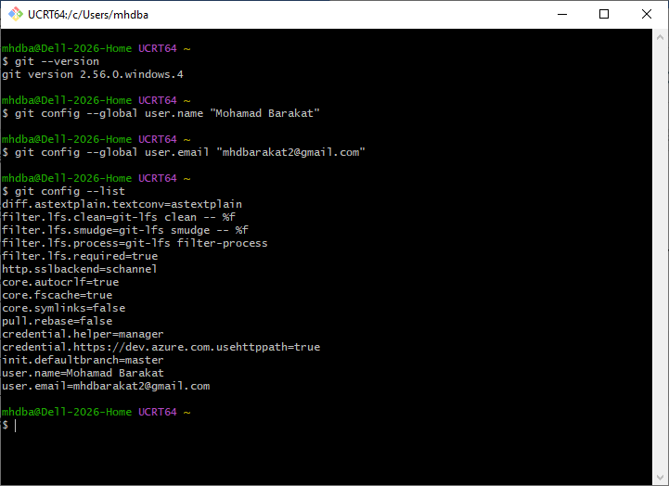
Figure 3: Verifying the Git version and configuring the user name and email
Explanation: The command git --version confirms that Git is installed correctly. The git config commands set the global user name and email (the same email used for GitHub) so that every commit is linked to the GitHub account, and git config --list displays the saved settings.

Step 1.4 – Create the TechnicalAnalysis Repository
A new public repository named TechnicalAnalysis was created from the GitHub menu (+ → New repository) with a README file. This repository stores all assignments of this course.
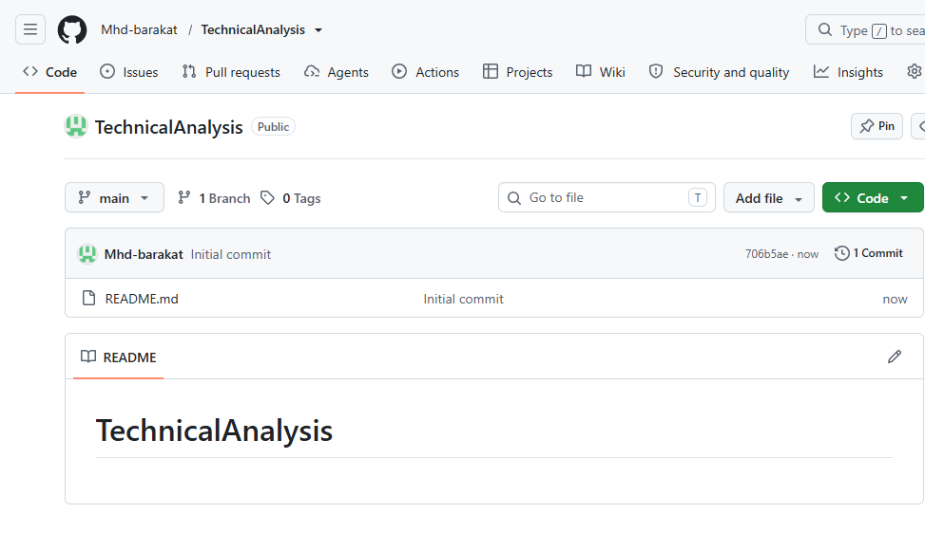
Figure 4: Creating the new repository "TechnicalAnalysis"
Explanation: This screenshot shows the "Create a new repository" form. The repository name is set to TechnicalAnalysis,

Step 1.5 – Create the Assignment2 Folder
Because each assignment must be placed in its own subdirectory, a folder named Assignment2 was created inside the repository using Add file → Create new file and the file name Assignment2/README.md, followed by Commit changes.
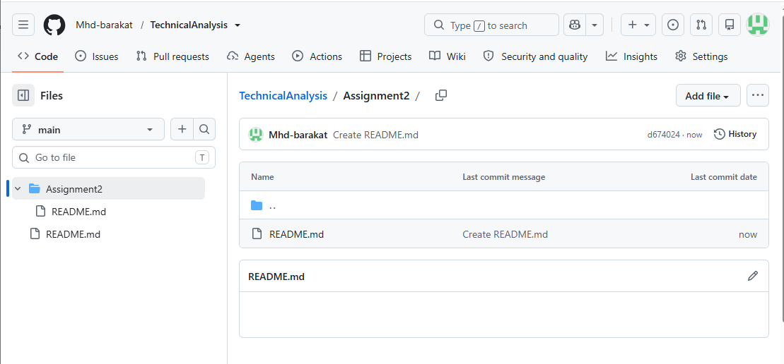
Figure 5: The TechnicalAnalysis repository with the Assignment2 folder
Explanation: This screenshot shows the newly created TechnicalAnalysis repository containing the README file and the Assignment2 subfolder, which will hold the report, the portfolio.txt file and the R script for this assignment.

2. Installing and Configuring R and RStudio

Step 2.1 – Download and Install R
R was downloaded from the CRAN website by selecting Download R for Windows → base → Download R-4.x.x for Windows, and then installed with the default settings.
The R installer was then run. The license was accepted and the default destination folder and components were kept until the setup wizard finished.
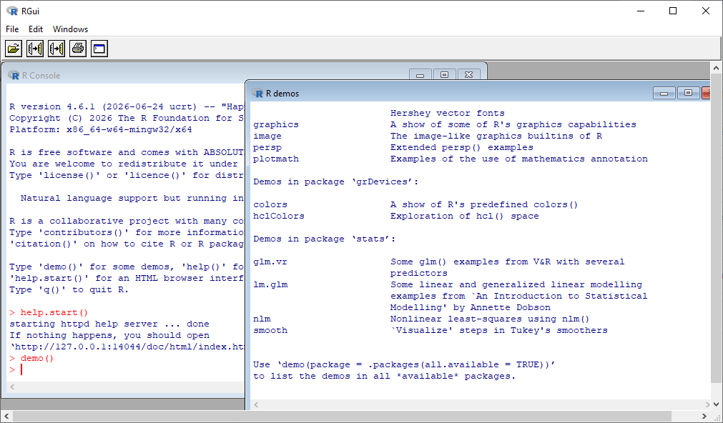
Figure 7: R– installation
Explanation: These screenshots show that R was installed successfully and is working correctly.

Step 2.2 – Download and Install RStudio Desktop

The RStudio installer was run, keeping the default installation folder and Start Menu settings until the installation completed.
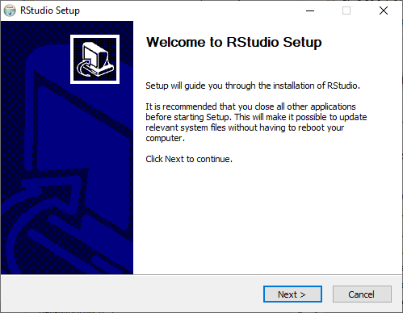

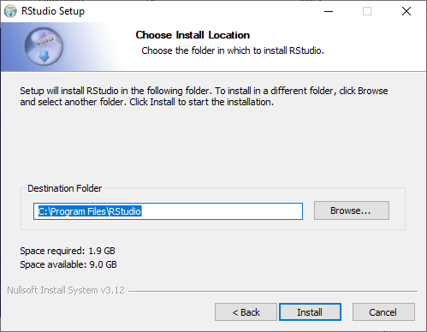

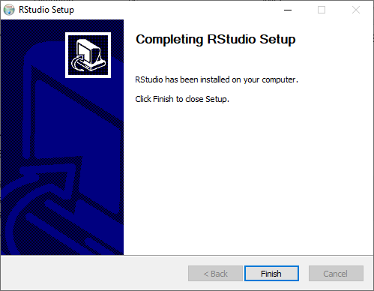
Figure 9: RStudio setup wizard – installation steps
Explanation: These screenshots show the RStudio setup wizard: the welcome screen, the selection of the installation folder, and the final screen confirming that RStudio was installed successfully.

Step 2.3 – Verify the Installation in RStudio
RStudio was opened and the following commands were typed in the Console to confirm that RStudio is connected to the installed version of R:
R.version.string # installed R version
RStudio.Version()$version # installed RStudio version
getwd() # current working directory
The result is shown in Figure 10.
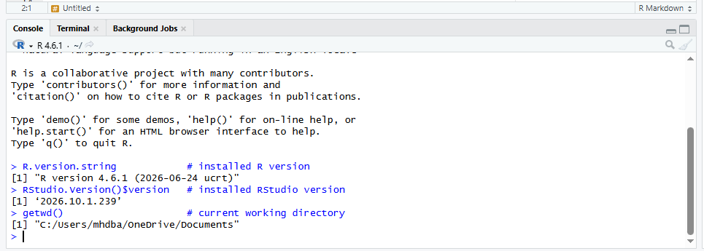
Figure 10: RStudio running and showing the installed R and RStudio versions
Explanation: This screenshot shows RStudio running successfully. The Console displays the installed R version and RStudio version, confirming that both programs are installed correctly and connected.

3. Downloading and Installing R Packages for Technical Analysis

Step 3.1 – Install the Packages
The packages were installed from CRAN with install.packages(), following the CRAN guide on installing packages. This code is also placed at the top of the script stock_analysis.R:
# ==========================================================
# BDA400 - Assignment 2: Technical Analysis using R (Stage 1)
# Author: Mohamad Barakat
# ==========================================================
# ---------- 1. Install the required packages (run once) ----------
install.packages(c("quantmod", "TTR", "xts", "zoo"))
# ---------- 2. Load the packages ----------
library(quantmod) # also loads xts, zoo and TTR
library(TTR)
# ---------- 3. Verify the installed versions ----------
packageVersion("quantmod")
packageVersion("TTR")
The installation output in the Console is shown in Figure 11.
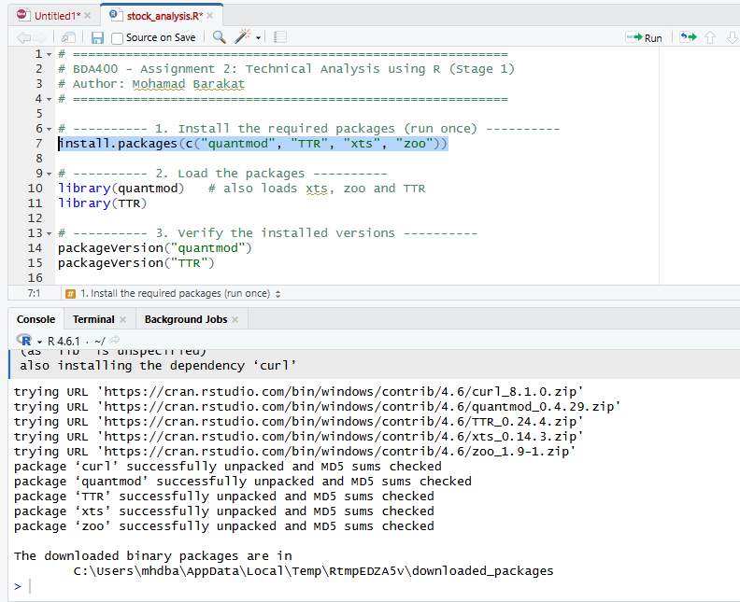

Figure 11: Installing quantmod, TTR, xts and zoo with install.packages()
Explanation: This screenshot shows the Console output of install.packages(). R downloaded each package and its dependencies from CRAN and displayed the message "package ... successfully unpacked and MD5 sums checked", confirming a successful installation.

Step 3.2 – Load and Verify the Packages
The packages were loaded into the session with library() and their versions were checked with packageVersion(). The Packages pane confirms that quantmod and TTR are installed and loaded.
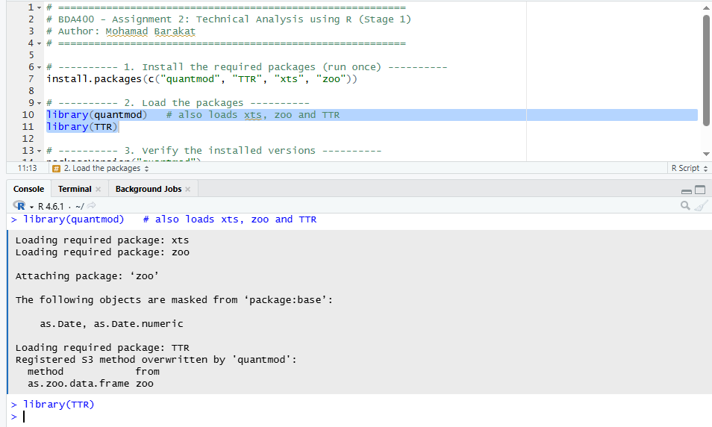

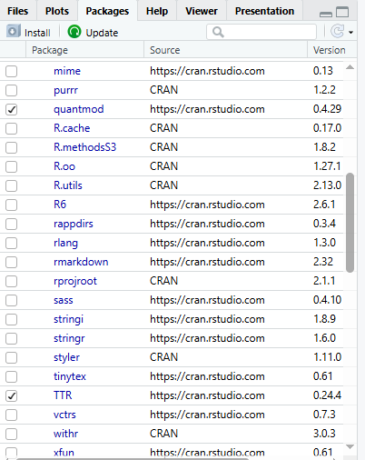

Figure 12: Loading the packages and verifying their versions
Explanation: This screenshot shows the packages loaded with library() without errors and the version numbers returned by packageVersion(). In the Packages pane, quantmod and TTR are ticked, which means they are loaded and ready to use.

4. Project Configuration and Initialization
What is required: Create a text file named portfolio.txt and list the stock symbols of an individual portfolio in it, one symbol per line. The file is stored in the project working folder so that R can read it.

Step 4.1 – Create the RStudio Project Folder
An RStudio project named Assignment2 was created (File → New Project → New Directory → New Project). The project folder becomes the working directory, so portfolio.txt and stock_analysis.R are saved in the same location and can be referenced by file name only.
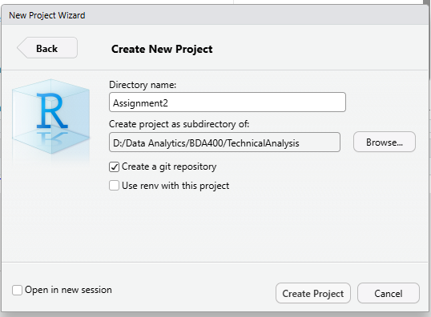
Figure 13: Creating the Assignment2 project in RStudio
Explanation: This screenshot shows the creation of a new RStudio project in a dedicated Assignment2 folder. Using a project keeps all assignment files together and automatically sets the working directory.

Step 4.2 – Create portfolio.txt
The file portfolio.txt was created with five stock symbols, one per line, written in capital letters using their Yahoo Finance tickers. The content of the file is:
AAPL
MSFT
GOOGL
AMZN
NVDA
These symbols represent Apple, Microsoft, Alphabet (Google), Amazon and NVIDIA. The file was verified in R with the following code:
getwd() # the project folder
file.exists("portfolio.txt") # should return TRUE
readLines("portfolio.txt") # shows the stock symbols
The file and the verification output are shown in Figure 14.
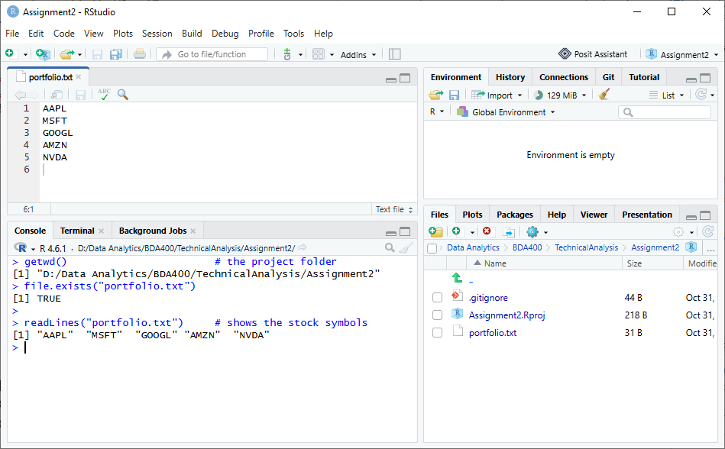
Figure 14: The portfolio.txt file and its verification in R
Explanation: This screenshot shows portfolio.txt open in the RStudio editor with one stock symbol per line. The Console confirms that the file exists in the working directory and that readLines() reads the five symbols correctly.

5. Writing a Function to Import and Load Stock Data
What is required: Develop a function, load_stock_data(), that reads portfolio.txt and imports the stock data for each symbol using the quantmod package, then stores the data in R as a separate data frame for each stock symbol.

Step 5.1 – The load_stock_data() Function
The function reads the symbols from portfolio.txt, removes blank lines and spaces, downloads one year of daily prices for each symbol from Yahoo Finance with getSymbols(), converts each xts object into a data frame with a Date column, and returns a named list of data frames. tryCatch() is used so that one invalid symbol does not stop the whole process.
# ---------- Function 1: Import and load stock data ----------
load_stock_data <- function(file_path = "portfolio.txt",
from = Sys.Date() - 365,
to = Sys.Date()) {
# Read the symbols: one per line, remove spaces and blank lines
symbols <- toupper(trimws(readLines(file_path, warn = FALSE)))
symbols <- symbols[symbols != ""]
stock_list <- list()
for (sym in symbols) {
tryCatch({
xts_data <- getSymbols(sym, src = "yahoo", from = from, to = to,
auto.assign = FALSE)
df <- data.frame(Date = index(xts_data), coredata(xts_data))
colnames(df) <- c("Date", "Open", "High", "Low", "Close", "Volume", "Adjusted")
df <- df[!is.na(df$Close), ] # remove missing prices
stock_list[[sym]] <- df
message("Loaded ", sym, ": ", nrow(df), " rows")
}, error = function(e) {
message("Could not load ", sym, ": ", conditionMessage(e))
})
}
return(stock_list)
}
The function code in the RStudio editor is shown in Figure 15.
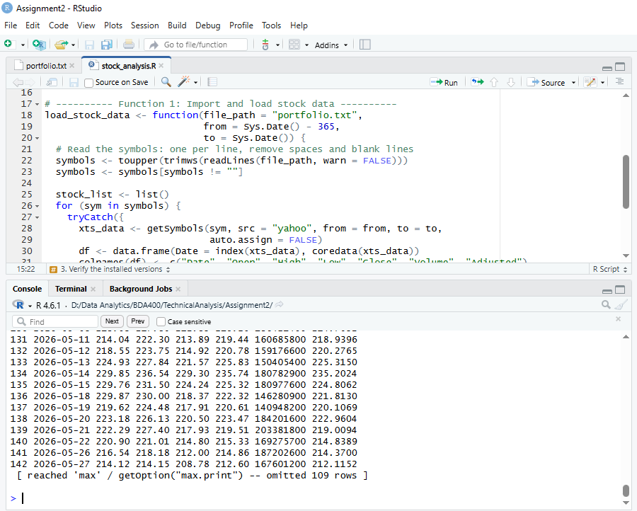
Figure 15: The load_stock_data() function in stock_analysis.R
Explanation: This screenshot shows the load_stock_data() function written in the R script. It takes the portfolio file path and a date range as arguments, reads the symbols, and imports the price data for each symbol using quantmod's getSymbols().

Step 5.2 – Run the Function and Store a Data Frame for Each Stock
The function was called, and list2env() was used to store each stock as its own data frame in the R environment (for example AAPL, MSFT, GOOGL):
# Import the data for all symbols in portfolio.txt
stocks <- load_stock_data("portfolio.txt")
# Store each stock as a separate data frame (AAPL, MSFT, GOOGL, ...)
list2env(stocks, envir = .GlobalEnv)
# Check the result
names(stocks)
class(AAPL)
str(AAPL)
The output and the Environment pane are shown in Figure 16.
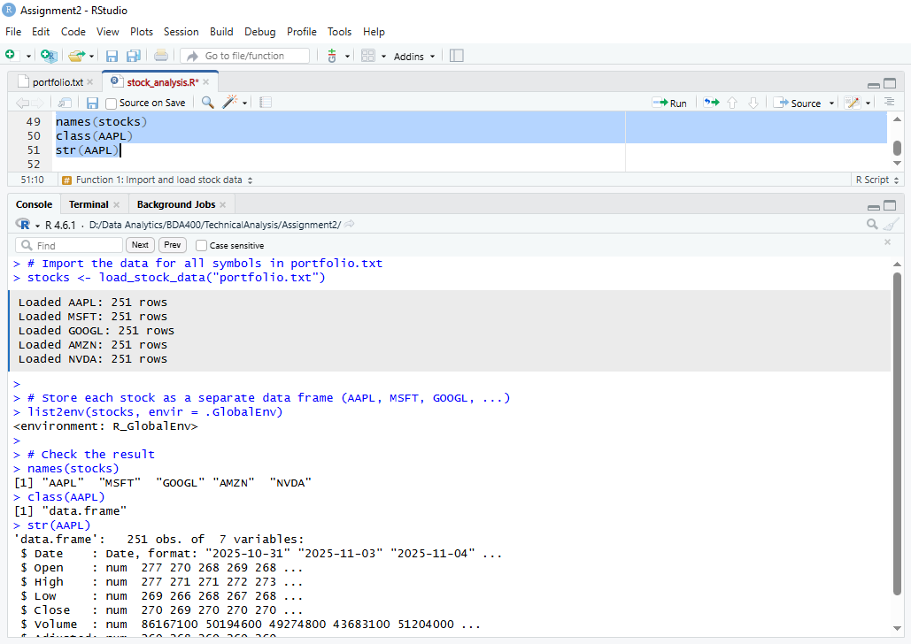
Figure 16: Stock data imported and stored as separate data frames
Explanation: This screenshot shows that the data for every symbol in portfolio.txt was imported successfully; the Console reports the number of trading days loaded for each stock. The Environment pane lists a separate data frame for each symbol, and str(AAPL) shows its columns: Date, Open, High, Low, Close, Volume and Adjusted.

6. Writing Functions to Compute Basic Statistics

Step 6.1 – The get_mode() and calculate_statistics() Functions
Because base R has no function for the statistical mode (the built-in mode() returns the storage type of an object), a helper function get_mode() was written first. It rounds the closing prices to two decimals and returns the most frequent value. The main function calculate_statistics() takes one stock's data frame as input, calculates the 20-day simple moving average with TTR::SMA(), and computes the mean, median, mode and standard deviation of the closing price. The results are returned as a structured list containing a one-row summary data frame and a data frame of daily closing prices with their moving average.
# ---------- Helper: statistical mode ----------
get_mode <- function(x, digits = 2) {
x <- round(x[!is.na(x)], digits) # prices are decimals, so round them first
if (length(x) == 0) return(NA)
freq <- table(x) # count how often each price occurs
as.numeric(names(freq)[which.max(freq)])
}
# ---------- Function 2: Compute basic statistics ----------
calculate_statistics <- function(stock_df, ma_period = 20) {
stock_df <- stock_df[!is.na(stock_df$Close), ]
close <- stock_df$Close
if (length(close) < ma_period) {
stop("Not enough data to calculate the moving average")
}
# Moving average (Simple Moving Average from the TTR package)
ma <- as.numeric(SMA(close, n = ma_period))
ma_df <- data.frame(Date = stock_df$Date, Close = close, SMA = ma)
# Summary statistics of the closing price
summary_df <- data.frame(
Mean = round(mean(close), 2),
Median = round(median(close), 2),
Mode = get_mode(close),
SD = round(sd(close), 2),
Latest_SMA = round(tail(ma, 1), 2)
)
# Structured result: a list with two data frames
return(list(summary = summary_df, moving_average = ma_df))
}
The function code in the RStudio editor is shown in Figure 17.
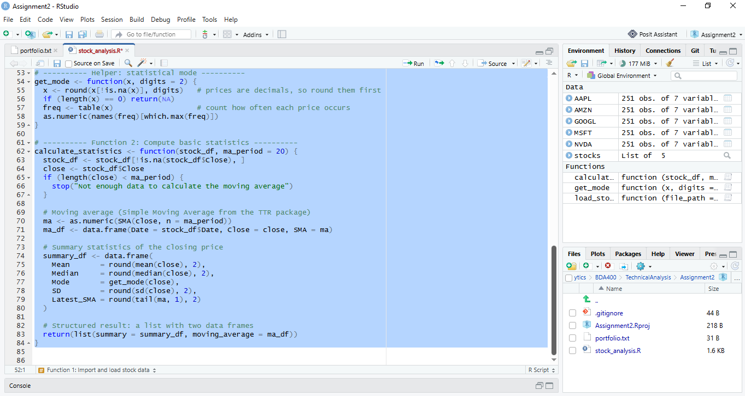
Figure 17: The get_mode() and calculate_statistics() functions in stock_analysis.R
Explanation: This screenshot shows the two statistics functions in the R script. get_mode() returns the most frequent rounded closing price, and calculate_statistics() computes the 20-day moving average, mean, median, mode and standard deviation for one stock. After running the code, both functions appear in the Environment pane under Functions.

Step 6.2 – Calculate and Store the Statistics for Each Stock
The function was applied to every stock data frame with lapply(). The results are stored in two structured formats: a named list, all_stats, that holds the full result for each symbol, and a single comparison data frame, stats_table, with one row per stock:
# Apply calculate_statistics() to every stock (result: a named list)
all_stats <- lapply(stocks, calculate_statistics)
# Combine the summaries into one data frame (one row per stock)
stats_table <- do.call(rbind, lapply(names(all_stats), function(sym) {
cbind(Symbol = sym, all_stats[[sym]]$summary)
}))
rownames(stats_table) <- NULL
# Check the result
stats_table
str(all_stats$AAPL)
tail(all_stats$AAPL$moving_average, 5)
The output in the Console is shown in Figure 18.
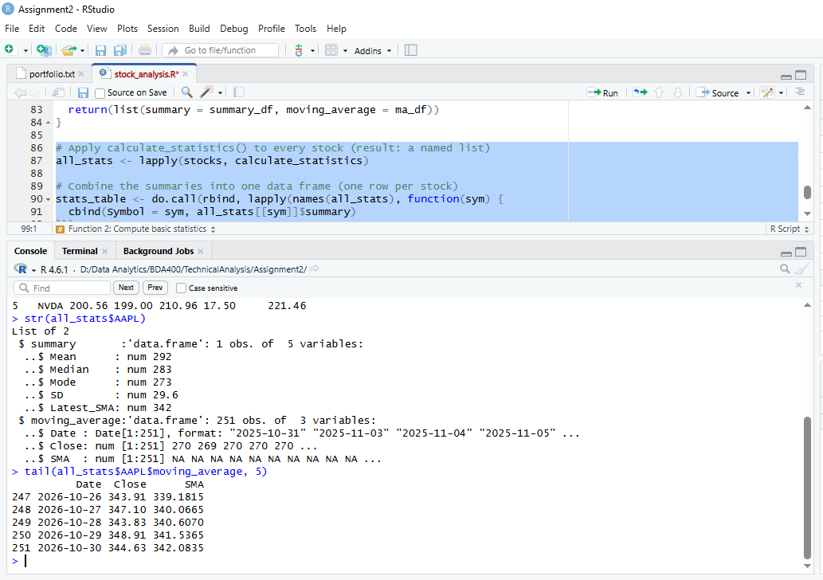
Figure 18: Basic statistics calculated and stored for each stock
Explanation: This screenshot shows the statistics calculated for every stock in the portfolio. stats_table lists the mean, median, mode, standard deviation and latest 20-day moving average of each stock's closing price. str(all_stats$AAPL) shows the structure of the stored result: a list with a summary data frame and a moving-average data frame. The first 19 SMA values are NA because a 20-day average needs 20 previous prices.

7. Displaying the Imported Data and Calculated Statistics

Step 7.1 – Display the Imported Stock Data
The function display_stock_data() loops through the list of stocks and, for each symbol, prints the number of trading days, the date range and the first rows of its data frame. View() opens a data frame as a full spreadsheet-style table in RStudio.
# ---------- Function 3: Display the imported data ----------
display_stock_data <- function(stock_list, n = 6) {
for (sym in names(stock_list)) {
df <- stock_list[[sym]]
cat("\n==========", sym, "==========\n")
cat("Trading days:", nrow(df),
"| From", format(min(df$Date)), "to", format(max(df$Date)), "\n")
print(head(df, n), row.names = FALSE)
}
}
# Display the data of all stocks
display_stock_data(stocks)
# Open one stock as a full table
View(AAPL)

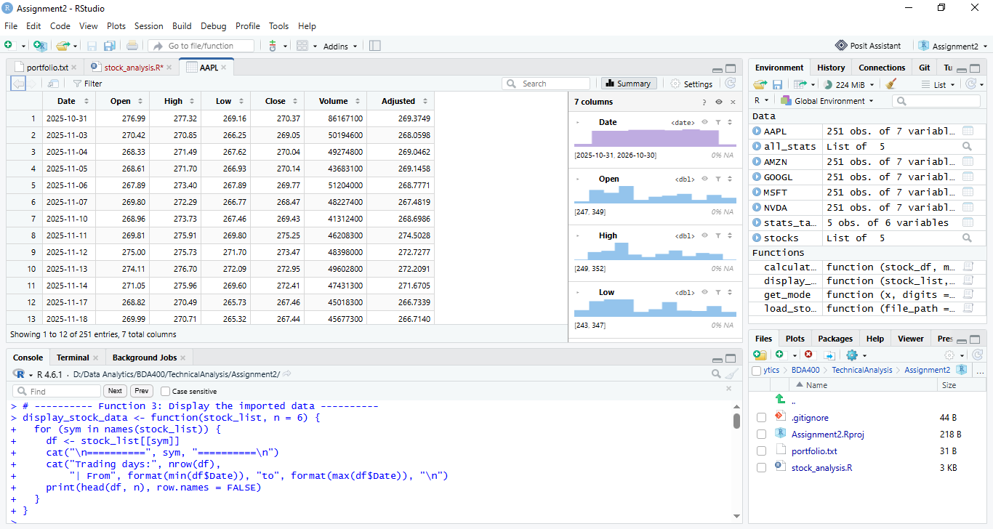

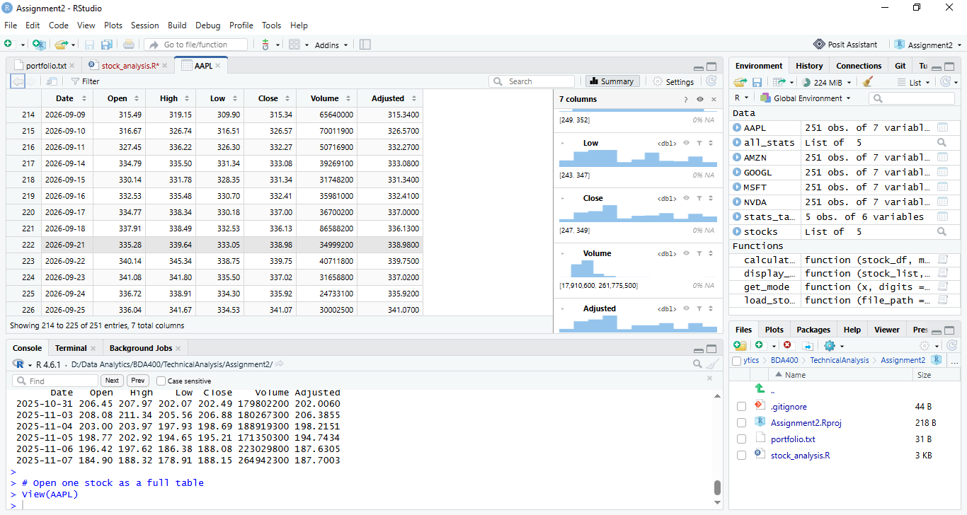

Figure 19: Displaying the imported stock data
Explanation: This screenshot shows the imported data displayed for each stock in the portfolio. For every symbol, the Console shows the number of trading days, the date range and the first six rows with the Date, Open, High, Low, Close, Volume and Adjusted columns. The View() tab shows the complete AAPL data frame as a table.

Step 7.2 – Display the Calculated Statistics
The function display_statistics() prints the summary statistics of each stock under a clear heading. The combined stats_table is also printed and opened with View() so that the stocks can be compared side by side.
# ---------- Function 4: Display the calculated statistics ----------
display_statistics <- function(stats_list) {
for (sym in names(stats_list)) {
cat("\n----- Statistics for", sym, "(closing price) -----\n")
print(stats_list[[sym]]$summary, row.names = FALSE)
}
}
# Display the statistics of every stock
display_statistics(all_stats)
# Display the comparison table of all stocks
print(stats_table, row.names = FALSE)
View(stats_table)

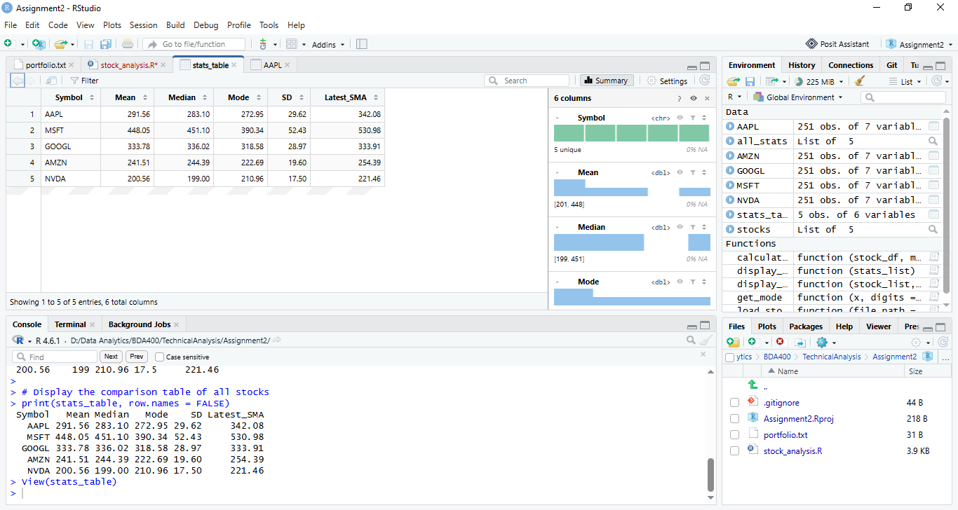
Figure 20: Displaying the calculated statistics for each stock
Explanation: This screenshot shows the statistics of each stock's closing price: mean, median, mode, standard deviation and the latest 20-day moving average. The comparison table makes it easy to see which stock has the highest average price and which has the highest standard deviation, meaning the largest price variation over the period.

Step 7.3 – Plot the Closing Price with the Moving Average
To display the moving average visually, plot_moving_average() draws the daily closing price of a selected stock together with its 20-day simple moving average.
# ---------- Function 5: Plot closing price and moving average ----------
plot_moving_average <- function(stats_list, symbol) {
ma_df <- stats_list[[symbol]]$moving_average
plot(ma_df$Date, ma_df$Close, type = "l", col = "steelblue", lwd = 2,
main = paste(symbol, "- Closing Price and 20-Day SMA"),
xlab = "Date", ylab = "Price (USD)")
lines(ma_df$Date, ma_df$SMA, col = "red", lwd = 2)
legend("topleft", legend = c("Close", "SMA 20"),
col = c("steelblue", "red"), lwd = 2)
}
# Plot one stock (change the symbol to plot another stock)
plot_moving_average(all_stats, "AAPL")

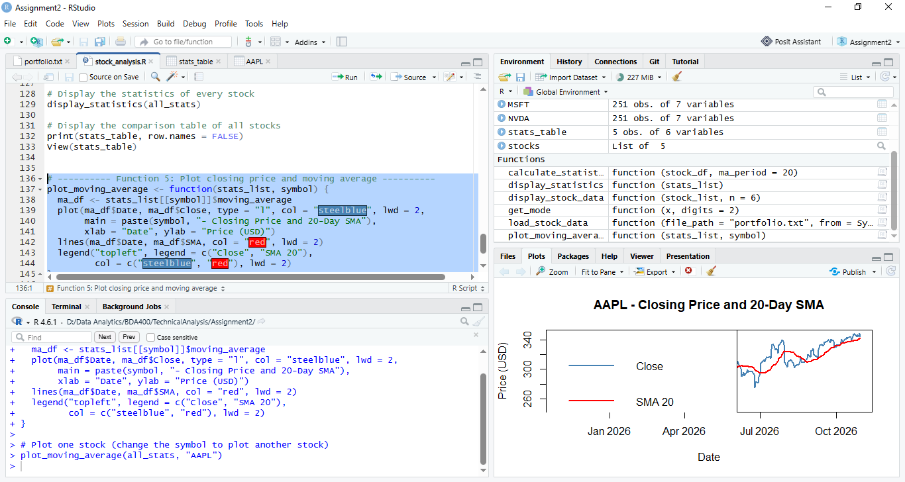
Figure 21: AAPL closing price with the 20-day simple moving average
Explanation: This chart shows the daily closing price of AAPL (blue line) and its 20-day simple moving average (red line). The moving average smooths short-term price changes and shows the general trend: when the price is above the SMA the short-term trend is upward, and when it is below the SMA the trend is downward.

8. Uploading the Assignment Files to GitHub

Step 8.1 – Upload the Files to the Assignment2 Folder
The final files were uploaded to the Assignment2 folder using Add file → Upload files and saved with the commit message "Add Assignment 2 files".
Figure 22: Assignment files uploaded to the Assignment2 folder on GitHub
Explanation: This screenshot shows the Assignment2 folder in the TechnicalAnalysis repository containing the R script stock_analysis.R, the portfolio.txt file and this report, which confirms that all deliverables are stored in the assignment subdirectory.

