**Introduction**

In the beginning, we analyzed our problem, using the methods and mechanisms of object analysis. The Object analysis is technical approach for analyzing and designing an application, system, or business by applying object-oriented programming, as well as using visual modeling throughout the software development process to guide stakeholder communication and product quality.

In our problem we used three analysis method to extract the problem and solve it.

1. Class Diagram
2. Functional and non-Functional requirements determining.
3. Use case

Each one of these methods help us to clearly solve the problem.

1. **Class Diagram**

Class diagrams are one of the most useful types of diagrams in UML as they clearly map out the structure of a particular system by modeling its classes, attributes, operations, and relationships between objects.

In our subsystem, we have six classes which

1. Donator
2. BloodBag
3. MedicalTest
4. ReceptionDesk
5. HeadBBC
6. LaboratoryAgent

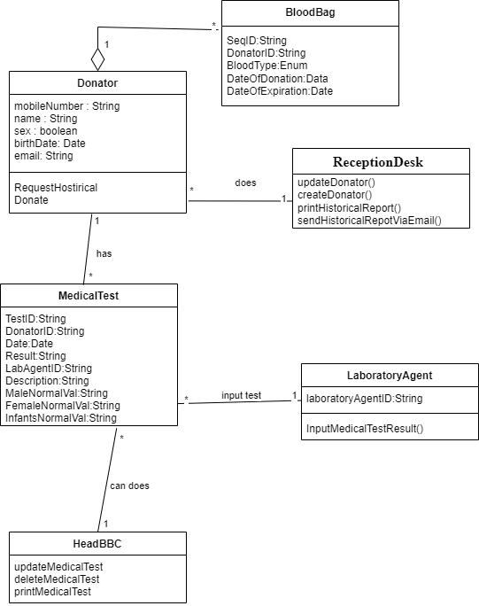

1. **Functional and non-Functional Requirements**

A functional requirement describes what a software system should do, while non-functional requirements place constraints on how the system will do so.

* Functional Requirements

1. The system must save the historical medical check-up
2. The system must allow user to send the reports via e-mail
3. The user can update the information of donator
4. The user can register donator
5. The system allows delete, update, print the medical check-up.

* non-Functional Requirements

1. The system must be speed
2. The system must be secure
3. The system must be maintainable
4. **Use case Diagram**
5. **Actors:** An actor is a user or anything else that exhibits behavior when interacting with the system. The actor could be another system, a piece of hardware, or an entire organization.

Table 1 – the actors with their descriptions

|  |  |
| --- | --- |
| Actor | Descriptions |
| Donator | Someone who gives the blood to helps the patients. |
| Reception Desk | Someone who receipts and registers the donator or update the info if he is already registered before. |
| Laboratory Agent | Someone who makes medical check-up for the donator and inputs the result of the medical check-up. |
| Head BBC | The Head of Blood Bank Center. He has all the roles in the Blood Bank |

1. **Cases:**

* **Use Case for Donation**: Donors can go to the blood bank center directly and register in the list of donors. If the donors were already registered, they will not be registered, but their information can be updated. The donor will not be able to donate if he does not undergo medical examinations. The results of the tests are stored in the system so that the donor can refer to them if he wants to.

A donor can donate more than once in a year.

* **System**: Blood Bank Center system.
* **Primary Actor**: Donator.

1. **Use case Diagram**

