**About**

The idea about this protégé is that there is book store. There are sellers and customers.

**Screenshot**

**Class**

There are two super classes.

Book and person, the person is divide into two subclasses, the seller is the one who can sells the book. The customer is the one who can buys the book.

The book has name and write_name, buy_operation_id and price.

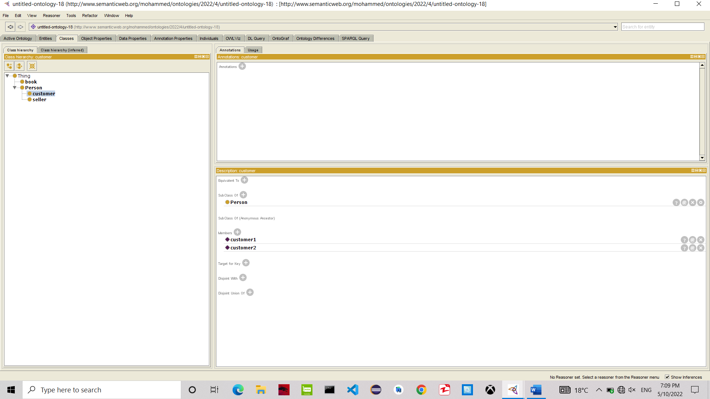

**Object properties**

There are two object properties, the **sells** which it’s domain is seller and it’s range is the book,

the **buys** which it’s domain customer and it’s range is the book.

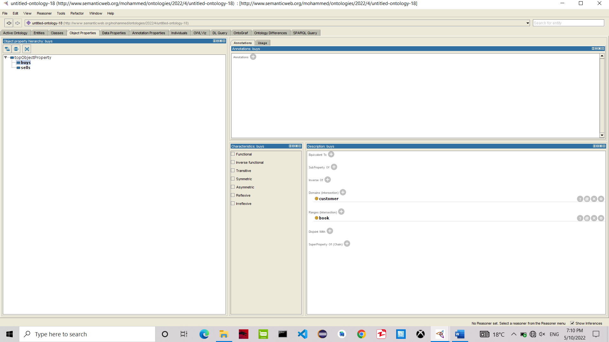

**Data properties**

There are many data properties

buy_operation_id, first_name, last_name, price, name, seller_id and writer_name.

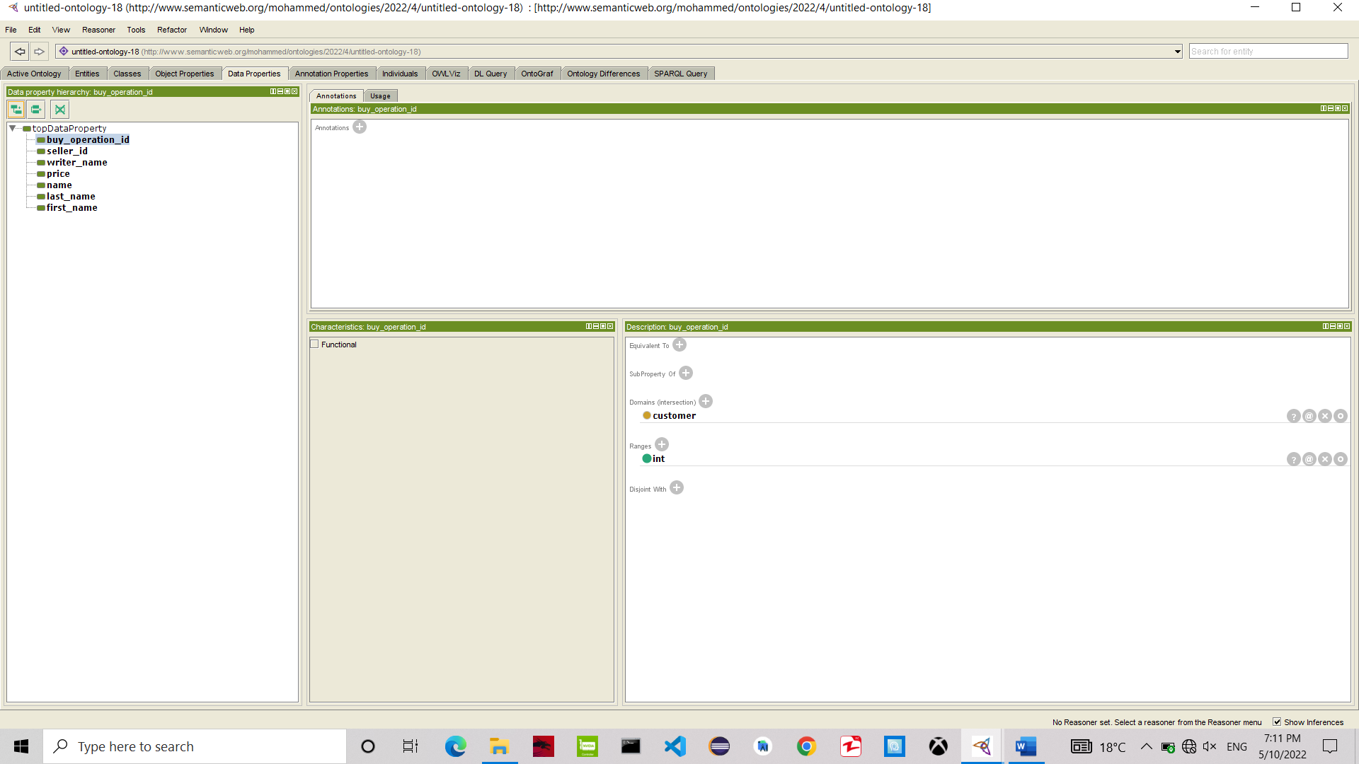

**Individual**

