**Student name : Sarah Ali**

**University ID : 2180005906**

**Introduction**

The ontology is about a simple education system, only has two process, studies and teaches, and teacher, student and course .

The student studies course, the teacher teaches course. The course has id and title, the student and teacher have first name and last name, the student has student id, the teacher has teacher id.

In the ontology, there are classes, data properties, object properties, and individuals.

**Body**

We use protégé program to build the ontology.

Protégé is a**free, open source ontology editor and a knowledge management system.**

can be adapted to build both simple and complex ontology-based applications. Developers can integrate the output of Protégé with rule systems or other problem solvers to construct a wide range of intelligent systems.

**Screenshot of the component of project in protégé program**

* Classes

The person class has two subclasses: student, teacher. If the two has the same attributes like first name, last name we will apply these attributes to the class person.

The course class has three subclasses : database, math, ontology. This means that if applying any attributes to it, the attribute will be owned to all its subclasses.

The below screenshot explains the heirarchy of the classes in the project .

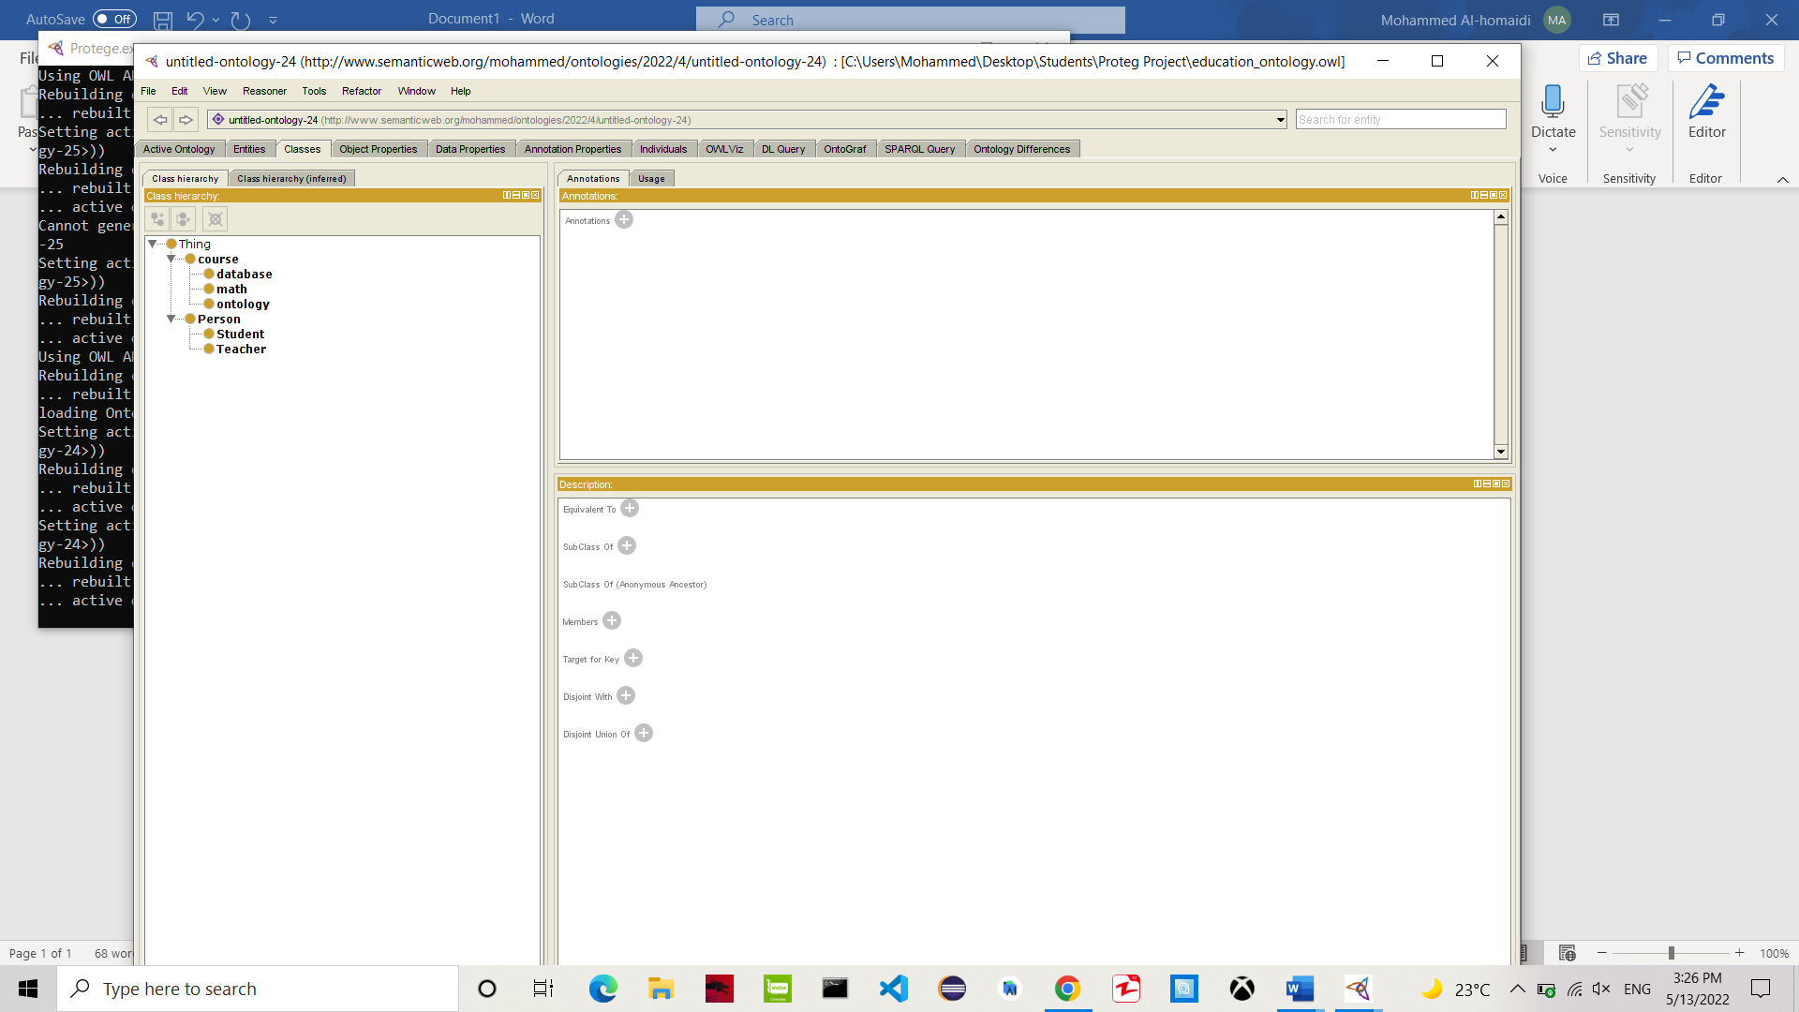

* Object properties

Object properties represent the**relations among classes**. In other words, they are the relationships between two classes or two individuals.

The below screenshot explains the object properties and its domain and range.

* Data properties

The data property hierarchy view displays the asserted and inferred data property hierarchies. The asserted data property hierarchy is visible by default.

The below screenshot explains the data properties hierarchy and its domain and range(datatype).

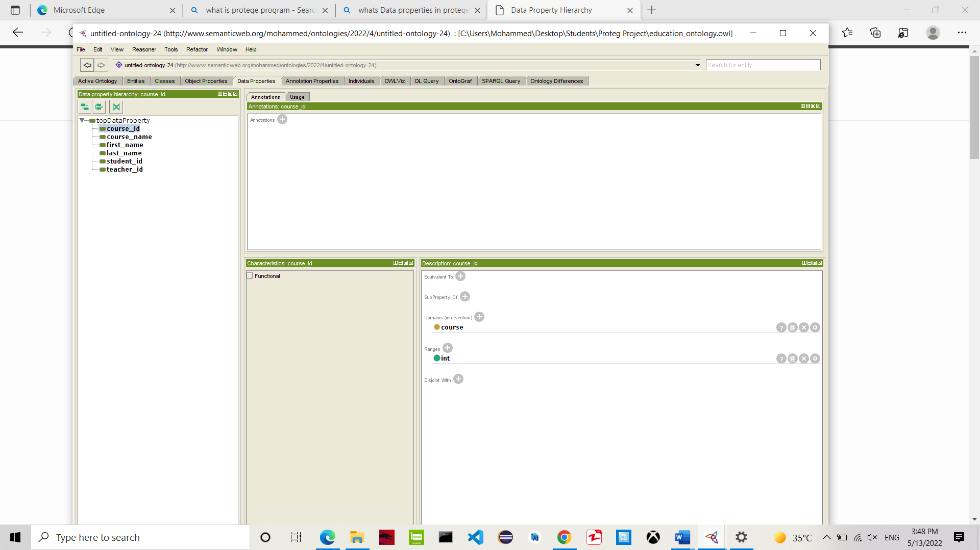

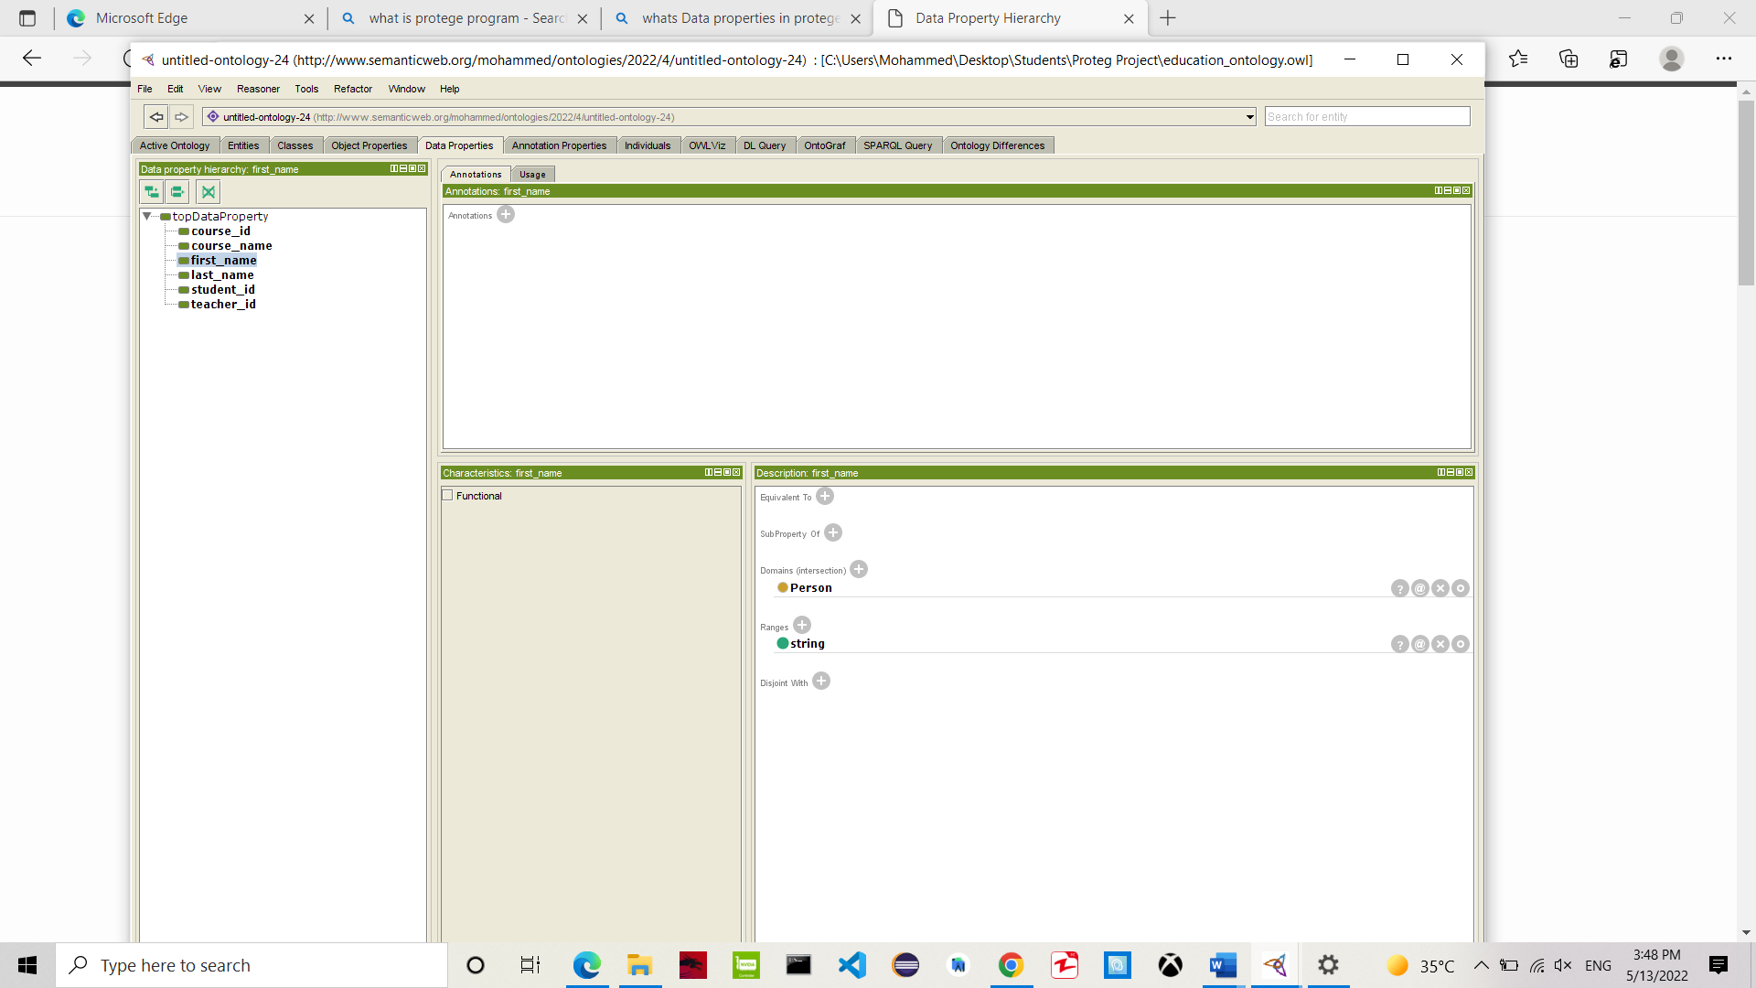

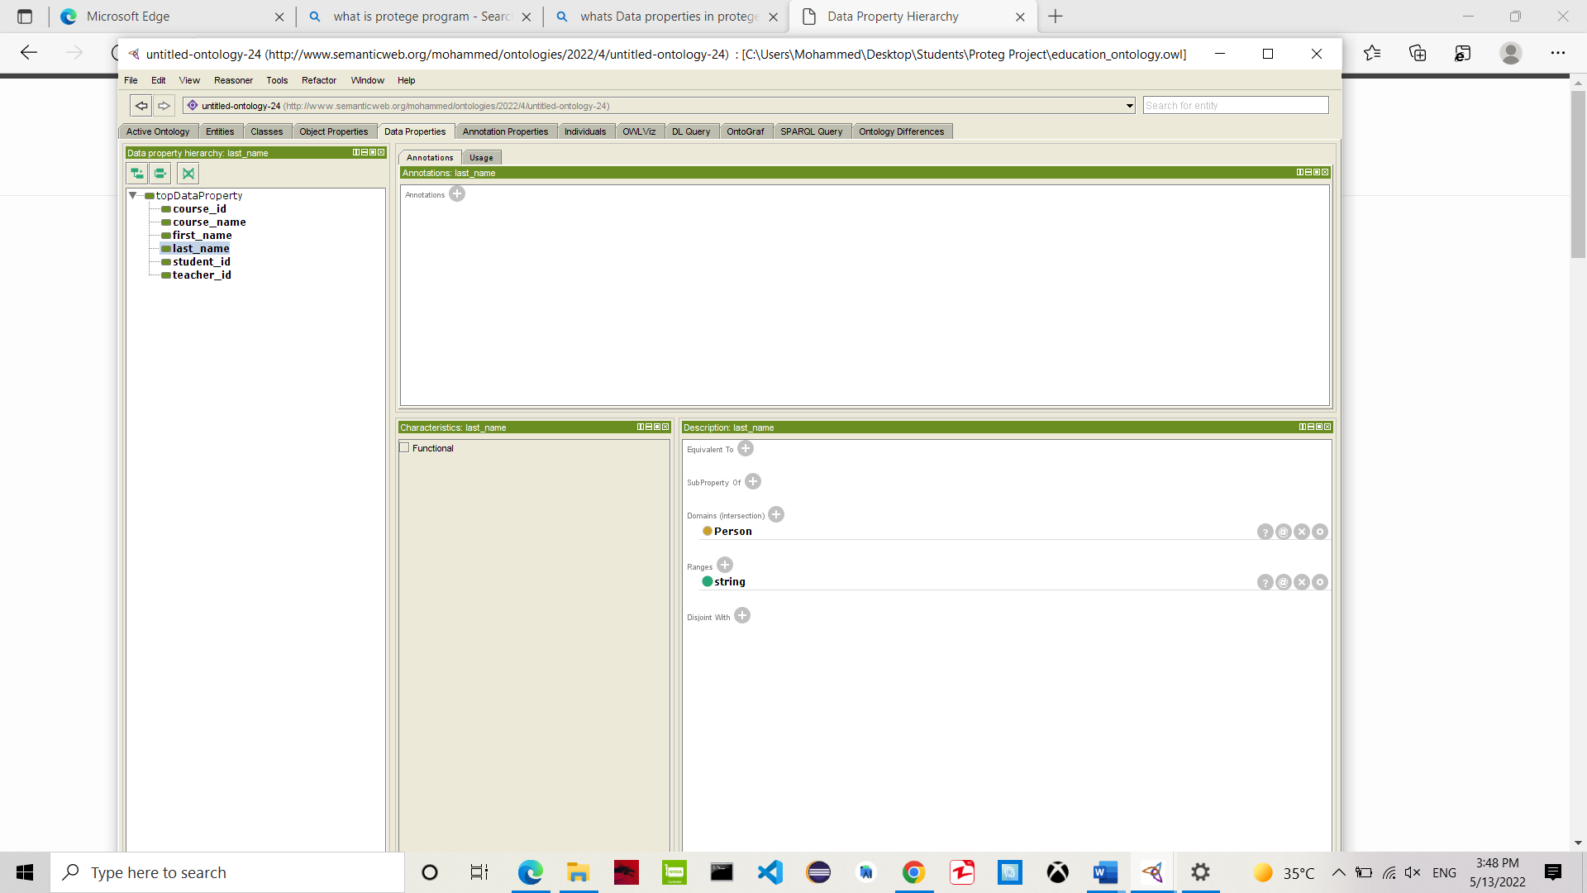

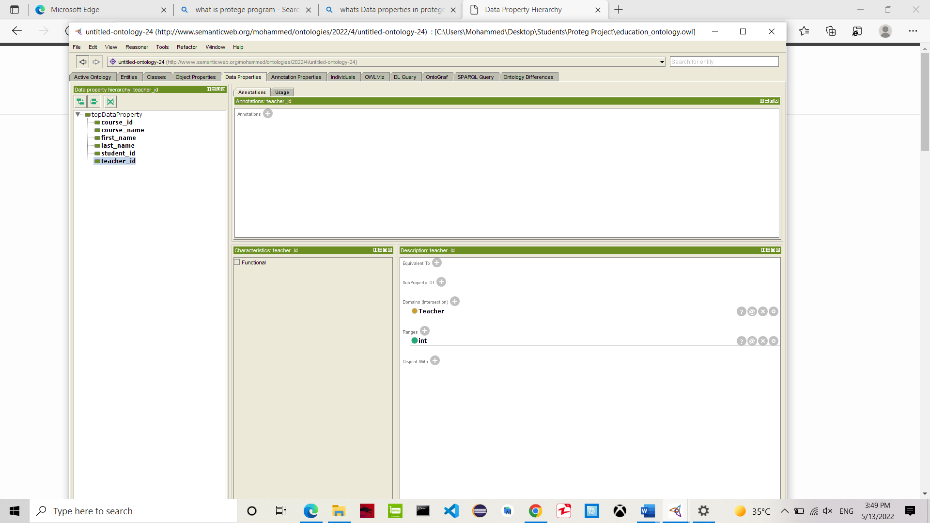

* Individuals

Individuals (instances) are the basic, "ground level" components of an ontology. The individuals in an ontology may include concrete objects such as people, animals, tables, automobiles, molecules, and planets, as well as abstract individuals such as numbers and words. Strictly speaking, an ontology need not include any individuals, but one of the general purposes of an ontology is to provide a means of classifying individuals, even if those individuals are not explicitly part of the ontology.

The below screenshot explains the individuals.

