N A M COLLEGE KALLIKKANDY
VIDYAGIRI-670693

MEDIMATE
By

MUHAMMED NISAM NM22CCSR30
RIFAPARVEEN NM22CCSR39
SAJANESRY NM22CCSR42

Under The Guidance Of
MR.FIRDOUS SIR
Project Report
Submitted to the NAM College KALLIKKANDY in partial fulfilment of the requirements
For the award of the degree
B.Sc. COMPUTER SCIENCE

N A M COLLEGE KALLIKKANDY
KANNUR DIST-670693

CERTIFICATE

This is to certify that the project entitled “CYBERTRACK" prepared by MUHAMMED NISAM,SAJA NESRY,RIFA PARVEEN is a bonafide record of work done by them towards the partial fulfilment for the award of Bachelor of Degree in Computer Science under the university of Kannur during the period 2024-2025.

Signature of lecturer in charge Signature of Head of the Dept.
Submitted for the University examination Examiners:
1.
2.

ACKNOWLEDGEMENT
We have immense pleasure in acknowledging the service and cooperation rendered by umpteen people in their non-fields and ways. The success of any task accomplished lies not only in hands of the accomplisher but also the guiding light offered by all those around, towards the road to success , they did much to shape up the success.
We are grateful to our college Principal Dr. MAJEESH T for extending facilities required throughout our project work.
We wish to express our deepest sense of gratitude to our guide Mr. Shameer sir & Mr. Muhammed Shafi Sir, Mr. Haseeb Sir, Ms. Mini Mol Miss, Ms. Saida Miss whose generous support, constant encouragement and healthy criticism have been invaluable help to us throughout the course of this project.
Last but not least We also express our heartfelt thanks to our classmates for providing valuable suggestions which make this endeavor a success.

 | TABLE OF CONTENTS
Serial  No | TOPIC | Page No
1 | ABSTRACT | 6
2 | INTRODUCTION | 7
2.1 INTROUDUCTION TO THE SYSTEM
2.2 ABOUT THE PROJECT
3 | PROBLEM FORMULATION | 8
3.1 OBJECTIVES
3.2 PROBLEM STATEMENT
3.3 SOFTWARE USED
3.4 PLATFORM REQUIREMENTS
4 | SYSTEM ANALYSIS | 27
4.1 PRESENT SYSTEM
4.2 PROPOSED SYSTEM
4.3 USE CASE ANALYSIS
4.4 FEASIBILITY ANALYSIS
5 | SYSTEM DESIGN | 32
5.1 INTRODUCTION
5.2 FUNDAMENTAL DESIGN CONCEPT
5.3 INPUT DESIGN
5.4 OUTPUT DESIGN
5.5 DATABASE DESIGN
5.6 TABLES
5.7 CONCEPTUAL SYSTEM DESIGN
5.8 VALIDATION AND CHECKS
6 | SYSTEM DEVELOPMENT | 48
7 | SYSTEM CODING AND TESTING | 49

7.1 SYSTEM TESTING
7.2 LEVELS OF TESTING
7.3 TESTING THE SYSTEM
 | 8 | SYSTEM IMPLEMENTATION | 53
 | 9 | FORMS | 55
 | 10 | CONCLUSION | 64
 | 11 | FUTURE SUGGESTION | 65
 | 12 | BIBLOGRAPHY | 66

1.ABSTRACT
Organizations often struggle with inefficiencies in managing employee data and HR processes manually, leading to administrative overhead, errors, and delays. To address these challenges, we propose CYBERTRACK, an Employee Management System designed to automate and streamline various HR tasks, including employee data management, attendance tracking, payroll processing, performance evaluation, and recruitment.
CYBERTRACK integrates multiple modules into a centralized platform, enabling HR personnel, employees, and clients to manage tasks seamlessly. HR teams can efficiently store and update employee records, manage leaves, track working hours, and process payroll with accuracy. The system’s performance evaluation feature facilitates feedback and goal tracking, fostering a culture of continuous growth and engagement. Additionally, the recruitment module simplifies the hiring process—from job postings to onboarding—ensuring smoother workflows.
A self-service portal empowers employees by providing access to payslips, leave requests, and personal information updates, promoting autonomy and transparency. The system also includes a client service module, allowing clients to assign projects, track progress, and provide feedback on employee performance. This enhances collaboration and ensures efficient project management. Furthermore, reporting and analytics tools enable HR teams to make data-driven decisions, improving employee satisfaction and organizational efficiency.
CYBERTRACK is built using Python (Django) for backend development, with a simple yet effective HTML/CSS frontend and SQLite or MySQL for database management. Its scalable and user-friendly design makes it an ideal solution for organizations seeking to optimize HR operations, enhance client collaboration, and improve the overall employee experience.

INTRODUCTION

2.1 INTRODUCTION
In the modern workplace, managing employee data and HR processes efficiently is critical for the smooth functioning of any organization. However, many organizations still face the challenge of managing these processes manually, resulting in inefficiencies, errors, and administrative overhead. Recognizing this issue, our project, "CYBERTRACK," aims to revolutionize how organizations manage their HR tasks.

"CYBERTRACK" is designed to automate and streamline various HR tasks, such as employee data management, attendance tracking, payroll processing, performance evaluation, and recruitment. By integrating these essential HR functions into one centralized platform, the system ensures seamless management of tasks by both HR personnel and employees.

The system provides a robust solution for HR teams to easily store and update employee data, track working hours, process payroll with accuracy, and manage leaves efficiently. Additionally, the performance evaluation module encourages growth and engagement by enabling goal setting and continuous feedback.

"CYBERTRACK" also simplifies the recruitment process, making hiring smoother and more organized, from job postings to onboarding new employees. The self-service portal offers employees the convenience of accessing their payslips, requesting leave, and updating their personal information, promoting transparency and autonomy.

With the integration of reports and analytics, HR teams can make data-driven decisions, improving operational efficiency and overall employee satisfaction. This project aims to reduce administrative burdens, enhance employee experience, and create a more productive work environment in organizations.

Built using Python (Django) for backend development, with a user-friendly HTML/CSS frontend, and supporting SQLite or MySQL for the database, "CYBERTRACK" is scalable, easy to use, and adaptable to various organizational needs.
2.2 ABOUT THE PROJECT
In the modern business environment, effective employee management is critical to organizational success. Recognizing the challenges faced by organizations in managing HR processes manually, we introduce "CYBERTRACK"—an advanced Employee Management System (EMS) designed to automate and streamline key HR tasks. This innovative solution combines a web-based platform with intuitive functionalities to support efficient management of employee data, attendance tracking, payroll processing, performance evaluations, and recruitment."CYBERTRACK" empowers HR teams to reduce administrative overhead, minimize errors, and improve operational efficiency by consolidating multiple HR functions into a single, easy-to-use system. The system offers features such as automated payroll calculations, leave management, and performance tracking, ensuring accuracy and saving valuable time.Additionally, the EMS includes a self-service portal for employees, providing them with direct access to their payslips, leave records, and personal data updates. This not only promotes transparency and autonomy but also improves the overall employee experience. With integrated analytics and reporting capabilities, HR teams can make informed, data-driven decisions to enhance employee satisfaction and organizational growth."CYBERTRACK" is more than just an automation tool—it's a comprehensive solution that bridges the gap between HR teams and employees, fostering a more efficient, transparent, and collaborative work environment. By introducing "CYBERTRACK," we aim to elevate employee management practices and set the stage for continuous improvement in human resource management.

3.PROBLEM FORMULATION

3.1 OBJECTIVES

CYBERTRACK aims to streamline and automate employee management processes, reducing administrative workload and improving efficiency. The system eliminates manual HR processes, minimizing errors and delays by integrating a centralized platform for employee data management, attendance tracking, payroll processing, performance evaluation, and recruitment.
The key objectives of CYBERTRACK include:
Enhancing HR Efficiency: Automating employee data storage, attendance, and payroll reduces administrative burden.
Improving Employee Experience: A self-service portal allows employees to access payslips, request leaves, and update personal details.
Optimizing Recruitment: The system facilitates resume analysis, job postings, and onboarding, making the hiring process smoother.
Data-Driven Decision-Making: Integrated analytics provide insights into employee performance, attendance trends, and HR operations.
- Client Collaboration: Clients can assign projects, track progress, and provide feedback on employee performance.
- Scalability & Security: CYBERTRACK is designed to support future expansion while ensuring data privacy and security.
CYBERTRACK consists of four primary user roles:Client, Project Manager, HR, and Employee (User). Each role has specific functionalities that enhance workflow efficiency.

1. PROJECT MANAGER
Project managers handle task assignments and ensure seamless collaboration between employees and clients. Their key tasks include:
- Task Management: Assign, update, and track employee tasks.
- Client Requests: View and respond to client project requirements.
- Performance Feedback: Provide feedback on employee contributions to projects.

2. HR (HUMAN RESOURCES)
HR personnel manage employee lifecycle activities, from recruitment to payroll processing. Their responsibilities include:
- Employee Management: Register, update, and track employee details.
- Attendance & Leave: Monitor attendance, approve leave requests, and manage work schedules.
- Payroll Processing: Calculate salaries and process payroll with accuracy.
- Recruitment & Resume Analysis: Analyze resumes, schedule interviews, and onboard new employees.
- Performance Evaluation: Review employee feedback and track goal achievements.

3. EMPLOYEES (USERS)
Employees can access self-service features to manage their work-related information. Their functionalities include:
- Profile Management: View and update personal details.
- Attendance Tracking: Check attendance records and work hours.
- Leave Requests: Apply for leave and track approval status.
- Task Overview: View assigned tasks and project updates.
- Payslip & Feedback Access: Download payslips and submit performance feedback.

4. CLIENTS
Clients interact with CYBERTRACK to manage project assignments and track employee performance. Their capabilities include:
- Project Assignment: Assign projects to employees.
- Progress Tracking: Monitor project status and deadlines.
- Employee Feedback: Provide feedback on the work delivered.

3.2 PROBLEM STATEMENT

What is the problem to be solved?
Understanding the limitations of the existing employee management system is crucial for developing an efficient solution. Traditional HR processes rely on manual record-keeping and outdated systems, leading to inefficiencies, administrative overhead, and delays in key operations such as attendance tracking, payroll processing, and recruitment. The lack of automation increases the risk of errors, miscommunication, and data loss, ultimately affecting employee productivity and organizational growth.

Disadvantages of the Existing System
- Time-Consuming Processes – Manual data entry and approval workflows slow down operations.
- Inefficiency – Tracking attendance, leave, and payroll manually leads to inconsistencies and errors.
- Limited Accessibility – Employees and HR teams struggle to access records efficiently.
- Lack of Transparency – Employees have limited visibility into their payroll, leave status, and performance feedback.
- Data Loss & Security Risks – Physical records or fragmented digital systems may lead to misplaced or unauthorized access to employee data.

3.3 SOFTWARE USED.
CYBERTRACK is designed using a combination of technologies that ensure a scalable, secure, and efficient employee management system. The chosen software stack enables seamless functionality, from frontend design to backend processing, database management, and deployment. The core technologies used in CYBERTRACK are as follows:

1. Frontend Technologies

1.1 HTML (HyperText Markup Language)
HTML is the fundamental technology used to structure the web pages in CYBERTRACK. It allows the system to present employee details, attendance logs, payroll information, and HR functionalities in a user-friendly interface.

Advantages of HTML in CYBERTRACK:
- Easy to Learn and Use – Enables quick development of the system’s UI.
- Cross-Platform Compatibility – Ensures CYBERTRACK runs smoothly on any web browser.
- Supports Multimedia – Facilitates the integration of images, tables, and forms for enhanced user interaction.
- High Search Engine Visibility – Ensures the system remains accessible and indexable.

1.2 CSS (Cascading Style Sheets)
CSS is used to style and format the web pages of CYBERTRACK, ensuring a visually appealing and responsive design. It helps in maintaining consistency across the platform.

Features of CSS in CYBERTRACK:
- Separation of Content and Design – Enhances maintainability and performance.
- Improved User Experience – Provides a clean and engaging interface.
- Mobile-Friendly Layout – Ensures compatibility across various devices.
- Faster Page Load Speed – Optimized stylesheets improve system responsiveness.

1.3 JavaScript (JS)
JavaScript is integrated into CYBERTRACK to enhance interactivity and user engagement. It is used for implementing dynamic features such as real-time notifications, form validation, and smooth UI transitions.

Key Features of JavaScript in CYBERTRACK:
- Lightweight & Fast Execution – Enhances user experience with real-time updates.
- Event-Driven Programming – Supports live attendance tracking and notifications.
- Cross-Browser Compatibility – Works on all major web browsers.
- Dynamic User Interaction – Allows dropdown menus, modals, and animated elements.

2. Backend Technologies

2.1 Python (Django Framework)
CYBERTRACK's backend is developed using Django, a high-level Python framework that simplifies database management, security, and business logic implementation. Django follows the Model-Template-View (MTV) architecture, making it highly scalable and efficient.

Advantages of Django in CYBERTRACK:
- Fast Development – Built-in functionalities reduce coding effort.
- Secure Framework – Protects against SQL injection and CSRF attacks.
- Scalability – Easily handles multiple employees, clients, and HR processes.
- Robust Admin Panel – Streamlines HR and payroll management.

3. Database Management

3.1 MySQL (Relational Database Management System)
CYBERTRACK uses MySQL to store employee records, attendance logs, payroll information, and performance evaluations. It ensures data consistency, integrity, and fast retrieval.

Key Features of MySQL in CYBERTRACK:
- Relational Database Structure – Organizes HR and employee data efficiently.
- High Performance & Speed – Processes payroll and attendance updates in real time.
- Secure Access Control – Protects sensitive employee data.
- Cross-Platform Support – Compatible with various operating systems.

4. Data Exchange & Processing

4.1 XML (Extensible Markup Language)
XML is used in CYBERTRACK for structured data exchange between the frontend and backend. It enables smooth integration of external HR tools and payroll systems.

Features of XML in CYBERTRACK:
- Machine-Readable Format – Ensures seamless data exchange.
- Scalability – Easily accommodates new data fields.
- Long-Term Data Storage – Preserves HR records efficiently.

5. Development & Deployment Tools

5.1 PyCharm (IDE for Python Development)
PYCHARM is used as the primary Integrated Development Environment (IDE) for developing and maintaining CYBERTRACK’s Django-based backend.

Key Features of PyCharm:
- Code Analysis & Debugging – Speeds up backend development.
- Integrated Version Control – Supports GitHub and other repositories.
- Database Integration – Allows smooth interaction with MySQL.

5.2 SQLyog (MySQL GUI Tool)
SQLyog is used for database management, making it easier to handle employee data, payroll transactions, and attendance records.

Advantages of SQLyog:
- Fast Query Execution – Optimizes payroll processing.
- Graphical User Interface – Simplifies database management.
- Cross-Version Compatibility – Works with multiple MySQL versions.

5.3 WAMP Server (Local Development Environment)
CYBERTRACK is tested on WAMP Server, a Windows-based development environment that includes Apache, MySQL, and PHP.

Advantages of WAMP Server:
- Easy Configuration – Quick setup for testing HR functionalities.
- Supports Multiple Applications – Helps in integrating external HR tools.

5.4 Adobe Dreamweaver (Web Development Tool)
Dreamweaver is used for frontend development, helping designers create responsive HR dashboards with HTML, CSS, and JavaScript.

Features of Adobe Dreamweaver:
- Live Preview Feature – Allows real-time UI testing.
- Integration with Django & MySQL – Ensures smooth data flow.

5.5 Android Studio (For Mobile Accessibility)
To enhance accessibility, CYBERTRACK supports mobile integration through Android Studio, enabling employees and HR teams to access the system via smartphones.

Key Features of Android Studio:
- Real-Time Employee Access – View attendance, leave status, and payroll.
- Push Notifications – Alerts for HR updates and performance feedback.
- Secure Mobile Authentication – Ensures data privacy.

3.4 PLATFORM REQUIREMENTS

HARDWARE REQUIREMNTS

- INPUTDEVICE : MOUSE,KEYBOARD,SCANNER
- OUTPUT DEVICE : MONITOR
- MEMORY : 4GB RAM (MINIMUM)
- PROCESSOR :INTEL i3 PROCESSOR

SOFTWARE REQUIREMENTS

- Operating system : Windows 8 OR Above
- Front end for website : HTML, CSS, JAVASCRIPT
- Front end for Android : XML
- Frame Work : DJANGO
- Back end : JAVA , PYTHON,MYSQL

4.SYSTEM ANALYSIS

4.1 PRESENT SYSTEM
Understanding the limitations of the existing employee management system is crucial in designing a more efficient and automated solution. Many organizations still rely on manual or partially computerized HR processes, leading to inefficiencies in handling employee data, attendance tracking, payroll processing, and recruitment. The current system lacks a centralized and automated approach, making it difficult for HR personnel, employees, and clients to collaborate effectively.

Disadvantages of the Existing System
- Time-Consuming Processes – Manual attendance tracking, leave approvals, and payroll processing cause delays.
- Inefficiency – Errors in record-keeping and data entry lead to discrepancies in salary calculations and performance evaluations.
- Limited Accessibility – Employees and HR personnel cannot easily access or update records in real-time.
- Lack of Transparency – Employees have limited visibility into their payroll, attendance, and performance data.
- Data Loss Risks – Paper-based or poorly managed digital records can lead to misplaced employee details and security vulnerabilities.
The existing system is fragmented, inefficient, and lacks scalability, making it necessary to implement a fully integrated, online employee management system like CYBERTRACK to streamline HR operations and improve organizational efficiency.

4.2 PROPOSED SYSTEM
CYBERTRACK is designed as a centralized, web-based Employee Management System that automates HR tasks and enhances employee and client collaboration. The system integrates Python (Django) for backend development, HTML, CSS, and JavaScript for the frontend, and MySQL or SQLite for secure database management.
In the proposed system, each user is assigned a unique username and password to access their respective functionalities. The system supports four primary user roles:
- Administrator – Manages employee data, payroll, recruitment, and system settings.
- HR Personnel – Oversees employee records, attendance tracking, and performance evaluation.
- Employee (User) – Views personal details, requests leaves, and accesses payroll records.
- Client – Assigns projects, tracks progress, and provides feedback on employee performance.

User Registration & Authentication
To ensure data security and system integrity, users must register and authenticate themselves before accessing the system. The registration details are validated, and access is granted based on the assigned role.

Administration Functions
The Administrator has complete control over system configurations and user access. Admins can:
- Approve or reject user registrations.
- Manage HR settings, attendance policies, and payroll configurations.
- Update system data, ensuring smooth operation.
The proposed system eliminates manual inefficiencies and ensures real-time data accessibility, enabling organizations to improve workforce productivity and HR efficiency.

4.3 USE CASE ANALYSIS
Use Case Diagrams help visualize how users interact with CYBERTRACK, ensuring all functionalities meet organizational needs. Unified Modeling Language (UML) is used to represent system functionalities and their interactions with different user roles.
A Use Case defines:
- Actors – The different user roles (Administrator, HR, Employee, Client) interacting with the system.
- Processes – The tasks each user role can perform (e.g., payroll processing, attendance tracking, task assignment).
- System Workflow – The interactions between users and the system for efficient HR management.
Throughout the development process, these Use Case Diagrams evolve as more requirements emerge, ensuring that CYBERTRACK provides all the necessary capabilities for efficient employee and client management.
.
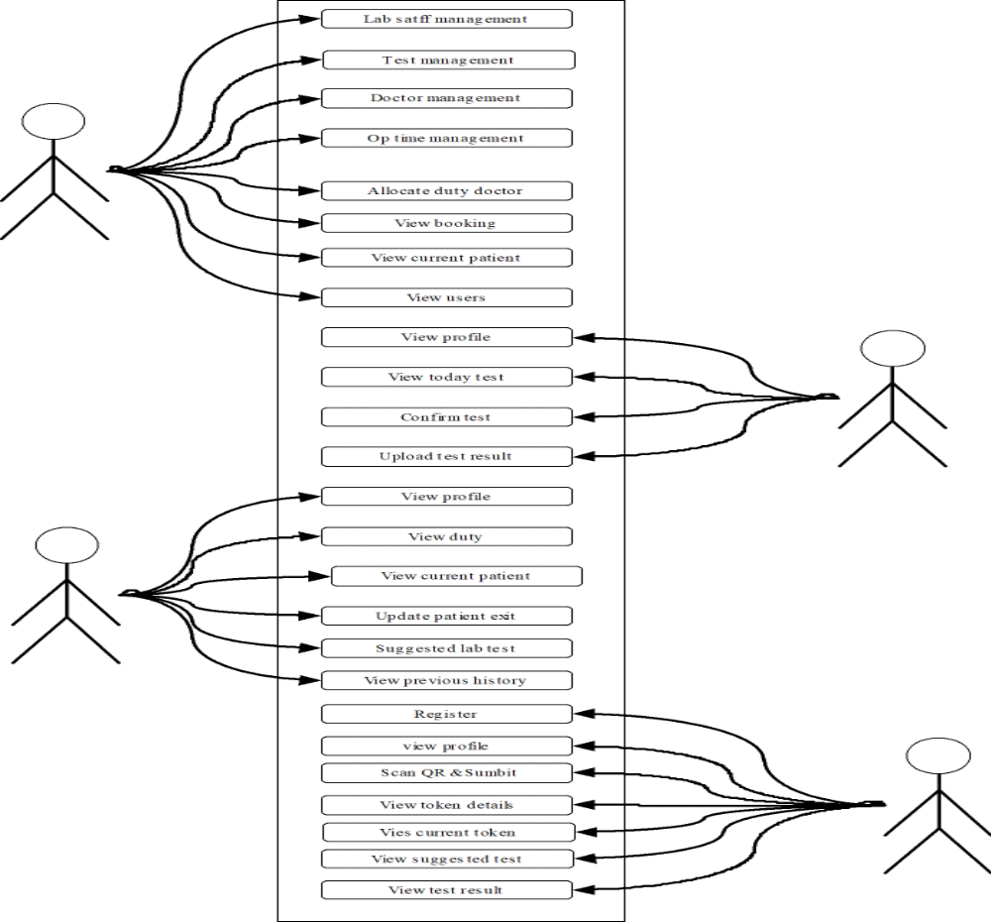

4.4 FEASIBILITY ANALYSIS
Preliminary investigations examine project feasibility, the likelihood the system organization. All projects are feasible-given unlimited resources and infinite time. Unfortunately, the development of a computer-based system or product is more likely plagued by a scarcity of resources and difficult delivery dates. It is both necessary and prudent to evaluate the feasibility of the project at the earliest possible time. Feasibility and risk analysis are related in many ways. Important tests of feasibility are studied and described below.
Technical Feasibility:
There are a number of technical issues, which are generally raised during the feasibility stage of the investigation. A study of function, performance and constraints that may affect the ability to achieve an acceptable system.
The considerations that are normally associated technical feasibility include:
- Development risk.
- Resource Availability.
3.Technology
Economic Feasibility:
Economic feasibility is an important task of system analysis. A system that can be developed technically and that will be used if installed must still be profitable for the organization. Financial benefits must equal or exceed the costs. The analyses raise financial and economic questions during the preliminary investigation to estimate the following:
1.The cost to conduct a full systems investigation
2.The cost of hardware and software for the class of application of the project being considered.
3.The benefits in the form of reduced costs or fewer costly errors.
4.The cost if nothing changes.
To be judged feasible, a proposal for the specific project must pass all these tests, otherwise it is not considered as a feasible project.
Operational Feasibility:
Proposed projects are beneficial only if they can be turned into information systems that will meet the operating requirements of the organization.This test of feasibility asks if the system will work when it is developed and installed. Maple properties satisfies all the operational conditions.
Legal Feasibility:
A determination of any infringement, violation, or liability that could result from
development of the system. Legal feasibility encompasses a broad range of concerns that include contracts, liability, infringement, and myriad other traps frequently unknown to technical staff.
Alternatives:
An evaluation of alternative approaches to the development of the system or product.The degree to which alternatives are considered is often limited by cost and time constraints; however, a legitimate but “unsponsored” variation should not be buried. The feasibility study may be documented as a separate report to upper management and included as an appendix to the system specification. The feasibility study is reviewed first by project management and upper management. The study should result in a “go/no-go” decision.

5.SYSTEM DESIGN

5.1 INTRODUCTION
System analysis is one of the important activities which are to be completed before starting the activities like designing, coding etc. If we will not do the Analysis part with ample importance or if we skip some functional areas of the system at the time of system analysis it is sure that the system developed by using the data obtained from that case not work in a proper way. Analysis is the first step towards solving the problem statement. It deals with devising a precise, concise, understandable and correct modal of the real system. Analysis helps to understand the requirements and the real-world environment in which the system will exist. The result of analysis should understand the problem as a preparation for design. The analysis model addresses the three aspects of the objects.
• Static structure
• Sequencing of interaction
. • Data transformations.
5.2 FUNDAMENTAL DESIGN CONCEPT
System design is the process of developing specifications for a candidate system that meet the criteria established in the system analysis -Major step in system design is the preparation of the input form and the output reports in a form applicable to the user. The main objective of the system design is to use the package easily by any computer operator. System design involves various stages as:
1. Data Entry
2. Transition
3. Communication
4. Search
5. Report
System Design is the creative act of invention, developing new inputs, a database, offline files, method, procedures and output for processing business to meet an organization objective. System design builds information gathered during the system analysis.

Requirement
Operation &
Maintenance

System and S/w Design

Implientation &
Unit testing

Integration&
System testing

• Requirement Analysis and definition
The system's services, constraints and goals are established by consultation with the system users. They are defined in a manner, which is understandable, by the users and development staff.
• System and software design
The system design process partitions the requirement to either hardware or software system. It establishes overall system architecture. Software design involves representing the software systems functions in a form that may be transformed in to one or more executable programs.
• Implementation and unit testing
During this stage,the software design is realized as a set of programs or program units.Unit testing involves that each unit meets its specification.
- Integration and system testing
The individual program units or programs are integrated and tested as a complete system to ensure that the software requirements have been met. After testing, the software system is delivered to the customer.
• Operation and maintenance
Normally this is the longest life cycle phase. The system is installed and put into practical use. Maintenance involves correcting errors which were not discovered in earlier stages of life cycle, improving the implementation of system units and enhancing the system's services as new requirements are discovered.

5.3 INPUT DESIGN
The input design is the process of converting the user-oriented inputs into the computerbased format. The data is fed into the system using simple interactive forms. Input data are collected and organized into a group of similar data. The forms have been supplied with messages so that user can enter data without facing any difficulty. The data is validated wherever it requires in the project. This ensures that only the correct data have been incorporated into the system. Inaccurate input data is me most common cause of data processing errors. Effective input design minimizes errors made by data entry operators.
The goal of designing input data is to make data entry as easy, logical and free from errors as possible. The proposed system has the input modules as
- Admin
- User
- Lab staff

5.4 OUTPUT DESIGN
A quality output is one, which meets the requirements of the end user and presents the information clearly. In any systems results of processing are communicated to the user and to other systems through outputs. Efficient and intelligent output design improves the system's relationship with the user and helps in decision-making.
Computer output is the important and direct source of information to the user. Efficient, intelligible output designs improve the system's relationships with the user and helps in decision making. They also provide a permanent hard copy of these results for later consultation.
The various types of output required by the system are:
- External output, whose destination is outside the concern and requires special attention
- Internal output, whose destination is within the concern and requires careful design because they are the user’s main interface within the computer
- Operation outputs, whose use is purely within the computer department, e.g., program listing, usage statistics etc.
- Interactive outputs, which involves the user in communicating directly with computers

5.5 DATABASE DESIGN
The overall objective in the development of database technology has been to treat data as an organizational resource and as an integrated whole. csdept.com allows data to protected and organized separately from other resources. Database is an integrated collection of data. The Database is an organized listing of all data elements that are pertinent to the system, with precise definitions so that both user and system analyst will have a common understanding of inputs, outputs, components of stores and intermediate calculations. There are 6 major steps in design process. The first 5 steps are usually done on paper and finally the design is implemented. Project’23 Prosgen-The promising generation BSc Computer Science NAM College Kallikkandy 30
- Identify the table and relationships
- Identify the data that is needed for each table and relationship
- Resolve the relationship
- Verify the design
- Implement the design

5.6 TABLE DESIGN
The overall objective in the development of database technology has been to treat data as an organizational resource and as an integrated whole. Database Management System allows data to be protected and organized separately from other resources. Database is an integrated collection of data.
This is the difference between logical and physical data.
The organization of data in the database aims to achieve three major objectives:
1. Data integration
2. Data integrity
3.Data independence
Normalization
The process of normalization is concerned with the transformation of the conceptual schema to a computer representable form. Normalization reduces the redundancies and anomalies.
The First Normal Form
First normal form does not allow multivalued and composite valued attributes. It states that the domain of an attribute must include only atomic values and that value of any attribute in a tuple must be single value from the domain of that attribute.
The Second Normal Form
In second normal form, for relations where primary key contains multiple attributes, non key attributes should not be functionally dependent on a part of the primary key.
Third Normal Form
In third normal form, relation should not have a non-key attribute functionally determined by another non-key attribute. That is there should be no transitive dependency of a non-key attribute on the primary key.
In Career Selection System, the tables are in third normal form (3NF). All tables satisfy all the
Conditions for third normal form. So there is no redundant data in the table.
There are two basic requirements for a database to be in third normal form:
• Already meet the requirements of both INF and 2NF
• Remove columns that are not fully dependent upon the primary key.
The first requirement is that the tables must satisfy the requirements of 1NF and 2NF. In the Motherland Seafood Management System any table does not contain duplicate columns and all tables have primary keys. Therefore, it satisfies the requirements of 1NF. There is no subset of data that apply to multiple rows. So we also satisfy the requirements of 2NF.
In each table each columns are fully depend on the primary key. So the tables satisfy the requirements of 3NF also.
The tables and field description used in this design are as follows

5.7 TABLES
1.TABLE NAME: login
primary key: login id
Column Name | Data Type | Description
Id | Int | Login id
username | Varchar(50) | User name
Password | Varchar(50) | password
Usertype | Varchar(50) | Type of user

2.TABLE NAME: doctor
primary key: doctor id
Column Name | Data Type | Description
Id | Int | Doctors id
Name | Varchar(50) | Doctors name
Email | Varchar(50) | Doctors email
Phone | Int | Doctors phone
Specialization | Varchar(50) | Doctors specialization
Qualification | Varchar(50) | Doctors qualifications
Image | Varchar(50) | Doctors image
Login_id | Int | Doctors login id

3.TABLE NAME: lab staff
primary key: lab staff-id
Column Name | Data Type | Description
Id | Int | Lab staff id
Name | Varchar(50) | Lab staff name
Email | Varchar(50) | Lab staff email
Phone | Int | Lab staff Phone
Login_id | Int | Lab staff login id
Image | Varchar(50) | Lab staff image

4.TABLE NAME: test
primary key: test id

Column Name | Data Type | Description
Id | Int | Test id
Test name | Varchar(50) | Test name
Description | Varchar(50) | Test description
Amount | Int | Test amount
Waiting time | Int | Test result waiting time

5.TABLE NAME: op time
primary key: op time id

Column Name | Data Type | Description
Id | Int | Optime id
Date | Date | Op date
From_time | Varchar(50) | Op fromtime
To_time | Varchar(50) | Op totime

6.TABLE NAME: duty allocation
primary key: duty allocation id

Column Name | Data Type | Description
Id | Int | Allocation id
Doctor_id | Int | Doctor id
Optime_id | Int | Optime id

7.TABLE NAME: bookings
primary key: bookings id
Column Name | Data Type | Description
Id | Int | Booking id
Date | Date | Booking date
Time | Varchar(50) | Booking time
Token | Int | Token no
Status | Varchar(50) | Booking status
Optime_id | Int | Optime id
Users_id | Int | User id

8.TABLE NAME: current patient
primary key: current patient id

Column Name | Data Type | Description
Id | Int | Current patient id
Status | Varchar(50) | Patient status
Booking_id | Int | Bookings id
Duty_allocation-id | Int | Duty allocation id

9.TABLE NAME: users
primary key: users id

Column Name | Data Type | Description
Id | Int | Users id
Name | Varchar(50) | User’s name
Email | Varchar(50) | User’s email
Phone | Int | User’s phone
Gender | Varchar(50) | User’s gender
Age | Int | User’s age
Login_id | Int | Users login id

10.TABLE NAME: today test
primary key: today test id

Column Name | Data Type | Description
Id | Int | Test id
Status | Varchar(50) | Test status
Bookings_id | Int | Bookings id
Doctors_id | Int | Doctors id
Test_id | Int | Test id

11.TABLE NAME: test result
primary key: test result id

Column Name | Data Type | Description
Id | Int | Test result id
File | Varchar(50) | Test result
Today_test_id | Int | Today test id

12.TABLE NAME: Bank
Primary key:
Column Name | Data Type | Description
Id | Int | Bank id
Bank | Varchar(50) | Bank name
Acc | Int | Account number
Pin | Int | Pin number
Balance | Int | Account balance

5.7 CONCEPTUAL SYSTEM DESIGN
After study and the analysis of the existing system the functional operational requirements were identified. Based on these requirements the conceptual model of the system is designed. The objective of the system design is to improve the existing system or design a new system with improved facilities.
Data Flow Diagram:
Data Flow Diagrams is the best and easiest tool to represent the flow of the data in the project. It is otherwise known as a bubble chart. It has the purpose of clarifying system requirements and identifying major transformations that will become programs in System design. It is the major starting point in the design phase that functionally decomposes the requirements specifications down to the lowest level of detail. A DFD consists of a series of bubbles joined by lines. The bubble represents data transformation and lines represent data flow in the system. In the normal convention a DFD has four major symbols.

Arrow, which shows data flow

Circle, which represents a process that transforms incoming data into outgoing flow

Open rectangle, which shows a data store

A DFD model of a system graphically depicts the transformation of the data input to the system to the final result through a hierarchy of levels. The DFD at the simplest level is referred to as the ‘zero level DFD’ or in simple words a ‘Context Analysis Diagram’. These are expanded level by level each explaining its process in detail. Processes are numbered for easy identification and are normally labelled in block letters. Each data flow is labelled for easy understanding

DFD

Level 0
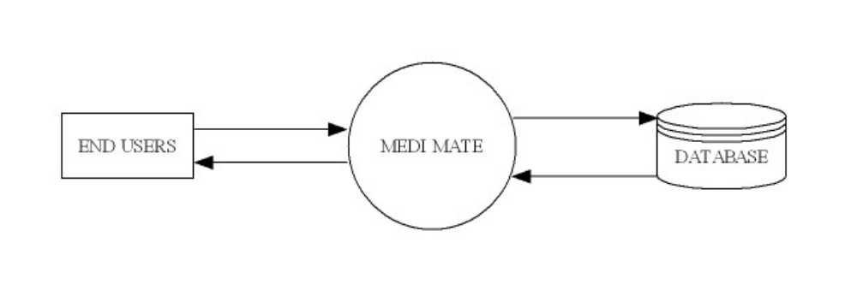

Level 1
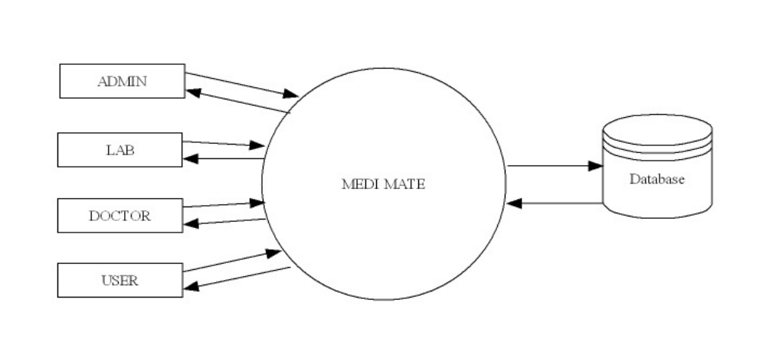

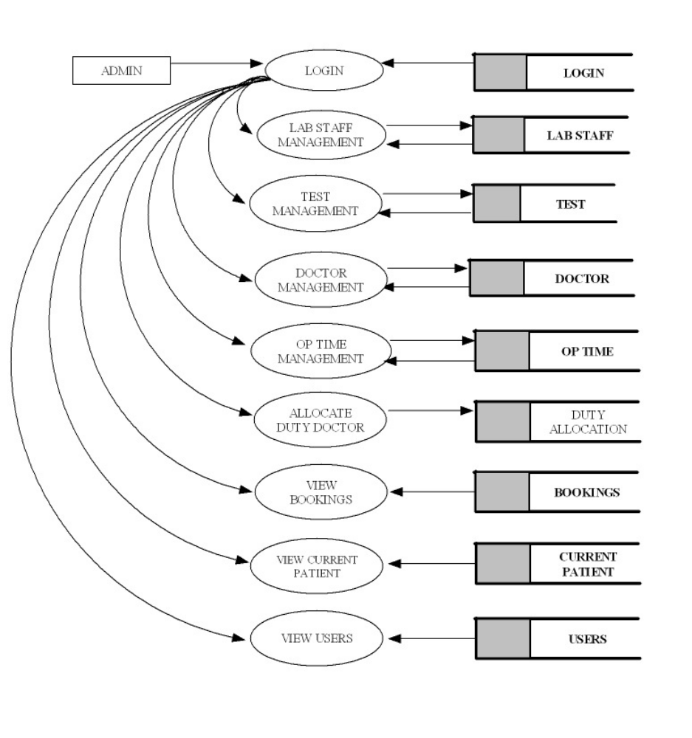Level 1.1 ADMIN

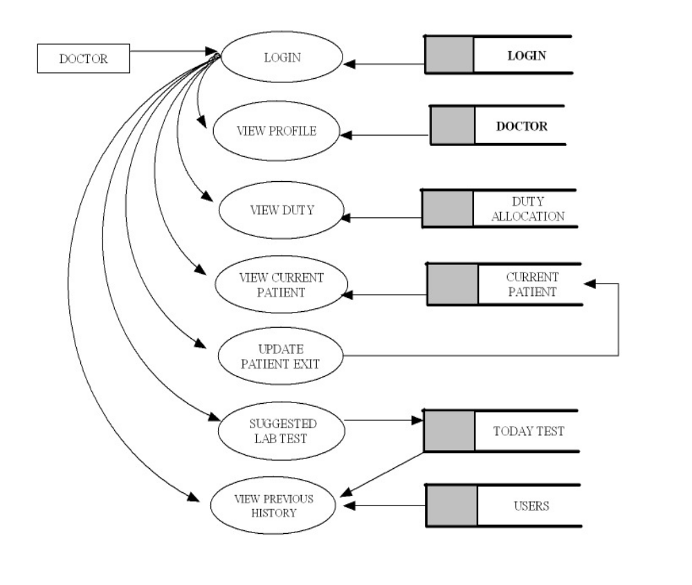Level 1.2 DOCTOR

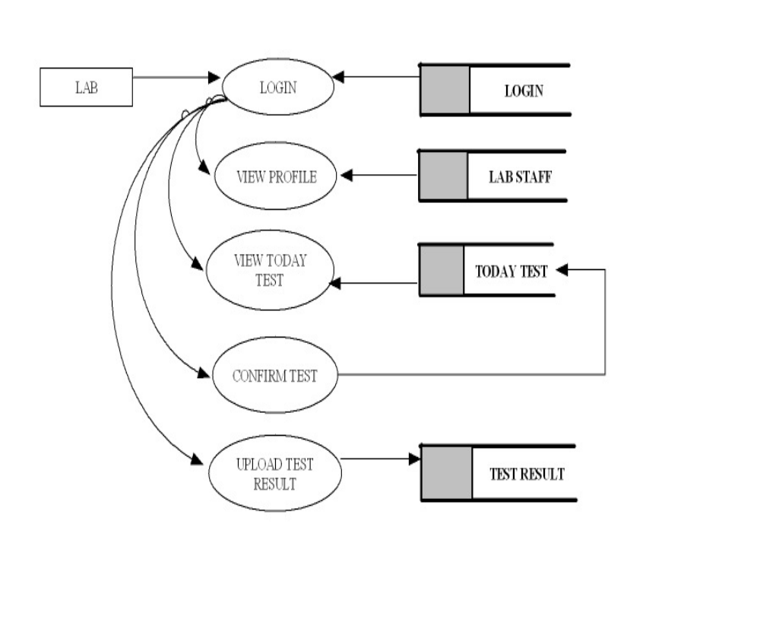Level 1.3 LAB STAFF

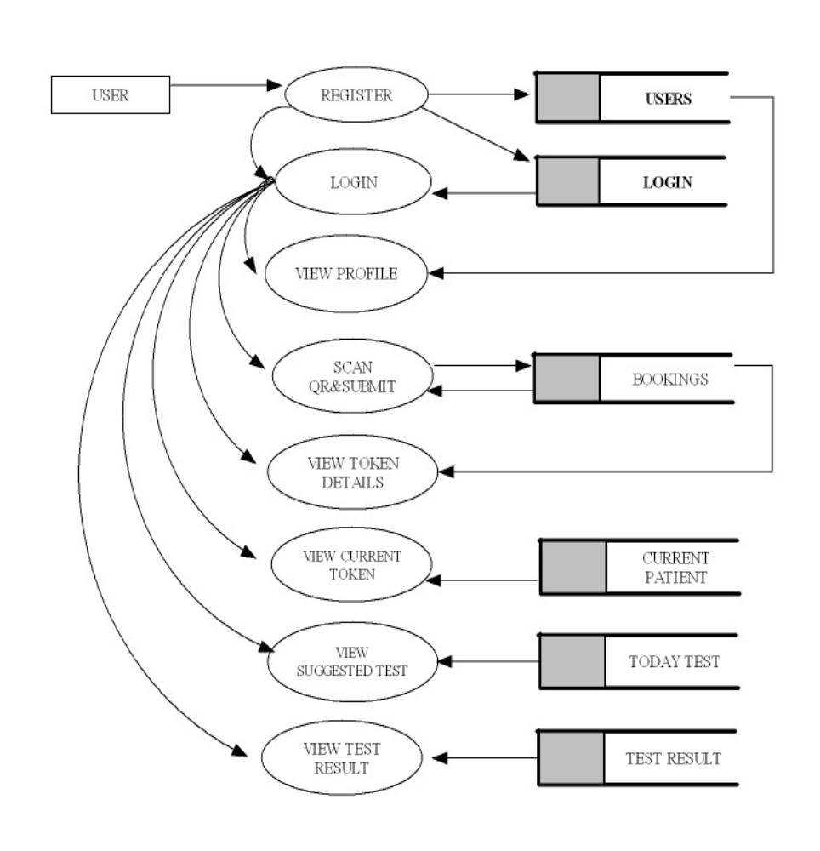Level 1.4 USER

5.8 VALIDATION AND CHECKS
Software validation is achieved through a series of tests that demonstrate conformity with requirements. Validation succeeds when software functions in a manner that can be reasonably expected by the customer. Here used line by line checking for to find errors. Comment line facility is used for checking errors. Testing is necessary for the success of the system. During testing, a program to be tested is executed with a set of test data and the output of the program for test data is evaluated to determine if the programs are performing as expected. Validation means checking the quality of software in both simulated and live environments. System validation ensures that the user can in fact match his/her claims, especially system performance. True validation is verified by having each system tested. First the application goes through a phase often referred as alpha testing in which the errors and failures based on simulated user requirements are verified and studied. The modified software is then subjected to phase two called beta testing in the actual user’s site or live environment. After a scheduled time, failures and errors are documented or final correction and enhancements are made before the package is released.

6.SYSTEMDEVELOPMENT

System development is a series of operations performed to manipulate data to produce output from a computer system. This highly depends on the programming language used. Programming techniques include the concept of "object-oriented programming." Object-oriented programming centers on the development of reusable program routines (modules) and the classification of data types (numbers, letters, dollars, etc.) and data structures (records, files, tables, etc.). Linking pre-scripted module objects to predefined data-class objects reduces development times and makes programs easier to modify. The development phase involves converting design specifications into executable programs. Effective development standards include requirements that programmers and other project participants discuss design specifications before programming begins. The procedures help ensure programmers clearly understand program designs and functional requirements. The principle activities performed during the development phase can be divided into two major related sequences. They are:
- External system development.
- Internal system development.

The major External system development activities are:
- Implementation
- Planning
- Preparation of manual
- Personal training
- Equipment acquisition
- Installation

The major system internal development activities are:
- Computer program development
- Performance testing

7.SYSTEM CODING ANDTESTING

7.1 SYSTEM TESTING
Testing is finding out how well something works. In terms of human beings, testing tells what level of knowledge or skill has been acquired. In computer hardware and software development, testing is used at key checkpoints in the overall process to determine whether objectives are being met. Testing is a process used to help identify the correctness, completeness and quality of developed computer software. With that in mind, testing can never completely establish the correctness of computer software. Testing helps in verifying ad validating if the software is working as it is intended to be working. For example, in software development, product objectives are sometimes tested by product user representatives. When the design is complete, coding follows and the finished code is then tested at the unit or module level by each programmer; at the component level by the group of programmers involved; and at the system level when all components are combined together.

Black box testing
It takes an external perspective of the test object to derive test cases. These tests can be functional or non-functional, though usually functional. The test designer selects valid and invalid inputs and determines the correct output. There is no knowledge of the test object's internal structure. This method of test design is applicable to all levels of software testing: unit, integration, functional testing, system and acceptance. The higher the level, and hence the bigger and more complex the box, the more one is forced to use black box testing to simplify. While this method can uncover unimplemented parts of the specification, one cannot be sure that all existent paths are tested.

White box testing
An internal perspective of the system to design test cases based on internal structure. It requires programming skills to identify all paths through the software. The tester chooses test case inputs to exercise paths through the code and determines the appropriate outputs. While white box testing is applicable at the unit, integration and system levels of paths within a unit, it can also test paths between units during integration, and between subsystems during a system level test. Though this method of test design can uncover an overwhelming number of test cases, it might not detect unimplemented parts of the specification or missing requirements, but one can be sure that all paths through the test object are executed. Several testing methods are present to ensure the quality of Online Identity.

7.2 LEVELS OF TESTING
Unit Testing:
Unit testing focuses verification effort on smallest unit of software design module. Here, there are three module namely, Admin System, Teacher System, Module System.
In unit testing:
- Module interface is tested to ensure that information properly flows into and output of the program under test.
- Local data structures are examined to ensure that data stored temporarily maintains its integrity during all steps in algorithm execution Boundary condition is tested to ensure that the module operates properly at boundaries established to limit or restrict processing.
- All independent paths through the control structures are executed to ensure that all statements in the module have been executed at least once.
- Error handling paths are also tested.
Unit testing focuses verification effort on the smallest unit of software design, the module. Here, the module interfaces, local data structure, boundary conditions, and all independent paths and last but not the least, all error handling paths were verified by inputting false data. Tests of data flow across each module interface of this software were done before any other test was initiated.

Integration Testing:
Integration testing is a systematic technique for constructing the program structure while at the same time conducting tests to uncover errors associated with interfacing. Unit tested module were taken and a single program structure was built that has been dictated by the design. Incremental integration has adopted here. The entire software was developed and tested in small segments, where errors were errors were easy to locate and rectify. Program builds (group of modules) were constructed corresponding to the successful testing of user interaction, data manipulation analysis, and display processing and database management.
There are two strategies of Integration testing.
- Top-down integration
- Bottom-up integration

Validation Testing:
Validation testing is done to ensure complete assembly of the error-free software. Validation can be termed successful only if it functions in manner that is reasonably expected by the customer.
Under Validation test:
- Alpha testing
- Beta testing
Alpha testing is where the end user tests the system rather than the developer, but in a controlled environment. The software is used on a natural setting with the developer monitoring the user using the system. The developer records the errors and usage problems encountered by the user.
The sales person conducts beta testing at one more sites. The developer is not present during the tests. Hence, beta test can be said as the live application of the software on an environment that cannot be controlled by the developer. The sales person takes down the problems encountering during beta testing and reports these to the developer at regular intervals. The developer makes suitable modifications of the software henceforth.

System Testing:
System testing is actually a series of different tests whose primary purpose to fully exercise the computer-based system. Each test works to verify that all system elements have been properly integrated.
Types of system tests are:
- Recovery Testing
- Security Testing
- Stress Testing.
- Performance Testing

7.3 TESTING THE SYSTEM
The test team of College Information through Mobile consists of the college Teacher, the Student and myself. We test the system by running it in several ways by inputting various values in the respective forms.
The main concerns in our testing are following:
- Browse compatibility: This test validates consistent applications performance on variety of browser type and configuration.
- Functional correctness: These tests validates that the application function correctly.
- Integration: These test the integration between browsers and servers, applications and data, hardware and software.
- Usability: These test the overall usability of a web page or a web application, including appearance clarity and navigation.
- Security: These test the adequacy and correctness of security controls including access control and authorizations.
- Performance: These test the performance of the web applications under load.
- Verification of codes: This validate that the code used in building the web application has been used in a correct manner.

SYSTEM IMPLEMENTATION
Crucial phase in the systems life cycle is the successful implementation of the new system design. Implementation means converting a new system into operation.
In the implementation phase, the team builds the components either from scratch or by composition. Given the architecture document from the design phase and the requirement document from the analysis phase, the team should build exactly what has been requested, though there is still room for innovation and flexibility. For example, a component may be narrowly designed for this particular system, or the component may be made more general to satisfy a reusability guideline. The architecture document should give guidance. Sometimes, this guidance is found in the requirement document the implementation phase deals with issues of quality, performance, baselines, libraries, and debugging. The end deliverable is the product itself.
Implementation is an application, execution of an idea, plan, model, specification, design, standard, policy and algorithm. Project Implementation process may be effective if some very important factors are kept in mind that are urgent in a project management system. It is crucial for everyone to start the project by keeping in mind some factors are identified in the article. Implementation of a project is the step where all the proper planned activities are put into action. Before starting the implementation of a project, the implementers must identify his weaknesses and strength. The customer's needs from the product of the project must be defined, and the project scope should be clearly known. Keep a record of when the project implementation process starts and finishes. The main thing to do before the implementation of a project is to predetermine and discuss the project budget and the estimated time, and the manpower required to finish the project.
To ensure successful project implementation, there are some important tips that you need to make use of. The project should have people who are dedicated more to create the situations of the successful project implementation. Before the project implementation process starts, ensure you have all factors of project process written or recorded on paper. This will make the project implementation process easier to manage, and they can be of used for the projects that are the same as the current project. Project monitoring is also an important thing to make sure that activities are implemented as per planned. This assists the project implementers to check how well they are getting their objectives. This process is fully based on the knowledge that the procedure, by which a project is implemented, has so many effects on its access, maintenance, and operation.
When you are looking for a project implementation process, the implementation process begins and includes many different phases. The first starts with project planning phase that wants you to plan your tasks of the project. The second one is the project design phase that consists of the creation of system design comprising of application designing, database designing and the data communication design. The other phases in the project implementation process consists of create and unit test phase, integration test phase, training phase, and finally, the close out phase. The project implementation process needs urgent pre requisites identified above in the article to make the project a success and reliable. The “Medimate” created can be implemented by first uploading it to the internet and can be made useful to the users.

9.1 SYSTEM EVALUATION

The options or facilities that have been included in the system are user friendly and up to the mark. The burden of the authority for many tedious tasks have been reduced to a great extends. The main advantage of the software being that it can be reconstructed as of desired format for the requirement rises from time to time. This makes it beneficiary not to think about a second one at a later stage. As a whole can be concluded that the system has met the needs of the developing authority to a great extend.
Various approaches of system evaluation that have been carried out to maintain the system performance are as follows.

- Requirement Analysis
- Criteria Definition
- Testing and Verification
- Comparative Analysis
- Feedback Collection
- Documentation and Reporting

10.FORMS

Home Page:
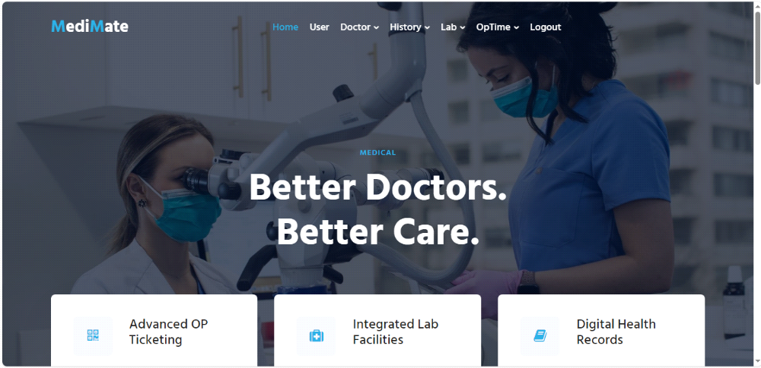

Profile page:

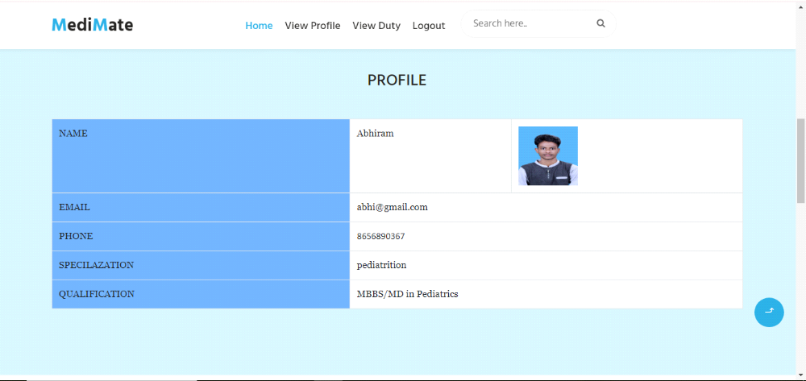

Doctor Page:
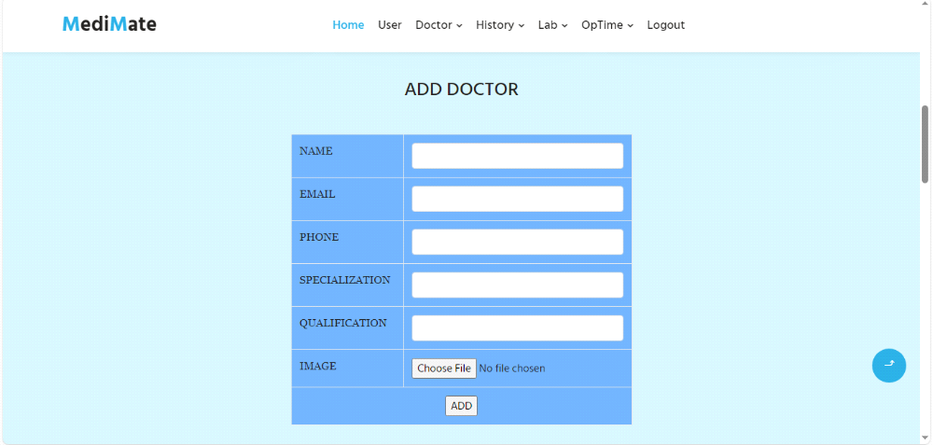

Patient Page:

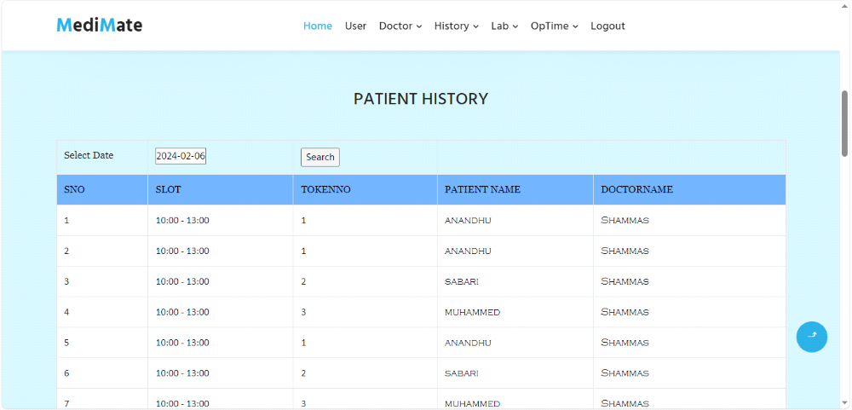

OP Time Page:
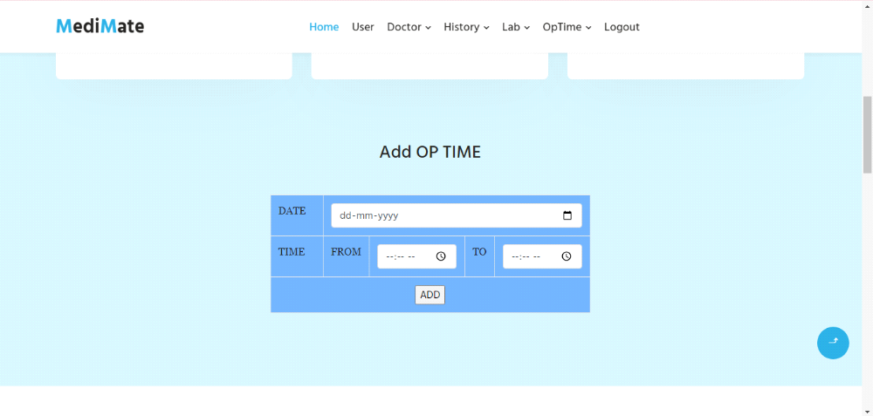

Patient details:

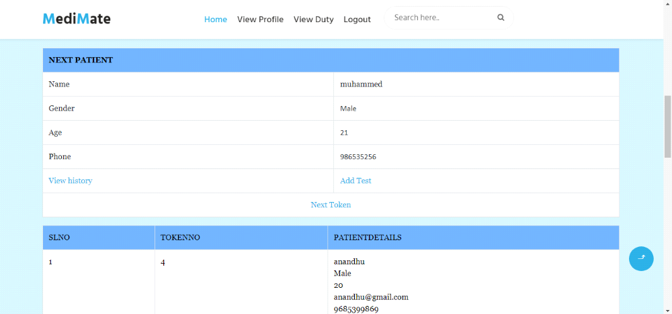

Op time:

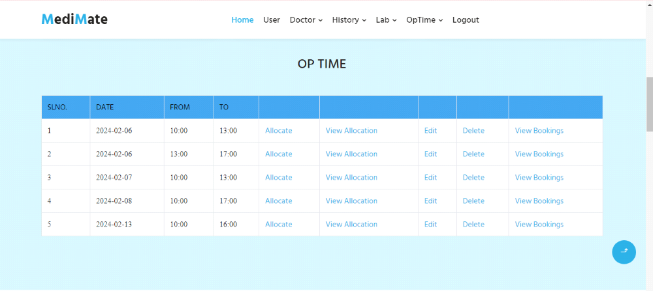

Doctors: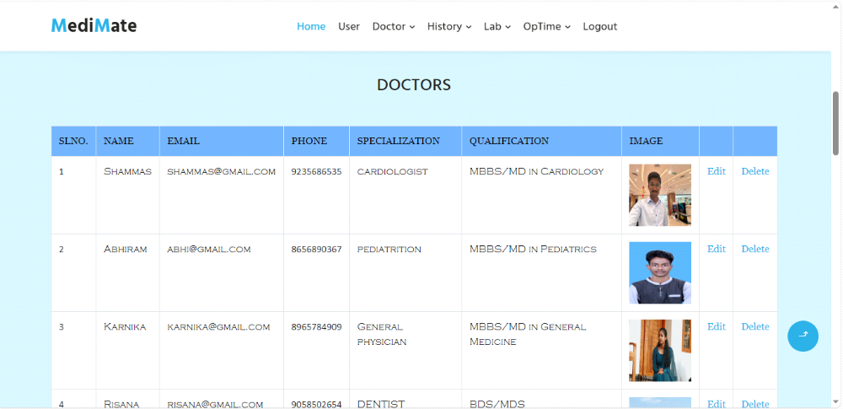

11. CONCLUSION
Conclusion is the summing up of arguments described in this article. This software provides a user-friendly approach towards the system. This system has been well developed and when implemented, is bound to satisfy all of the requirements. Painstaking efforts have been taken to make the software impeccable and upgradeable. There is a hope that this software will be utilized to its maximum and will do a good job in the long run. With blessings of God, the exertions are hoped to bear fruit. The program for carrying out various activities have been run and successfully tested to ensure that the software developed meets the needs satisfactorily. Any users can process the Online PROSGEN-THE PROMISING GENERATION without any experience in any software products. The major advantages of software products are:
- Fast retrieval of entries from database
- Cost effective.
- Quick implementation results.
- Available in diskette.
- Convenience,
- Ubiquity.
The software was developed in HTML, PYTHON and SQL.it is expected to live up to the objectives for which it was designed.
The primary objective of this project “MEDIMATE” is providing a healthy young generation. Students are treasures of our world and we are trying to protect those treasures. The drawbacks of the system were analyzed and carefully studies. The new system was designed and its reusability checked at later stage. Beside the security provides by the window additional security has been built into the system.
System has been successfully tested and implemented with running on different computers and it is seen that the system has high degree of accuracy and user friendliness.
The system is a user-friendly system and further changes can be incorporated into the system easily.

