DESIGN AND DEPLOYMENT OF A SECURE CLOUD-BASED PATIENT DATA MANAGEMENT SYSTEM USING A THREE-TIER ARCHITECTURE ON AWS

MOHAMED OMAR MOHAMED GAD MAKHLOUF

UNIVERSITI TEKNOLOGI MALAYSIA

PSZ 19:16 (Pind. 1/23)

UNIVERSITI TEKNOLOGI MALAYSIA DECLARATION OF THESIS

Author’s full name :
Matric No. : Academic : Session
Date of Birth : UTM Email : Thesis Title :

I declare that this thesis is classified as:
OPEN ACCESS I agree that my report to be published as a hard copy or
made available through online open access.

RESTRICTED
Contains restricted information as specified by the organization/institution where research was done. (The library will block access for up to three (3) years)

CONFIDENTIAL Contains confidential information as specified in the Official
Secret Act 1972)
(If none of the options are selected, the ;rst option will be chosen by default)

I acknowledged the intellectual property in the thesis belongs to Universiti Teknologi Malaysia,
and I agree to allow this to be placed in the library under the following terms :
- This is the property of Universiti Teknologi Malaysia
- The Library of Universiti Teknologi Malaysia has the right to make copies for the purpose of only.

- The Library of Universiti Teknologi Malaysia is allowed to make copies of this thesis for academic exchange.
Signature of Student:
Signature :
Full Name Mohamed Omar Mohamed Gad Makhlouf
Date : 09/07/2026
Approved by Supervisor(s)


Signature of Supervisor I: Signature of Supervisor II

Full Name of Supervisor I Full Name of Supervisor II
Johan Mohamad Sharif (Dr.)

Date :
09/07/2026
Date :

NOTES : If the thesis is CONFIDENTIAL or RESTRICTED, please attach with the letter from the organization with period and reasons for confidentiality or restriction

This letter should be written by a supervisor and addressed to Perpustakaan UTM. A copy of this letter should be attached to the thesis.

Date:
Librarian
Jabatan Perpustakaan UTM, Universiti Teknologi Malaysia, Johor Bahru, Johor

Sir,

CLASSIFICATION OF THESIS AS RESTRICTED/CONFIDENTIAL TITLE:
AUTHOR'S FULL NAME:

Please be informed that the above-mentioned thesis titled should be classified as RESTRICTED/CONFIDENTIAL for a period of three (3) years from the date of this letter. The reasons for this classification are
(i)
(ii)
(iii)

Thank you.

Yours sincerely,

SIGNATURE:
NAME:
ADDRESS OF SUPERVISOR:


“We hereby declare that we have read this thesis and in our opinion this thesis is sufficient in terms of scope and quality for the award of the degree of Bachelor of Computer Science (Computer Networks and Security) in Specialization”

Signature :

Name of Supervisor I : JOHAN MOHAMAD SHARIF Date : JULY 9, 2026

Signature :

Name of Supervisor II : SECOND SV Date : JULY 9, 2026

Signature :

Name of Supervisor III : THIRD SV Date : JULY 9, 2026

Declaration of Cooperation

This is to confirm that this research has been conducted through a collaboration
and .

Certified by:

Signature :
Name :
Position :
Official Stamp Date

* This section is to be filled up for theses with industrial collaboration

Pengesahan Peperiksaan

Tesis ini telah diperiksa dan diakui oleh: Nama dan Alamat Pemeriksa Luar :

Nama dan Alamat Pemeriksa Dalam :

Nama Penyelia Lain (jika ada) :

Disahkan oleh Timbalan Pendaftar di Fakulti: Tandatangan :
Nama :
Tarikh :

DESIGN AND DEPLOYMENT OF A SECURE CLOUD-BASED PATIENT DATA MANAGEMENT SYSTEM USING A THREE-TIER ARCHITECTURE ON AWS

MOHAMED OMAR MOHAMED GAD MAKHLOUF

A thesis submitted in fulfilment of the requirements for the award of the degree of
Bachelor of Computer Science (Computer Networks and Security)

Computer Science Computing
Universiti Teknologi Malaysia

JULY 2026

DECLARATION

I declare that this thesis entitled “DESIGN AND DEPLOYMENT OF A SECURE CLOUD-BASED PATIENT DATA MANAGEMENT SYSTEM USING A THREE-TIER

ARCHITECTURE ON AWS” is the result of my own research except as cited in the references. The thesis has not been accepted for any degree and is not concurrently submitted in candidature of any other degree.

Signature :

Name : MOHAMED OMAR MOHAMED GAD
MAKHLOUF
Date : JULY 9, 2026

ACKNOWLEDGEMENT

I dedicate this template to those who have spent countless hours to make this possible.

ABSTRACT

In this study, a design of the Secure Cloud-Based Patient Data Management System for the Alamin Clinic of Saudi Arabia, a privately owned healthcare organization, is introduced. This private healthcare facility faced the challenge of having its on-premise infrastructure breached by a ransomware that led to the encryption of all patient data and operational disruptions. Four major vulnerabilities that have allowed such cyber-attack are identified in this study. They include a flat network architecture; manual infrastructure management ; lack of data encryption, and a lack of infrastructure recovery plan. Thus, these factors enabled the ransomware attack. They are also reflect the security posture of other similar small scale private healthcare organizations that use their legacy on-premises infrastructure. In order to address these challenges, the proposed design uses a three-tier architecture hosted within the environment of Amazon Web Services, where presentation, application, and database layers are placed in separate subnets within a VPC and database tier has no Internet access paths. In addition, a solution with Infrastructure as Code is used using Terraform. It allows not only an automated process of deployment but also quick recovery in case of infrastructure crashes. The DevSecOps continuous integration and delivery pipeline uses Trivy, SonarQube, and Checkov applications and provides automated vulnerability scan at each code commit, making any critical finding impossible to deploy. Finally, the access to the application and database is restricted using Identity and Access Management policies and Role Based Access Control. Row-level security of the PostgreSQL databases ensures the enforcement of individual data isolation at the storage layer. The proposed network topology, security group configuration, database schema with row-level security policies, DevSecOps pipeline specifications, and wireframe for interfaces are included in this design to establish an architectural blueprint. The main evaluation criteria are set as a recovery time objective under fifteen minutes and achieving passing HIPAA security posture, measured through AWS Security Hub.

ABSTRAK

Dalam kertas penyelidikan ini, reka bentuk Sistem Pengurusan Data Pesakit Berasaskan Awan yang Selamat untuk Klinik Alamin di Arab Saudi, sebuah organisasi penjagaan kesihatan swasta, diperkenalkan. Fasiliti ini menghadapi cabaran pencerobohan infrastruktur on-premise oleh perisian tebusan yang mengakibatkan penyulitan data pesakit dan gangguan operasi. Empat kerentanan utama dikenal pasti: seni bina rangkaian rata, pengurusan infrastruktur manual, ketiadaan penyulitan data, dan ketiadaan pelan pemulihan. Faktor ini membolehkan serangan tersebut dan mencerminkan tahap keselamatan organisasi kesihatan kecil lain yang menggunakan infrastruktur warisan. Bagi menangani cabaran ini, reka bentuk cadangan menggunakan seni bina tiga lapis pada Amazon Web Services, di mana lapisan persembahan, aplikasi, dan pangkalan data diasingkan dalam subnet VPC tanpa capaian Internet bagi pangkalan data. Infrastruktur sebagai Kod menggunakan Terraform membolehkan pelaksanaan automatik dan pemulihan pantas. Talian paip DevSecOps menyepadukan Trivy, SonarQube, dan Checkov untuk imbasan kerentanan automatik pada setiap commit bagi menghalang penggunaan kod berisiko. Capaian dihadkan melalui polisi IAM dan RBAC, manakala keselamatan peringkat baris PostgreSQL memastikan pengasingan data pada lapisan storan. Topologi rangkaian, konfigurasi kumpulan keselamatan, skema pangkalan data, spesifikasi talian paip DevSecOps, dan rangka dawai antara muka disertakan sebagai pelan tindakan pelaksanaan PSM2. Kriteria penilaian utama adalah objektif masa pemulihan bawah lima belas minit dan pencapaian tahap keselamatan HIPAA melalui AWS Security Hub.

TABLE OF CONTENTS

TITLE PAGE

DECLARATION iii
ACKNOWLEDGEMENT v
ABSTRACT vi
ABSTRAK vii
TABLE OF CONTENTS viii
LIST OF TABLES xii
LIST OF FIGURES xiv
LIST OF ABBREVIATIONS xvi
LIST OF APPENDICES xviii
CHAPTER 1 INTRODUCTION 1
  - Introduction 1
  - Problem Statement 2
  - Project Aim 3
  - Project Objectives 3
  - Project Scope 3
    - In-Scope 3
    - Data and Subjects 4
    - Out-of-Scope 4
  - Project Importance 5
  - Project Stakeholders 6
  - Report Organization 6
CHAPTER 2 LITERATURE REVIEW 9
  - Introduction 9
  - Case Study: Alamin Clinic (Saudi Arabia) 9
    - Alamin Clinic: Organizational Structure 10
    - Manual Operation 11
    - Interview with Clinic Stakeholders 13
    - Current System Workflow 14
    - Proposed System Workflow 16
  - Current System Analysis 19
    - Problem Analysis Using the 5W 1H Frame-
work 19
    - Security Domain Analysis 20
  - Comparison between existing systems 21
    - Features Adopted from Existing Systems 22
  - Literature Review of Technology Used 23
    - Cloud Computing in Healthcare 23
    - Three-Tier Architecture 24
    - AWS and the Shared Responsibility Model 25
    - Infrastructure as Code (Terraform) 26
    - DevSecOps and Shift-Left Security 26
    - Identity and Access Management and Role-
Based Access Control 27
    - HIPAA Compliance 28
  - Chapter Summary 29

CHAPTER 3 | SYSTEM DEVELOPMENT METHODOLOGY | 31
3.1 | Introduction | 31
3.2 | Methodology Choice and Justification | 31
 | 3.2.1 Overview of Candidate Methodology | 31
 | 3.2.2 Justification for Agile with DevSecOps | 32
3.3 | Phases of the Chosen Methodology | 34
 | 3.3.1 Sprint 1: Requirements and Architecture
 | Design | 34
 | 3.3.2 Sprint 2: Network Infrastructure and
 | Database Layer | 35
 | 3.3.3 Sprint 3: Application Layer and Authenti-
 | cation | 35
 | 3.3.4 Sprint 4: DevSecOps Pipeline and Monitor-
 | ing | 35
 | 3.3.5 Sprint 5: Security Evaluation and Compli-
 | ance Testing | 36

  - Technology Used Description 36
    - Cloud Infrastructure: Amazon Web Ser-
vices (AWS) 36
    - Infrastructure as Code: Terraform 38
    - Containerisation: Docker 38
    - CI/CD Pipeline: GitHub Actions 38
    - Security Scanning Tools 39
    - Application Stack 39
  - System Requirement Analysis 41
    - Functional Requirements 41
    - Non-Functional Requirements 41
  - Chapter Summary 41

CHAPTER 4 | REQUIREMENT ANALYSIS AND DESIGN |  | 43
4.1 | Introduction |  | 43
4.2 | Requirement Analysis |  | 43
 | 4.2.1 Use Case Overview |  | 44
 | 4.2.2 User Stories |  | 45
 | 4.2.3 Use Case Descriptions |  | 46
 | 4.2.4 Sequence Diagrams |  | 47
4.3 | Project Design |  | 47
 | 4.3.1 | System Architecture Overview | 47
 | 4.3.2 | VPC Network Design | 48
 | 4.3.3 | Security Group Configuration | 49
 | 4.3.4 | Network Access Control List (NACL) Con-
 |  | figuration | 49
 | 4.3.5 | IAM Policy Design | 50
 | 4.3.6 | DevSecOps Pipeline Design | 50
 | 4.3.7 | Application Layer Class Design | 51
 | 4.3.8 | Security Design | 52
4.4 | Database | Design | 53
 | 4.4.1 | Entity-Relationship Model | 53
 | 4.4.2 | Database Schema | 54
 | 4.4.3 | Row-Level Security Policy | 54

4.5 | Interface | Design | 55
 | 4.5.1 | Login Screen | 55
 | 4.5.2 | Doctor Dashboard | 56
 | 4.5.3 | Admin Dashboard | 57
 | 4.5.4 | Patient Portal | 58
4.6 Chapter Summary 59

CHAPTER 5 | CONCLUSION | 61
5.1 | Introduction | 61
5.2 | Achievements | 62
 | 5.2.1 Findings from Literature Review | 62
 | 5.2.2 Status of Project Objectives | 63
5.3 Suggested Plan for Project Implementation and Execution 63

REFERENCES 67
REFERENCES 67

 | LIST OF TABLES
TABLE NO. | TITLE | PAGE
Table 2.1 | Summary of Stakeholder Interview Findings | 13
Table 2.2 | Comparison Between the Current System and the Proposed Cloud-Based System | 18
Table 2.3 | 5W1H Analysis of the Current System Vulnerabilities | 19
Table 2.4 | Comparison of Existing Healthcare Management Systems | 21
Table 2.5 | Features Adopted from Existing Systems | 22
Table 2.6 | Proposed System vs Standard AWS Architecture | 23
Table 3.1 | Methodology Comparison | 33
Table 4.1 | User Stories by Module | 45
Table 4.2 | System Use Case Directory | 46
Table 4.3 | VPC Subnet Configuration | 49
Table 4.4 | DevSecOps Pipeline Stages Summary | 51
Table B.1 | User Stories by Module | 73
Table D.1 | Functional Requirements | 85
Table D.2 | Non-Functional Requirements | 86
Table E.1 | Database Table: users | 89
Table E.2 | Database Table: patients | 90
Table E.3 | Database Table: doctors | 90
Table E.4 | Database Table: medical records | 91
Table E.5 | Database Table: appointments | 92
Table E.6 | Database Table: audit log | 93

Table G.1 | Security Group Rules | 97
Table G.2 | NACL Rules Summary | 98
Table G.3 | Role-Permission Matrix | 100
Table G.4 | HTTP Security Headers Configuration | 101
Table G.5 | Network Security Group Configuration Matrix | 102
Table G.6 | HIPAA Security Rule Compliance Mapping | 105

 | LIST OF FIGURES
FIGURE NO. | TITLE | PAGE
Figure 2.1 | Alamin Clinic Organisational Structure | 11
Figure 2.2 | Current System Workflow Flowchart | 15
Figure 2.3 | Proposed System Workflow Flowchart | 17
Figure 3.1 | Agile + DevSecOps Sprint Cycle with Integrated Security Gates | 34
Figure 3.2 | System Technology Stack Diagram | 40
Figure 4.1 | UML Use Case Diagram: Secure Patient Data Management System | 44
Figure 4.2 | AWS Three-Tier System Architecture for the Patient Data Management System (PDMS) | 48
Figure 4.3 | CI/CD Pipeline with Shift-Left Security Gates (GitHub Actions) | 50
Figure 4.4 | UML Class Diagram of the Patient Data Management System | 52
Figure 4.5 | Entity-Relationship Diagram of the Patient Data Manage-ment System Database Schema | 54
Figure 4.6 | Login Screen Wireframe | 56
Figure 4.7 | Doctor Dashboard Wireframe | 57
Figure 4.8 | Admin Dashboard Wireframe | 58
Figure 4.9 | Patient Dashboard Wireframe | 59
Figure A.1 | FYP 1 Gantt Chart | 71
Figure A.2 | FYP 2 Sprints Gantt Chart | 71

Figure C.1 | Email sent by Mohamed Omar Makhlouf | to | Alamin
 | Medical Clinic. |  |  | 77
Figure C.2  Figure C.3 | Reply email from Alamin Medical Clinic.  Official request letter |  | (Ref: | 78
UTM.FC/SECRH/FYP.PSM1/2026/01) - Page 1. 79
Figure C.4 Official request letter (Ref: UTM.FC/SECRH/FYP.PSM1/2026/01) - Page 2. 80
Figure C.5 Official requirements confirmation letter (Ref: AMC/FYP/2026/01) - Page 1. 82
Figure C.6 Official requirements confirmation letter (Ref:

 | AMC/FYP/2026/01) - Page 2. | 83
Figure H.1 | Sequence Diagram: User Login (UC-04) | 107
Figure H.2 | Sequence Diagram: Create Medical Record (UC-01) | 108
Figure H.3 | Sequence Diagram: Schedule Appointment (UC-02) | 109
Figure H.4 | Sequence Diagram: Patient Views Own Medical Records (UC-03) | 110

LIST OF ABBREVIATIONS

AES - Advanced Encryption Standard
ALB - Application Load Balancer
API - Application Programming Interface
AWS - Amazon Web Services
AZ - Availability Zone
CI/CD - Continuous Integration and Continuous Delivery CIDR - Classless Inter-Domain Routing
CVE - Common Vulnerabilities and Exposures DevSecOps - Development, Security, and Operations EBS - Elastic Block Store
ECR - Elastic Container Registry
EHR - Electronic Health Record
ER - Entity-Relationship
FHIR - Fast Healthcare Interoperability Resources FR - Functional Requirement
FTP - File Transfer Protocol
HCL - HashiCorp Configuration Language
HIPAA - Health Insurance Portability and Accountability Act HL7 - Health Level 7
HMS - Hospital Management System HTTPS - Hypertext Transfer Protocol Secure IAM - Identity and Access Management
IaC - Infrastructure as Code
JWT - JSON Web Token
KMS - Key Management Service
NACL - Network Access Control List
NAT - Network Address Translation

NFR - Non-Functional Requirement
NVD - National Vulnerability Database
PC - Personal Computer
PDMS - Patient Data Management System PDPL - Personal Data Protection Law
PSM - Projek Sarjana Muda
RBAC - Role-Based Access Control
RDS - Relational Database Service
RLS - Row-Level Security
RTO - Recovery Time Objective
SAST - Static Application Security Testing
SHA - Secure Hash Algorithm
SQL - Structured Query Language
SSL - Secure Sockets Layer
TLS - Transport Layer Security
UAT - User Acceptance Testing
UC - Use Case
UML - Unified Modelling Language
US - User Story
UTM - Universiti Teknologi Malaysia
UUID - Universally Unique Identifier
VPC - Virtual Private Cloud
YAML - YAML Ain’t Markup Language

 | LIST OF APPENDICES
APPENDIX | TITLE | PAGE
Appendix A | Project Gantt Chart | 71
Appendix B | Complete Use Case Specifications | 73
Appendix C | Stakeholder Requirements Validation Correspondence | 77
Appendix D | System Requirements | 85
Appendix E | Database Schema | 89
Appendix F | Interview Protocol | 95
Appendix G | Security Design Specification | 97
Appendix H | Sequence Diagrams | 107

CHAPTER 1

INTRODUCTION

Introduction
The rapid adoption of digital technologies has transformed the entire process of collecting and storing information in the clinic.Transitioning from paper processes to the use of EHRs in clinics and hospitals which made healthcare information management infrastructure crucial since sensitive patient data must be protected. Information security and protection of secret patient information has always been an area of concern, especially in cases of breaches where patient privacy and security is put at risk.

While the importance of adopting a secure infrastructure becomes obvious with the growth in the number of cybersecurity threats, there are still many small clinics and hospitals which rely on the legacy on-premises server solution and ignore the growing risks linked with the lack of enough cybersecurity measures. The traditional server infrastructure does not allow implementing any additional measures to prevent attacks or limit their impact on the system, thus increasing the risks Significantly. This project aims at designing and implementing a cloud-based solution that would be able to effectively protect patients’ confidential information from malicious attacks and unauthorized access. The proposed cloud-based system will feature a three-tier architecture and be deployed into isolated network subnets using Virtual Private Cloud (VPC) and Infrastructure as Code (IaC) solutions such as Terraform. The DevSecOps pipeline will enable developers to scan every piece of code before deployment.

A practical example of the need for this system is seen at the case of the Alamin Clinic which suffered a cyberattack and became a victim of ransomware. Thus, the selected organization will provide requirements for the system design and implementation to solve the identified problem.

Problem Statement
At present, the management of the patient data management system at the Alamin Clinic relies on an on-premises physical server that provides services of the web frontend, application backend, and patient database in a single network without any segmentation of layers of the architecture. In other words, all of these elements of infrastructure are manually configured, deployed, and managed; for example, the code for applications is deployed to a production environment through FTP or USB drive while updates for antivirus programs and firewalls are applied on a manual basis with significant delays.

However, such an approach revealed its flaws when the clinic was hacked and its patients’ data was affected by the ransomware threat. The hackers gained access to the system, Found its way into the network and encrypted the entire database. Due to the lack of network segmentation and isolation, all the components of the system became vulnerable and unusable until the data is restored manually.The lack of automation and regular backups increased downtime and made it impossible to restore data at time.

It appears that the problem described above align with a wider problem that affects small healthcare organizations. Argaw et al. (2019) noted that cyberattacks in hospitals take advantage of old infrastructure, poor network segregation, and inadequate patching policies. Moreover, as Al-Issa et al. (2019) reported, cloud computing technologies used in the healthcare industry have some specific problems related to access management and Unprotected date, among others.

In summary, the problems described above reveal one major gap typical for small scale organizations that is a lack of proper information security measures implemented since the beginning. To address the issue, the proposed solution will be based on cloud computing and ensure security from the very beginning through Compliance with the security-by-design principle.

Project Aim
The aim of this project is to design and deploy a secure cloud-based Patient Data Management System for Alamin Clinic using a three-tier architecture on AWS, Integrating Infrastructure as Code and a DevSecOps pipeline to ensure automated, reproducible, and security-validated deployments.

Project Objectives
The objectives of the project are:

- To investigate core concepts including cloud computing security, three-tier architecture, network segmentation, Identity and Access Management, and secure system design practices within the context of healthcare applications.

- To develop a secure Cloud-Based Patient Data Management System based on a three-tier architecture on AWS, covering Virtual Private Cloud networking, access control through IAM and Role-Based Access Control (RBAC), and a DevSecOps CI/CD pipeline with integrated security scanning.

- To evaluate the performance of the system using automated vulnerability assessment tools such as Trivy, SonarQube, and Checkov. The performance evaluation includes RTO testing via a ransomware recovery simulation test and a HIPPA compliance test using AWS Security Hub. Lastly, User Acceptance Testing (UAT) will be carried out using Doctors, Admins, and Patients.

Project Scope
This system addresses the development of a secure patient data management system that is designed to serve doctors, administration staff, and patients of the Alamin clinic. This system will be developed as a functional prototype on AWS, and security monitoring will be done using the results of vulnerability scans, CloudWatch, and recovery time tests.

In-Scope
The project will be run within the following scopes:

- Core patient record management functionality, including Patient Registration, Medical Records Management, Appointment Scheduling, and User Authenti-cation with Role Management (Doctor, Admin, Patient).
- Design of an AWS Virtual Private Cloud (VPC) with public subnets and private subnets for each respective layer
- A 3 tier architecture that includes a React frontend layer hosted in S3, a Node.js/Express backend layer on EC2 instance, and a PostgreSQL database layer on Amazon RDS.
- AWS services include but not limited to VPC, EC2, RDS, App Load Balancer (ALB), NAT Gateway, and Internet Gateway.
- Security and Network Groups Access Control Lists (NACLs).
- Identity and Access Management (IAM) with least-privilege policies and Role-Based Access Control (RBAC) applied across all three user roles.
- Data encryption at rest using AES-256 through AWS Key Management Service (KMS) and encryption in transit using TLS/HTTPS.
- A DevSecOps CI/CD pipeline built on GitHub Actions with Docker container-ization and Terraform IaC, incorporating automated security scanning using Trivy (container images), SonarQube (static code analysis), and Checkov (IaC misconfiguration scanning).
- Monitoring and audit logging using Amazon CloudWatch and AWS CloudTrail.
- HIPAA compliance posture assessment using AWS Security Hub.

Data and Subjects
The system will be evaluated using a pilot dataset of simulated patient records generated for testing purposes. User Acceptance Testing will be conducted with a minimum of three representative participants, one per user role (Doctor, Admin, Patient). No real patient data will be used during development or testing only dummy data to test system functionality.

Out-of-Scope
To maintain focus on the security architecture and infrastructure, the following modules are explicitly excluded from this project:

(i) hospital billing and insurance claim management; (ii) pharmacy inventory and dispensing management; (iii) Emergency Room (ER) management; and (iv) specialized Obstetrics and Gynaecology (O&G) clinical modules.

Project Importance
The importance of the project comes out in several aspects: clinical, technical, and academic.

First of all, when it comes to clinical issues, one should understand that patient information is considered to be one of the most sensitive types of personal data. An information leak or loss of availability caused by a ransomware attack like in Alamin Clinic’s case may have serious consequences, both for patients and doctors, as well as reputational and legal ramifications. Therefore, the development of a system that will be characterized by high availability, security, and integrity of patient data cannot be regarded as a technical task.

Secondly, one needs to consider the technical part of the project. Infrastructure as Code and DevSecOps approaches allowed for the conversion of an outdated and manual environment into a self healing infrastructure with the use of code and security validation. The whole infrastructure is coded using the Terraform language, and this gives us the opportunity to redeploy it from a clean state in minutes. Furthermore, a security scan conducted prior to deployment ensures that any threats are discovered and prevented from moving forward.

Finally, on the academic aspect, the project allows for a practical application of theoretical concepts in terms of cloud security, using HIPAA as the compliance standard and AWS Security Hub as an evaluation tool. This hands-on implementation directly bridges the gap between theoretical security principles and real-world infrastructure deployment within a secure multi-tier architecture

Project Stakeholders
The key stakeholders for this project are the individuals and groups whose operational needs, security concerns, and data are directly addressed by the proposed system.

Al Amin Clinic (Primary Stakeholder) is the real-world case study organisation whose operational challenges and ransomware incident motivate the system design. The clinic’s management, administrative staff, doctors, and patients constitute the primary user base of the proposed system. Their requirements gathered through structured interviews conducted with clinic management and nursing staff, and formally confirmed through written correspondence directly shape the functional and security requirements defined in Chapter 3. The clinic’s Head Manager, Ibrahim Shaheel Al Quad, provided written confirmation of these requirements (see Appendix C).

Doctors are the clinical users of the system. They require secure, role-restricted access to medical records and appointments for patients assigned to their care. Their primary concern is the availability and integrity of patient records during and after clinical consultations.

Administrative Staff manage patient registration and appointment scheduling. They require access to administrative data only and must be explicitly prevented from accessing clinical record content, in accordance with the principle of least privilege and the clinic’s internal data governance requirements.

Patients are the end users of the patient-facing portal. They require read-only access to their own medical records and appointments, with no visibility into other patients’ data or any administrative information.

Report Organization
This report is organized as follows:

Chapter 1: Introduction presents the background to the project, the problem statement at Alamin Clinic, the project aim and objectives, scope, and the importance of the study.

Chapter 2: Literature Review presents the complete literature analysis relevant to the system. technologies, frameworks, security practices, encryption mechanisms, Infrastructure as Code, and DevSecOps practices.This chapter discusses the strengths and weaknesses of existing systems and identifies the research gaps that the proposed solution attempts to fill.

Chapter 3 discusses the technique employed throughout the project. It explains the development methodology, tools, techniques, and the overall project workflow that guides the design and execution of the PDMS.

Chapter 4 is about the system requirements and the proposed solution design.This includes functional and non-functional specifications, followed by system design architecture, database schema, security policies and system design interface.

Chapter 5: Conclusion summarizes the achievement of the project objectives, reflects on the limitations of the current implementation, and proposes directions for future improvement.

CHAPTER 2

LITERATURE REVIEW

Introduction
Developing a secure cloud-based system that manages patients’ information require knowledge from various areas, which involve threats faced by healthcare information systems, architecture principles used in cloud computing, patients’ data regulations, and DevSecOps processes that ensure that the system is developed and deployed in a secure manner. This chapter reviews the knowledge on how the proposed system can be designed are reviewed. This is done through first considering the case study organization before moving to general technological and literature.

Section 2.2 introduces the case study organization, Alamin Clinic, through analysing its organizational structure, current manual operating model, and the interview outcomes from key people in clinic. The section also analyzes the difference between the current followed process and the process followed when the new system is introduced in the clinic. Section 2.3 carries out a 5W 1H analysis on the problems faced by the current system. Section 2.4 compares the proposed system to existing healthcare systems, including the unique aspects from each existing healthcare management system. Section 2.5 highlights the major technologies used in designing the new system and their supporting literature. Section 2.6 presents key conclusions from the literature review.

Case Study: Alamin Clinic (Saudi Arabia)
Alamin Clinic is a private independent health care service in Saudi Arabia. In essence, this is the organization to be considered a stakeholder and used as the main case study for this proposal. The incident that has happened to Alamin Clinic and led to the development of this idea was an attack by ransomware on their IT services.

The patient base of Alamin Clinic includes people who seek various types of consultations, follow-up sessions, and health record administration services. The key stakeholders, which include doctors, administrative staff, and patients themselves, all have different ways of interacting with the database of patients in the clinic, and therefore, will need different access control mechanisms. this diversity of roles makes the design of a Role-Based Access Control (RBAC) model a fundamental requirement of the proposed system.

Alamin Clinic: Organizational Structure
There is a three-level organization hierarchy in Alamin Clinic that is common among small private clinics in the region. At the clinical level, there are general specialist physicians, which include doctors that will consult the patient, diagnose the illnesses, and manage the patient’s medical records. The physician will need read and write access to the medical record and will not have access to the administrative record like billing and salary of employees.

At the administrative level, there are people that will register and schedule patients. Administrators should have access to registration and scheduling only and should not be allowed to see medical records or any other information. The organizational structure is illustrated in Figure 2.1.

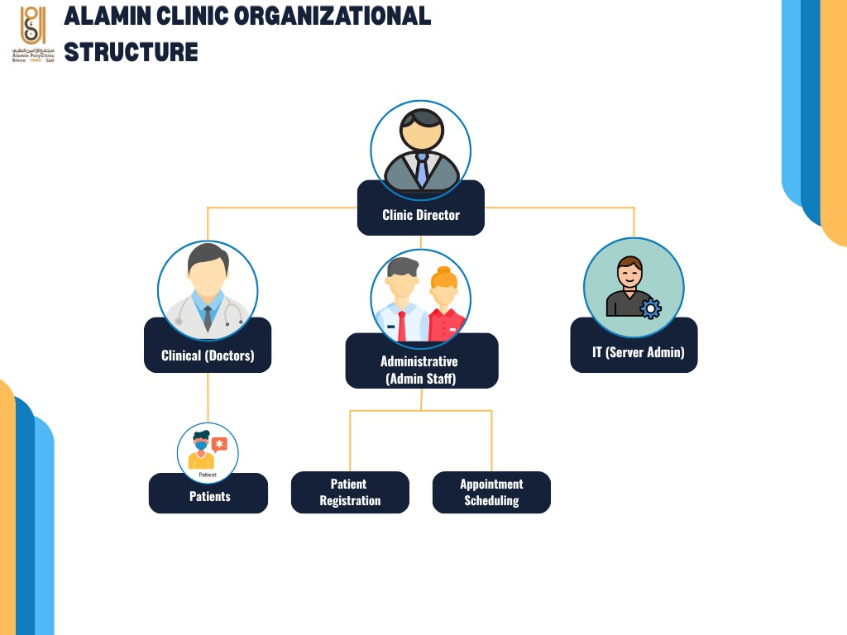
Figure 2.1 Alamin Clinic Organisational Structure

It is important to ensure separation of duties as this will keep confidential the patients’ data and will be made possible through the recommended IAM framework. Patient that are registered in Alamin Clinic can login into the system to read their medical records and appointments.

Manual Operation
The existing system used at Alamin Clinic for storing patient information fol-lows a traditional on-premises design model defined by the following characteristics: manual server configuration, manual deployment, local hosting, and reactive security.

Manual Server Configuration. The server hardware installed at the clinic is configured locally by IT staff of the clinic. Server configuration is done manually without maintaining infrastructure versions and automating server deployment processes. This methodology is Unreliable because it relies on manual configuration

of servers with no control over drift. It is impossible to roll back the configuration in case of failure because no automated server provisioning is used (Paidy and Chaganti, 2024).

Manual Deployment. The code deployed in the development environment is manually moved to the production server with the use of either FTP clients or storage devices, such as USB drives. This methodology slowdown the deployment time and prevents implementing automatic checks of the code for security or quality issues before deploying it to the production environment. Furthermore, the manual deployment process ensures that malware can enter the production environment bypassing any controls.

Local Hosting. The frontend of the website, the backend logic of the application, and the patient database are all hosted on the same physical servers. There is no network segmentation between these layers, which means that gaining access to any of the components is enough to access the rest. The absence of network segmentation and isolation is considered one of the key factors that contribute to ransomware infections among healthcare facilities, allowing the malicious code to move directly to the database layer (Argaw et al., 2019; Thamer and Alubady, 2021).

Reactive Security. Firewalls and antivirus solutions are updated manually by IT staff according to available information about existing threats. This practice does not provide enough protection against emerging cyberattacks because updates are carried out reactively and are therefore lagging behind the threat landscape. As a result, known vulnerabilities are patched late, exposing the facility to attacks.

In effect, it was shown by the fact that the clinic’s security was compromised after a ransomware attack, where the hackers managed to encrypt all the patients’ information, making the records inaccessible for use by the clinic. As such, it was evident that there were no protective measures to block an intruder from reaching their target data.

Interview with Clinic Stakeholders
In order to get first hand information about the problems faced by the clinic and weaknesses of the system, two major stakeholders of the clinic were interviewed in person through a video conferencing. These include one Administrative Staff member who is involved in registering patients and scheduling appointments and a Clinical Staff member who performs routine operations at the clinic. Considering the privacy concerns of the participants, there was no audio recording of the interviews; instead, notes were made while conducting the interviews. There were a total of eight open-ended questions in the interview protocol.

The full interview instrument is provided in Appendix F. Selected findings are summarized below in Table 2.1.

Table 2.1 Summary of Stakeholder Interview Findings

Question  Theme | Administrative Staff | Clinical Staff
Daily Access | Individual logins for a 3rd-party desktop app via external vendor.  Limited remote access. | Same desktop app; managed by provider. No in-house IT capability  for diagnosis.
Main Difficulties | No unique patient IDs cause dupli-cation. Slow billing. Manual Excel  tracking for appointments. | Inconsistent entry compounding du-plication. No automated monitoring  or alerting for the server.
Ransomware Discovery | All data inaccessible. Operations halted. Used paper forms as fallback. | All departments frozen simultane-  ously. Doctors could not access files; appointments cancelled.
Downtime Dura-tion | 72 hours of total blackout. Restora-tion failed due to corrupted or incom-  plete data. | 5-day recovery window. Significant backlog accumulated before opera-  tions resumed.
Data Lost | All patient records inaccessible. No clean backup existed to restore the  system. | Records in the attack period were permanently lost. Access unavail-  able during recovery.
Security Measures | Basic antivirus with manual updates. No formal backup policy or sched-  uled reviews. | No formal security policy or staff awareness of recovery procedures.

Question  Theme | Administrative Staff | Clinical Staff
Improvements | Web interface, auto-notifications, re-mote access, unique IDs, and a  public website. | Dept-specific modules, automated workflows, and faster performance  during consultations.
Migration Con-cerns | Data sovereignty and internet relia-bility in the clinic’s operating region. | Data privacy, access control clarity,  and training requirements for the new system.

These findings collectively inform the system requirements and design decisions developed in the chapters that follow. A formal written confirmation of the requirements gathered was subsequently obtained from the clinic management (see Appendix C).

Current System Workflow
The current process for managing patient information in Alamin Clinic relies entirely on manual handling without any automated means. Figure 2.2 highlights the flowchart for managing the main processes for patient information from the arrival of patients to storing their records.

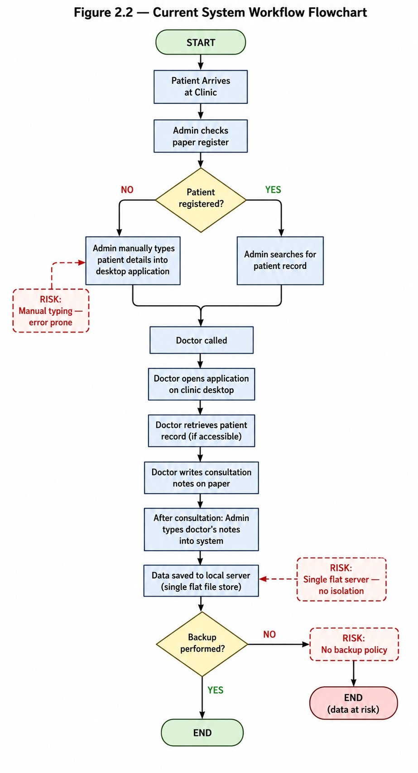
Figure 2.2 Current System Workflow Flowchart

There are five significant threats associated with the current workflow process. Firstly, all inputs into the process are made manually by administrative staff, resulting in errors and time wastage. Secondly, there is no distinction between the application that processes the information and the database that holds the data because both use the same server process and file structure. Thirdly, there is no distinction between the logins for physicians and administrative staff since both log into the same application with the security measures depending purely on trust. Fourthly, there is no automatic backup system for the process, meaning that all information storage depends entirely on the availability of the actual server. Lastly, there is no way to track who accessed or changed what in patients’ files.

Proposed System Workflow
The proposed system replaces each manual, insecure step in the current workflow with an automated, security-enforced equivalent. Figure 2.3 presents the flowchart of the proposed system’s patient record management process.

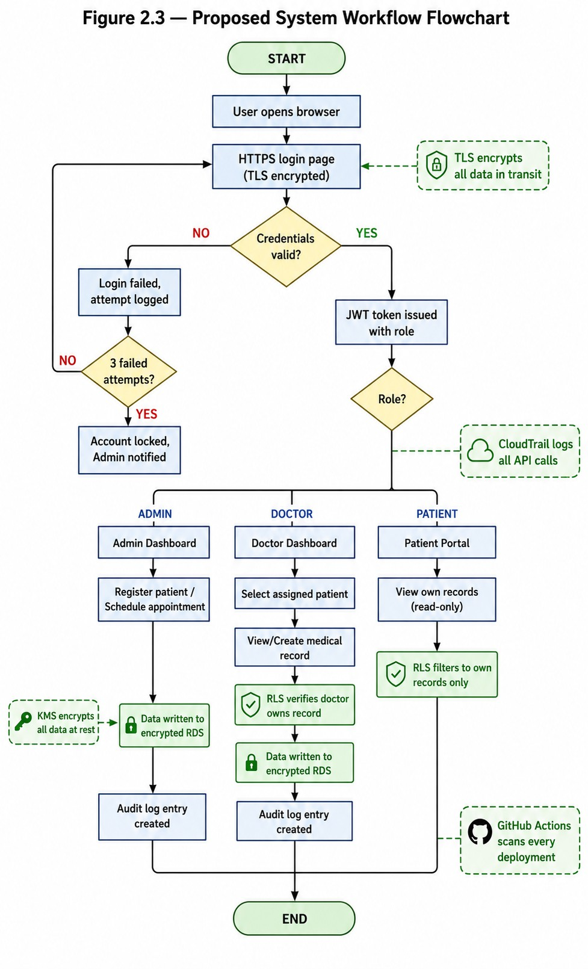
Figure 2.3 Proposed System Workflow Flowchart

The solution presented here solves all of the mentioned vulnerabilities in the system. Instead of manual data entry, there is now an input-validation web page. In addition, the single-server design is swapped for a three-tier VPC architecture in which

the database has been separated into a private subnet that does not have internet access. Instead of using role enforcement, the authentication mechanism relies on JWT and PostgreSQL row-level security to control who accesses what data. Physical hardware backup is no longer used; instead, the system will automatically create snapshots in RDS and redeploy the entire infrastructure with Terraform. Finally, audit logging has been introduced via CloudTrail and an audit table in the application.

Table 2.2 presents a side-by-side comparison of the current and proposed workflows across the five identified vulnerability dimensions.

Table 2.2 Comparison Between the Current System and the Proposed Cloud-Based System

Dimension | Current System | Proposed System
Data entry | Manual typing by admin,  error-prone | Structured web forms with  validation
Architecture | Single flat server, all tiers co-  hosted | Three-tier VPC — presenta-  tion, app, DB isolated
Authentication | Single shared login, trust-  based | JWT tokens + RBAC en-  forced at app & DB layers
Backup and recovery | No backup policy; full data loss risk | Automated RDS snapshots + Terraform redeploy in < 15  min
Audit trail | None | CloudTrail API logs + appli-  cation audit log table
Deployment | Manual FTP/USB, no secu-rity gate | GitHub Actions CI/CD with Trivy, SonarQube, &  Checkov
Encryption | None at rest; inconsistent in  transit | KMS AES-256 at rest; TLS  1.2+ in transit

Current System Analysis
This section analyses the existing patient data management system at Alamin Clinic to identify the root causes of its security vulnerabilities. The analysis is structured across two dimensions: a 5W 1H problem decomposition to establish the full scope of the problem, and a domain-specific security assessment to identify technical deficiencies across the network, access control, data protection, and operational resilience layers.

Problem Analysis Using the 5W 1H Framework
The 5W 1H framework — Who, What, When, Where, Why, and How — provides a structured approach that ensures all dimensions of the issue are addressed before a solution is designed. Table 2.3 applies this framework to the Alamin Clinic problem.

Table 2.3 5W1H Analysis of the Current System Vulnerabilities

Dimension | Analysis
Who is affected? | Doctors cannot access patient records or create diagnoses. Administrative staff cannot manage appointments. Patients cannot receive care during outages. The clinic director faces operational and potential legal liability for data loss.
What is the problem? | A ransomware attack encrypted the patient database. No recovery capability or backups existed. The systemic problem is an infrastructure designed without security controls at any layer.
When does it exist? | At all times. The server is exposed to the internet with no isolation. Patches are reactive, and every manual deployment is a security risk.
Where does it originate? | In the flat network architecture of the on-premise server, providing no barrier to lateral movement. In the absence of network segmentation between web, application, and database layers.
Why does it persist? | Small healthcare providers lack the budget for enterprise security platforms and under-resourced IT staffing. This is the market gap the proposed system addresses.
Continued on next page

Table 2.3 – Continued from previous page

Dimension | Analysis
How will it be solved? | Through a security-by-design cloud architecture:  - Three-tier VPC isolation.  - Terraform IaC for configuration consistency.  - DevSecOps pipeline (Trivy, SonarQube, & Checkov).  - IAM/RBAC with PostgreSQL row-level security.  - KMS encryption & TLS in transit.  - AWS Security Hub for HIPAA compliance posture.

Security Domain Analysis
The assessment of the existing infrastructure of the Alamin Clinic, before Starting on the migration process, shows that there are weaknesses in the four areas of security:

Network Architecture. In the case of the clinic, the network architecture is highly simplified in that all three tiers of applications—the web, application, and database are hosted in one machine with one network interface, No DMZ for internet connected parts of the network, and no way to prevent lateral movements once the system is breached. This completely violates the concept of defense in depth because it does not offer more than one line of defense (Al-Issa et al., 2019).

Access Control. The user access to the system is determined based on the authentication carried out only at the application level without having any kind of identity management. There are role separations between doctors, administration, and patients that are implemented in the application level but do not have any restrictions at the networking or storage level.

Data Security. The patient data stored in the database of the clinic is not encrypted in its static form. The transmission of the data from the browser of the user to the server is not reliably encrypted using TLS due to the lack of analysis of the HTTP settings used by the clinic. Both the static and the dynamic data are exposed to the threat of being intercepted and stolen(Shojaei et al., 2024).

Operational Resilience. There is no official data backup policy at the clinic, nor is there any officially documented way to recover from such situations. This scenario has been noted in many studies involving ransomware attacks on other small health care providers.Argaw et al. (2019) noted that the lack of backup and recovery policy contributed to prolonged disruption during such incidents.

In combination, all of the flaws above shows that the existing model does not meet even the basic criteria of security for a healthcare information system.

Comparison between existing systems
To frame the proposed model among other solutions for managing healthcare, a comparative Table 2.4 is presented below that shows how the proposed solution fits alongside three other systems, namely, a conventional HMS system, the OpenEMR system, the Epic Systems solution, and the proposed Secure Cloud PDMS.

Table 2.4 Comparison of Existing Healthcare Management Systems

System | Key Features | Security Model | Main  Limitations
Traditional On-Premise | Full data control, no internet  dependency. | Reactive, manual patches, perimeter  firewall. | High ransomware risk, no isolation,  poor scalability.
OpenEMR | Patient portal, billing, EHR. | Reactive, community  patches. | Manual security updates, no  auto-deployment.
Epic Systems | Comprehensive clinical suite,  HL7/FHIR. | Proactive, vendor-managed  updates, IAM. | Prohibitive cost for small clinics,  vendor lock-in.
Proposed System | Patient records, roles, cloud-native. | Proactive, shift-left, automated  scanning, RBAC. | Infrastructure focus; billing/pharmacy  out of scope.

The comparison highlights a unique weakness of the existing market towards small healthcare providers. On-premise software applications and open-source projects like OpenEMR provide high levels of flexibility but require all aspects of security management to be undertaken by the IT staff of the medical facility, as proven by the history of the Alamin Clinic.

This project will fill this niche through a combination of a low-cost model associated with the use of cloud hosting and the application of automation technologies. The inclusion of the infrastructure as code through Terraform and the automatic scanning of security issues during the CI/CD process will reduce the need for manual IT procedures, thus minimizing this primary weakness of the existing solution.

Features Adopted from Existing Systems
The comparison provided in Table 2.4 made it possible to choose the features from the existing systems that would be relevant to the goals of the suggested system, both in terms of scope and security considerations. The features borrowed from the existing systems and the modifications made are shown in Table 2.5.

Table 2.5 Features Adopted from Existing Systems

Feature | Adopted From | Justification
Patient Registration | OpenEMR | Core requirement; directly addresses  ransomware data loss.
Appointment Scheduling | OpenEMR | Operational necessity; appointment data was  highly disruptive when lost.
Patient Portal | OpenEMR | Reduces admin load; addresses patient  autonomy.
RBAC Model | Epic Systems | Enterprise-grade pattern validated by Singh &  Chatterjee (2015).
Audit Logging | Epic Systems | HIPAA requirement; key missing finding  from incident review.
HIPAA Framework | Epic Systems | Recognized benchmark for healthcare data  security.

Another difference of the system under discussion from its competitors lies in the comparative analysis of the standard AWS architecture design template. Table 2.6 compares these two types of templates.

Table 2.6 Proposed System vs Standard AWS Architecture

Feature | Standard AWS Architec-  ture | Proposed Solution
Deployment | Manual or basic scripts | Fully automated via Ter-  raform IaC
Security Model | Added after build (Reactive) | Shift-left scanned at every  CI/CD stage
Post-attack Recovery | Long manual rebuild pro-  cess | Instant redeployment from  Terraform state
Data Protection | Basic private subnets | Hardened NACLs + Private  RDS + KMS encryption
Compliance | Ad hoc manual checks | HIPAA posture measured  via AWS Security Hub

Literature Review of Technology Used
This section reviews the academic and industry literature underpinning the key technologies adopted in the proposed system. Seven technology domains are examined: cloud computing in healthcare, three-tier web architecture, the AWS shared responsibility model, Infrastructure as Code with Terraform, DevSecOps and shift-left security, Identity and Access Management with Role-Based Access Control, and HIPAA compliance frameworks. For each domain, the review establishes the academic basis for the technology choice and identifies how existing findings inform specific design decisions in the proposed system.

Cloud Computing in Healthcare
Since the early 2010s, the use of cloud computing technology within healthcare has been extensively researched. The study performed by Ahuja et al. (2012), which

can be considered one of the first comprehensive investigations of cloud computing usage in healthcare settings, concludes that cost savings, scalability, and improved data access are the most common factors contributing to widespread adoption, whereas data protection, regulatory issues, and vendor reliability stand out as the key barriers. All those findings still hold true today. In particular, the security problems mentioned by Ahuja et al. (2012), such as concerns about data sovereignty and access control, have influenced the design of the IAM policy for our solution.

In the same spirit, Al-Issa et al. (2019) investigated cloud security issues specific to eHealth environments. Their survey revealed that unauthorized access, data corruption, and service availability issues are the leading threats affecting eHealth clouds. Accordingly, each threat mentioned in their study is addressed by the corresponding design requirement in our case: unauthorized access is controlled via IAM/RBAC; integrity violations are prevented using CloudTrail audit logging and KMS encryption; and availability is guaranteed with a multi-AZ architecture and fast recovery provided by Terraform.

The stakeholder concerns regarding cloud data privacy raised by the clinic stakeholders in section 2.2.3 interviews are handled by the proposed solution with the use of (a) the AWS region chosen to be in gulf region according to PDPL data residency rules, (b) IAM least privilege principles, and (c) row-level security of PostgreSQL database which ensures that one cannot access another user’s data regardless of infrastructure level access(Ramayanam, 2025).

Three-Tier Architecture
The three-tier architectural approach involves breaking down a web application into three different layers which are physically and logically segregated from one another, namely the presentation tier (frontend), application tier, and data tier (database). There are two key advantages to using this model from a security perspective. First, the damage scope for a breach in a particular tier is significantly reduced. Second, it allows for the independent scaling and access control to be implemented at the level of each individual tier.

In this particular case, the three-tier architecture is deployed using the AWS Virtual Private Cloud (VPC). In accordance with the model, the presentation tier uses an Application Load Balancer running on a public subnet while the application tier uses EC2 instances running on the private application subnet. Finally, the database tier utilizes Amazon RDS, residing in the dedicated private database subnet. The fact that this tier cannot be accessed directly from the Internet can be seen as a built-in protection against the network flatness exploited during the attack at Alamin Clinic.

The proposed design differs from the current design in that it makes use of a three-tiered structure compared to a single-server flat approach used now (Section 2.2.4). The new design includes three tiers that will each have their own separate security group policy, as well as having the database without an outbound Internet route(Gaber et al., 2025).

AWS and the Shared Responsibility Model
The Amazon Web Services runs on a shared responsibility model where there are clearly defined boundaries about who is accountable for what part of the security. It states:

“AWS manages security of the cloud, you are responsible for security in the cloud.”

This means that AWS will take care of the physical security of data centers, the hypervisor level, and the managed services itself. While the clinic in the case is accountable for OS management, Network Security Groups rules, IAM policies, application security, and data encryption.

It is crucial in the design process for the new system since moving away from traditional hosting to the cloud doesn’t relieve the clinic of any security concerns; instead, it shifts them around. It changes the list of those tasks that have been historically difficult for Alamin Clinic to manage manually to the set that can be easily automated using Terraform, KMS, and IAM policies (Mendoza and Reyes, 2023).

Infrastructure as Code (Terraform)
IaC refers to the use of machine-readable configuration files in lieu of manual procedures to describe and provision computing infrastructure. According to Paidy and Chaganti (2024), IaC significantly decreases configuration drift, making the infrastructure failure recoverability fast and reliable in multi-region AWS deployments.

The chosen IaC tool is HashiCorp’s Terraform, which supports a declarative configuration approach that allows the representation of the whole topology of the VPC network, EC2 instance settings, RDS parameter groups, IAM policies, and security group rules in version-controlled code. In effect, the entire environment could be rebuilt from scratch in minutes that allows turning the Recovery Time Objective into a quantifiable metric.

The discovery directly correlates with the most important insight gained during the stakeholder interview when the IT Administrator was asked about how long it takes to recover from the ransomware attack, and the answer was a period of five days. The recommended RTO target of the system should be less than fifteen minutes, which is possible only due to the configuration being scripted in Terraform and deployable to a clean AWS environment with one command.

Checkov is a static code analyzer tool for IaC that is included in the CI/CD pipeline to scan Terraform scripts before the infrastructure is put to production to avoid common infrastructures security pitfalls, such as excessive permissions on security groups or unprotected storage volumes(Verdet et al., 2023; Espinha Gasiba et al., 2021).

DevSecOps and Shift-Left Security
DevSecOps refers to the process of incorporating security testing and verification during the software development and deployment process, as opposed to mandating security as a gate for the software development and deployment process after development(Valde´s-Rodr´ıguez et al., 2023). “Shift-left” involves moving security tests from their current position closer to the development stage, where issues

are detected and fixed at the least cost, even before they become part of the production code base (Paidy and Chaganti, 2024).

In the current deployment process, there is no security gate at any stage. This process involves pushing the code to the production server using FTP. In the new system, there is a CI/CD pipeline in GitHub Actions that carries out security scans in three types on each commit:

      - Trivy: Scans Docker container images for known Common Vulnerabilities and Exposures (CVEs) before any image is pushed to the container registry.
      - SonarQube: Performs Static Application Security Testing (SAST) by analyzing the application source code for security anti-patterns, injection vulnerabilities, and code quality issues.
      - Checkov: Analyzes Terraform configuration files for infrastructure-level security misconfigurations, ensuring that the defined AWS resources adhere to best practices

Any pipeline breach during a critical discovery ensures that the software will not be released, guaranteeing that no software containing a critical flaw is ever deployed into the production environment. The move from no security gate to an automated blocking gate in three stages will solve the reactive security stance described in Section 2.2.2 (Rajapakse et al., 2022; Akbar et al., 2022).

Identity and Access Management and Role-Based Access Control
IAM refers to the policies, procedures, and technologies that control the access to certain resources by a particular user within the system. IAM on AWS provides granular and rule-based control over access to infrastructure components, thereby complementing the application-based RBAC mechanism.

Singh and Chatterjee (2015) proved that for effective security management in the cloud computing environment, there is a need for security enforcement across various tiers, ranging from the application login page to network and resource

levels. This paper’s proposed framework follows this approach, as it combines AWS IAM policies, which restrict the API calls available to each application module, with application-level RBAC, which restricts the data that each authorized user can read/write, and PostgreSQL Row Level Security, which enforces isolation of data at the storage level, irrespective of the application level.

Three IAM roles will be created for the intended system according to the clinic’s three user groups which is Doctor, Admin, and Patient. Specifically, the Doctor role will have read/write access to their patients’ information, the Admin role will be allowed to read/write information concerning scheduling and registrations, and the Patient role will only have read access to their own information. Each IAM role will have minimum privileges sufficient for their intended purpose(Butt et al., 2023).

PostgreSQL row-level security as an additional control measure will address the issue raised in Section 2.3 regarding inadequate controls on the access aspect of the current system design since the application-based role access controls offer zero security against direct access to the underlying database, which is what ransomware attackers exploit(Cobrado et al., 2024).

HIPAA Compliance
The Health Insurance Portability and Accountability Act (HIPAA) is the main regulatory framework used in securing and protecting patient health information within the United States and is considered a gold-standard benchmark for healthcare data security across the world. HIPAA Security Rule outlines the technical requirements of access control, audit logging, integrity of data, and encryption during data transmission, all of which relate directly to the IAM, CloudTrail, KMS, and TLS of the proposed system (Abbasi and Smith, 2024).

AWS Security Hub is an AWS-managed service designed to provide continuous posture assessment of the AWS environment in relation to HIPAA compliance and provides detailed assessments where there are discrepancies between the configuration and the standards. The suggested architecture uses AWS Security Hub to measure and assess HIPAA posture compliance.

The current framework does not meet the criteria for any of the technical safeguards prescribed by HIPAA, which includes failure to provide proper access control at the infrastructure level, failure to maintain an audit log of data access activities, absence of data integrity through encryption, and lack of reliable transmission security measures. The recommended framework caters to all four areas, thus positioning HIPAA readiness as the benchmark for the assessment process.

Chapter Summary
This chapter provides the theoretical basis and comparison of the proposed secure cloud-based system for managing patient data. Four major vulnerabilities of the current legacy on-premises solution were identified based on structured interviews conducted as part of the Alamin Clinic case study: the flat structure of the network, poor access control, lack of data encryption, and weak infrastructure resilience. All those factors combined helped the ransomware breach and led to five days of downtime and considerable data loss. The 5W1H technique was applied to categorize all the aforementioned problems along six axes.

To address these problems, workflow analysis outlines the transformation from the current manual solution to a new, secure architecture. Main improvements include moving from a flat network to three-tier VPC, switching from FTP deployments to the DevSecOps CI/CD pipeline, implementation of zero trust access control using JWT and Row-Level Security (RLS) in PostgreSQL, reduction of infrastructure recovery time to 15 minutes using Terraform, and implementing continuous audit with AWS CloudTrail. The thorough literature review proves these solutions according to academic and industry standards and ensures HIPPA-compliant technology stack using AWS Security Hub. Finally, the chapter explains the methodology used to develop the project.

CHAPTER 3

SYSTEM DEVELOPMENT METHODOLOGY

Introduction
This chapter details the design and development procedure of the proposed PDMS using cloud computing and DevSecOps approach and Justifies the methodology against the project requirements. The design and deployment of a secure cloud infrastructure shows a distinct set of procedural challenges: the system must be developed in iterations to allow the security requirements to be validated on each stage, the pipeline should integrate security tools that execute after every code change, and the infrastructure will follow an incremental build, test, and hardening without requiring a complete rebuild between phases.

Section 3.2 presents the chosen methodology, An Agile development integrated with DevSecOps practices and justifies this choice. Section 3.3 describes the phases of the methodology as applied to the proposed project with each phase and its deliverables. Section 3.4 provides a technical walkthrough of each tool and technology used in the system. Section 3.5 presents the complete system requirement analysis, covering both functional and non-functional requirements. Section 3.6 summarises the chapter.

Methodology Choice and Justification
This section presents the development methodology selected for this project and provides a structured justification for that choice. Agile with DevSecOps integration was selected as the development methodology, based on its alignment with the specific requirements of a cloud security system development project.

Overview of Candidate Methodology
Agile with DevSecOps integration expands on Scrum by introducing security testing, scanning for vulnerabilities, and compliance into the sprint cycle and CI/CD

pipeline. In other words, instead of performing security tests at some phase following the implementation, they are integrated directly into the process itself such that the product increments have inherent security properties. DevSecOps integration into the Agile cycle is referred to as a natural extension of Agile to the sphere of security, where, just as Agile blurred the lines between the phases of requirements gathering and implementation, DevSecOps does the same to development and security. This principle has been formulated early on in DevSecOps research (Bass et al., 2015), confirmed by more recent research on resilient cloud deployments Paidy and Chaganti (2024).

Justification for Agile with DevSecOps
The Agile with DevSecOps methodology is selected for this project on the basis of four aligned criteria.

Iterative security validation. The system’s security architecture, VPC network topology, IAM policy structure, encryption configuration, and CI/CD pipeline should be tested at every step of building process. It is not sufficient to test it once. Due to the agile nature of sprints, every piece of infrastructure can be constructed, analyzed, and verified before another piece is relying on its work.

Shift-left security integration. The early execution of security tests in DevSecOps by ensuring that security is integrated as early as possible in the software development process.hence identifying vulnerabilities during commit and not deployment when it becomes expensive to fix.

Infrastructure as Code compatibility. Since infrastructure is declared in Terraform, it fits into Agile development methodology very well. This means that at each sprint, developers will have a version-controlled configuration for their environment. It would be possible to rebuild the entire environment starting with any version of the code and even roll it back to an earlier version if necessary.

Measurable compliance. The HIPAA compliance goal demands that security postures are constantly measured rather than being evaluated only once at the end of the development process.

Table 3.1 summarises the comparison of the three candidate methodologies against the project’s key requirements.

Table 3.1 Methodology Comparison

Criteria | Waterfall | Scrum (Agile) | Agile + DevSecOps
Iterative development | → | ↭ | ↭
Security integrated at each  stage | → | → | ↭
Supports IaC incremental  build | Partial | ↭ | ↭
Automated pipeline compati-  bility | → | Partial | ↭
Continuous compliance mea-  surement | → | → | ↭
Suited for changing security  requirements | → | ↭ | ↭

Figure 3.1 illustrates the sprint cycle of the selected Agile with DevSecOps methodology, showing the integration of automated security gates at each phase of the iterative development process.

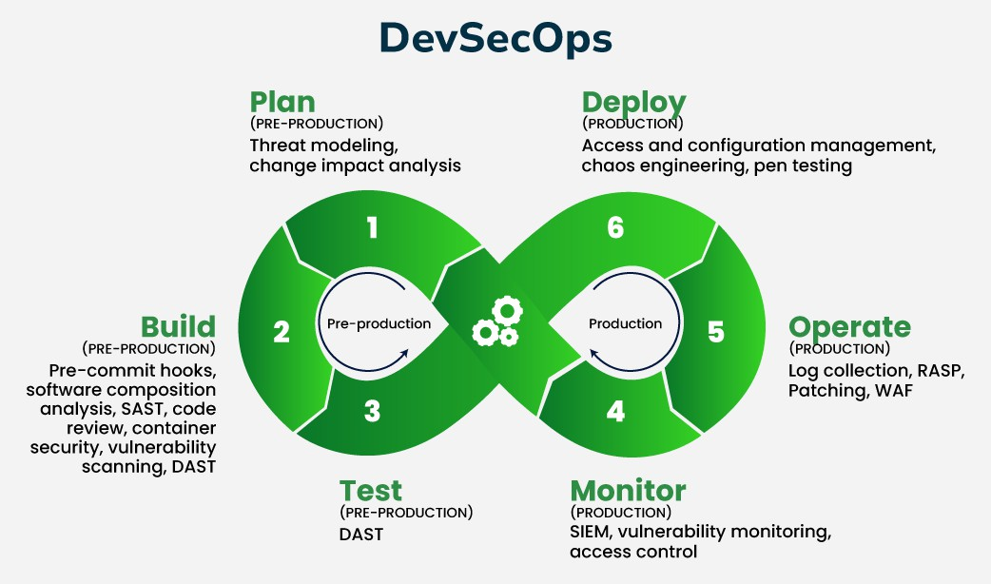
Figure 3.1 Agile + DevSecOps Sprint Cycle with Integrated Security Gates

Phases of the Chosen Methodology
The project is organized into five sprints. Each sprint has a defined scope, a set of deliverables, and a security gate that must pass before the sprint is considered complete. The full project schedule spanning all five sprints is presented in Appendix A, Figure A.2.

Sprint 1: Requirements and Architecture Design
Scope: Determine and document both functional and non-functional requirements of the system.System Architecture Design should be produced along with VPC network architecture, IAM policies and DevSecOps pipeline design.

Deliverables: Document of system requirements (Chapter 3.5), VPC network architecture, IAM policies and CI/CD pipeline.

Security gate: Perform architectural review for the technical safeguard requirements under the HIPAA Security Rule. All control gaps shall be identified and fixed in the design phase before moving to Sprint 2.

Sprint 2: Network Infrastructure and Database Layer
Scope: Provision the AWS VPC using Terraform, including the public subnet (Application Load Balancer), private application subnet (EC2), and isolated database subnet (RDS). Configure Security Groups, Network ACLs, NAT Gateway, and Internet Gateway. Deploy and configure the Amazon RDS database instance with KMS encryption at rest.

Deliverables: Terraform configuration files for VPC, subnets, routing tables, security groups, and RDS instance. Checkov scan report for all IaC configurations.

Security gate: Checkov scan must report zero critical misconfigurations. RDS instance must be confirmed as unreachable from the public internet. Encryption at rest must be verified in the AWS Console.

Sprint 3: Application Layer and Authentication
Scope: Deploy the Docker-containerised application that consist of React frontend and Node.js/Express backend to EC2 instances in the private application subnet. Implement the RBAC authentication system with three roles (Doctor, Admin, Patient). Configure the Application Load Balancer with HTTPS termination and TLS certificate.

Deliverables: Dockerfiles for frontend and backend, application deployment Terraform modules, IAM role definitions, Trivy scan report for container images.

Security gate:Trivy scan must report zero critical CVEs in deployed container images. TLS termination must be verified at the ALB. Application-level RBAC must be confirmed to enforce role boundaries through test cases covering each user role.

Sprint 4: DevSecOps Pipeline and Monitoring
Scope: Design and set up the CI/CD pipeline on GitHub Actions, using Trivy, SonarQube, and Checkov as automated steps within the pipeline. Set up the Amazon CloudWatch log groups and alarm metrics. Set up the AWS CloudTrail audit logs for all the API calls and access events.

Deliverables: GitHub Actions pipeline YAML files, SonarQube settings, CloudWatch dashboard settings, CloudTrail settings.

Security gate: The pipeline should show that any commit that is injected with a critical vulnerability (test CVE injection) gets blocked from proceeding beyond the build phase and does not reach the deployment stage. CloudTrail should have been shown to track access to patient data.

Sprint 5: Security Evaluation and Compliance Testing
Scope: Implement the entire security assessment framework, which includes automated vulnerability assessments from Trivy, SonarQube, and Checkov; black box and white box pen testing of the application; Recovery Time Objective (RTO) test of a simulated ransomware wipe and redeploy attack; and an AWS Security Hub HIPAA posture assessment.

Deliverables: Security assessment report; pen testing report; RTO test report that captures the time taken to recover; and AWS Security Hub HIPAA posture assessment report.

Security gate: RTO test is done and documented. The HIPAA posture score obtained from AWS Security Hub should be documented as the key measure for compliance. The critical findings from Security Hub should be remediated before sprint completion.

Technology Used Description
This section. highlight each tool and service used in the proposed system

Cloud Infrastructure: Amazon Web Services (AWS)
Amazon Web Services is the cloud provider for the proposed system. below are AWS services thats used:

Amazon Virtual Private Cloud (VPC) it enable creating an Isolated of logical network in the AWS cloud environment is made possible by this strategy. The proposed

design suggests the creation of one VPC that includes three subnets, namely the public subnet, the application subnet, and the database subnet. The subnets should span across several Availability Zones. VPCs are the main tool to create network isolation in Alamin Clinic.

Amazon EC2 (Elastic Compute Cloud) it servers as the backend server which the application will run on. EC2 instances are deployed within the private application subnet, accessible only through the Application Load Balancer, and are not directly reachable from the internet.

Amazon RDS (Relational Database Service) the managed relational database is provided by RDS. The service is installed in the private subnet without internet access. Data at rest encryption is done by KMS, and backups have been set up for point-in-time recovery. The system utilizes Amazon RDS for PostgreSQL which is running in the private subnet with KMS at rest encryption.

Application Load Balancer (ALB) distributes incoming HTTPS traffic across EC2 instances. The ALB terminates TLS, ensuring that all traffic entering the application layer is encrypted in transit. It is the only entry point to the application from the public internet.

AWS Key Management Service (KMS) provides managed cryptographic keys for encrypting the RDS database and any sensitive data stored in Amazon S3. AES-256 encryption is applied at rest.

Amazon CloudWatch Monitors and alerts on the infrastructure being deployed. The log group captures application logs and system metrics; alarms are set up for alerting on any irregular behavior in patterns like multiple failed logins or API calls.

AWS CloudTrail records every AWS API call within the account. This satisfies the HIPAA requirement for audit logging and provides logs capability to help in a security incident.

AWS Security Hub Aggregates security data from various services in AWS and measures the overall security stance against the HIPAA Security Rule. Security Hub is the main compliance metric tool used in this project.

Infrastructure as Code: Terraform
Terraform, an IaC software created by HashiCorp, is used as the Infrastructure as Code software to create and manage all AWS services in this project. Terraform uses HCL, a declarative configuration language, where the final configuration of the infrastructure to be created is declared and then the order in which API requests are to be made is decided.

Containerisation: Docker
Containerization using docker is utilized for packaging the application frontend and backend components as Docker images. Containerization ensures consistency in the application runtime environment during the development, testing, and production phases, which helps avoid any configuration mismatch across these different phases. The Docker images are created through the CI/CD pipeline and then scanned using Trivy before pushing to the container registry.

CI/CD Pipeline: GitHub Actions
GitHub Actions acts as the CI/CD platform utilized for automating the build, scanning, and deployment process pipeline. Workflow set up via YAML gets triggered on each commit pushed into the main branch of the repository. Following this, the pipeline goes through the below-stated processes in order:

- Code checkout and dependency installation
- SonarQube SAST scan of application source code
- Trivy container image vulnerability scan
- Checkov IaC misconfiguration scan of Terraform files
- Terraform plan and apply (deployment) only if all scan stages pass

A failure at any scan stage with a critical or high-severity finding terminates the pipeline and blocks deployment.

Security Scanning Tools
Trivy (Aqua Security) is an open source software vulnerability scanner that supports container images, file system, and Git repository scanning. Trivy scans Docker images against the National Vulnerability Database (NVD) in order to identify known CVEs in the base image and its dependencies.

SonarQube is an example of Static Application Security Testing (SAST). This testing tool performs static code analysis to find security flaws in the code, code quality problems, as well as injection vulnerabilities.

Checkov is an infrastructure as code static analysis tool that evaluates Terraform configurations against security and compliance policy knowledge bases. In this particular implementation, the following policies among others are enforced using Checkov: Encryption should be turned on for all RDS instances; S3 buckets should not be accessible to the public; No Security Groups should allow unrestricted inbound SSH; and CloudTrail should be enabled.

Application Stack
The React framework powers the JavaScript components that make up the web frontend of the system, including the patient portal, the appointment scheduling UI, and the administrative dashboards. The React app is served as a static package using the Application Load Balancer. Figure 3.2 shows the complete application stack.

Node.js with Express makes up the JavaScript runtime and web framework used in the backend of the application. This gives us the RESTful API layer that handles authentication, role authorization, and data access.

PostgreSQL This is the relational database management system running on Amazon RDS. The PostgreSQL database system was selected because of its excellent

capabilities in enforcing row-level security policies that enhance the role-based access control system through database-level restrictions per each user role.

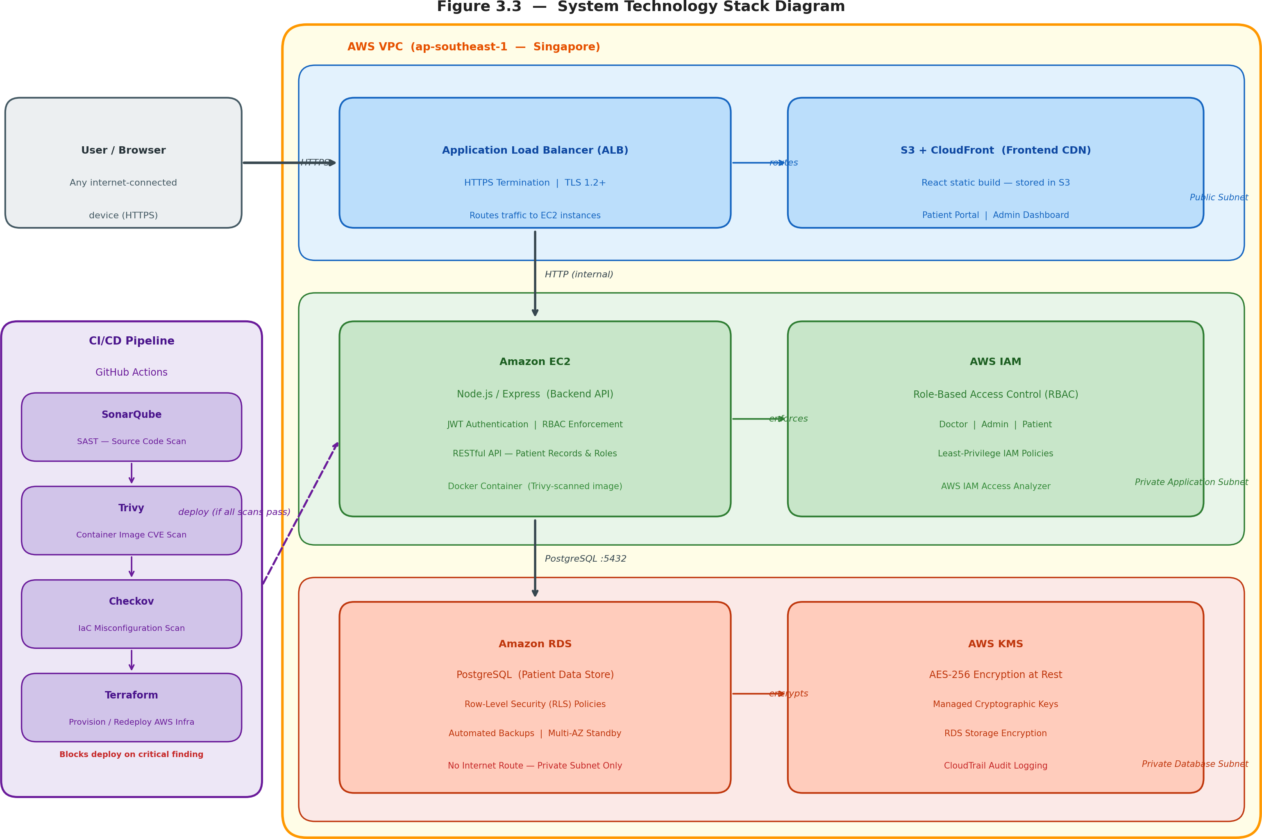

Figure 3.2 System Technology Stack Diagram

System Requirement Analysis
System requirements have been divided into two groups: functional requirements which define what the system will do, and non-functional requirements which set the constraints for quality within which the system should work. These two groups of requirements have been taken straight from the problems found in the case study of Alamin Clinic (Chapter 2) and HIPAA Security Rule technical safeguards requirements.

Functional Requirements
Functional requirements define the operations and behaviors that need to be supported by the system. The system consists of twelve functional requirements categorized into five areas such as user login and management (FR-07, FR-08, FR-10), patient registration and management (FR-01), medical record management (FR-02, FR-03, FR-06), scheduling of appointments (FR-04, FR-05), and security controls (FR-09, FR-11, FR-12). Table D.1 in Appendix D that provides all functional requirements.

Non-Functional Requirements
Non-functional requirements define the performance, security, reliability, and compliance constraints the system must satisfy. The system has eleven non-functional requirements across five categories: security (NFR-01 through NFR-04: KMS encryption, TLS, least-privilege IAM, pipeline blocking), availability and recovery (NFR-05: 99.9% uptime; NFR-06: RTO 15 minutes), compliance and auditability (NFR-07: HIPAA Security Hub posture; NFR-08: CloudTrail 90-day retention), performance (NFR-09: API response 3 s under 50 concurrent users), scalability (NFR-10: EC2 Auto Scaling), and maintainability (NFR-11: all infrastructure in Terraform). The complete requirements table is provided in Appendix D, Table D.2.

Chapter Summary
This chapter defined the Agile with DevSecOps methodology adopted for the project and justified its selection over Waterfall and standard Scrum approaches on the basis of four criteria: iterative security validation, shift-left pipeline integration, Infrastructure as Code compatibility, and measurable compliance tracking.

The project is structured into five sprints. Sprint 1 covers requirements and architecture design. Sprints 2 through 5 cover network infrastructure, application layer, pipeline integration, and security evaluation respectively. Each sprint is bounded by a security gate that must be cleared before the next sprint proceeds.

The technology stack was described across six categories: AWS cloud services (VPC, EC2, RDS, ALB, KMS, CloudWatch, CloudTrail, Security Hub), Terraform IaC, Docker containerisation, GitHub Actions CI/CD, security scanning tools (Trivy, SonarQube, Checkov), and the application stack (React, Node.js/Express, PostgreSQL). Each technology selection was grounded in the security and operational requirements established in the literature review.

The system requirement analysis produced twelve functional requirements and eleven non-functional requirements, each with a defined verification method. The non-functional requirements establish the measurable security, availability, recovery, and compliance targets against which the system will be evaluated in Chapter 5. Chapter 4 proceeds to translate these requirements into the complete system design.

CHAPTER 4

REQUIREMENT ANALYSIS AND DESIGN

Introduction
This chapter describes the system design that has been developed based on the requirements from Chapter 3. It starts with the use case analysis that defines how users of each role will behave in the system. The next step involves describing the architecture design for the system, which includes such aspects as the network topology within AWS, security control setting, IAM policy design, and DevSecOps pipeline design. Next comes the database schema design that includes PostgreSQL table design and row-level security policies that ensure proper data isolation at the storage level.

The requirement analysis is described by user stories and use cases in Section
4.2. The design of the whole project involving system architecture is provided in Section 4.3. Database design and its schema will be provided in Section 4.4. Interface design for all users is given in Section 4.5. Finally, Section 4.6 provides a summary of the chapter.

Requirement Analysis
This section documents the functional requirements of the proposed system as derived from the stakeholder discussions conducted at Alamin Clinic, described in Section 2.2.3. The requirements are presented through three complementary representations: a use case diagram that maps the relationships between each actor and the operations they are authorised to perform, a set of user stories that express requirements from each actor’s perspective in Agile format, and detailed use case specifications that define the precise interaction behaviour expected at each system entry point.

Use Case Overview
The system supports three types of users including: Doctor, Admin, and Patient, each with their own set of allowable operations. Figure 4.1 illustrates the use case diagram that includes all actors along with their allowable operations in the system.

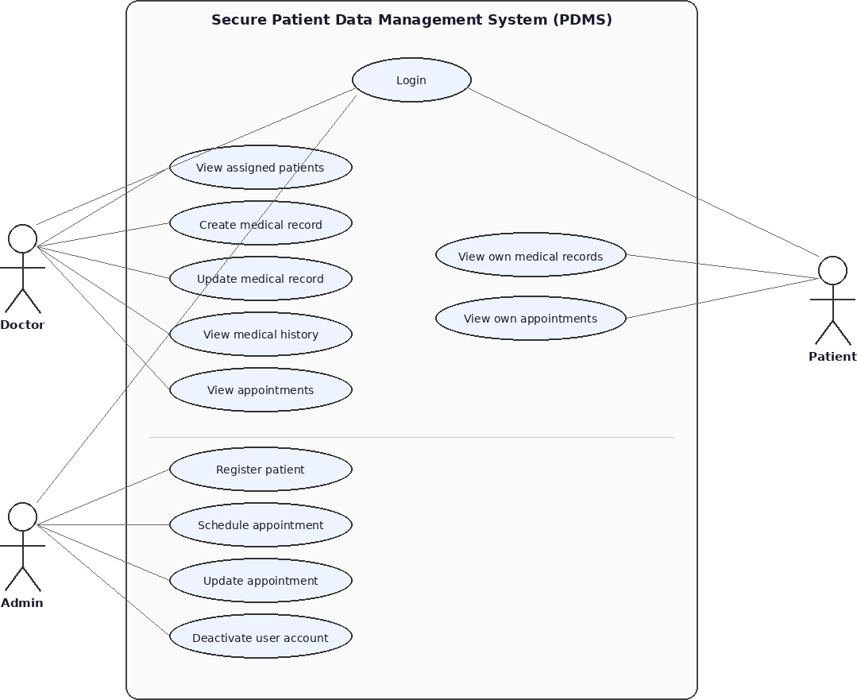

Figure 4.1 UML Use Case Diagram: Secure Patient Data Management System

User Stories
User stories capture the system’s functional requirements from the perspective of each actor, following the Agile format: ”As a [role], I want to [action], so that [benefit].” Table B.1 presents all eighteen user stories, organized by module. These stories were derived directly from the stakeholder interviews conducted in Section
2.2.3 and informed the use case design in Section 4.2.3.

Table 4.1 presents a representative sample of the user stories derived from the stakeholder requirements, organized by functional module. Each story follows the Agile format: “As a [role], I want to [action], so that [benefit].”

Table 4.1 User Stories by Module

ID | Role | User Story | Module
US-05 | Admin | As an Admin, I want to deactivate user accounts, so that former staff or inactive patients can no longer access the system. | Auth
US-06 | Admin | As an Admin, I want to register new patients and assign them a treating doctor, so that their records can be managed securely from the point of registration. | Patient Mgmt
US-10 | Doctor | As a Doctor, I want to create medical records for my assigned patients, so that I can document diagnoses and prescriptions in a secure, auditable system. | Medical Records
US-11 | Doctor / Patient | As a Doctor, I want to view records of my assigned patients; as a Patient, I want to view my own records in read-only mode to ensure data is accessible. | Medical Records
US-14 | Admin | As an Admin, I want to schedule appointments linking a patient to a doctor at a specific date and time, so that consultations are organised. | Appointments

The complete set of eighteen user stories covering all four modules is provided in Appendix B, Table B.1.

Use Case Descriptions
Table 4.2 lists all eighteen use cases for the proposed system, organised by functional module.

Table 4.2 System Use Case Directory

UC ID | Use Case Name | Actor | Summary Description
UC-01 | User Login | Doctor, Admin, Patient | Authenticate via credentials; issue JWT via  httpOnly cookie.
UC-02 | User Logout | Doctor, Admin, Patient | Terminate session; clear JWT cookie and write audit log.
UC-03 | Account Lockout | System, Admin | Automatic lock after 3 failed logins; emit CloudWatch alert.
UC-04 | Admin Creates User | Admin | Create user with role and link corresponding profile row.
UC-05 | Admin Deactivates User | Admin | Soft-delete user via active flag; preserve records, block login.
UC-06 | Register New Patient | Admin | Register demographics and doctor; generate temp credentials.
UC-07 | View Patient Profile | Doctor, Admin | View demographics; Doctors restricted to assigned patients.
UC-08 | Update Patient Info | Admin | Update demographic details and record changes to audit log.
UC-09 | Assign Doctor to Patient | Admin | Reassign doctor; changes visibility boundary via PostgreSQL RLS.
UC-10 | Create Medical Record | Doctor | Doctor writes clinical record for assigned patient; logs action.
UC-11 | View Medical Record | Doctor, Patient | Doctor views assigned patients; Patient views own data via RLS.
UC-12 | Update Medical Record | Doctor | Doctor modifies record they authored; RLS blocks cross-updates.
UC-13 | View Medical History | Doctor | Doctor views chronological clinical history of assigned patient.
UC-14 | Schedule Appointment | Admin | Book appointment; run conflict validation checks before confirmation.
Continued on next page

Table 4.2 – Continued from previous page

UC ID | Use Case Name | Actor | Summary Description
UC-15 | View Doctor Schedule | Doctor | Doctor views own upcoming schedule; cross-doctor requests rejected.
UC-16 | View Own Appointments | Patient | Read-only patient access to own appointments; actions disabled.
UC-17 | Update Appointment | Admin | Edit appointment; rerun conflict validation checks on new time slot.
UC-18 | Cancel Appointment | Admin | Set appointment status to ’cancelled’; retain row for auditing.

Sequence Diagrams
Sequence diagrams for the four primary use cases are presented in Appendix H (Figures H.1–H.4). Each diagram traces the complete request path from the user’s browser through the React frontend, Express API, and PostgreSQL database. Figure H.1 (UC-04 Login) illustrates the bcrypt verification and JWT issuance flow. Figure H.2 (UC-01 Create Medical Record) shows the three-layer authorisation chain: RBAC middleware, application-layer ownership check, and PostgreSQL RLS. Figure Figure H.3 (UC-02 Schedule Appointment) demonstrates the conflict detection logic. Figure H.4 (UC-03 Patient Views Records) shows the RLS read-path enforcement.

Project Design
This section presents the complete design of the proposed Secure Cloud-Based Patient Data Management System. The design is organised across five components: the overall three-tier system architecture deployed within an AWS Virtual Private Cloud, the VPC network topology and subnet configuration, the security controls applied at the network and identity layers, the six-stage DevSecOps CI/CD pipeline, and the user interface wireframes for each of the three user roles. Together, these components constitute the full technical blueprint that will guide implementation of the system.

System Architecture Overview
The designed architecture for the system uses a three-tiered web application running on the AWS Virtual Private Cloud network. The presentation layer, application

layer, and data layer of the system have been designed to be present in separate layers of subnets with their respective access policies. There is no direct connection between the presentation layer and the data layer. Figure 4.2 Shows the system architecture.

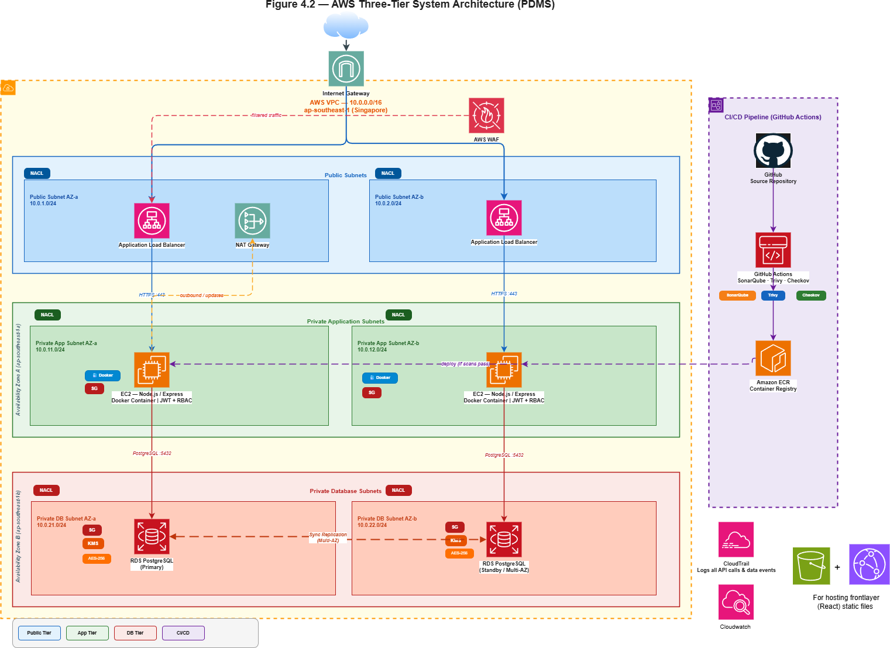
Figure 4.2 AWS Three-Tier System Architecture for the Patient Data Management System (PDMS)

VPC Network Design
The system is deployed within a single AWS VPC with the CIDR block ‘10.0.0.0/16‘. The VPC is divided into six subnets across two Availability Zones with three subnet tiers per AZ to achieve high availability and fault isolation. Table 4.3 presents the six subnets provisioned within the VPC, distributed across two Availability Zones to achieve high availability and fault isolation.

Table 4.3 VPC Subnet Configuration

Subnet | CIDR | Availability Zone | Tier | Purpose
public-subnet-a | 10.0.1.0/24 | ap-southeast-1a | Public | ALB, NAT Gateway
public-subnet-b | 10.0.2.0/24 | ap-southeast-1b | Public | ALB (multi-AZ)
app-subnet-a | 10.0.3.0/24 | ap-southeast-1a | Private | EC2 application instances
app-subnet-b | 10.0.4.0/24 | ap-southeast-1b | Private | EC2 application instances
db-subnet-a | 10.0.5.0/24 | ap-southeast-1a | Isolated | RDS primary instance
db-subnet-b | 10.0.6.0/24 | ap-southeast-1b | Isolated | RDS standby instance (Multi-AZ)

Routing configuration. The public subnets are bound to the route table which sends the traffic destined for ‘0.0.0.0/0‘ through the Internet Gateway, thus allowing internet traffic directed to the ALB and outbound internet traffic from NAT. The application subnets are bound to the route table which sends the traffic destined for ‘0.0.0.0/0‘ via the NAT Gateway, thus allowing EC2 instances to establish outbound connections (to AWS API, package repositories, etc.), but not being accessible from the internet itself. Database subnets have no connectivity to the internet at all their route table consists of only one route which is the local VPC route (‘10.0.0.0/16‘).

Security Group Configuration
Security Groups act as virtual firewalls at the instance level, enforcing allow-list rules for inbound and outbound traffic. the complete inbound and outbound rule definitions for all three Security Groups are provided in Appendix G, Table G.1.

Network Access Control List (NACL) Configuration
Network ACLs provide a stateless secondary security boundary at the subnet level, complementing Security Groups. Three NACLs are defined, one per subnet tier.The full NACL rule sets for all three subnet tiers are provided in Appendix G, Table G.2.

IAM Policy Design
The three IAM roles and their associated permission boundaries are defined in full in Appendix G, Table G.3. The governing principle across all three roles is least privilege.

DevSecOps Pipeline Design
The CI/CD pipeline is implemented in GitHub Actions and is triggered on every push to the ‘main‘ branch. The pipeline executes six stages in sequence. A failure at any stage with a critical finding terminates the pipeline and the deployment does not proceed. Figure 4.3 shows the pipeline flow diagram, furthermore, Table 4.4 details how a failure at any scan stage blocks the pipeline and prevents the deployment from proceeding.

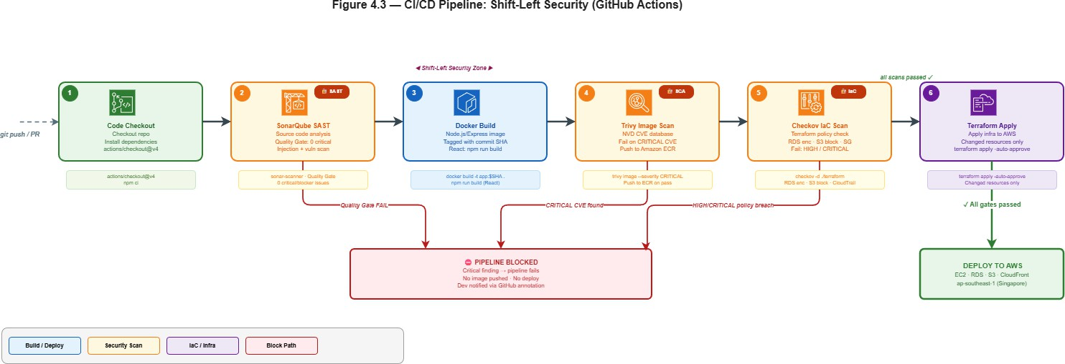
Figure 4.3 CI/CD Pipeline with Shift-Left Security Gates (GitHub Actions)

Table 4.4 DevSecOps Pipeline Stages Summary

Stage | Stage Name | Core Tool | Target Artifact | Failure / Gate  Condition
1 | Code Checkout | GitHub Actions | Source Code | Dependency res-olution or fetch  failure
2 | SonarQube SAST | SonarQube Scanner | Application Code | Quality  Gate failure (Critical/Blocker)
3 | Build | Docker / npm | Container / Static | Compilation or  image assembly failure
4 | Trivy Image Scan | Trivy | Backend Image | Any CRITICAL  severity CVE finding
5 | Checkov IaC Scan | Checkov | Terraform Files | Any HIGH or  CRITICAL  policy violation
6 | Terraform Apply | Terraform CLI | AWS Infrastruc-ture | Cloud provider API or syntax  execution error

Application Layer Class Design
Figure 4.4 presents the class diagram for the Node.js/Express application layer, showing the six data model classes and the two service classes that together form the backend of the system.

The six model classes (‘User‘, ‘Patient‘, ‘Doctor‘, ‘MedicalRecord‘, ‘Appoint-ment‘, and ‘AuditLog‘) correspond to the database schema provided in Section 4.4. They represent their respective database tables in the application with static methods for table query and manipulation. The two service classes (‘AuthController‘ and ‘RBACMiddleware‘) are implemented at the request handler level. ‘AuthController‘ is responsible for managing the processes of logging in, logging out, and validating the

JWT token. ‘RBACMiddleware‘ handles all incoming requests and ensures the caller meets RBAC requirements before reaching the handler.

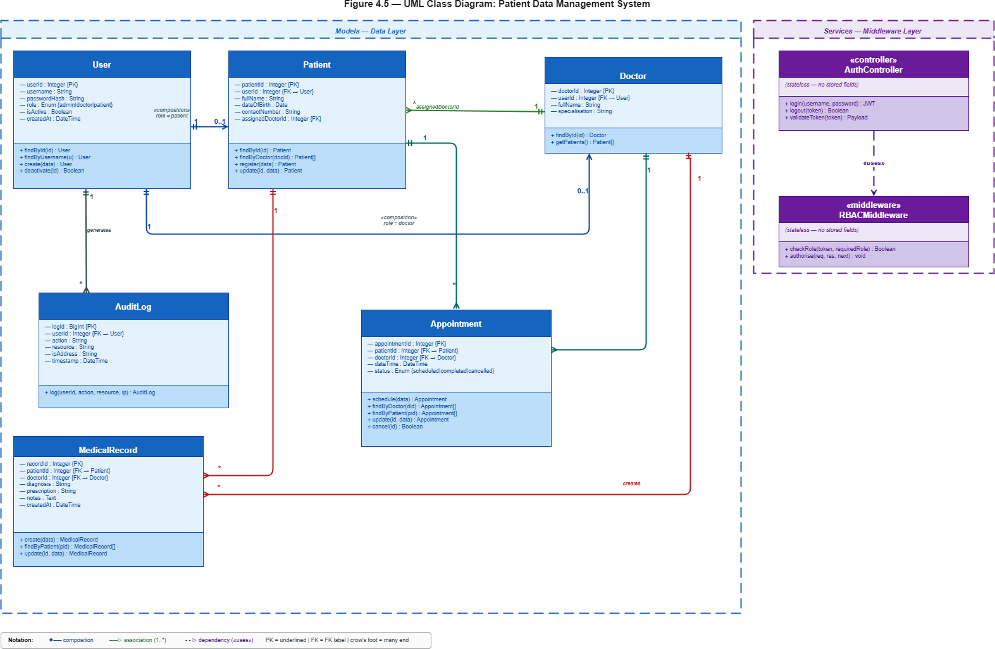
Figure 4.4 UML Class Diagram of the Patient Data Management System

Security Design
This system utilizes a layered security approach spanning five layers. Authentication uses bcrypt hashing for passwords (with cost of 12) and the generation of JSON Web Tokens as cookies which have the attributes httpOnly, Secure, and SameSite=Strict, with account lockout after three failed attempts. Two independent layers of authorization are used, which include the RBACMiddleware class at the API layer and Row-Level Security in PostgreSQL at the database layer; such that bypassing one layer does not lead to access. API hardening includes rate limiting, input validation with express-validator, parameterized queries to prevent SQL injection attacks, and security headers with Helmet.js. Isolation of network traffic is performed by using

Security Groups, Network Access Control Lists (NACLs), and VPC subnet isolation as described in Sections 4.3.3 and 4.3.4. At-rest encryption of all data is performed by AWS KMS (AES-256 with RDS), and transit encryption is performed using TLS 1.2 on the Application Load Balancer. An audit log is created by using the audit log table at the application level and AWS CloudTrail. The full security control specifications and HIPAA compliance mapping are provided in Appendix G

Database Design
This section presents the relational database schema designed for the proposed system. The design specifies the entity relationships, table structures, column definitions, and row-level security policies that enforce the access control requirements defined in Section 4.2. The schema comprises six tables — ‘users‘, ‘patients‘, ‘doctors‘, ‘medical records‘, ‘appointments‘, and ‘audit log‘ — each documented with its purpose, inter-table relationships, and the PostgreSQL row-level security policies that restrict data access to authorized users only.

Entity-Relationship Model
The database schema consists of six tables: ‘users‘, ‘patients‘, ‘doctors‘, ‘medicalrecords‘, ‘appointments‘, and ‘auditlog‘. Figure 4.5 presents the entity-relationship diagram.

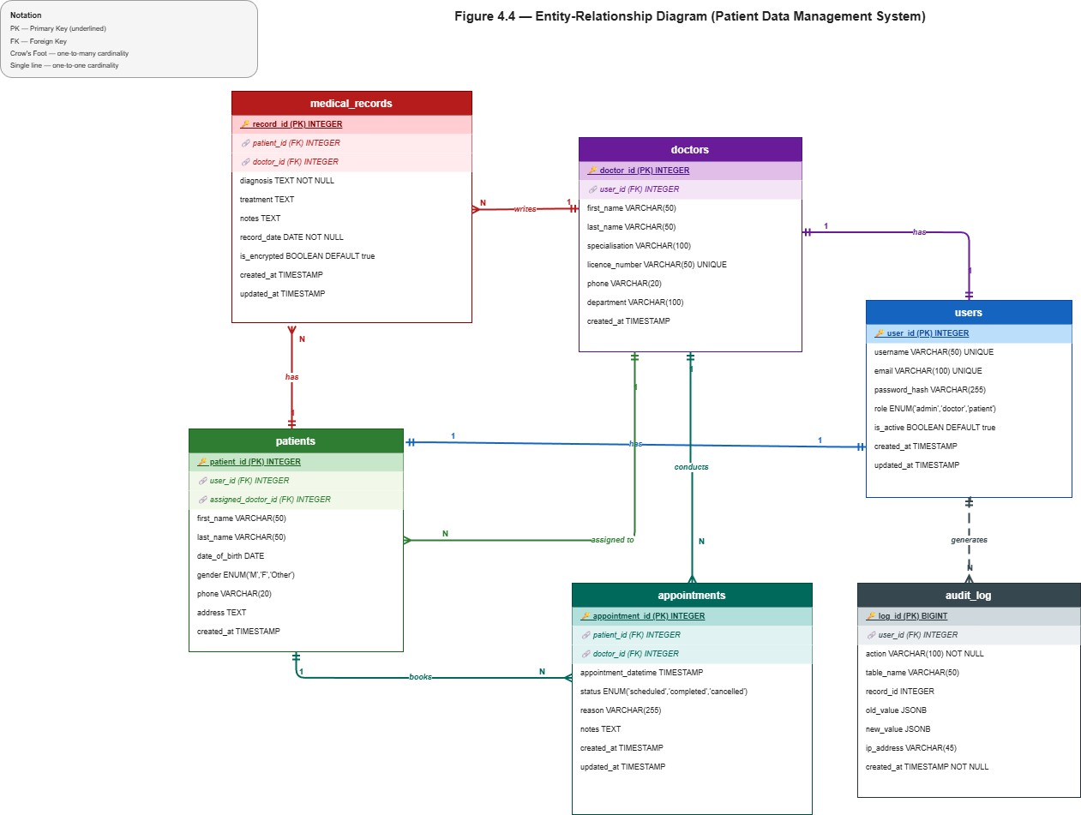
Figure 4.5 Entity-Relationship Diagram of the Patient Data Management System Database Schema

Database Schema
The database for the system consists of six tables namely users, patients, doctors, medical records, appointments, and audit log. In all the tables, all the primary keys make use of the UUID datatype to avoid enumeration attacks. Referential integrity in all the foreign key relationships is enforced by making sure that there can be no patient data without an existing user account and there is no entry in medical records for a nonexistent patient. All the timestamp fields have NOW() as their default value at the database level to prevent tampering of timestamps on the client side. The complete column-level schema for all six Tables is provided in Appendix E.

Row-Level Security Policy
Row-level security on the PostgreSQL database is enabled for the ‘medical-Records‘ table and ‘patients‘ table in order to provide data isolation within the database

system, independent of application layer permissions. The following three policies are listed:

Policy 1 Doctor access to medical records: A doctor may only select, insert, or update records where ‘doctorId‘ matches the current database session user. Records assigned to other doctors are invisible and inaccessible.

Policy 2 Patient access to own records: A patient may only select rows from ‘medicalRecords‘ and ‘patients‘ where ‘patientid‘ matches their own user identifier. No patient can query another patient’s records regardless of application behaviour.

Policy 3 Admin exclusion from medical content: Admin database sessions are granted access to the ‘patients‘ and ‘appointments‘ tables only. Row-level security on ‘medicalRecords‘ denies all access to sessions authenticated with the admin role, ensuring that administrative staff cannot view clinical record content even with direct database access.

This gives another level of protection; in case there is any vulnerability in the Node.js/Express application layer, the database will refuse to accept any queries that exceed their roles.

Interface Design
There are three unique interface views for the three types of users. These interface views have been made in such a way that there is role segregation, where all functionalities that a user needs to perform and can access are visible to him only.

Login Screen
All users access the system through a single login screen. The screen presents a username field, a password field, and a login button. On successful authentication, the system reads the role from the JWT token and redirects the user to the appropriate dashboard — Doctor Dashboard, Admin Dashboard, or Patient Portal. The wireframe layout for the login screen is shown in Figure 4.6.

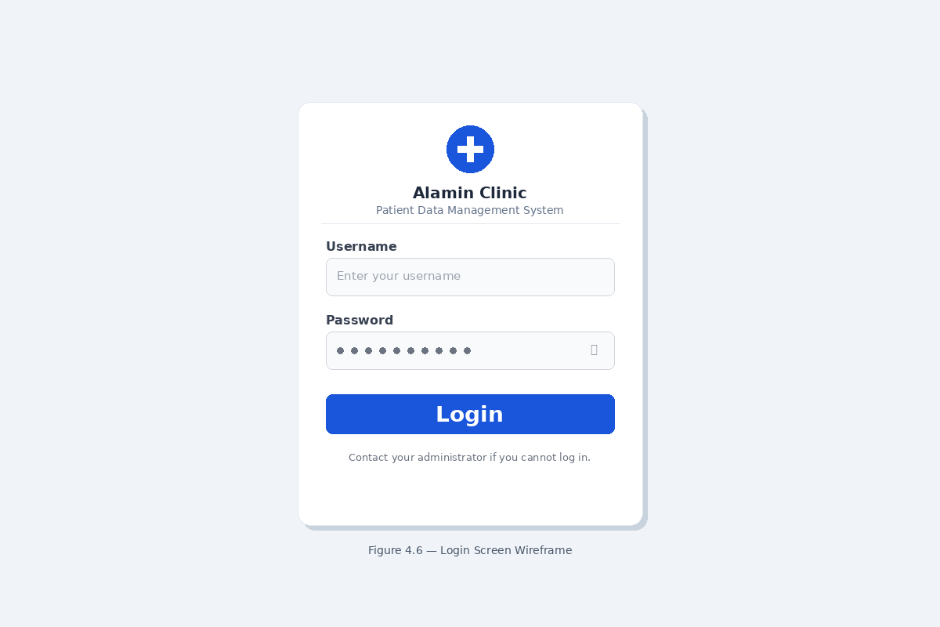
Figure 4.6 Login Screen Wireframe

Doctor Dashboard
The Doctor Dashboard presents the doctor with their assigned patient list and appointment schedule as the primary views. A navigation sidebar provides access to Patient Records and the appointment calendar. The patient list displays each patient’s name, date of last visit, and a ”View Records” action button. Selecting a patient opens the patient detail view, showing the full medical record history and a ”New Record” button. The new record form presents fields for Diagnosis, Prescription, and Clinical Notes with a Submit button. Figure 4.7 presents the wireframe layout for the Doctor Dashboard.

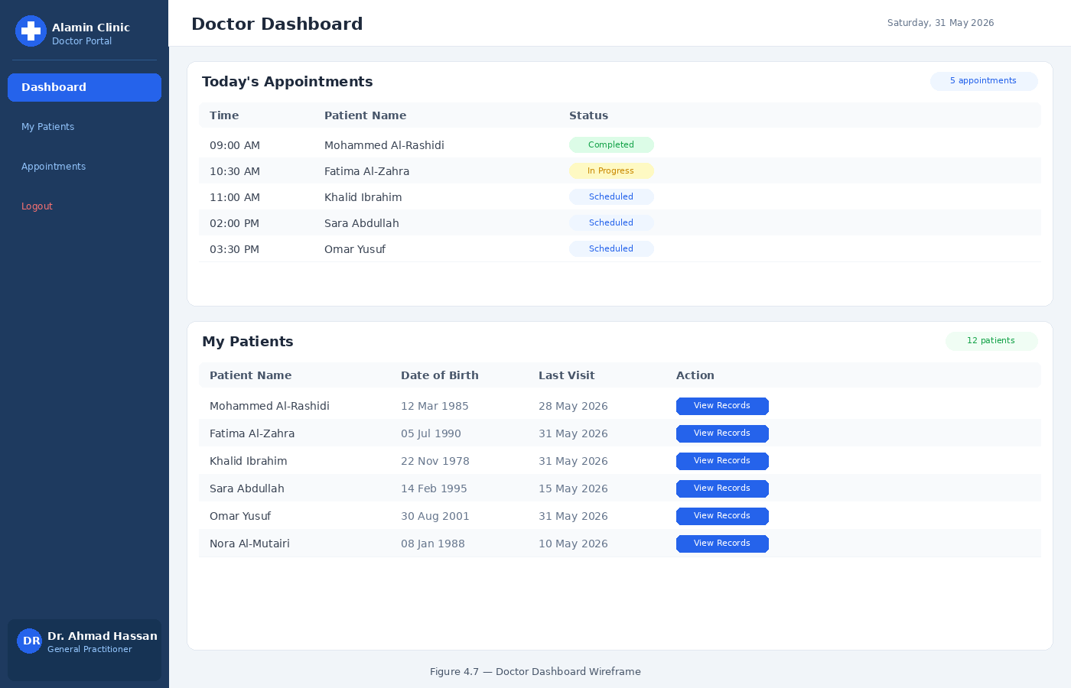
Figure 4.7 Doctor Dashboard Wireframe

Admin Dashboard
The Admin Dashboard centres on appointment management and patient registration. The navigation sidebar provides access to Patient Registration, Appointment Scheduling, and User Management. The appointment scheduling screen presents a calendar view with time slot selection. Admin selects a patient, selects a doctor, picks a date and time, and confirms the booking. The patient registration screen presents a form for new patient demographic details and doctor assignment. Figure 4.8 presents the wireframe layout for the Admin Dashboard.

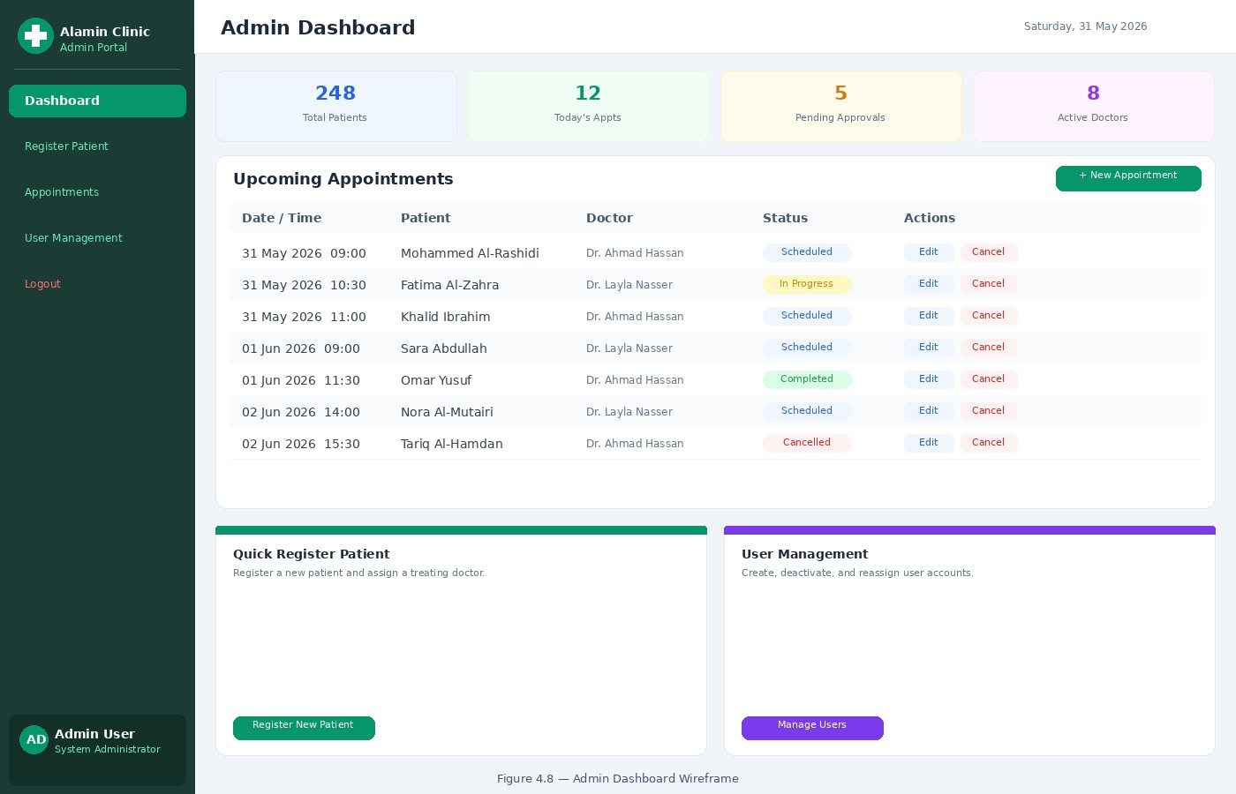
Figure 4.8 Admin Dashboard Wireframe

Patient Portal
Patient portal is a read-only portal. A patient can access his or her own medical records and appointments. There are no options to create, modify, or delete information within the patient’s area. In the records view, user can will a list of records in chronological order that show date, physician, and patient’s diagnosis. When a record is clicked on, it gives you full information including any prescribed medication or additional notes from the doctor. In the appointments view, future appointments are listed by date and time. Figure 4.9 presents the wireframe layout for the Patient Portal.

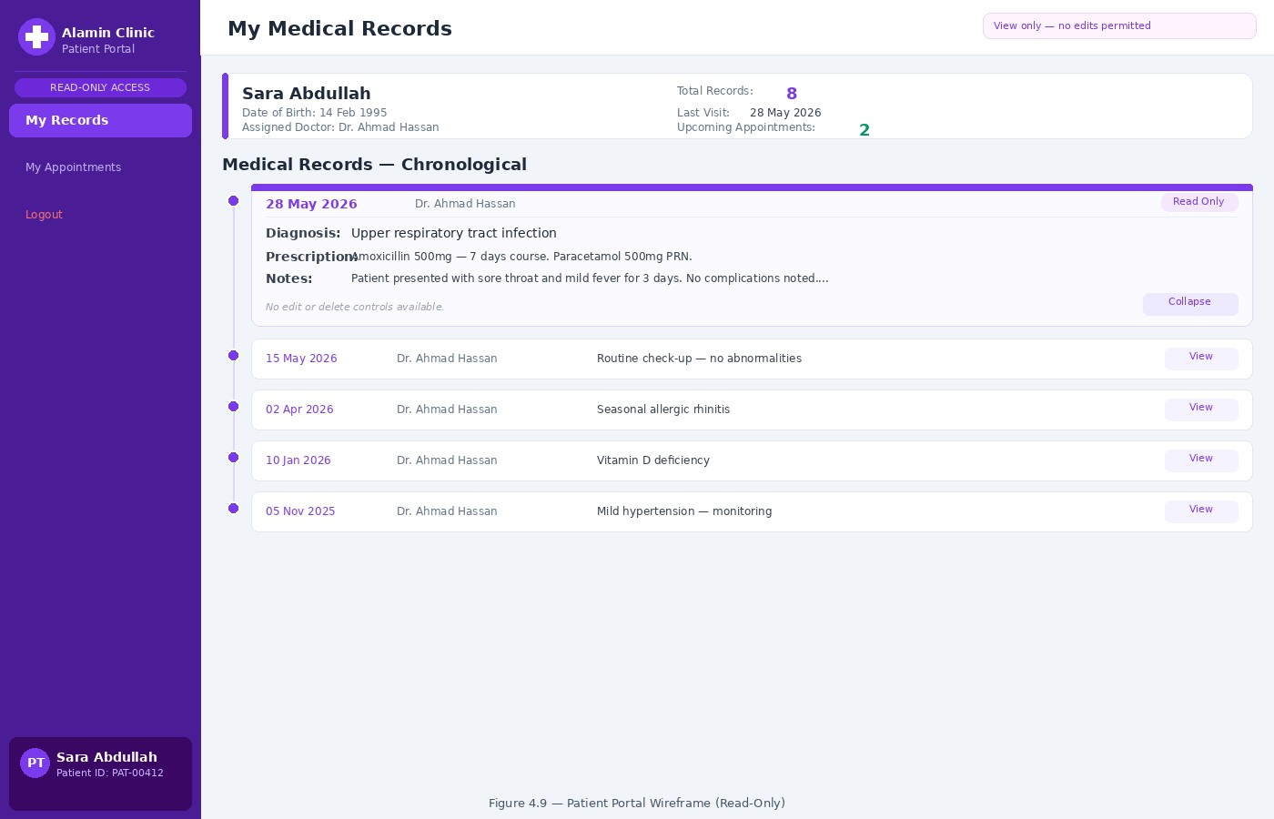
Figure 4.9 Patient Dashboard Wireframe

Chapter Summary
The chapter elaborates on the thorough requirement analysis and design of the Secure Cloud-Based Patient Data Management System, addressing the limitations outlined in the case study discussed in Chapter 2 and requirements described in Chapter 3. The architecture describes a very robust and resilient design, including the implementation of a three-tier architecture with six subnets on AWS VPC across two availability zones, along with layers of security groups, NACLs, and more precise IAM policies. In addition, a DevSecOps pipeline with automatic quality gates is introduced in order to ensure the left-shifted security approach to immediately block any deployment if it is found to be vulnerable. On the data layer, the PostgreSQL database employs a six-table schema with primary keys, foreign keys, an audit tracking table for HIPAA compliance, and separate RLS policy to ensure that role-based access control applies directly on the storage layer. Finally, the UI design defines the four different designs for the Login portal, Doctor Dashboard, Admin Dashboard, and Patient Portal, thus defining the architectural blueprint to support the implementation discussed in Chapter 5.

CHAPTER 5

CONCLUSION

Introduction
The current project is about an important problem of healthcare information security, which has been widely acknowledged by researchers before – the lack of affordable and security-oriented infrastructure for small private healthcare institutions. The case study chosen to motivate the current research illustrates the problem in question, which is common to all small healthcare facilities, because of the limited budget and reactive attitude toward information security issues.

The goal of this project is to develop and implement the Secure Cloud-based Patient Data Management System for Alamin Clinic using the three-tier architecture approach in Amazon Web Services that would use Infrastructure as Code and DevSecOps pipelines to allow for automated, reproducible, and security validated deployments. The goal is aided by three specific objectives, which include:
(a) investigating the fundamental technologies and security principles behind the development of the proposed system; (b) developing the architecture, database structure, and user interface for the system; and (c) evaluating the system after its deployment via testing.

The importance of the project is evident in three areas. Firstly, the system tackles the problems which led to five days of downtime and data loss for patients at Alamin Clinic. Secondly, it proves that infrastructure as code and DevSecOps automation can make advanced enterprise security practices applicable to healthcare organizations which lack resources. Lastly, academically, it presents a case study evaluation of cloud security practices using HIPAA compliance as a metric.

Achievements
This section summarises the outcomes achieved at the conclusion of PSM1 across three workstreams: the key findings established through the literature review, the status of each project objective defined in Chapter 1, and the limitations of the current phase of work alongside notes on how each will be addressed during PSM2 implementation.

Findings from Literature Review
The literature review performed in Chapter 2 reveals three facts that support the design of the proposed solution directly.

First, security shortcomings discovered at Alamin Clinic are typical for small healthcare providers. According to (Argaw et al., 2019), cyberattacks against hospitals use the same security gaps as those present at Alamin Clinic: the presence of old equipment, lack of network segmentation, and insufficient patching processes. Hence, the security issues faced by Alamin Clinic are not exceptional but representative of a common problem.

Second, no currently existing solutions fill the existing gap. The comparison between current solutions performed in Chapter 2 shows that neither traditional on-premise solutions nor open source solutions, such as OpenEMR, can take care of the clinic’s security needs, as both types of solutions shift all the responsibility for securing operations from the cloud to the organization’s IT specialists. Commercial solutions, like Epic Systems, offer comprehensive security features but cannot be afforded by small and private clinics due to their high price and excessive complexity. There are no currently existing affordable off-the-shelf solutions with security automation features.

Third, the chosen technical solution is supported by scientific researches. In particular,Paidy and Chaganti (2024) prove that IaC greatly decreases the amount of configuration drifts and helps in quick and efficient recovery from infrastructure incidents. Also, Al-Issa et al. (2019) state that access to confidential information, integrity attacks, and availability attacks, these three threats that the proposed solution is aimed at are the most prevalent ones in healthcare cloud solutions.

Status of Project Objectives
Objective (a): Explore underlying principles: This objective has been fully accomplished. Chapter 2 performs an exhaustive review of the relevant academic and industrial literature relating to the suggested system in seven fields: cloud computing in the context of healthcare; three-tier architecture; AWS shared responsibility model; Infrastructure as Code using Terraform; DevSecOps; shift-left security; and Identity and Access Management using Role-Based Access Control (RBAC). It validates the appropriateness of every selected technology and establishes the academic background for the design choices presented in Chapter 4.

Objective (b): System Design. The design process in relation to the above objective has been fully completed in PSM1. Chapter 4 provides the complete design for the above objective, which includes the following: three-tier VPC network design having six subnets in two different Availability Zones; design of Security Groups and Network ACLs in two separate network layers; IAM roles and Least Privilege Policy design; six-staged DevSecOps CI/CD pipeline with blocking automation on critical issues; PostgreSQL database design with six tables having Row Level Security policy; and finally the interface wireframes for the three user roles. The development process is scheduled for PSM2 Sprints 2 to 4.

Objective (c) System Testing: The objective has been partially achieved from the perspective of design. The testing strategy has been established in terms of including operational testing consisting of vulnerability scans (using Trivy, SonarQube, and Checkov), an RTO stress test that involves the case of wiping the infrastructure then redeploying due to ransomware attack, and assessment of HIPAA compliance posture using AWS Security Hub. The user acceptance testing (UAT) would consist of not less than three users being tested, wherein each of them will represent one of the user roles presented in the system.

Suggested Plan for Project Implementation and Execution
PSM2 stage of the project will proceed in four sprints, as per the Agile with DevSecOps approach discussed in Chapter 3. The sprints would be based on the design specifications of Chapter 4, and each sprint would be limited by a security gate before moving ahead to the next sprint.

Sprint 2: Network Infrastructure and Database Layer The first sprint for implementing this architecture will configure the AWS VPC with Terraform, which will set up the full three-tier network infrastructure including the public subnets that will have the Application Load Balancer and the NAT Gateway running on them, the private application subnets where the EC2 instances will be located and the isolated database subnets for the RDS PostgreSQL instance. The Security Groups and Network ACLs will be configured according to Chapter 4, Sections 4.3.2 and 4.3.3. The RDS instance will be launched with data encryption using KMS and backups being automatically generated. This sprint will finish when Checkov detects no critical misconfiguration in the Terraform files and the RDS instance cannot be reached from the public internet.

Sprint 3: Application Layer and Authentication The second implementa-tion sprint will launch the Docker containerised application stack containing a React frontend and a Node.js/Express backend onto the EC2 instances running in the private application subnet. The JWT-based RBAC authentication system will be developed with three roles being defined – Doctor, Admin and Patient – according to Chapter 4, Section 4.3.5. The PostgreSQL row-level security policies will be added to the medical records and patients tables according to Chapter 4, Section 4.4.3. The Application Load Balancer will be configured to perform the HTTPS termination with the ACM-provided TLS certificate. The sprint will end once Trivy detects no critical CVEs in the container images and all three roles are tested.

Sprint 4: DevSecOps Pipeline & Monitoring

Third Implementation Sprint will involve setting up and configuring GitHub Actions CI/CD pipeline with Trivy, SonarQube, and Checkov as automated blocking stages, as specified in Chapter 4, Section 4.3.6. Amazon CloudWatch will be configured using log groups, metric alarms, and alerting thresholds for anomalous authentication patterns. AWS CloudTrail will be configured for full API audit logging. The sprint will be concluded once the pipeline is able to block test commit which intentionally contains a critical vulnerability and AWS CloudTrail will be confirmed to log any accesses to patients’ data.

Sprint 5: Security Assessment & HIPPA Compliance Testing

Final Implementation Sprint will conduct full security assessment procedure. Scan reports obtained from automated scans performed with Trivy, SonarQube, and Checkov will be reviewed. Recovery Time Objective stress test will involve simulating total infrastructure wipeout followed by re-deploying using Terraform and measuring recovery time in terms of time required for redeployment, compared to NFR-06 which requires recovery time not longer than 15 minutes. HIPPA compliance will be assessed using AWS Security Hub. User Acceptance Testing will be conducted using three representative participants from Doctor, Admin, and Patient roles. Results of this sprint will form the main part of Chapter 5 (Implementation and Testing) of the PSM2 report.

Deliverables of PSM2 will conclude the objectives of this project and include the final report with Chapters 5 and 6, appendices, and fully deployed application running on AWS.

REFERENCES

Abbasi, N. and Smith, D. (2024). Cybersecurity in Healthcare: Securing Patient Health Information (PHI), HIPAA Compliance Framework and the Responsibilities of Healthcare Providers. Journal of Knowledge Learning and Science Technology. 3(3), 278–287. doi:10.60087/jklst.vol3.n3.p.278-287.
Ahuja, S., Mani, S. and Zambrano, J. (2012). A Survey of the State of Cloud Computing in Healthcare. Network and Communication Technologies. 1(2). doi: 10.5539/nct.v1n2p12.
Akbar, M. A., Smolander, K., Mahmood, S. and Alsanad, A. (2022). Toward Successful DevSecOps in Software Development Organizations: A Decision-Making Framework. Information and Software Technology. 147, 106894. doi: 10.1016/j.infsof.2022.106894.
Al-Issa, Y., Ottom, M. A. and Tamrawi, A. (2019). EHealth Cloud Security Challenges: A Survey. Journal of Healthcare Engineering. 2019, 1–15. doi: 10.1155/2019/7516035.
Argaw, S., Bempong-Ahun, N., Eshaya-Chauvin, B. and Flahault, A. (2019). The State of Research on Cyberattacks Against Hospitals and Available Best Practice Recommendations: A Scoping Review. BMC Medical Informatics and Decision Making. 19. doi:10.1186/s12911-018-0724-5.
Bass, L., Weber, I. and Zhu, L. (2015). DevOps: A Software Architect’s Perspective. SEI Series in Software Engineering. Pearson Education. ISBN 9780134049878. Retrievable at https://books.google.com.my/books? id=fcwkCQAAQBAJ.
Butt, A. U. R., Mahmood, T., Saba, T., Bahaj, S. A. O., Alamri, F. S., Iqbal, M. W. and Khan, A. R. (2023). An Optimized Role-Based Access Control Using Trust Mechanism in E-Health Cloud Environment. IEEE Access. 11, 138813–138826. doi:10.1109/ACCESS.2023.3335984.
Cobrado, U. N., Sharief, S., Regahal, N. G., Zepka, E., Mamauag, M. and Velasco,
L. C. (2024). Access Control Solutions in Electronic Health Record Systems: A

Systematic Review. Informatics in Medicine Unlocked. 49, 101552. doi:10.1016/j. imu.2024.101552.
Espinha Gasiba, T., Andrei-Cristian, I., Lechner, U. and Pinto-Albuquerque, M. (2021). Raising Security Awareness of Cloud Deployments Using Infrastructure as Code Through CyberSecurity Challenges. In Proceedings of the 16th International Conference on Availability, Reliability and Security. ARES ’21. New York, NY, USA: Association for Computing Machinery, 1–8. doi:10.1145/3465481.3470030.
Gaber, O., Anis Aziz, W. and Soliman, J. (2025). Three-Tier Cloud Application Deployment Using AWS With Identity Management. In Proceedings of the International Conference on Cloud Computing and Services Science.
Mendoza, C. and Reyes, C. (2023). Exploring the Impact of Shared Responsibility Models on Cloud Security Posture and Vulnerability Management. Journal of Emerging Technologies.
Paidy, P. and Chaganti, K. (2024). Resilient Cloud Architecture: Automating Security Across Multi-Region AWS Deployments. International Journal of Emerging Trends in Computer Science and Information Technology. 5(2), 82–93.
Rajapakse, R. N., Zahedi, M., Babar, M. A. and Shen, H. (2022). Challenges and Solutions When Adopting DevSecOps: A Systematic Review. Information and Software Technology. 141, 106700. doi:10.1016/j.infsof.2021.106700.
Ramayanam, S. (2025). Data Security and Compliance in Modernized Cloud-Enabled Healthcare and Financial Systems. Journal of International Crisis and Risk Communication Research, 406–414. doi:10.63278/jicrcr.vi.3378.
Shojaei, P., Vlahu-Gjorgievska, E. and Chow, Y.-W. (2024). Security and Privacy of Technologies in Health Information Systems: A Systematic Literature Review. Computers. 13(2), 41. doi:10.3390/computers13020041.
Singh, A. and Chatterjee, K. (2015). A Secure Multi-Tier Authentication Scheme in Cloud Computing Environment. In 2015 International Conference on Circuits, Power and Computing Technologies (ICCPCT-2015). 1–7. doi:10.1109/ICCPCT. 2015.7159276.
Thamer, N. and Alubady, R. (2021). A Survey of Ransomware Attacks for Healthcare Systems: Risks, Challenges, Solutions and Opportunity of Research. In 2021

1st Babylon International Conference on Information Technology and Science (BICITS). 210–216. doi:10.1109/BICITS51482.2021.9509877.
Valde´s-Rodr´ıguez, Y., Hochstetter-Diez, J., D´ıaz-Arancibia, J. and Cadena-Mart´ınez,
R. (2023). Towards the Integration of Security Practices in Agile Software Development: A Systematic Mapping Review. Applied Sciences. 13(7), 4578. doi: 10.3390/app13074578.
Verdet, A., Hamdaqa, M., Silva, L. and Khomh, F. (2023). Exploring Security Practices in Infrastructure as Code: An Empirical Study. doi:10.48550/arXiv.2308. 03952. ArXiv preprint arXiv:2308.03952.

Appendix A Project Gantt Chart

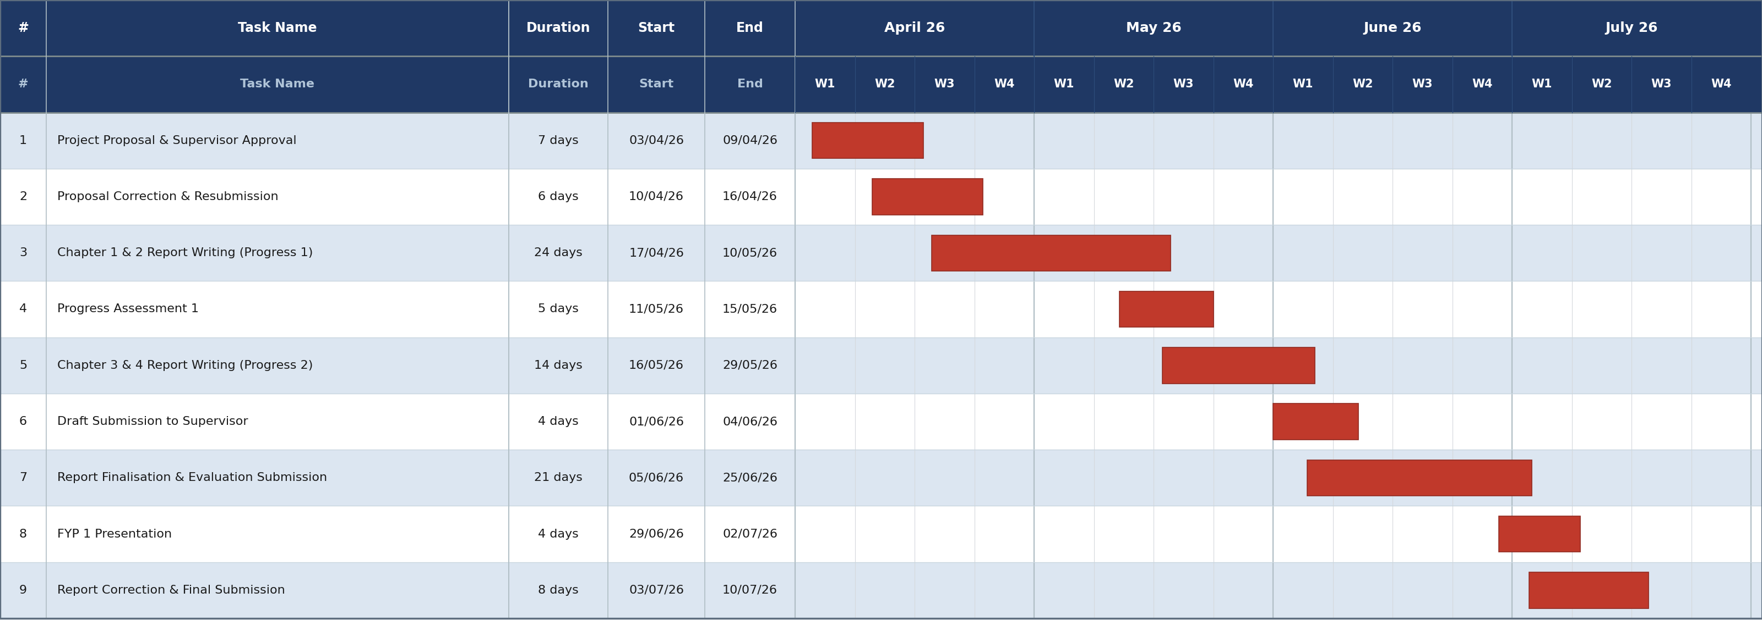
Figure A.1 FYP 1 Gantt Chart

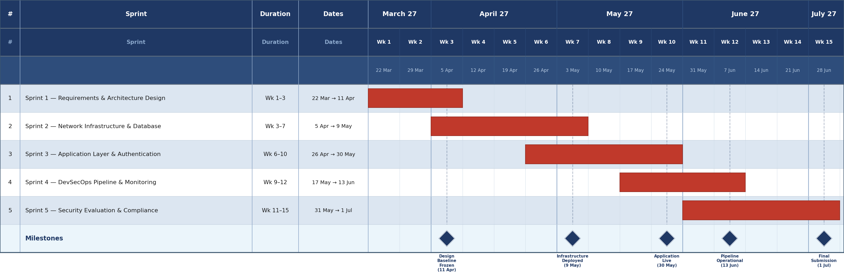
Figure A.2 FYP 2 Sprints Gantt Chart

Appendix B Complete Use Case Specifications

Table B.1 User Stories by Module

ID | Role | User Story | Module
US-01 | Doctor / Admin  / Patient | As a user, I want to log in with my username  and password, so that I can securely access my role-specific dashboard. | Auth
US-02 | All roles | As a logged-in user, I want to log out, so that  my session is terminated and my account is protected on shared devices. | Auth
US-03 | System | As a user, I want the system to lock my account after three consecutive failed login attempts, so that brute-force attacks are  prevented and the admin is alerted. | Auth
US-04 | Admin | As an Admin, I want to create user accounts with assigned roles, so that doctors, staff, and patients can access the system with the  correct permissions. | Auth
US-05 | Admin | As an Admin, I want to deactivate user accounts, so that former staff or inactive  patients can no longer access the system. | Auth
US-06 | Admin | As an Admin, I want to register new patients and assign them a treating doctor, so that their records can be managed securely from  the point of registration. | Patient Mgmt
US-07 | Doctor / Admin | As a Doctor or Admin, I want to view a patient’s profile, so that I can review their details before providing care or scheduling  an appointment. | Patient Mgmt
US-08 | Admin | As an Admin, I want to update patient demographic information, so that the system  holds accurate and current patient details. | Patient Mgmt

ID | Role | User Story | Module
US-09 | Admin | As an Admin, I want to assign or reassign a treating doctor to a patient, so that the correct  doctor has access to that patient’s records. | Patient Mgmt
US-10 | Doctor | As a Doctor, I want to create medical records for my assigned patients, so that I can document diagnoses and prescriptions in a  secure, auditable system. | Medical Records
US-11 | Doctor / Patient | As a Doctor, I want to view records of my assigned patients; as a Patient, I want to view my own records in read-only mode, so that clinical data is accessible only to authorised  parties. | Medical Records
US-12 | Doctor | As a Doctor, I want to update a record I created, so that I can correct or supplement clinical documentation after the initial con-  sultation. | Medical Records
US-13 | Doctor | As a Doctor, I want to view the complete chronological medical history of my as-signed patients, so that I can make informed  clinical decisions. | Medical Records
US-14 | Admin | As an Admin, I want to schedule appoint-ments linking a patient to a doctor at a specific date and time, so that consultations  are organised and conflict-free. | Appointments
US-15 | Doctor | As a Doctor, I want to view my appointment schedule, so that I know which patients I will be seeing and can prepare for each  consultation. | Appointments
US-16 | Patient | As a Patient, I want to view my upcoming appointments in read-only mode, so that I am informed of when and with whom my  consultations are scheduled. | Appointments

ID | Role | User Story | Module
US-17 | Admin | As an Admin, I want to update appoint-ment details, so that changes in scheduling requirements are reflected accurately in the  system. | Appointments
US-18 | Admin | As an Admin, I want to cancel appointments, so that unavailable time slots are freed and appointment records remain accurate for  audit purposes. | Appointments

Appendix C Stakeholder Requirements Validation Correspondence

This appendix presents the stakeholder requirements validation correspondence conducted between the student, the project supervisor, and Al Amin clinic. The system requirements were initially gathered through direct verbal discussions with clinic staff, including administrative staff, clinic management, and nursing staff. To formally document and validate these requirements, a structured written confirmation process was initiated. A formal request letter was prepared by the project supervisor, Dr Johan Mohamed Sharif, on official UTM Faculty of Computing letterhead, and submitted to the clinic. The clinic subsequently responded with a signed confirmation letter on their official letterhead, verified by the Head Manager and stamped with the clinic’s official seal. The complete emails, the clinic’s email reply, the supervisor’s signed request letter, and the clinic’s signed confirmation letter is presented in Figures C.1 through C.4.

Figure C.1 shows the email sent to Alamin Medical Clinic on 4 July 2026. The email introduces the purpose of the correspondence, references the attached UTM supervisor letter, and requests the clinic to review, sign, and return the enclosed reply letter confirming the system requirements discussed with their staff.

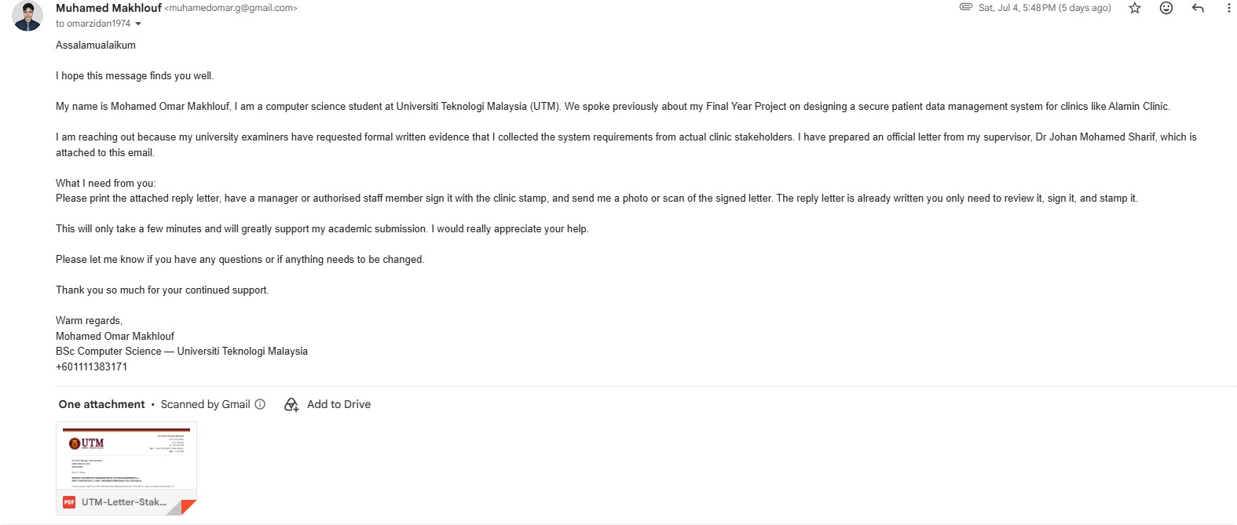
Figure C.1 Email sent by Mohamed Omar Makhlouf to Alamin Medical Clinic.

Figure C.2 shows the clinic’s email reply, received on 7 July 2026 from Alamin Medical Clinic. The reply formally confirms the clinic’s support for the student’s Final Year Project and references the attached signed confirmation letter (Ref: AMC/FYP/2026/01), in which the clinic verifies that the system requirements documented by the student accurately reflect their operational needs.
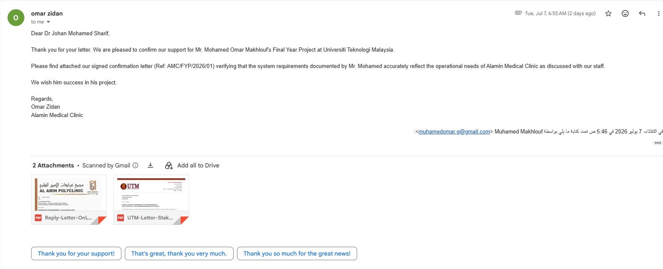
Figure C.2 Reply email from Alamin Medical Clinic.

Figure C.3 presents the formal request letter issued on UTM Faculty of Computing official letterhead (Ref: UTM.FC/SECRH/FYP.PSM1/2026/01), dated 3 July 2026. The letter was authored and signed by the project supervisor, Dr Johan Mohamed Sharif, and addressed to the Clinic Manager of Alamin Medical Clinic. It lists the six categories of system requirements gathered from stakeholder discussions and formally requests the clinic’s written confirmation that these requirements accurately reflect their operational needs.

Universiti Teknologi Malaysia

81310 Johor Bahru Johor, Malaysia Tel: +607-553 3333
Ref : UTM.FC/SECRH/FYP.PSM1/2026/01
Date : 3 July 2026

The Clinic Manager / Administration Alamin Medical Clinic
Saudi Arabia

Dear Sir / Madam,

REQUEST FOR WRITTEN CONFIRMATION OF SYSTEM REQUIREMENTS — FINAL YEAR PROJECT — PSM 1 (MOHAMED OMAR MAKHLOUF, A23CS4014)

I am the academic supervisor of Mr. Mohamed Omar Makhlouf (Student ID: A23CS4014), a final year student in the Bachelor of
Computer Science (Information Security) programme at the Faculty of Computing, Universiti Teknologi Malaysia (UTM), Johor Bahru.

Mr. Mohamed’s Final Year Project (PSM 1), titled “Design and Deployment of a Secure Cloud-Based Patient Data Management System Using a Three-Tier Architecture on AWS,” is a system development project aimed at addressing the data security challenges faced by small and medium-sized private clinics. As part of the requirements elicitation phase, Mr. Mohamed conducted direct discussions with your clinic’s administrative and clinical staff to understand the existing patient data management workflow and to identify the system
requirements for the proposed solution.

I write to formally request that an authorised representative of Alamin Medical Clinic provide written confirmation that the following requirements, as documented by Mr. Mohamed from those discussions, accurately reflect the operational needs of your clinic:
- Role-Based Access Control
  - Three distinct user roles must be enforced: Doctor, Administrative Staff, and Patient
  - Each user must have unique, individual login credentials — shared access is not acceptable
  - Staff must be restricted to data and functions relevant to their designated role only
  - Three consecutive failed login attempts must result in automatic account lockout

- Patient Records Management
  - Doctors may only view and create records for patients directly assigned to them
  - Administrative staff manage patient registration and appointments, without access to clinical data
  - Patients may view their own records and appointments in read-only mode

- Appointment Scheduling

  - Administrative staff must be able to create, update, and cancel patient appointments
  - Doctors must be able to view their own appointment schedule
  - Patients must be able to view their upcoming appointments

- Audit Trail and Activity Logging
  - All access to and modifications of patient records must be logged automatically
  - Each log entry must record the user identity, action, affected record, and timestamp
  - The audit log must not be editable or deletable by any user — essential for forensic accountability

Figure C.3 Official request letter (Ref: UTM.FC/SECRH/FYP.PSM1/2026/01) - Page 1.

- Data Security and Disaster Recovery
  - All patient data must be encrypted both in storage and in transit
  - Automated backups must be performed regularly
  - The system must be fully recoverable in the event of a ransomware attack or system failure, with minimal downtime

- Cloud-Based Deployment

  - The system should be hosted securely in the cloud, accessible by authorised staff from any location
  - No reliance on on-premise servers that are vulnerable to physical compromise

Your written confirmation — whether by signing and returning this letter or by providing a brief official reply on clinic letterhead —
would serve as important documentary evidence in the student’s academic report and would significantly strengthen the credibility of the research findings.
We thank you sincerely for your cooperation and support of this project. Should you require any further information, please do not hesitate to contact me directly.

Thank you.
“MALAYSIA MADANI” “BERKHIDMAT UNTUK NEGARA”


I, who uphold the trust,

(DR JOHAN MOHAMED SHARIF)
Project Supervisor — Bachelor of Computer Science (SECRH) Faculty of Computing
Universiti Teknologi Malaysia, Johor Bahru
☏ +6011-2136 0472
✉ Johan@utm.my
innovative • entrepreneurial • global

Figure C.4 Official request letter (Ref: UTM.FC/SECRH/FYP.PSM1/2026/01) - Page 2.

Figure C.4 presents the signed confirmation letter from Al Amin clinic (Ref: AMC/FYP/2026/01), issued on the clinic’s official letterhead. The letter was signed by Ibrahim Shaheel Al Quad, Head Manager, and bears the clinic’s official stamp. It confirms the conducted discussions with administrative staff, clinic management, and nursing staff, and that the five categories of system requirements documented, that cover role-based access control, patient records management, audit trail, data security and recovery, and cloud-based deployment which reflect the clinic’s operational needs.


Ref : AMC/FYP/2026/01
Date :

Dr Johan Mohamed Sharif
Project Supervisor — Bachelor of Computer Science (SECRH) Faculty of Computing, Universiti Teknologi Malaysia, Johor Bahru

Dear Dr Johan,

CONFIRMATION OF SYSTEM REQUIREMENTS — FINAL YEAR PROJECT PSM 1 (MOHAMED OMAR MAKHLOUF, A23CS4014)

Thank you for your letter dated 3 July 2026. We are pleased to provide this written confirmation in support of Mr. Mohamed Omar Makhlouf’s Final Year Project at Universiti Teknologi Malaysia.
We confirm that Mr. Mohamed conducted discussions with the following members of our clinic:

- Administrative Staff — patient registration and appointment management workflow
- Clinic Management — operational and security concerns following the data security incident in May 2023
- Nursing Staff — clinical workflow for patient record access and documentation

Based on those discussions, we confirm the following requirements accurately reflect the needs of Al Amin Polyclinic:

- Role-Based Access Control — Three user roles: Doctor, Administrative Staff, and Patient, each with unique individual login credentials. Staff restricted to their designated role only; lockout after three failed login attempts.
- Patient Records & Appointments — Doctors access records of assigned patients only. Admin manages registration and scheduling with no access to clinical data. Patients view their own records in read-only mode.
- Audit Trail — All record access and modifications logged automatically with user identity, action, and timestamp. Log is append-only and cannot be edited or deleted by any user.
- Data Security & Recovery — All patient data encrypted in storage and in transit. Automated backups in place; full system recovery possible in the event of a ransomware attack with minimal downtime.
- Cloud-Based Deployment — System hosted securely in the cloud, accessible by authorised staff from any location, with no reliance on on-premise servers.
We consider the above requirements to be a correct and complete representation of the system needs as discussed. We support this project and hope the proposed system will serve as a viable model for improving data security in clinics of similar scale.
Yours sincerely,

Name
Ibrahim Shaheel Al Quad
Position
Head Manager
Signature
Date
1448-01-22

Figure C.5 Official requirements confirmation letter (Ref: AMC/FYP/2026/01) - Page 1.

Figure C.6 Official requirements confirmation letter (Ref: AMC/FYP/2026/01) - Page 2.

Appendix D System Requirements

Table D.1 Functional Requirements

ID | Requirement | User Role | Priority
FR-01 | The system shall allow new patients to be  registered with a unique identifier, personal details, and assigned doctor. | Admin | High
FR-02 | The system shall allow authenticated doctors  to create, read, and update medical records for patients assigned to their care. | Doctor | High
FR-03 | The system shall allow authenticated doctors  to read the medical history of their assigned patients. | Doctor | High
FR-04 | The system shall allow authenticated admin-  istrators to create, update, and cancel patient appointments. | Admin | High
FR-05 | The system shall allow authenticated patients to view their own upcoming and past appoint-  ments. | Patient | High
FR-06 | The system shall allow authenticated patients to view their own medical records in read-only  mode. | Patient | High
FR-07 | The system shall authenticate all users with a  unique username and password before granting access to any system function. | All | High
FR-08 | The system shall enforce role-based access control, ensuring that each user role can only access the data and functions authorised for that  role. | All | High
FR-09 | The system shall log all patient data access  events, including the user identity, timestamp, and action performed. | System | High

ID | Requirement | User Role | Priority
FR-  10 | The system shall allow administrators to create,  deactivate, and reassign user accounts. | Admin | Medium
FR-  11 | The system shall transmit all data between the  client browser and the server over HTTPS. | System | High
FR-12 | The system shall store all patient records in an encrypted database with no direct internet  access path. | System | High

Table D.2 Non-Functional Requirements

ID | Category | Requirement | Metric / Verifica-  tion Method
NFR-01 | Security | All data stored in the RDS database  shall be encrypted at rest using AES-256 via AWS KMS. | AWS Console, RDS encryption status
NFR-02 | Security | All data in transit between the client  and ALB shall be encrypted using TLS 1.2 or higher. | SSL Labs scan,  ALB listener configuration
NFR-03 | Security | All IAM roles shall be configured with least-privilege policies, grant-ing only the permissions required  for the role’s function. | IAM policy review, AWS IAM Access Analyzer
NFR-04 | Security | The CI/CD pipeline shall block deployment on any critical or high-severity finding from Trivy, Sonar-  Qube, or Checkov. | GitHub Actions pipeline log
NFR-05 | Availability | The system shall maintain 99.9% uptime through multi-AZ EC2 and  RDS deployment. | CloudWatch availability metric

ID | Category | Requirement | Metric / Verifica-  tion Method
NFR-06 | Recovery | The system shall be fully redeploy-able from a clean Terraform state within 15 minutes of a complete  infrastructure wipe. | RTO stress test, measured recovery time
NFR-07 | Compliance | The system shall achieve and main-tain a passing HIPAA posture score  as measured by AWS Security Hub. | Security Hub  HIPAA standard findings report
NFR-08 | Auditability | All AWS API calls and patient data access events shall be logged in CloudTrail with a minimum  retention period of 90 days. | CloudTrail configu-ration, S3 log bucket
NFR-09 | Performance | The system shall respond to au-thenticated API requests within 3 seconds under normal load (up to  50 concurrent users). | Load test results
NFR-10 | Scalability | The application tier shall support horizontal scaling through EC2 Auto Scaling to accommodate in-  creased patient load. | Auto Scaling group configuration
NFR-11 | Maintainability | All infrastructure shall be defined as version-controlled Terraform code, with no manually provisioned re-sources in the production environ-  ment. | Terraform state file audit

Appendix E Database Schema

users: Stores authentication credentials and role assignment for all system users. Passwords are stored as bcrypt hashes. hence the plaintext password is never persisted.

Table E.1 Database Table: users

Column | Type | Constraints | Description
user id | UUID | PRIMARY KEY | Unique identifier
username | VARCHAR(50) | UNIQUE, NOT  NULL | Login username
password hash | VARCHAR(255) | NOT NULL | bcrypt hash of pass-  word
role | ENUM(’doctor’,  ’admin’,’patient’ | NOT NULL  ) | Assigned role
is active | BOOLEAN | DEFAULT TRUE | Account active status
created at | TIMESTAMP | DEFAULT  NOW() | Account creation  timestamp
last login | TIMESTAMP | NULLABLE | Last successful login

patients: Stores patient demographic information. Linked to the ‘users‘ table for authentication and to the ‘doctors‘ table for the assigned doctor relationship.

Table E.2 Database Table: patients

Column | Type | Constraints | Description
patient id | UUID | PRIMARY KEY | Unique identifier
user id | UUID | FK ↑  users.user id | Authentication account
first name | VARCHAR(100) | NOT NULL | Patient first name
last name | VARCHAR(100) | NOT NULL | Patient last name
date of birth | DATE | NOT NULL | Date of birth
contact number | VARCHAR(20) | NULLABLE | Phone number
assigned doctor | iUdUID | FK ↑  doctors.doctor | Assigned treating doc-  itdor
registered at | TIMESTAMP | DEFAULT NOW() | Registration timestamp

doctors: Stores clinical staff information, linked to the ‘users‘ table for authentication.

Table E.3 Database Table: doctors

Column | Type | Constraints | Description
doctor id | UUID | PRIMARY KEY | Unique identifier
user id | UUID | FK ↑  users.user id | Authentication account
first name | VARCHAR(100) | NOT NULL | Doctor first name
last name | VARCHAR(100) | NOT NULL | Doctor last name
specialisation | VARCHAR(100) | NULLABLE | Medical specialisation

medicalRecords: Stores clinical records created by doctors. Each record is linked to exactly one patient and one creating doctor.

Table E.4 Database Table: medical records

Column | Type | Constraints | Description
record id | UUID | PRIMARY KEY | Unique identifier
patient id | UUID | FK ↑  patients.patien | Associated patient  t id
doctor id | UUID | FK ↑  doctors.doctor | Creating doctor  id
diagnosis | TEXT | NOT NULL | Clinical diagnosis
prescription | TEXT | NULLABLE | Prescribed treatment
notes | TEXT | NULLABLE | Additional clinical  notes
created at | TIMESTAMP | DEFAULT NOW() | Record creation times-  tamp
updated at | TIMESTAMP | DEFAULT NOW() | Last update timestamp

appointments: Stores scheduled appointments linking patients to doctors at a defined time.

Table E.5 Database Table: appointments

Column | Type | Constraints | Description
appointment id | UUID | PRIMARY KEY | Unique identifier
patient id | UUID | FK ↑  patients.patien | Attending patient  t id
doctor id | UUID | FK ↑  doctors.doctor | Attending doctor  id
scheduled at | TIMESTAMP | NOT NULL | Appointment  date and time
status | ENUM(’scheduled’,  ’completed’, ’cancelled’) | DEFAULT  ’scheduled’ | Current status
notes | TEXT | NULLABLE | Admin notes
created by | UUID | FK ↑  users.user id | Admin who cre-  ated booking

auditLog: An append-only table recording every significant data access event. This table satisfies the HIPAA audit control requirement and the CloudTrail complement at the application data level.

Table E.6 Database Table: audit log

Column | Type | Constraints | Description
log id | UUID | PRIMARY KEY | Unique identifier
user id | UUID | FK ↑  users.user id | User who performed  the action
action | VARCHAR(50) | NOT NULL | Action type (CREATE, READ, UPDATE,  DELETE)
table name | VARCHAR(50) | NOT NULL | Target table
record id | UUID | NOT NULL | Target record identifier
ip address | INET | NULLABLE | Client IP address
performed at | TIMESTAMP | DEFAULT NOW() | Event timestamp

Appendix F Interview Protocol

Interview Questions with the Stakeholder

- How do you currently access and manage patient records on a daily basis?

- What are the most significant difficulties you face when using the current system?

- How was the ransomware incident discovered, and what was the immediate impact on your work?

- How long was the clinic unable to access patient records, and how was this period managed?

- What data was lost or inaccessible as a result of the attack?

- Were there any security policies or backup procedures in place at the time of the incident?

- What features of a new system would most improve your day-to-day work?

- What security or privacy concerns do you have about moving patient data to a cloud system?

Appendix G Security Design Specification

Table G.1 Security Group Rules

Security  Group | Direction | Protocol | Port | Source / Desti-  nation | Purpose
alb-sg | Inbound | TCP | 443 | 0.0.0.0/0 | HTTPS from in-  ternet
alb-sg | Inbound | TCP | 80 | 0.0.0.0/0 | HTTP (redirected  to 443)
alb-sg | Outbound | TCP | 5000 | ec2-sg | Forward to appli-  cation
ec2-sg | Inbound | TCP | 5000 | alb-sg | Accept only from  ALB
ec2-sg | Outbound | TCP | 5432 | rds-sg | Connect to  database
ec2-sg | Outbound | TCP | 443 | 0.0.0.0/0 | AWS API / NAT  outbound
rds-sg | Inbound | TCP | 5432 | ec2-sg | Accept only from  EC2
rds-sg | Outbound | — | — | None | No outbound per-  mitted

Table G.2 NACL Rules Summary

NACL | Applies To | Key Inbound Rules | Key Outbound Rules
public-nacl | Public subnets | Allow TCP 443 from 0.0.0.0/0; Allow TCP 80  from 0.0.0.0/0; Allow ephemeral ports (1024–  65535) from 0.0.0.0/0 | Allow all to 0.0.0.0/0
app-nacl | App subnets | Allow TCP 5000 from 10.0.1.0/24 and 10.0.2.0/24  (public subnets); Allow ephemeral ports from 10.0.5.0/24 and 10.0.6.0/24  (DB response) | Allow TCP 5432 to 10.0.5.0/24 and 10.0.6.0/24; Allow  ephemeral ports to public subnets
db-nacl | DB subnets | Allow TCP 5432 from 10.0.3.0/24 and 10.0.4.0/24  (app subnets) only; Deny all  other inbound | Allow ephemeral ports to 10.0.3.0/24 and 10.0.4.0/24 only

Authentication Mechanism
Authentication identifies the user before access is granted to any system resources. The system uses a credentials-based process for authentication, whereby bcrypt hash passwords are used for authentication, while sessions are maintained using JWT.

Password security: Plaintext user passwords are not retained at any point. During user signup, the password undergoes the bcrypt hashing function with a cost of 12, resulting in a 60 character long hash value. A cost of 12 means that the verification process takes around 250 milliseconds per hash on normal hardware, rendering offline brute force attack attempts computationally impossible. The plaintext password is deleted after the hashing process and never logged anywhere or written into any columns or error messages.

JWT Access Tokens: After a successful login process, the server generates a signed JWT that includes ‘userId‘, ‘role‘, and the time of expiration. This token is signed on the server-side using a secret key with the HMAC-SHA256 hashing function, making it impossible to forge on the client side. The access token expires in 15 minutes, whereas the refresh token lasts 7 days.

Cookie Security: The cookie containing the JWT will be set on the client side as an ‘httpOnly‘, ‘Secure‘, ‘SameSite=Strict‘ cookie. By setting ‘httpOnly‘ on the cookie, no JavaScript can access its value, mitigating the risk of XSS attacks which could steal the cookie from the client. By using the ‘Secure‘ cookie setting, only secure connections will be able to transfer the cookie from the client to the server.

Account Lockout Policy: Following the third unsuccessful login attempt, the flag ‘isActive‘ is set to false and all subsequent login attempts will fail with a standard message. The notification of the system alert is sent to the admin role. This policy fulfills the HIPAA security requirements of protection from repeated access attempts.

Authorization and Access Control
Authorisation decides what the authenticated user can perform. Authorisation has a two-tiered scheme, which comprises role-based access control (RBAC) in the application layer and row-level security (RLS) in the database layer.

Role-Based Access Control at Application Layer: The ‘RBACMiddleware‘ class captures every HTTP request sent to the API post-authentication. It fetches the ‘role‘ field value from the decoded JWT and matches it with the expected role on the corresponding route. In case the caller does not have the appropriate role assigned to him/her, the HTTP 403 Forbidden status is returned, and the request is not processed by the route handler. Table G.1 highlight the permission rules for each actor.

Row-Level Security (RLS) Database Layer: The policies defined using PostgreSQL RLS will enforce restrictions at the storage layer irrespective of any other layer. Hence, despite any circumvention of the application RBAC, such as by way of

Table G.3 Role-Permission Matrix

Operation | Doctor | Admin | Patient
Login / Logout | ↭ | ↭ | ↭
View assigned patients | ↭ | ↭ | —
Register / update patient | — | ↭ | —
Assign / reassign doctor | — | ↭ | —
Deactivate user account | — | ↭ | —
Create medical record | ↭ | — | —
View medical record | ↭ (own patients) | — | ↭ (own only)
Update medical record | ↭ (own records) | — | —
Schedule appointment | — | ↭ | —
View appointments | ↭ | ↭ | ↭ (own only)
Update / cancel appointment | — | ↭ | —

a hijacked API call, the database itself would not allow any retrieval of data rows that are unauthorized for the authenticated user. Important RLS policies are:

        - medical records: a Doctor may only SELECT or UPDATE rows where doctor id matches the session’s userId. A Patient may only SELECT rows where patient id maps to their own user account.

        - patients: a Doctor may only SELECT patients where assigned doctor id matches their doctorId.

        - appointments: visibility is scoped to the doctor id or patient id matching the session user.

Admin’s database user account, on the other hand, operates under policies that grant full row-level permissions to all data in its administrative activities but are limited only to administration-related tables and activities.

API Security Controls
The REST API exposed by the Node.js/Express backend is hardened through a layered set of middleware controls applied globally to all routes.

Rate Limiting: With the help of ‘express-rate-limit‘, each request from an IP can be limited up to a total of 100 per 15 minutes. The limit for the login endpoint is reduced even further to just 10 in 15 minutes. All those requests which exceed the limit will get a 429 HTTP response status code.

Input Validity and Sanitization: All inputs to ‘POST‘ and ‘PUT‘ requests are validated by ‘express-validator‘ prior to execution of the corresponding route handlers. The validation process includes checking the input type, length, and other criteria, including formatting dates according to ISO 8601 and validating phone numbers as purely numeric values. If the input data fails the validation check, it is rejected with an HTTP 400 response and an informative message.

Parameterised Queries: All queries made to the database are done using the ‘node-postgres‘ library with parameterised queries. None of the queries have any form of SQL statement built up via concatenating user input together. User inputs for the parameterised query statements are passed to the PostgreSQL server where SQL injection is not possible.

Security Headers: The ‘Helmet.js‘ middleware package sets the following HTTP response headers on all API responses. below Table G.2 shows each header and its corespondent value and protection:

Table G.4 HTTP Security Headers Configuration

Header | Value | Protection
Content-Security-  Policy | default-src  ’self’ | Prevents inline script execution
X-Content-Type-  Options | nosniff | Prevents MIME-type sniffing
X-Frame-Options | DENY | Prevents clickjacking via iframes
Strict-Transport-  Security | max-age=31536000 | Forces HTTPS for one year
Referrer-Policy | no-referrer | Suppresses referrer header leakage

CORS Policy: The CORS policy is set up such that any request must come from the cloud front origin of the clinic. Wildcards are strictly disallowed. The following methods are allowed for CORS policy: ‘GET‘, ‘POST‘, ‘PUT‘, and ‘DELETE‘.

Error Handling: Error handler middleware is used to capture any exceptions that have not been handled. The response to the user contains a simple error message together with an HTTP status code. Information such as stack trace, database error message, and server paths is never exposed since this might be harmful.

Network Security Controls
The AWS network architecture enforces isolation between public-facing, application, and database tiers using a layered set of controls that ensure no component is directly reachable unless explicitly permitted.

VPC and Subnet Isolation: The whole setup takes place within a private Virtual Private Cloud (VPC). Both EC2 and RDS servers are located in the private subnet and do not have any internet connectivity whatsoever. The Application Load Balancer (ALB) and the NAT Gateway are the only services in the public subnet. In other words, there is no way for anyone from the internet to get access to the application/database tiers unless going through the ALB.

Security Groups: AWS Security Groups act as stateful virtual firewalls at the instance level. Three security groups enforce least-privilege ingress rules. Table G.3 explains each security group and which protocol it governs:

Table G.5 Network Security Group Configuration Matrix

Security Group | Inbound Rule | Source
ALB-SG | TCP 443 (HTTPS) | 0.0.0.0/0
EC2-SG | TCP 3000 (Node.js) | ALB-SG only
RDS-SG | TCP 5432 (PostgreSQL) | EC2-SG only

Inbound traffic via SSH or any other administrative ports from the internet will not be allowed. Access to the EC2 instance for performing any kind of maintenance tasks can only be accomplished via AWS Systems Manager (SSM) Session Manager where no inbound ports are created.

ALB HTTPS Termination: The Application Load Balancer is provided with a listener on HTTPS port 443 that utilizes the SSL policy named ‘ELBSecurityPolicy-TLS13-1-2-2021-06‘, which mandates the use of TLS 1.2 as the minimum protocol but also supports TLS 1.3. The other HTTP listener on port 80 issues an HTTP 301 redirection to its HTTPS counterpart URL. SSL certificates are taken care of by AWS Certificate Manager.

NAT Gateway: Outbound internet traffic from the EC2 instance is routed via the NAT Gateway located in the public subnet. The EC2 instance does not have an Elastic IP address or any outbound internet connection path; however, it still maintains the capacity for outgoing internet communications when necessary.

Data Encryption
All patient health information (PHI) is encrypted both at rest and in transit, satisfying the HIPAA encryption specification.

In-Transit Encryption: The traffic between the client browser and the system is encrypted using TLS 1.2 or above, terminating at the ALB. SSL encryption is used for the network traffic between the EC2 application server and the RDS PostgreSQL server, and it is enabled through the ‘rds.force ssl‘ parameter value as ‘1‘. There is no plaintext communication link anywhere in the data path.

At-Rest Encryption Database: The RDS PostgreSQL instance is provisioned via ‘storage encrypted = true‘ through Terraform, where encryption uses an AWS CMK (Customer Managed Key). All data files, automatic backups, read replicas, and database snapshots are encrypted using the same CMK. Automatic key rotation for the CMK takes place once per year. In other words, if the actual storage (EBS volume) is taken off, no one will be able to read anything without having access to the CMK.

Encryption at Rest Object Storage: The React static site build stored on the S3 bucket is protected with encryption via server-side encryption (SSE-S3 [AES-256]). The settings for block-public-acls, block-public-policy, ignore-public-acls, and restrict-public-buckets have all been configured to “true”, ensuring that the S3 bucket contents cannot be accessed directly from the Internet. The CloudFront distribution has access to the S3 bucket via the OAI (Origin Access Identity).

Monitoring, Audit Trail, and Incident Response
Continuous monitoring and a complete audit trail are required to detect security incidents and to demonstrate accountability for all actions taken on patient data.

Application Audit Log: All actions, including the creation, reading, updating, and deletion of data, done on patient records will be logged in the ‘audit log‘ table through the ‘AuditLog‘ model class. These logs include the ‘userId‘, the type of action performed, the resource ID, the IP address, and timestamp. The logs form an immutable set of data for forensic purposes as per HIPAA audit controls requirements (§164.312(b)).

CloudTrail: CloudTrail is available in all AWS regions and logs each and every API request sent to the AWS account, including details such as who initiated it, its IP, and the exact time it was executed. CloudTrail logs are uploaded to an S3 bucket having MFA delete set to ”on,” and this makes sure that these logs cannot be tampered with.

AWS CloudWatch: Application logs from the EC2 instance are streamed to CloudWatch Logs using the CloudWatch agent. CloudWatch alarms are configured for the following conditions:

        - Five or more failed login attempts within a five-minute window → triggers SNS notification to the administrator.

        - HTTP 5xx error rate exceeding 1% of requests → alarm for application layer failures.

        - RDS CPU utilisation exceeding 80% for five consecutive minutes →
capacity alert.

AWS Security Hub: This service combines findings from AWS GuardDuty (threat detection), Amazon Inspector (vulnerability scanning for EC2 instances), and the Checkov IaC scan in the CI/CD pipeline into one security posture view. Any finding marked as either ‘HIGH‘ or ‘CRITICAL‘ triggers an alert.

HIPAA Security Rule The technical architecture aligns directly with the standards to ensure the confidentiality, integrity, and availability of protected health information (PHI). As detailed in Table G.4, specific HIPAA Security Rule requirements are mapped to exact implementation mechanisms across the application and infrastructure layers. This includes the enforcement of granular access controls via Role-Based Access Control (RBAC) and Row-Level Security (RLS), strict transmission security utilizing TLS 1.2+ protocols, and comprehensive audit tracking through AWS CloudTrail and dedicated database logging.

Table G.6 HIPAA Security Rule Compliance Mapping

HIPAA Requirement | Reference | Implementation
Access Control | §164.312(a)(1) | RBAC middleware + PostgreSQL RLS
Unique User Identification | §164.312(a)(2)(i) | UUID per user, bcrypt passwords
Automatic Logoff | §164.312(a)(2)(iii) | JWT 15-minute access token expiry
Encryption / Decryption | §164.312(a)(2)(iv) | KMS CMK at rest, TLS 1.2+ in transit
Audit Controls | §164.312(b) | audit log table + AWS CloudTrail
Integrity Controls | §164.312(c)(1) | PostgreSQL FK constraints + RLS policies
Person or Entity Authenti-  cation | §164.312(d) | bcrypt cost 12 + account lockout after 3 failures
Transmission Security | §164.312(e)(1) | HTTPS-only ALB, httpOnly JWT cookie,  TLS RDS connection

Appendix H Sequence Diagrams

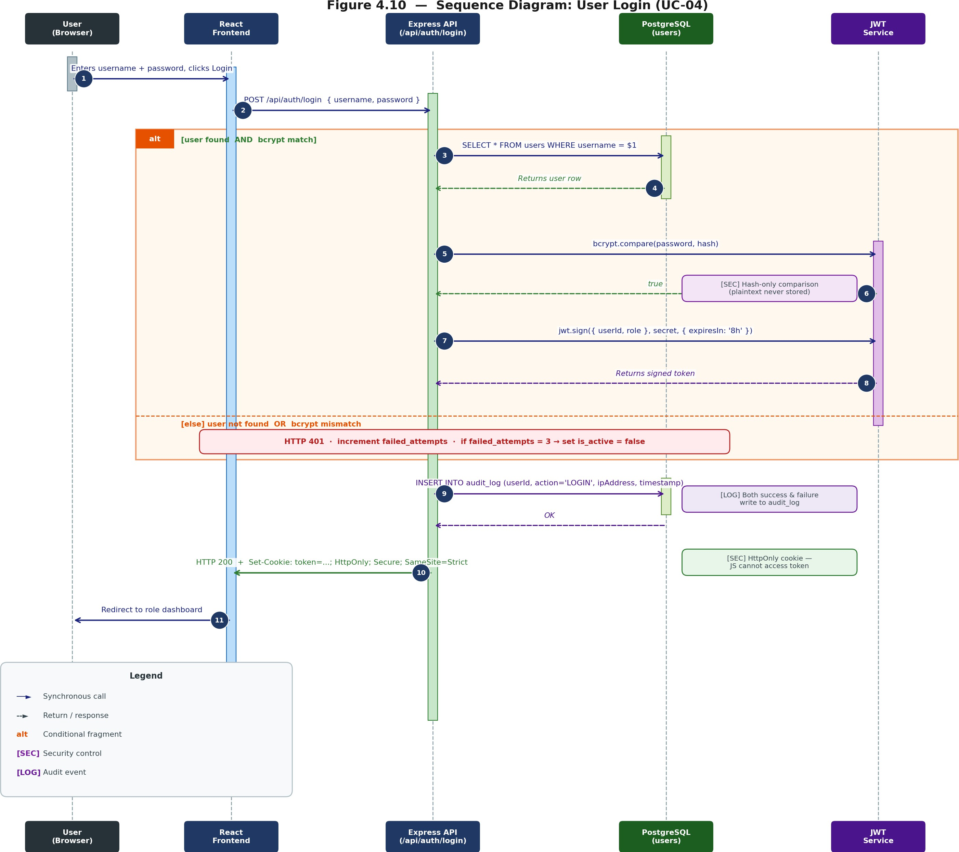

Figure H.1 Sequence Diagram: User Login (UC-04)

Login is the first security checkpoint for the whole system. Key decisions made in this architecture include: (1) No comparisons of the password are done in clear text; bcrypt.compare() is performed solely on the hashed value; (2) the JWT token is set as an httpOnly cookie so it cannot be accessed via JavaScript; (3) Both successful and unsuccessful authentication writes to the audit log.

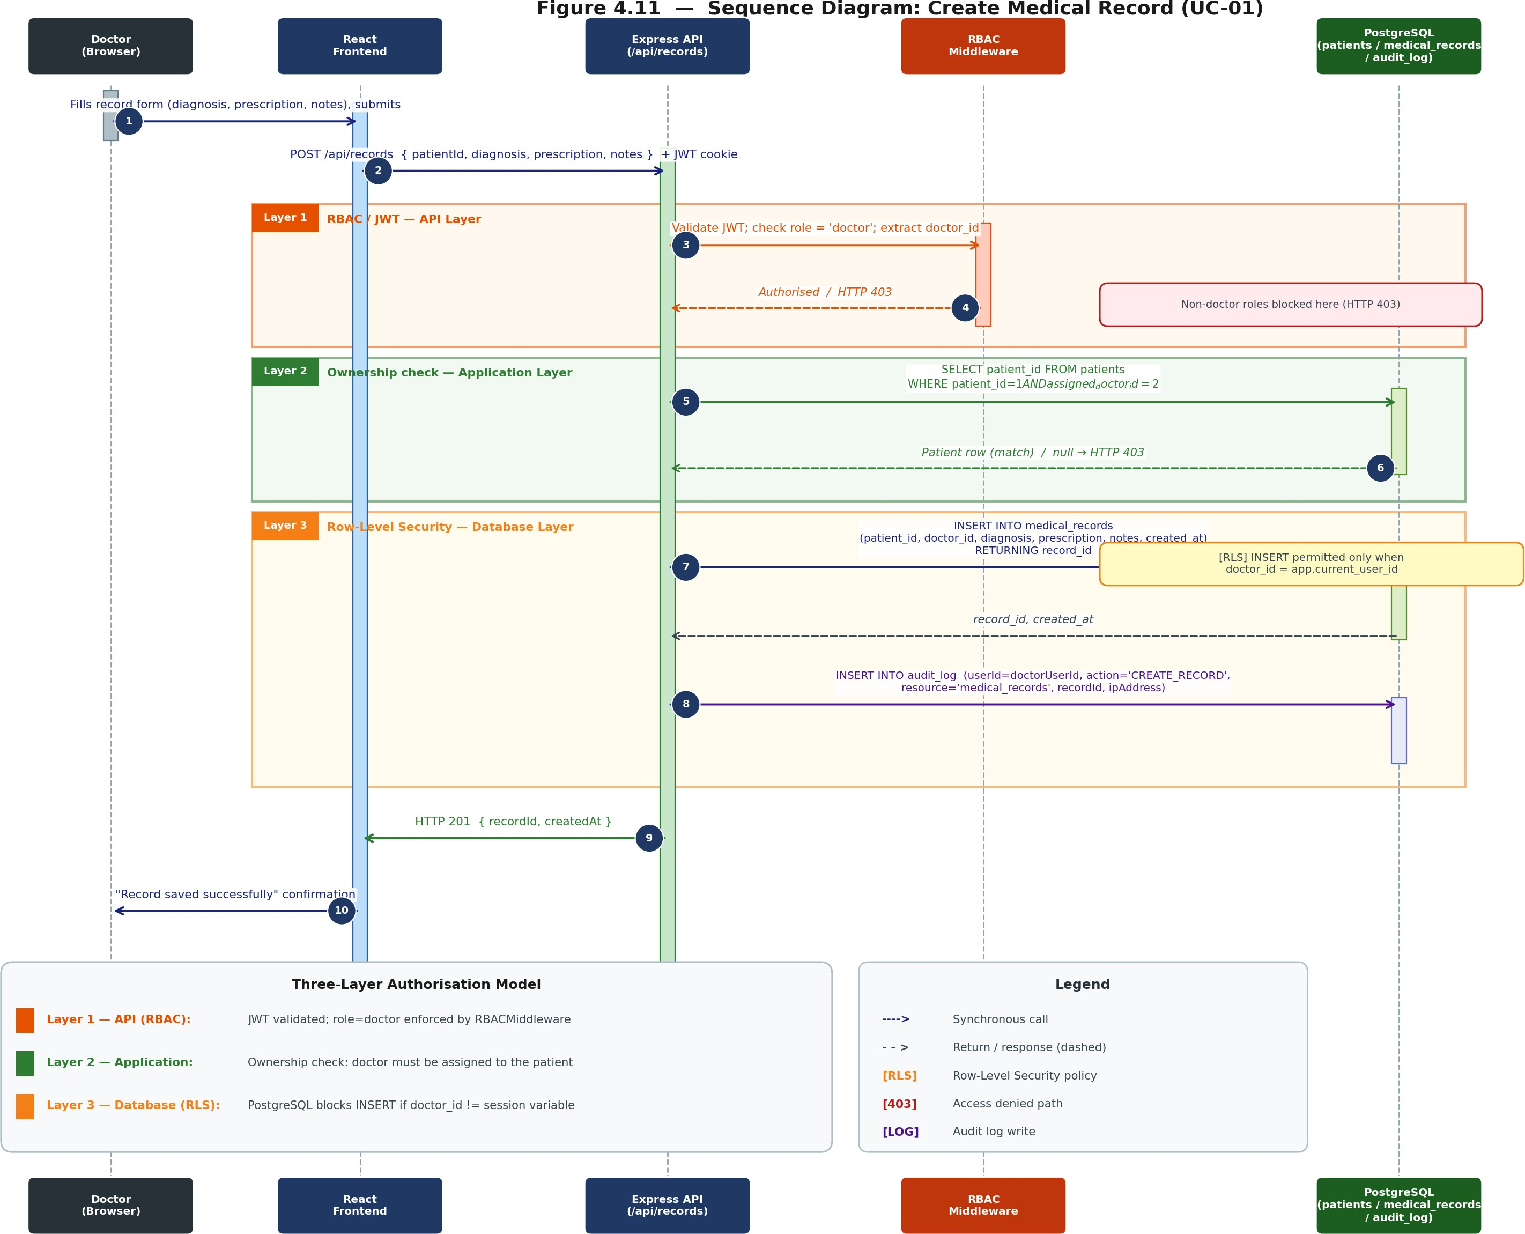
Figure H.2 Sequence Diagram: Create Medical Record (UC-01)

This figure illustrates the use of the three-layer authorization pattern on the most sensitive write transaction in the application. RBAC Middleware in step 3 prevents all other users except Doctors from accessing the application API. Ownership check at step 5 guarantees that the specific doctor is responsible for the particular patient, which is verified in the application layer. RLS on step 7 denotes enforcement in the database layer.

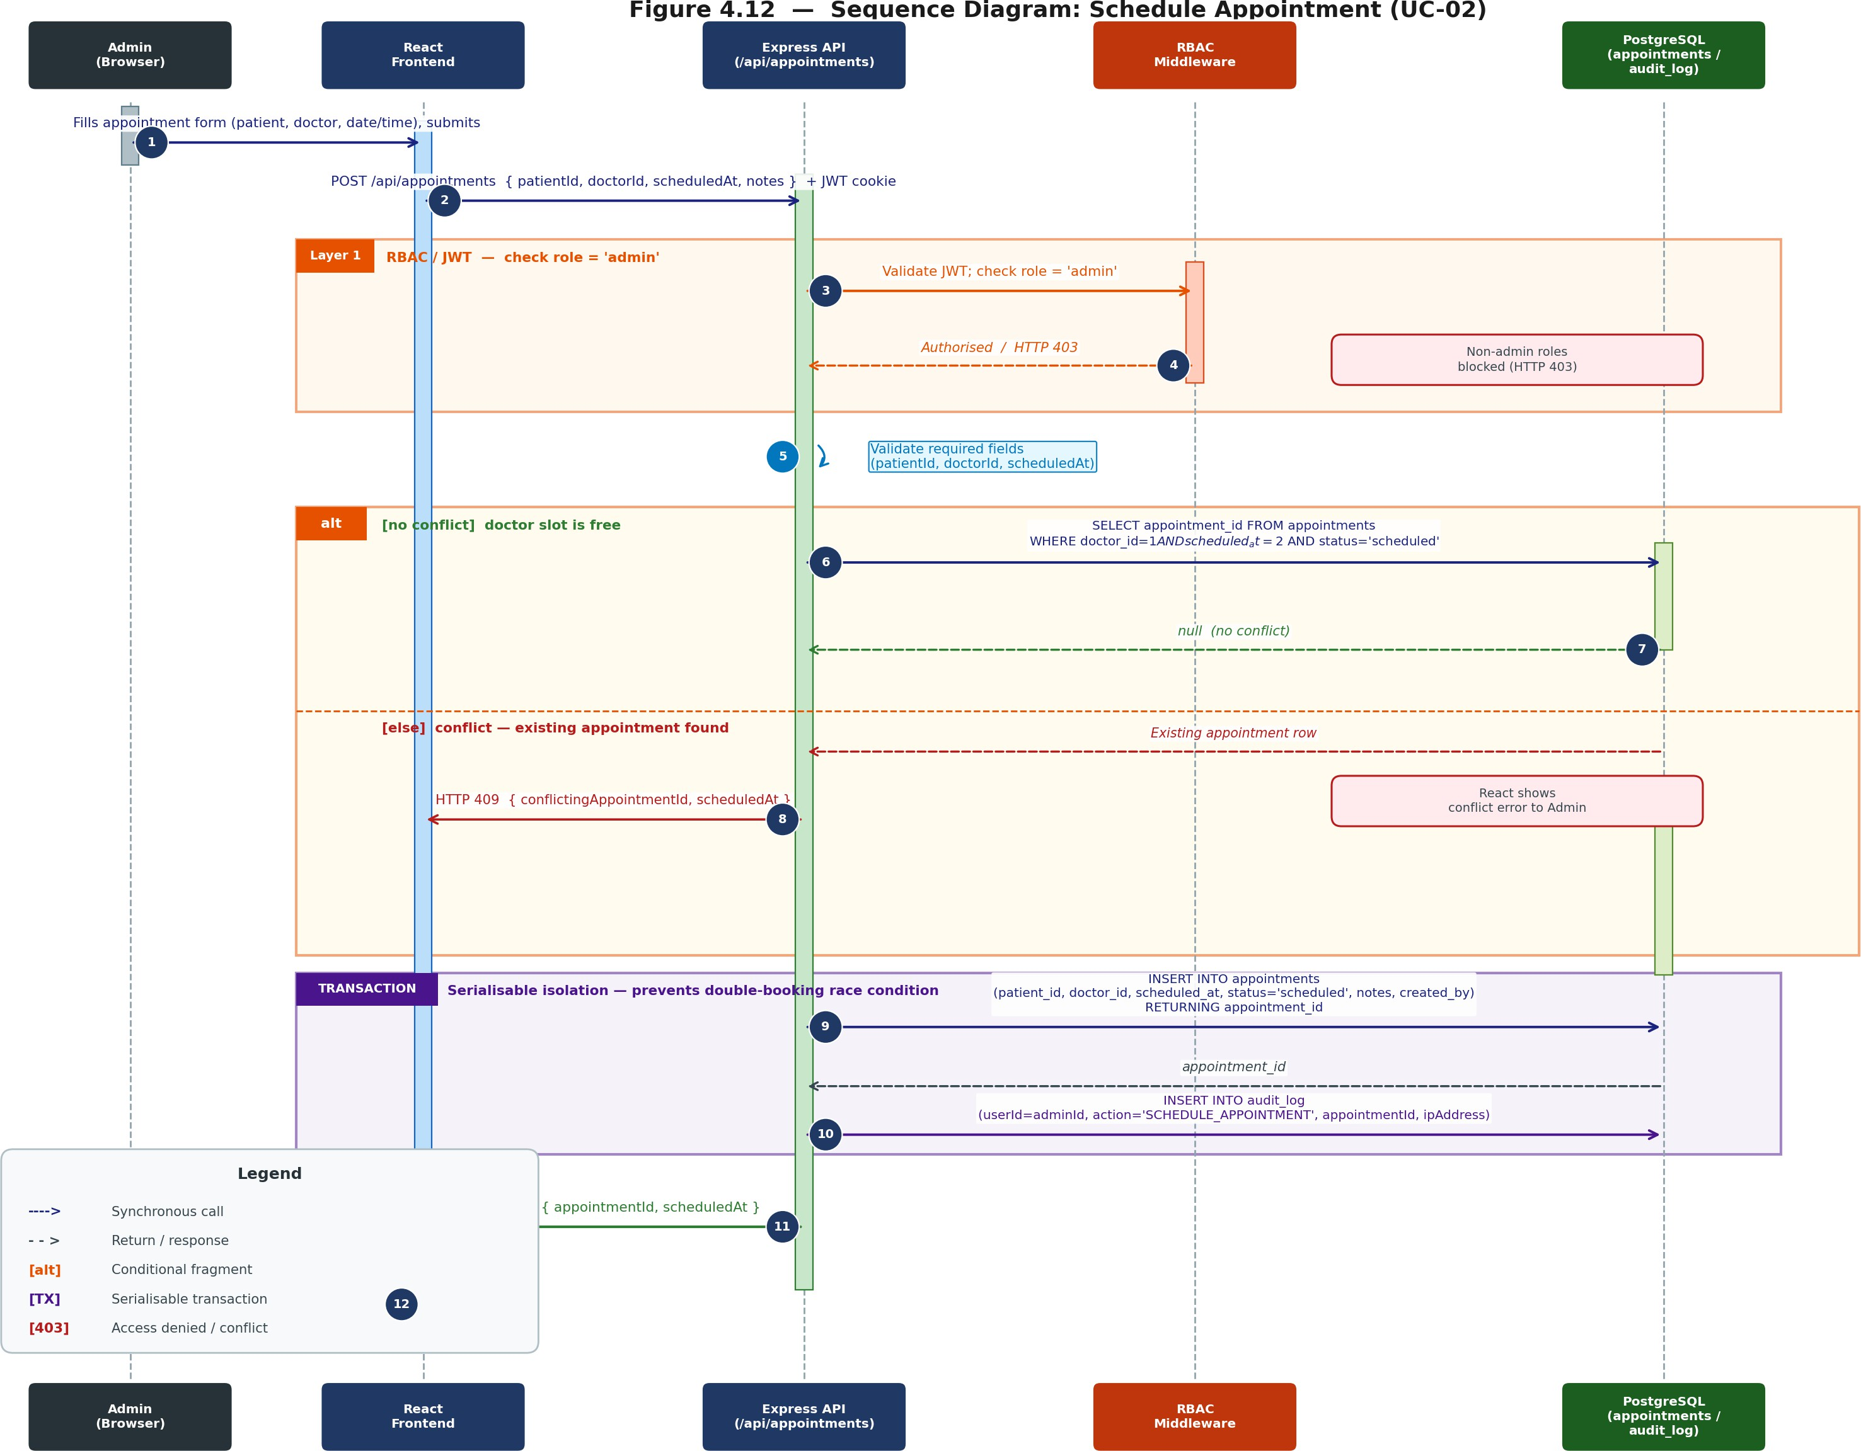
Figure H.3 Sequence Diagram: Schedule Appointment (UC-02)

The scheduling algorithm brings in the conflict checking mechanism. The database will check whether there exists any appointment for that doctor in the same time slot prior to saving, and return an HTTP 409 response upon finding any conflict. Step 9 and Step 10 are executed in a serializable transaction to avoid any race condition between two admins scheduling the same slot.

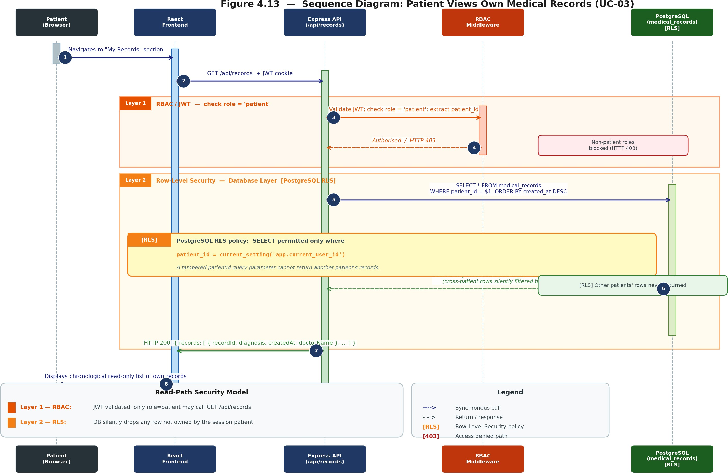
Figure H.4 Sequence Diagram: Patient Views Own Medical Records (UC-03)

This is the example of how the read-path security approach works for the Patient role. Step 6 here, where RLS is annotated, is the critical step because even when the hacker attempts to manipulate the API request using the altered patient id, the RLS feature automatically filters out all the records that do not belong to the authenticated session user in the database layer.

