DESIGN AND DEPLOYMENT OF A SECURE CLOUD-BASED PATIENT DATA MANAGEMENT SYSTEM USING A THREE-TIER ARCHITECTURE ON AWS

MOHAMED OMAR MOHAMED GAD MAKHLOUF

UNIVERSITI TEKNOLOGI MALAYSIA
PSZ 19:16 (Pind. 1/13)
UNIVERSITI TEKNOLOGI MALAYSIA

DECLARATION OF THESIS / UNDERGRADUATE PROJECT REPORT AND COPYRIGHT
Author’s full name : MOHAMED OMAR MOHAMED GAD MAKHLOUF

Date of Birth : 27/09/2003

Title : DESIGN AND DEPLOYMENT OF A SECURE CLOUD-BASED
PATIENT DATA MANAGEMENT SYSTEM USING A THREE-TIER ARCHITECTURE ON AWS

Academic Session :

I declare that this thesis is classified as:

 | CONFIDENTIAL | (Contains confidential information under the Official Secret Act 1972)*
 | RESTRICTED | (Contains restricted information as specified by the organization where research was done)*
 | OPEN ACCESS | I agree that my thesis to be published as online open access (full text)

- I acknowledged that Universiti Teknologi Malaysia reserves the right as follows:
  - The thesis is the property of Universiti Teknologi Malaysia
  - The Library of Universiti Teknologi Malaysia has the right to make copies for the purpose of research only.
  - The Library has the right to make copies of the thesis for academic exchange.
 |  |  | Certified by:
 | SIGNATURE OF STUDENT |  | SIGNATURE OF SUPERVISOR
 | A23CS4014 |  | DR. Johan Mohamad Sharif
 | MATRIX NUMBER |  | NAME OF SUPERVISOR
 | Date: 10 MAY 2026 |  | Date: 10 MAY 2026

NOTES : If the thesis is CONFIDENTIAL or RESTRICTED, please attach with the letter from the organization with period and reasons for confidentiality or restriction

“I hereby declare that we have read this thesis and in my
opinion this thesis is suffcient in term of scope and quality for the
award of the degree of Bachelor of Computer Science (Computer Networks & Security)”

Signature | : | ________________________________
Name of Supervisor | : | JOHAN MOHAMED SHARIF
Date | : | 10 May 2026

DESIGN AND DEPLOYMENT OF A SECURE CLOUD-BASED PATIENT DATA MANAGEMENT SYSTEM USING A THREE-TIER ARCHITECTURE ON AWS

MOHAMED OMAR MOHAMED GAD MAKHLOUF

A thesis submitted in fulfilment of the
requirements for the award of the degree of
Bachelor of Computer Science (Computer Networks & Security)

Faculty of Computing
Universiti Teknologi Malaysia

MAY 2026

DECLARATION

I declare that this thesis entitled “DESIGN AND DEPLOYMENT OF A SECURE CLOUD-BASED PATIENT DATA MANAGEMENT SYSTEM USING A THREE-TIER ARCHITECTURE ON AWS ” is the result of my own research except as cited in the references. The thesis has not been accepted for any degree and is not concurrently submitted in candidature of any other degree.

Signature | : | ....................................................
Name | : | MOHAMED OMAR MOHAMED GAD MAKHLOUF
Date | : | 10 May 2026

DEDICATION

This thesis is dedicated to my father, who taught me that the best kind of knowledge to have is that which is learned for its own sake. It is also dedicated to my mother, who taught me that even the largest task can be accomplished if it is done one step at a time.

ACKNOWLEDGEMENT
In preparing this thesis, I was in contact with many people, researchers, academicians, and practitioners. They have contributed towards my understanding and thoughts. In particular, I wish to express my sincere appreciation to my main thesis supervisor, Professor Dr. XX, for encouragement, guidance, critics and friendship. I am also very thankful to my co-supervisor Professor Dr YY and Associate Professor Dr. ZZZ for their guidance, advices and motivation. Without their continued support and interest, this thesis would not have been the same as presented here.
My fellow student should also be recognised for their support. My sincere appreciation also extends to all my colleagues and others who have provided assistance at various occasions. Their views and tips are useful indeed. Unfortunately, it is not possible to list all of them in this limited space. I am grateful to all my family member.

ABSTRACT
In this study, a design of the Secure Cloud-Based Patient Data Management System for the Alamin Clinic of Saudi Arabia, a privately owned healthcare organization, is introduced. This private healthcare facility faced the challenge of having its on-premise infrastructure penetrated by a ransomware that led to the encryption of all patient data and operational disruptions. Four major vulnerabilities that have allowed such cyber-attack are identified in this study. They include a flat network architecture; manual infrastructure management procedures; lack of data encryption capabilities, and a lack of infrastructure recovery plan. Thus, these factors enabled the ransomware attack. They are also indicative of the security posture of other similar small scale private healthcare organizations that use their legacy on-premises infrastructure.

In order to address these challenges, the proposed design uses a three-tier architecture hosted within the environment of Amazon Web Services, whereby presentation, application, and database layers are placed in separate subnets within a VPC and database tier has no Internet access paths. In addition, a solution with Infrastructure as Code is used using Terraform. It allows not only an automated process of deployment but also quick recovery in case of infrastructure malfunctioning. The DevSecOps continuous integration and delivery pipeline incorporates Trivy, SonarQube, and Checkov applications and provides automated vulnerability scan at each commit, making any critical finding impossible to deploy. Finally, the access to the application and database is restricted using Identity and Access Management policies and Role Based Access Control. Row-level security of the PostgreSQL databases ensures the enforcement of individual data isolation at the storage layer.

The proposed network topology, security group configuration, database schema with row-level security policies, DevSecOps pipeline specifications, and wireframe for interfaces are included in this design to establish an architectural blueprint for PSM2 implementation. The main evaluation criteria are set as a recovery time objective under fifteen minutes and achieving passing HIPAA security posture, measured through AWS Security Hub.

ABSTRAK
Dalam kertas penyelidikan ini, reka bentuk Sistem Pengurusan Data Pesakit Berasaskan Awan yang Selamat untuk Klinik Alamin di Arab Saudi, sebuah organisasi penjagaan kesihatan swasta, diperkenalkan. Fasiliti ini menghadapi cabaran pencerobohan infrastruktur on-premise oleh perisian tebusan yang mengakibatkan penyulitan data pesakit dan gangguan operasi. Empat kerentanan utama dikenal pasti: seni bina rangkaian rata, pengurusan infrastruktur manual, ketiadaan penyulitan data, dan ketiadaan pelan pemulihan. Faktor ini membolehkan serangan tersebut dan mencerminkan tahap keselamatan organisasi kesihatan kecil lain yang menggunakan infrastruktur warisan.
Bagi menangani cabaran ini, reka bentuk cadangan menggunakan seni bina tiga lapis pada Amazon Web Services, di mana lapisan persembahan, aplikasi, dan pangkalan data diasingkan dalam subnet VPC tanpa capaian Internet bagi pangkalan data. Infrastruktur sebagai Kod menggunakan Terraform membolehkan pelaksanaan automatik dan pemulihan pantas. Talian paip DevSecOps menyepadukan Trivy, SonarQube, dan Checkov untuk imbasan kerentanan automatik pada setiap commit bagi menghalang penggunaan kod berisiko. Capaian dihadkan melalui polisi IAM dan RBAC, manakala keselamatan peringkat baris PostgreSQL memastikan pengasingan data pada lapisan storan.
Topologi rangkaian, konfigurasi kumpulan keselamatan, skema pangkalan data, spesifikasi talian paip DevSecOps, dan rangka dawai antara muka disertakan sebagai pelan tindakan pelaksanaan PSM2. Kriteria penilaian utama adalah objektif masa pemulihan bawah lima belas minit dan pencapaian tahap keselamatan HIPAA melalui AWS Security Hub.

TABLE OF CONTENTS
 | TITLE | PAGE

DECLARATION ii
DEDICATION iii
ACKNOWLEDGEMENT iv
ABSTRACT v
ABSTRAK vi
TABLE OF CONTENTS vii
LIST OF TABLES x
LIST OF FIGURES xi
LIST OF ABBREVIATIONS xii
LIST OF SYMBOLS xiii
LIST OF APPENDICES xiv
CHAPTER 1 INTRODUCTION 1
1.1 Introduction 1
1.2 Problem Background 1
1.3 Project Aim 2
1.4 Project Objectives 2
1.5 Project Scope 3
1.6 Project Importance 3
1.7 Report Organization 3
CHAPTER 2 LITERATURE REVIEW 5
2.1 Introduction 5
2.2 Case Study (If any) 6
2.2.1 Company Organization Structure 6
2.2.2 Manual Operation 7
2.3 Current System Analysis 7
2.4 Comparison between existing systems 8
2.5 Literature Review of Technology Used 8
2.6 Chapter Summary 8
CHAPTER 3 SYSTEM DEVELOPMENT METHODOLOGY 9
3.1 Introduction 9
3.2 Methodology Choice and Justification 9
3.3 Phases of the Chosen Methodology 9
3.4 Technology Used Description 10
3.5 System Requirement Analysis 10
3.6 Chapter Summary 11
CHAPTER 4 REQUIREMENT ANALYSIS AND DESIGN 12
4.1 Introduction 12
4.2 Requirement Analysis 12
4.3 Project Design 12
4.4 Database Design 12
4.5 Interface Design 13
4.6 Chapter Summary 13
CHAPTER 5 IMPLEMENTATION AND TESTING 15
5.1 Introduction 15
5.2 Coding of System Main Functions 15
5.3 Interfaces of System Main Functions 15
5.4 Testing 16
5.4.1 Black box Testing 16
5.4.1.1 System Flow 16
5.4.1.2 Input Output Verification 17
5.4.1.3 Error Messages 17
5.4.2 White box Testing 17
5.4.3 User Testing 18
5.5 Chapter Summary 18
CHAPTER 6 CONCLUSION 19
6.1 Introduction 19
6.2 Achievement of Project Objectives 19
6.3 Suggestions for Future Improvement 19
REFERENCES 21

LIST OF TABLES
TABLE NO. | TITLE | PAGE
Table 2.1 Example Repeated Header Table 6
Table 2.2 Regression analysis for the results of preliminary feature screening 6
Table 2.3 Estimated effects and regression coefficients for the recogniser's performance (reduced model) 6
Table 4.1 Regression analysis for the results of preliminary feature screening 14
Table A.1 Example Repeated Header Table 24

LIST OF FIGURES
FIGURE NO. | TITLE | PAGE
Figure 2.1 Alamin Clinic Organization Strucure 11

LIST OF ABBREVIATIONS
AES | - | Advanced Encryption standard
ALB | - | Application Load Balancer
API | - | Application Programming Interface
AWS | - | Amazon Web Services
AZ | - | Availability Zone
CI/CD  CIDR | - | Continuous Integration and Continuous Delivery  Classless Inter-Domain Routing
CVE | - | Common Vulnerabilities and Exposures
DevSecOps | - | Development, Security, and Operations
EBS | - | Elastic Block Store
ECR | - | Elastic Container Registry
EHR  ER  FHIR  FR  FTP  HCL  HIPAA  HL7  HMS  HTTPS  IAM  IAC  JWT  KMS  NACL  NAT  NFR  NVD  PC  PDMS  PDPA  PSM  RBAC  RDS  RTO  SAST  SHA  SQL  SSL  TLS  UAT  UC  UML  US  UTM  UUID  VPC  YAML | -  -  -  -  -  -  -  -  -  -  -  -  -  -  -  -  -  -  -  -  -  -  -  -  -  -  -  -  -  -  -  -  -  -  -  -  -  - | Electronic Health Record  Entity-Relationship  Fast Healthcare Interoperability Resources  Functional Requirement  File Transfer Protocol  HashiCorp Configuration Language  Health Insurance Portability and Accountability Act  Health Level 7  Hospital Management System  Hypertext Transfer Protocol Secure  Identity and Access Management  Infrastructure as Code  JSON Web Token  Key Management Service  Network Access Control List  Network Address Translation  Non-Functional Requirement  National Vulnerability Database  Personal Computer  Patient Data Management System  Personal Data Protection Act  Projek Sarjana Muda  Role-Based Access Control  Relational Database Service  Recovery Time Objective  Static Application Security Testing  Secure Hash Algorithm  Structured Query Language  Secure Sockets Layer  Transport Layer Security  User Acceptance Testing  Use Case  Unified Modelling Language  User Story  Universiti Teknologi Malaysia  Universally Unique Identifier  Virtual Private Cloud  YAML Ain't Markup Language

LIST OF SYMBOLS
δ | - | Minimal error
 | - | Diameter
 | - | Force
 | - | Velocity
 | - | Pressure
 | - | Moment of Inersia
 | - | Radius
 | - | Reynold Number

LIST OF APPENDICES
APPENDIX | TITLE | PAGE
Appendix A Mathematical Proofs 23
Appendix B Psuedo Code 25
Appendix C Time-series Results Long 26

INTRODUCTION

Introduction

The quick adoption of digital technologies has transformed the entire process of collecting and storing information in the clinic. Transitioning from paper-based processes to the use of EHRs in clinics and hospitals has made healthcare information management infrastructure crucial since sensitive patient data must be protected. Information security and protection of confidential patient information has always been an area of concern, especially in cases of breach where patient privacy and security is put at risk.
While the importance of adopting a secure infrastructure becomes obvious with the growth in the number of cybersecurity threats, there are still many small clinics and hospitals which rely on the legacy on-premises server solution and ignore the growing risks associated with the lack of adequate cybersecurity measures. Traditional server infrastructure does not allow implementing any additional measures to prevent attacks or limit their impact on the system, thus increasing the risks considerably.
Thus, this project aims at designing and implementing a cloud-based solution that would be able to effectively protect patients' confidential information from malicious attacks and unauthorized access. The proposed cloud-based system will feature a three-tier architecture and be deployed into isolated network subnets using Virtual Private Cloud (VPC) and Infrastructure as Code (IaC) solutions such as Terraform. The DevSecOps pipeline will enable developers to scan every piece of code before deployment.
A practical example motivating the adoption of a new system is represented by the case of the Alamin Clinic which suffered a cyberattack and became a victim of ransomware. Thus, the selected organization will provide requirements for the system design and implementation to solve the identified problem.

Problem Background
At present, the management of the patient data management system at the Alamin Clinic relies on an on-premises physical server that provides services of the web frontend, application backend, and patient database in a single network without any segmentation of layers of the architecture. In other words, all of these elements of infrastructure are manually configured, deployed, and managed; for example, the code for applications is deployed to a production environment through FTP or USB drive while updates for antivirus programs and firewalls are applied on a reactive basis with significant delays.
However, such an approach revealed its flaws when the clinic was hacked and its patients' data was affected by the ransomware threat. Namely, the hackers gained access to the system, freely roamed the network, and encrypted the entire database. Due to the lack of network segmentation, all the components of the system became vulnerable and unusable until the manual restoration of data. Lack of automation and regular backups increased downtime and made it impossible to restore data timely.
It appears that the problem described above aligns with a wider issue that affects small healthcare organizations. (Argaw et al., 2019) noted that cyberattacks in hospitals take advantage of old infrastructure, poor network segregation, and inadequate patching policies. Moreover, as (Al-Issa et al., 2019) reported, cloud computing technologies used in the healthcare industry have some specific problems related to access management and data exposure, among others.
In sum, the problems described above reveal one major gap typical for small-scale organizations – lack of proper information security measures implemented since the beginning. To address the issue, the proposed solution will be based on cloud computing and ensure security from the very beginning through adherence to the security-by-design principle.

Project Aim
The aim of this project is to design and deploy a secure cloud-based Patient Data Management System for Alamin Clinic using a three-tier architecture on AWS, incorporating Infrastructure as Code and a DevSecOps pipeline to ensure automated, reproducible, and security-validated deployments.

Project Objectives
The objectives of the project are:
(a) To investigate core concepts including cloud computing security, three-tier architecture, network segmentation, Identity and Access Management, and secure system design practices within the context of healthcare applications.
(b) To develop a secure Cloud-Based Patient Data Management System based on a three-tier architecture on AWS, covering Virtual Private Cloud networking, access control through IAM and Role-Based Access Control (RBAC), and a DevSecOps CI/CD pipeline with integrated security scanning.
(c) To evaluate the system’s performance through automated vulnerability scanning using Trivy, SonarQube, and Checkov. Evaluation includes RTO stress testing via a simulated ransomware recovery scenario and a HIPAA compliance assessment using AWS Security Hub. Finally, User Acceptance Testing (UAT) will be conducted with Doctors, Admins, and Patients to validate functional requirements.

Project Scope
This project focuses on the design and deployment of a Secure Patient Data Management System for use by doctors, administrative staff, and patients at Alamin Clinic. The system will be deployed on AWS as a functional prototype, with security evaluation evidence provided through scan reports, CloudWatch logs, and recovery time test results.

In-Scope
The following areas are within the scope of this project:
(a) Core patient record management functionality, including Patient Registration, Medical Records Management, Appointment Scheduling, and User Authentication with Role Management (Doctor, Admin, Patient).
(b) Design of a Virtual Private Cloud (VPC) with public subnets for internet-facing components and private subnets for the application and database layers.
(c) Three-tier architecture comprising a React frontend layer, a Node.js/Express backend layer on EC2, and a PostgreSQL database layer on Amazon RDS.
(d) AWS services including VPC, EC2, RDS, Application Load Balancer (ALB), NAT Gateway, and Internet Gateway.
(e) Network security controls including Security Groups and Network Access Control Lists (NACLs).
(f) Identity and Access Management (IAM) with least-privilege policies and Role-Based Access Control (RBAC) enforced across all three user roles.
(g) Data encryption at rest using AES-256 through AWS Key Management Service (KMS) and encryption in transit using TLS/HTTPS.
(h) A DevSecOps CI/CD pipeline built on GitHub Actions with Docker containerisation and Terraform IaC, incorporating automated security scanning using Trivy (container images), SonarQube (static code analysis), and Checkov (IaC misconfiguration scanning).
(i) Monitoring and audit logging using Amazon CloudWatch and AWS CloudTrail, with defined alerting thresholds and log retention policies.
(j) HIPAA compliance posture assessment using AWS Security Hub.

Data and Subjects
The system will be evaluated using a pilot dataset of simulated patient records generated for testing purposes. User Acceptance Testing will be conducted with a minimum of three representative participants, one per user role (Doctor, Admin, Patient). No real patient data will be used during development or testing.

Out-of-Scope
To maintain focus on the security architecture and infrastructure, the following modules are explicitly excluded from this project:

- Hospital billing and insurance claim management
- Pharmacy inventory and dispensing management
- Emergency Room (ER) management
- Obstetrics and Gynaecology (O&G) clinical modules

Project Importance
The importance of the project comes out in several aspects: clinical, technical, and academic.
First of all, when it comes to clinical issues, one should understand that patient information is considered to be one of the most sensitive types of personal data. An information leak or loss of availability caused by a ransomware attack like in Alamin Clinic's case may have serious consequences, both for patients and doctors, as well as reputational and legal ramifications. Therefore, the development of a system that will be characterized by high availability, security, and integrity of patient data cannot be regarded merely as a technical task.
Secondly, one needs to consider the technical part of the project. Infrastructure as Code and DevSecOps approaches allowed for the conversion of an outdated and manual environment into a self-healing infrastructure with the use of code and security validation. The whole infrastructure is coded using the Terraform language, and this gives us the opportunity to redeploy it from a clean state in minutes. Furthermore, a security scan conducted prior to deployment ensures that any threats are discovered and prevented from moving forward.
Finally, let us focus on the academic aspect. In this case, our project allows for practical application of the theoretical notions in terms of cloud security. Using HIPAA as the standard of compliance and AWS Security Hub as an evaluation tool, we create a more industry-oriented way of testing.

Report Organization
This report is organized as follows:

Chapter 1 — Introduction presents the background to the project, the problem statement at Alamin Clinic, the project aim and objectives, scope, and the importance of the study.

Chapter 2 — Literature Review presents a complete literature analysis relevant to the project. Analysis of the current system at Alamin Clinic, a comparison of existing healthcare management systems, and a review of the technologies and methods employed in the proposed solution, including cloud security, three-tier architecture, Infrastructure as Code, and DevSecOps practices.
Chapter 3 — System Development Methodology describes the development approach adopted for this project. It justifies the choice of methodology, outlines its phases as applied to this system, describes the technologies used, and presents the system requirements analysis.
Chapter 4 — Requirement Analysis and Design present the detailed functional and non-functional requirements of the system, followed by the complete system design including the network architecture, database schema, IAM policy structure, and system interface design.
Chapter 5 — Conclusion summarizes the achievement of the project objectives, reflects on the limitations of the current implementation, and proposes directions for future improvement.

LITERATURE REVIEW

Introduction
Developing a secure cloud-based system that manages patients’ information include knowledge drawn from various connected areas, which involve threats faced by healthcare information systems, architecture principles used in cloud computing, regulations controlling patients’ data, and DevSecOps processes that ensure that the system is developed and deployed in a secure manner. In this chapter, the various areas that provide knowledge on how the proposed system can be designed are reviewed. This is done through first considering the case study organization before moving to general technological and scholarly literature.
Section 2.2 introduces the case study organization, Alamin Clinic, through analysing its organizational structure, current manual operating model, and the outcomes from an interview of key people within the clinic. The section further analyzes the difference between the process followed currently and the process followed when the new system is introduced in the clinic. Section 2.3 carries out a 5W 1H analysis on the problems faced by the current system. Section 2.4 compares the proposed system to existing healthcare management systems, including the unique aspects that have been derived from each existing healthcare management system. Section 2.5 highlights the major technologies used in designing the new system and their supporting literature. Section 2.6 presents key conclusions from the literature review.

Case Study: Alamin Clinic (Saudi Arabia)
Alamin Clinic is a private independent health care service in Saudi Arabia. In essence, this is the organization to be considered a stakeholder and used as the main case study for this proposal. The incident that has happened to Alamin Clinic and led to the development of this idea was an attack by ransomware on their on-site IT services.
The patient base of Alamin Clinic includes people who seek various types of consultations, follow-up sessions, and health record administration services. The key stakeholders, which include doctors, administrative personnel, and patients themselves, all have different ways of interacting with the database of patients in the clinic, and therefore, will need different access control mechanisms. this diversity of roles makes the design of a Role-Based Access Control (RBAC) model a fundamental requirement of the proposed system.

Alamin Clinic: Organization Structure
Alamin Clinic has a three-level organizational hierarchy that is usually common among small private clinics in the region.

The clinical level consists of general practitioners and specialist doctors who consult patients, diagnose illnesses, and keep medical records. Doctors need read and write permissions on the medical records they treat. They should not be able to access administrative records like bills and salaries of employees.

The administrative level is made up of people who register and schedule patients. Administrators should only be able to access registration data and appointment data but should not be able to see anything else like medical records. Separation of responsibilities is vital for patient confidentiality and should be guaranteed by the IAM structure proposed here.

Patients registered at Alamin Clinic can log into the application and check their medical records and scheduled appointments. Patient access will only allow them to read their records but not any other data like other patients' records or any administrative record.

The clinic also has a basic IT function that had only one on-premise server. There was no security policy or any patch management policy before the proposed migration.

The organizational structure is illustrated in Figure 2.1.

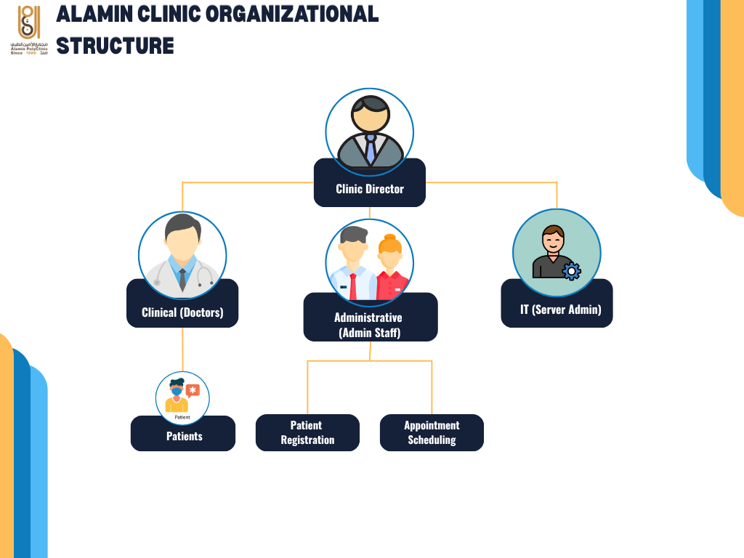
Figure 2.1 Alamin Clinic Organizational Structure

Manual Operation
The existing system used at Alamin Clinic for storing patient information follows a traditional on-premises design model defined by the following characteristics: manual server configuration, manual deployment, local hosting, and reactive security.
Manual Server Configuration. The server hardware installed at the clinic is configured locally by IT personnel employed by the clinic. Server configuration is accomplished manually without maintaining infrastructure versions and automating server deployment processes. This methodology is inherently flawed because it relies on manual configuration of servers with no control over drift. It is impossible to roll back the configuration in case of failure because no automated server provisioning is used (Paidy & Chaganti, 2024).
Manual Deployment. Code deployed in the development environment is manually moved to the production server with the use of either FTP clients or storage devices, such as USB drives. This methodology prolongs the deployment time considerably and prevents implementing automatic checks of the code for security or quality issues prior to deploying it to the production environment. Furthermore, the manual deployment process ensures that malware can enter the production environment bypassing any controls.
Local Hosting. The frontend of the website, the backend logic of the application, and the patient database are all hosted on the same physical server. There is no network segmentation between these layers, which means that gaining access to any of the components is sufficient to access the rest. The absence of network segmentation is considered one of the key factors that contribute to ransomware infections among healthcare facilities, allowing the malicious code to move directly from the internet-exposed layer to the database layer (Argaw et al., 2019).
Reactive Security. Firewalls and antivirus solutions are regularly updated manually by IT personnel according to available information about existing threats. This practice does not provide adequate protection against emerging cyberattacks because the updates are carried out reactively and are therefore lagging behind the threat landscape. As a result, known vulnerabilities are patched late, exposing the facility to attacks.

Current System Analysis
Study of theory/algorithm/method that can contribute towards solving the problem, Justification of chosen theory/algorithm/method, Every sub-topic within the domain must have a review.
(2.1)
To change the way a picture fits in your document, click it and a button for layout options appears next to it. When you work on a table, click where you want to add a row or a column, and then click the plus sign. Reading is easier, too, in the new Reading view. You can collapse parts of the document and focus on the text you want. If you need to stop reading before you reach the end, Word remembers where you left off - even on another device. Video provides a powerful way to help you prove your point. When you click Online Video, you can paste in the embed code for the video you want to add. You can also type a keyword to search online for the video that best fits your document. To make your document look professionally produced, Word provides header, footer, cover page, and text box designs that complement each other. For example, you can add a matching cover page, header, and sidebar.

Comparison between existing systems
Video provides a powerful way to help you prove your point. When you click Online Video, you can paste in the embed code for the video you want to add. You can also type a keyword to search online for the video that best fits your document. To make your document look professionally produced, Word provides header, footer, cover page, and text box designs that complement each other. For example, you can add a matching cover page, header, and sidebar.

Literature Review of Technology Used
Video provides a powerful way to help you prove your point. When you click Online Video, you can paste in the embed code for the video you want to add. You can also type a keyword to search online for the video that best fits your document. To make your document look professionally produced, Word provides header, footer, cover page, and text box designs that complement each other. For example, you can add a matching cover page, header, and sidebar.

Chapter Summary
Video provides a powerful way to help you prove your point. When you click Online Video, you can paste in the embed code for the video you want to add. You can also type a keyword to search online for the video that best fits your document. To make your document look professionally produced, Word provides header, footer, cover page, and text box designs that complement each other. For example, you can add a matching cover page, header, and sidebar.

SYSTEM DEVELOPMENT METHODOLOGY

Introduction
On the Insert tab, the galleries include items that are designed to coordinate with the overall look of your document. You can use these galleries to insert tables, headers, footers, lists, cover pages, and other document building blocks. When you create pictures, charts, or diagrams, they also coordinate with your current document look. You can easily change the formatting of selected text in the document text by choosing a look for the selected text from the Quick Styles gallery on the Home tab.

Methodology Choice and Justification
On the Insert tab, the galleries include items that are designed to coordinate with the overall look of your document. You can use these galleries to insert tables, headers, footers, lists, cover pages, and other document building blocks. When you create pictures, charts, or diagrams, they also coordinate with your current document look. You can easily change the formatting of selected text in the document text by choosing a look for the selected text from the Quick Styles gallery on the Home tab.

Phases of the Chosen Methodology
On the Insert tab, the galleries include items that are designed to coordinate with the overall look of your document. You can use these galleries to insert tables, headers, footers, lists, cover pages, and other document building blocks. When you create pictures, charts, or diagrams, they also coordinate with your current document look. You can easily change the formatting of selected text in the document text by choosing a look for the selected text from the Quick Styles gallery on the Home tab.

Technology Used Description
On the Insert tab, the galleries include items that are designed to coordinate with the overall look of your document. You can use these galleries to insert tables, headers, footers, lists, cover pages, and other document building blocks.

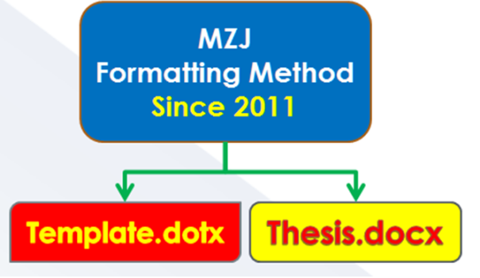
Figure 3.1 Example of Formatting Method

System Requirement Analysis
Video provides a powerful way to help you prove your point. When you click Online Video, you can paste in the embed code for the video you want to add. You can also type a keyword to search online for the video that best fits your document. To make your document look professionally produced, Word provides header, footer, cover page, and text box designs that complement each other. For example, you can add a matching cover page, header, and sidebar.

Chapter Summary
Video provides a powerful way to help you prove your point. When you click Online Video, you can paste in the embed code for the video you want to add. You can also type a keyword to search online for the video that best fits your document. To make your document look professionally produced, Word provides header, footer, cover page, and text box designs that complement each other. For example, you can add a matching cover page, header, and sidebar.

REQUIREMENT ANALYSIS AND DESIGN

Introduction
Video provides a powerful way to help you prove your point. When you click Online Video, you can paste in the embed code for the video you want to add. You can also type a keyword to search online for the video that best fits your document.

Requirement Analysis
Video provides a powerful way to help you prove your point. When you click Online Video, you can paste in the embed code for the video you want to add. You can also type a keyword to search online for the video that best fits your document.

Project Design
Video provides a powerful way to help you prove your point. When you click Online Video, you can paste in the embed code for the video you want to add. You can also type a keyword to search online for the video that best fits your document.

Database Design
Video provides a powerful way to help you prove your point. When you click Online Video, you can paste in the embed code for the video you want to add. You can also type a keyword to search online for the video that best fits your document.

Interface Design
Video provides a powerful way to help you prove your point. When you click Online Video, you can paste in the embed code for the video you want to add. You can also type a keyword to search online for the video that best fits your document.

Chapter Summary
Video provides a powerful way to help you prove your point. When you click Online Video, you can paste in the embed code for the video you want to add. You can also type a keyword to search online for the video that best fits your document.

Title | Title | Title | Title | Title | Title | Title
Table 4.1 Regression analysis for the results of preliminary feature screening

IMPLEMENTATION AND TESTING

Introduction
Video provides a powerful way to help you prove your point. When you click Online Video, you can paste in the embed code for the video you want to add. You can also type a keyword to search online for the video that best fits your document. To make your document look professionally produced, Word provides header, footer, cover page, and text box designs that complement each other. For example, you can add a matching cover page, header, and sidebar.

Coding of System Main Functions
Video provides a powerful way to help you prove your point. When you click Online Video, you can paste in the embed code for the video you want to add. You can also type a keyword to search online for the video that best fits your document. To make your document look professionally produced, Word provides header, footer, cover page, and text box designs that complement each other. For example, you can add a matching cover page, header, and sidebar.

Interfaces of System Main Functions
Video provides a powerful way to help you prove your point. When you click Online Video, you can paste in the embed code for the video you want to add. You can also type a keyword to search online for the video that best fits your document. To make your document look professionally produced, Word provides header, footer, cover page, and text box designs that complement each other. For example, you can add a matching cover page, header, and sidebar.

Testing
Video provides a powerful way to help you prove your point. When you click Online Video, you can paste in the embed code for the video you want to add. You can also type a keyword to search online for the video that best fits your document. To make your document look professionally produced, Word provides header, footer, cover page, and text box designs that complement each other. For example, you can add a matching cover page, header, and sidebar.

Black box Testing
Video provides a powerful way to help you prove your point. When you click Online Video, you can paste in the embed code for the video you want to add. You can also type a keyword to search online for the video that best fits your document. To make your document look professionally produced, Word provides header, footer, cover page, and text box designs that complement each other. For example, you can add a matching cover page, header, and sidebar.

System Flow
Video provides a powerful way to help you prove your point. When you click Online Video, you can paste in the embed code for the video you want to add. You can also type a keyword to search online for the video that best fits your document. To make your document look professionally produced, Word provides header, footer, cover page, and text box designs that complement each other. For example, you can add a matching cover page, header, and sidebar.

Input Output Verification
Video provides a powerful way to help you prove your point. When you click Online Video, you can paste in the embed code for the video you want to add. You can also type a keyword to search online for the video that best fits your document. To make your document look professionally produced, Word provides header, footer, cover page, and text box designs that complement each other. For example, you can add a matching cover page, header, and sidebar.

Error Messages
Video provides a powerful way to help you prove your point. When you click Online Video, you can paste in the embed code for the video you want to add. You can also type a keyword to search online for the video that best fits your document. To make your document look professionally produced, Word provides header, footer, cover page, and text box designs that complement each other. For example, you can add a matching cover page, header, and sidebar.

White box Testing
Video provides a powerful way to help you prove your point. When you click Online Video, you can paste in the embed code for the video you want to add. You can also type a keyword to search online for the video that best fits your document. To make your document look professionally produced, Word provides header, footer, cover page, and text box designs that complement each other. For example, you can add a matching cover page, header, and sidebar.

User Testing
Video provides a powerful way to help you prove your point. When you click Online Video, you can paste in the embed code for the video you want to add. You can also type a keyword to search online for the video that best fits your document. To make your document look professionally produced, Word provides header, footer, cover page, and text box designs that complement each other. For example, you can add a matching cover page, header, and sidebar.

Chapter Summary
Video provides a powerful way to help you prove your point. When you click Online Video, you can paste in the embed code for the video you want to add. You can also type a keyword to search online for the video that best fits your document. To make your document look professionally produced, Word provides header, footer, cover page, and text box designs that complement each other. For example, you can add a matching cover page, header, and sidebar.

CONCLUSION

Introduction
Video provides a powerful way to help you prove your point. When you click Online Video, you can paste in the embed code for the video you want to add. You can also type a keyword to search online for the video that best fits your document. To make your document look professionally produced, Word provides header, footer, cover page, and text box designs that complement each other. For example, you can add a matching cover page, header, and sidebar.

Achievement of Project Objectives
Video provides a powerful way to help you prove your point. When you click Online Video, you can paste in the embed code for the video you want to add. You can also type a keyword to search online for the video that best fits your document. To make your document look professionally produced, Word provides header, footer, cover page, and text box designs that complement each other. For example, you can add a matching cover page, header, and sidebar.

Suggestions for Future Improvement
Video provides a powerful way to help you prove your point. When you click Online Video, you can paste in the embed code for the video you want to add. You can also type a keyword to search online for the video that best fits your document. To make your document look professionally produced, Word provides header, footer, cover page, and text box designs that complement each other. For example, you can add a matching cover page, header, and sidebar.

REFERENCES
Chen, M.-C. and Huang, S.-H. (2003) ‘Credit scoring and rejected instances reassigning through evolutionary computation techniques’, Expert Systems with Applications, 24(4), pp. 433–441.
Clerc, M. and Kennedy, J. (2002) ‘The particle swarm - explosion, stability, and convergence in a multidimensional complex space’, IEEE Transactions on Evolutionary Computation, 6(1), pp. 58–73.
Gosnell, M., Woodley, R., Hicks, J. and Cudney, E. (2014) ‘Exploring the Mahalanobis-Taguchi Approach to Extract Vehicle Prognostics and Diagnostics’, in Computational Intelligence in Vehicles and Transportation Systems (CIVTS), 2014 IEEE Symposium on, pp. 84–91.
Gupta, A. (2015) ‘Classification of Complex UCI Datasets Using Machine Learning Algorithms Using Hadoop’, International Journal of Scetific & Techology Research, 4(5), pp. 85–94.
Hu, J., Zhang, L., Liang, W. and Wang, Z. (2009) ‘Incipient mechanical fault detection based on multifractal and MTS methods’, Petroleum Science, 6(2), pp. 208–216.
Huang, C.-L., Chen, Y. H. and Wan, T.-L. J. (2012) ‘The mahalanobis taguchi system—adaptive resonance theory neural network algorithm for dynamic product designs’, Journal of Information and Optimization Sciences, 33(6), pp. 623–635.
Jain, A. K. A. K., Duin, R. P. W. and Mao, J. (2000) ‘Statistical pattern recognition: a review’, IEEE Transactions on Pattern Analysis and Machine Intelligence, 22(1), pp. 4–37.
Khalid, S., Khalil, T. and Nasreen, S. (2014) ‘A survey of feature selection and feature extraction techniques in machine learning’, 2014 Science and Information Conference, pp. 372–378.
Li, C., Yuan, J. and Qi, Z. (2015) ‘Risky group decision-making method for distribution grid planning’, International Journal of Emerging Electric Power Systems, 16(6), pp. 591–602.
Lv, Y. and Gao, J. (2011) ‘Condition prediction of chemical complex systems based on Multifractal and Mahalanobis-Taguchi system’, in ICQR2MSE 2011 - Proceedings of 2011 International Conference on Quality, Reliability, Risk, Maintenance, and Safety Engineering, pp. 536–539.
der Maaten, L. J. P., Postma, E. O., den Herik, H. J., van der Maaten, L., Postma, E. O., van den Herik, J., der Maaten, L. J. P., Postma, E. O. and den Herik, H. J. (2009) ‘Dimensionality Reduction: A Comparative Review’, Technical Report TiCC TR 2009-005, 10(January), pp. 1–41.
Motwani, R. and Raghavan, P. (1996) ‘Randomized algorithms’, ACM Computing Surveys, 28(1), pp. 33–37.
Qinbao Song, Jingjie Ni and Guangtao Wang (2013) ‘A Fast Clustering-Based Feature Subset Selection Algorithm for High-Dimensional Data’, IEEE Transactions on Knowledge and Data Engineering, 25(1), pp. 1–14.
Rao, V. M. and Singh, Y. P. (2013) ‘Decision Tree Induction for Financial Fraud Detection’, in Proceeding of the International Conference on Artificial Intelligence in Computer Science and ICT (AICS 2013), pp. 321–328.
Shi, Y. and Eberhart, R. (1998) ‘A modified particle swarm optimizer’, 1998 IEEE International Conference on Evolutionary Computation Proceedings. IEEE World Congress on Computational Intelligence (Cat. No.98TH8360), pp. 69–73.
Soylemezoglu, A., Jagannathan, S. and Saygin, C. (2011) ‘Mahalanobis-Taguchi system as a multi-sensor based decision making prognostics tool for centrifugal pump failures’, IEEE Transactions on Reliability, 60(4), pp. 864–878.
Theodoridis, S., Koutroumbas, K., Holmstrom, L. and Koistinen, P. (2009) Pattern Recognition, Wiley Interdisciplinary Reviews Computational Statistics.
Zaki, M. J., Wong, L., Berry, M. J. A., Linoff, G. S., Hegland, M., Zaki, M. J. and Wong, L. (2003) ‘Data Mining Techniques’, WSPC/Lecture Notes Series: 9in x 6in, 10(1–2), p. 545.

Appendix A Mathematical Proofs
Video provides a powerful way to help you prove your point. When you click Online Video, you can paste in the embed code for the video you want to add. You can also type a keyword to search online for the video that best fits your document. To make your document look professionally produced, Word provides header, footer, cover page, and text box designs that complement each other. For example, you can add a matching cover page, header, and sidebar.
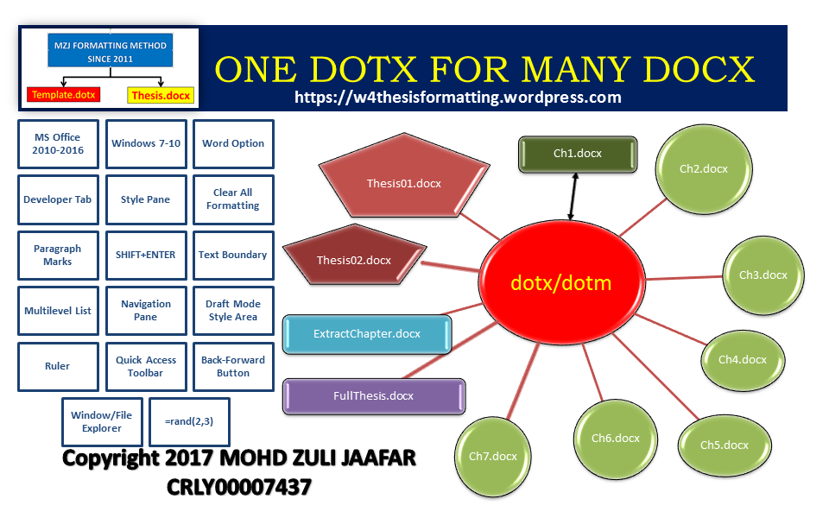
Figure A.1 xxxxxxxxxxxxxxxx


Figure A.2 xxxxxxxxxxxxxx

Table A.1 Example Repeated Header Table
Title | Title | Title | Title

Appendix B Psuedo Code

Appendix C Time-series Results Long

