Project Design Phase-II
Data Flow Diagram & User Stories

Date | 31 January 2025
Team ID | SWTID-2026-7788
Project Name | Streamlining IT Procurement: Automating Standard Laptop Orders with Flow Designer
Maximum Marks | 4 Marks

Data Flow Diagrams:
A Data Flow Diagram (DFD) is a traditional visual representation of the information flows within a system. A neat and clear DFD can depict the right amount of the system requirement graphically. It shows how data enters and leaves the system, what changes the information, and where data is stored.
DFD for Standard Laptop Order Automation:
The diagrams below show how a standard laptop request from an employee moves through policy and approval check, inventory check, fulfillment, asset update and status notification in ServiceNow Flow Designer.
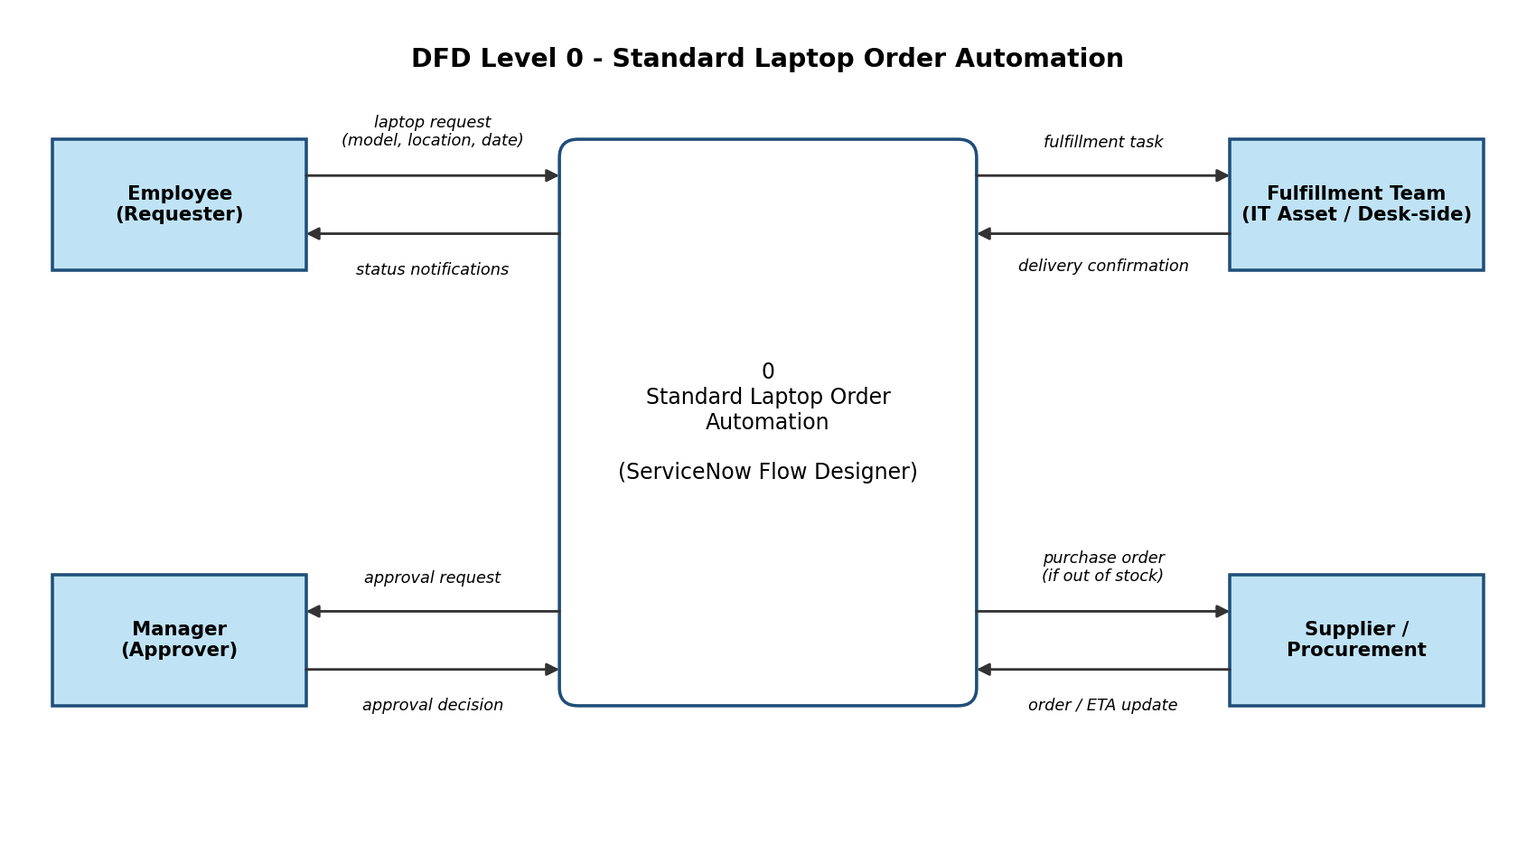

DFD Level 1:
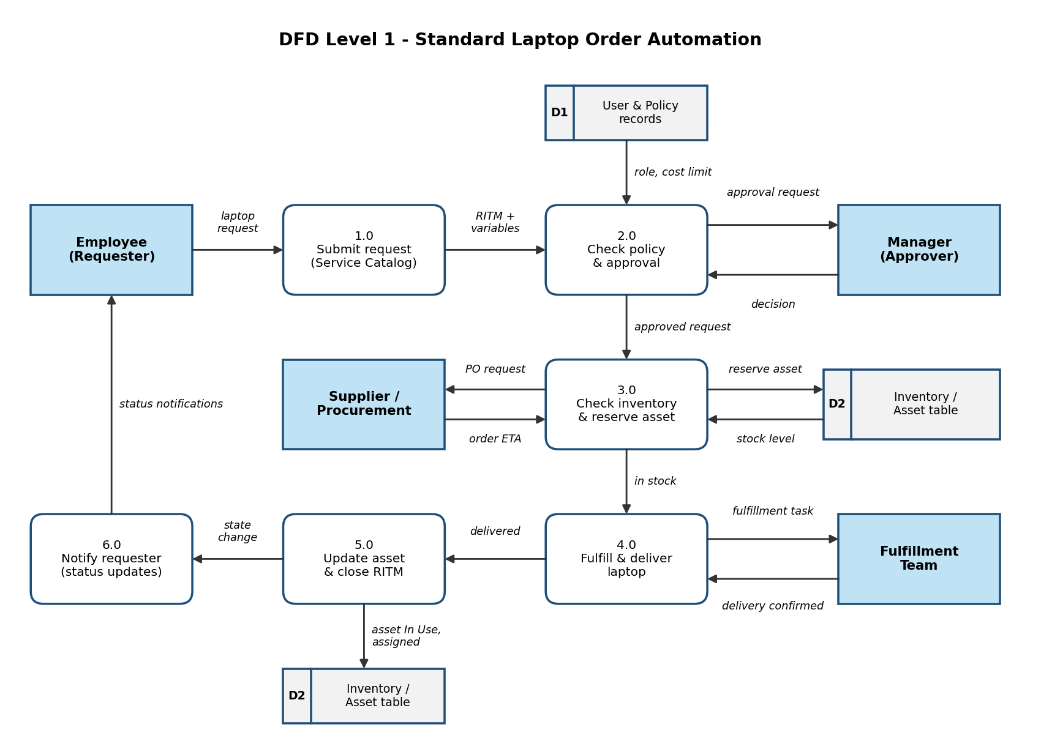

User Stories
User stories for the Standard Laptop Order Automation solution (ServiceNow Flow Designer).
User Type | Functional Requirement (Epic) | User Story Number | User Story / Task | Acceptance criteria | Priority | Release
Employee (Requester) | Request Laptop | USN-1 | As an employee, I can find the Standard Laptop item in the Service Catalog so that I can request a laptop. | I can see the Standard Laptop item and open the request form | High | Sprint-1
 |  | USN-2 | As an employee, I can see the laptop model pre-selected based on my role and department. | Model is auto-populated from my user record | Medium | Sprint-1
 |  | USN-3 | As an employee, I can submit the request by entering only the justification, ship-to location and needed-by date. | Request (RITM) is created and I receive a request number | High | Sprint-1
 | Track Order | USN-4 | As an employee, I receive a notification at each status change of my request. | I receive an email / notification on approval, shipment and delivery | High | Sprint-2
 |  | USN-5 | As an employee, I can view the current status of my request in the portal. | Status is visible under My Requests | Medium | Sprint-2
 | Feedback | USN-6 | As an employee, I receive a satisfaction survey after my request is closed. | Survey is sent automatically when the RITM is closed | Low | Sprint-3
Manager (Approver) | Approval | USN-7 | As a manager, I receive an approval request only when the laptop cost is above the policy threshold. | Requests within policy are auto-approved; others go to my approval queue | High | Sprint-1
 |  | USN-8 | As a manager, I can approve or reject a request from email or the portal and add comments. | Decision is recorded on the RITM and the requester is notified | High | Sprint-2
IT Fulfillment Team | Fulfillment | USN-9 | As a fulfillment agent, I get a fulfillment task automatically when stock is available. | Task is created for my group with the asset already reserved | High | Sprint-2
 |  | USN-10 | As a fulfillment agent, I can mark the laptop as delivered and the asset is assigned to the employee automatically. | Asset state is In Use, assigned to the user, and the RITM is closed | High | Sprint-2
IT Asset Manager / Procurement | Inventory | USN-11 | As an asset manager, I want the flow to check stock automatically for every approved request. | Stock is looked up on the asset table and reserved when available | High | Sprint-1
 |  | USN-12 | As an asset manager, I want a purchase requisition to be created automatically when stock is not available. | PO is linked to the RITM and the requester is told about the delay | Medium | Sprint-3
Administrator | Monitoring & Reporting | USN-13 | As an administrator, I want rejected requests and flow failures routed to an IT queue. | A task is created in the IT queue for every rejection or flow error | Medium | Sprint-3
 |  | USN-14 | As an administrator, I can view a dashboard of request cycle time and stock trends. | Dashboard shows average cycle time and current stock levels | Low | Sprint-3

