Ideation Phase
Empathize & Discover
Date | 29 September 2026
Team ID | SWTID-2026-7788
Project Name | Streamlining IT Procurement: Automating Standard Laptop Orders with Flow Designer
Maximum Marks | 4 Marks

Empathy Map Canvas:
An empathy map is a simple, easy-to-digest visual that captures knowledge about a user’s behaviours and attitudes. It is a useful tool to helps teams better understand their users.
Creating an effective solution requires understanding the true problem and the person who is experiencing it. The exercise of creating the map helps participants consider things from the user’s perspective along with his or her goals and challenges.
Example:
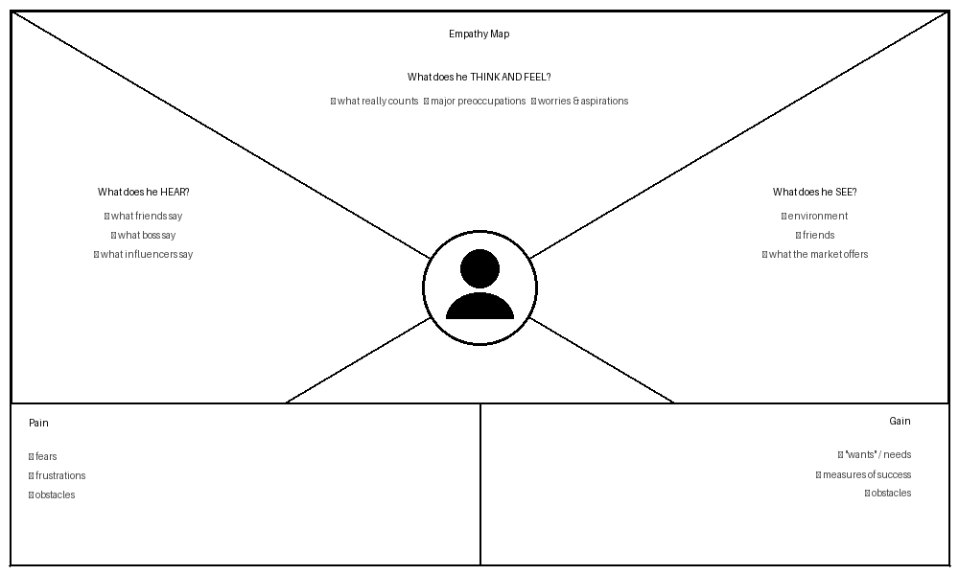
Reference: https://www.mural.co/templates/empathy-map-canvas
Example: Food Ordering & Delivery Application


