Project Planning Phase
Streamlining IT Procurement: Automating Standard Laptop Orders with Flow Designer

Date | 29 September 2026
Team ID | SWTID-2026-7788
Project Name | Streamlining IT Procurement: Automating Standard Laptop Orders with Flow Designer
Maximum Marks | 5 Marks

Product Backlog, Sprint Schedule, and Estimation (4 Marks)
Use the below template to create product backlog and sprint schedule
Sprint | Functional Requirement (Epic) | User Story Number | User Story / Task | Story Points | Priority | Team Members
Sprint-1 | Catalog Item Setup | USN-1 | As an IT procurement admin, I can gather the standard laptop requirements (model, specifications, approvers) so that the catalog item can be designed. | 2 | High
Sprint-1 |  | USN-2 | As an admin, I can create the Standard Laptop catalog item in the Service Catalog so that employees can order it. | 1 | High
Sprint-1 | Flow Design | USN-3 | As an admin, I can design a Flow Designer flow that is triggered when a Standard Laptop request is submitted. | 3 | High
Sprint-1 |  | USN-4 | As a manager, I receive an approval request for every laptop order so that I can approve or reject it. | 3 | High
Sprint-1 |  | USN-5 | As an employee, I am notified with the reason when my laptop request is rejected. | 3 | Medium
Sprint-2 | Fulfillment Automation | USN-6 | As a procurement team member, a catalog task is created automatically once the order is approved. | 2 | High
Sprint-2 |  | USN-7 | As an employee, I receive email notifications on the status of my laptop order. | 2 | Medium
Sprint-2 |  | USN-8 | As an employee, I can see my request status updated automatically in the portal. | 2 | Medium
Sprint-2 |  | USN-9 | As a procurement team member, the flow checks laptop stock in inventory before creating the order. | 4 | Medium
Sprint-2 | Testing | USN-10 | As a tester, I can run the flow end-to-end to verify the approval, rejection and fulfilment paths. | 5 | High
Sprint-2 | Deployment | USN-11 | As an admin, I can deploy the flow to production so that employees can start ordering laptops. | 5 | High

Project Tracker, Velocity & Burndown Chart: (4 Marks)
Sprint | Total Story Points | Duration | Sprint Start Date | Sprint End Date (Planned) | Story Points Completed (as on Planned End Date) | Sprint Release Date (Actual)
Sprint-1 | 12 | 6 Days | 29 Sep 2026 | 04 Oct 2026
Sprint-2 | 20 | 6 Days | 06 Oct 2026 | 11 Oct 2026

Velocity:
Our sprint duration is 6 days, and the velocity of the team is 16 (points per sprint), based on 12 + 20 story points across 2 sprints. Let’s calculate the team’s average velocity (AV) per iteration unit (story points per day)
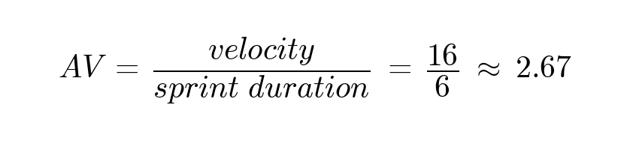

Burndown Chart:
A burn down chart is a graphical representation of work left to do versus time. It is often used in agile software development methodologies such as Scrum. However, burn down charts can be applied to any project containing measurable progress over time.

https://www.visual-paradigm.com/scrum/scrum-burndown-chart/
https://www.atlassian.com/agile/tutorials/burndown-charts

Reference:
https://www.atlassian.com/agile/project-management
https://www.atlassian.com/agile/tutorials/how-to-do-scrum-with-jira-software
https://www.atlassian.com/agile/tutorials/epics
https://www.atlassian.com/agile/tutorials/sprints
https://www.atlassian.com/agile/project-management/estimation
https://www.atlassian.com/agile/tutorials/burndown-charts

