Streamlining IT Procurement: Automating Standard Laptop Orders with Flow Designer
Project Development Phase
Model Performance Test

Date | 29 September 2026
Team ID | SWTID-2026-7788
Project Name | Streamlining IT Procurement: Automating Standard Laptop Orders with Flow Designer
Maximum Marks

Model Performance Testing:
Project team shall fill the following information in model performance testing template.
S.No. | Parameter | Values | Screenshot
1. | Model Summary | ServiceNow Flow Designer automation to streamline IT procurement by automatically processing standard laptop orders (request, approval, fulfilment and notification).  Note : If the laptop request matches the standard catalog item and conditions, the flow runs and the order is created automatically; otherwise the flow shows an error / routes for manual approval. | 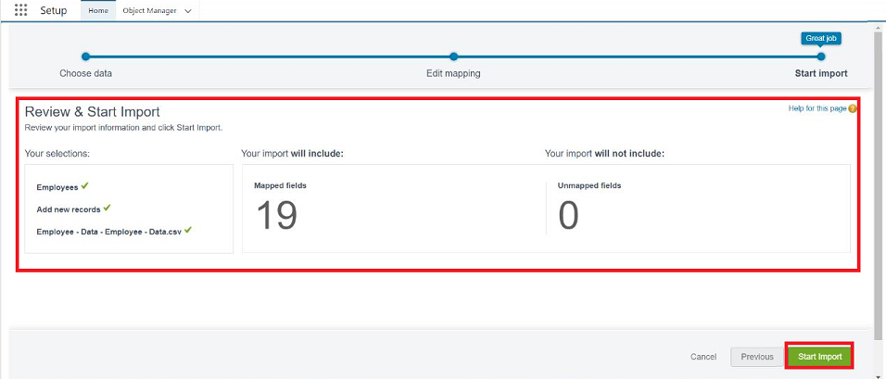
2. | Accuracy | Flow Execution Success Rate - 98%  Approval and Fulfilment Accuracy - 98% | 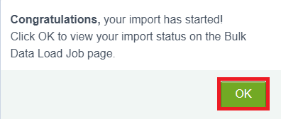
3. | Flow Execution Status | Flow Status - Shows whether the flow, triggers and actions (approval, task, notification) executed correctly, and reports any errors.  Success Rate - The flow completed 92% of laptop order requests correctly without manual intervention. | 

