Project Design Phase
Solution Architecture

Date | 29 September 2026
Team ID | SWTID-2026-7788
Project Name | Streamlining IT Procurement: Automating Standard Laptop Orders with Flow Designer
Maximum Marks | 4 Marks

Solution Architecture:
Solution architecture is a complex process – with many sub-processes – that bridges the gap between business problems and technology solutions. Its goals are to:
- Find the best tech solution to solve existing business problems.
- Describe the structure, characteristics, behavior, and other aspects of the software to project stakeholders.
- Define features, development phases, and solution requirements.
- Provide specifications according to which the solution is defined, managed, and delivered.

Example - Solution Architecture Diagram:

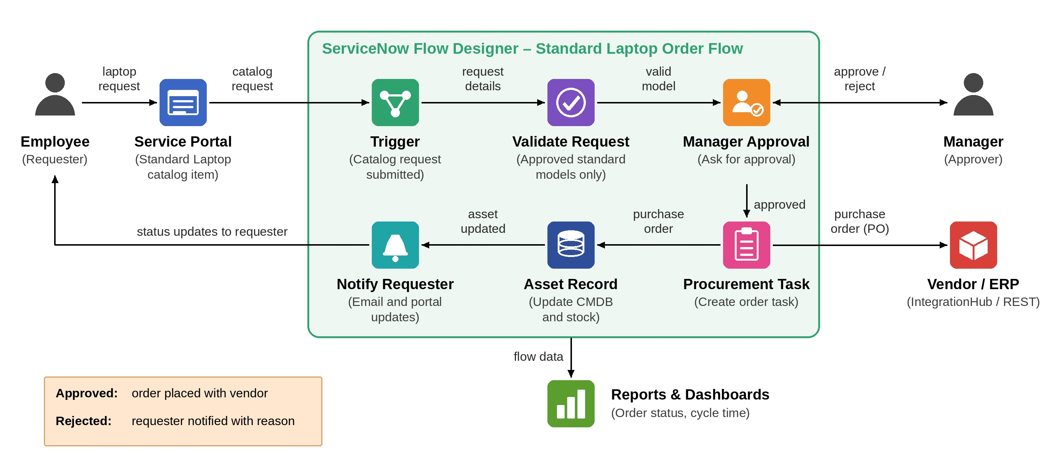
Figure 1: Architecture and data flow of the automated standard laptop order process using Flow Designer
Reference: https://www.servicenow.com/docs/r/application-development/flow-designer.html

