Project Design Phase-II
Technology Stack (Architecture & Stack)

Date | 29 September 2026
Team ID | SWTID-2026-7788
Project Name | Streamlining IT Procurement: Automating Standard Laptop Orders with Flow Designer
Maximum Marks | 4 Marks

Technical Architecture:
The Deliverable shall include the architectural diagram as below and the information as per the table1 & table 2
Example: Automated standard laptop order processing in ServiceNow
Reference: ServiceNow Flow Designer and Service Catalog documentation
Guidelines:
Include all the processes (As an application logic / Technology Block)
Provide infrastructural demarcation (Local / Cloud)
Indicate external interfaces (third party API’s etc.)
Indicate Data Storage components / services
Indicate interface to machine learning models (if applicable)
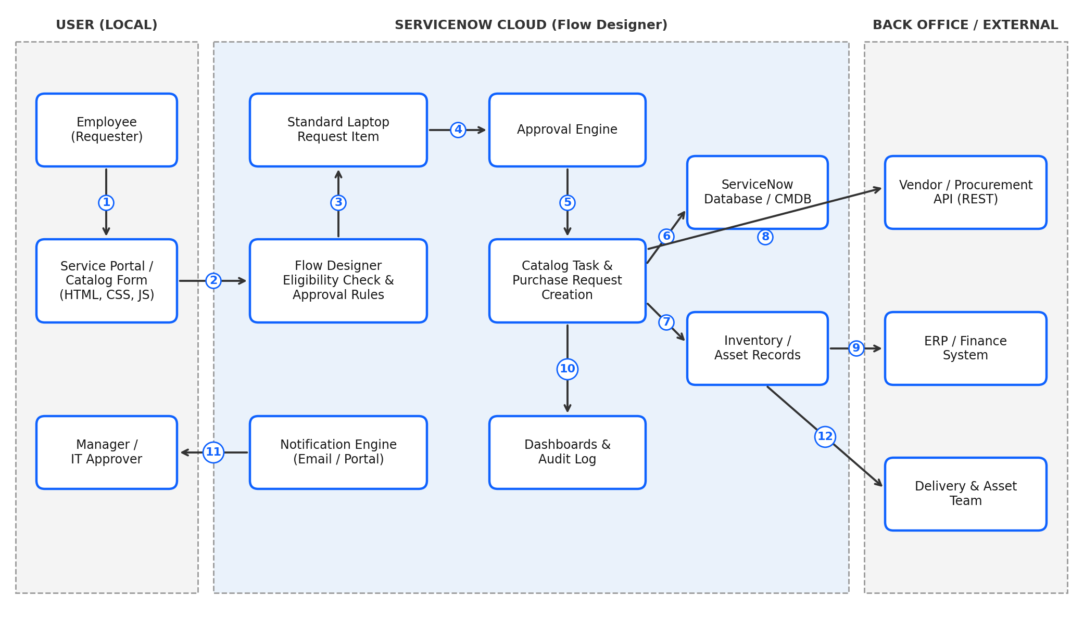

Table-1 : Components & Technologies:
S.No | Component | Description | Technology
 | User Interface | Employee raises a standard laptop request through the Service Catalog form; requester tracks status in the portal | ServiceNow Service Portal (HTML, CSS, JavaScript, Angular JS widgets)
 | Application Logic-1 | Flow Designer flow: validates the model is standard and within budget, then auto-approves or routes for approval | ServiceNow Flow Designer, Decision / Approval actions
 | Application Logic-2 | Creates catalog task, purchase request and stock reservation automatically after approval | Flow Designer, Subflows, Server-side JavaScript
 | Application Logic-3 | Sends email / portal notifications on submission, approval, dispatch and delivery | ServiceNow Notifications, Email Scripts
 | Database | Stores requests, approvals, catalog items and user / department data | ServiceNow platform database (relational)
 | Cloud Database | Hosted database service on the ServiceNow cloud instance | ServiceNow Cloud (managed instance), CMDB
 | File Storage | Stores quotes, approval attachments and delivery documents | ServiceNow Attachments (platform storage)
 | External API-1 | Sends purchase orders to the vendor / procurement system and receives order status | REST / SOAP API via IntegrationHub
 | External API-2 | Syncs cost center and budget checks with the finance / ERP system | REST API, IntegrationHub spoke
 | Machine Learning Model | Not used in the current scope; optional future use for demand forecasting of laptop stock | N/A (optional: ServiceNow Predictive Intelligence)
 | Infrastructure (Server / Cloud) | Application deployed on the ServiceNow cloud instance. Local Server Configuration: not required. Cloud Server Configuration: ServiceNow managed instance (Dev / Test / Prod) | ServiceNow Cloud

Table-2: Application Characteristics:
S.No | Characteristics | Description | Technology
 | Open-Source Frameworks | Open-source and standard web frameworks used in portal widgets and scripts | AngularJS, Bootstrap, JavaScript (Rhino)
 | Security Implementations | Role-based access for requesters, approvers and procurement; approvals audited; data encrypted in transit and at rest | ACLs, IAM / SSO roles, TLS 1.2+, AES-256, OWASP guidelines
 | Scalable Architecture | Multi-tier platform architecture; logic kept in reusable flows and subflows so new models / departments need only configuration | 3-tier architecture, Flow Designer subflows
 | Availability | Managed cloud instance with data-center redundancy, failover and backups | ServiceNow Cloud, load balancers, disaster recovery
 | Performance | Automated approvals reduce manual steps; async flow execution and cached catalog data keep response fast | Asynchronous flows, platform caching, indexed tables

References:
https://c4model.com/
https://developer.ibm.com/patterns/online-order-processing-system-during-pandemic/
https://www.ibm.com/cloud/architecture
https://aws.amazon.com/architecture
https://medium.com/the-internal-startup/how-to-draw-useful-technical-architecture-diagrams-2d20c9fda90d

