**PROJECT PROPOSAL**

*Doomsday Chat App*

Table of Contents

Project Abstract 3

Conceptual Design 3

Proof of Concept 3

Background 3

Required Resources 3

## Project Abstract

This application enables users to communicate at medium to long distances (up to few miles) with no cell/data coverage using LoRa radio module, connected via USB to the smartphone. Adafruit M0 LoRa RFM95x microcontroller is connected to the smartphone interface, with and android app that reads the serial data from the module and parses it for plain text messages, distress calls, requests.

## Conceptual Design

This application requires Adafruit M0 LoRa RFM95x (provided by me) which will be connected to the smartphone via USB (micro-USB to smartphone). Android application will be used to design the interface, which will read/write messages to serial port (USB) and the LoRa module will receive/transmit using radio signal. The hardware will be programmed in Arduino IDE and the application will be built using Android studio.

*Picture showcasing the hardware setup: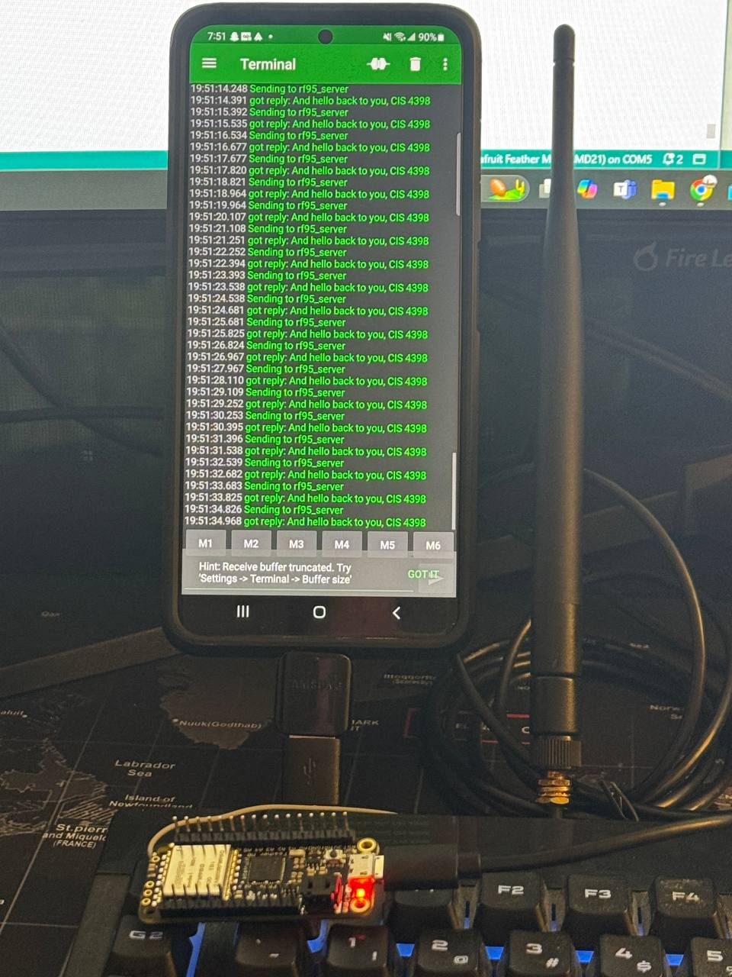*

Here, outlined in red is the Adafruit M0 LoRa RFM95x, connected to smartphone via USB. Antena is optional.

Sequence Diagram (Conceptual)

Component Diagram (Conceptual)

## Proof of Concept

Link to GitHub repository: <https://github.com/MherTemple/DoomsdayChatApp>

*Message sent from smartphone.*

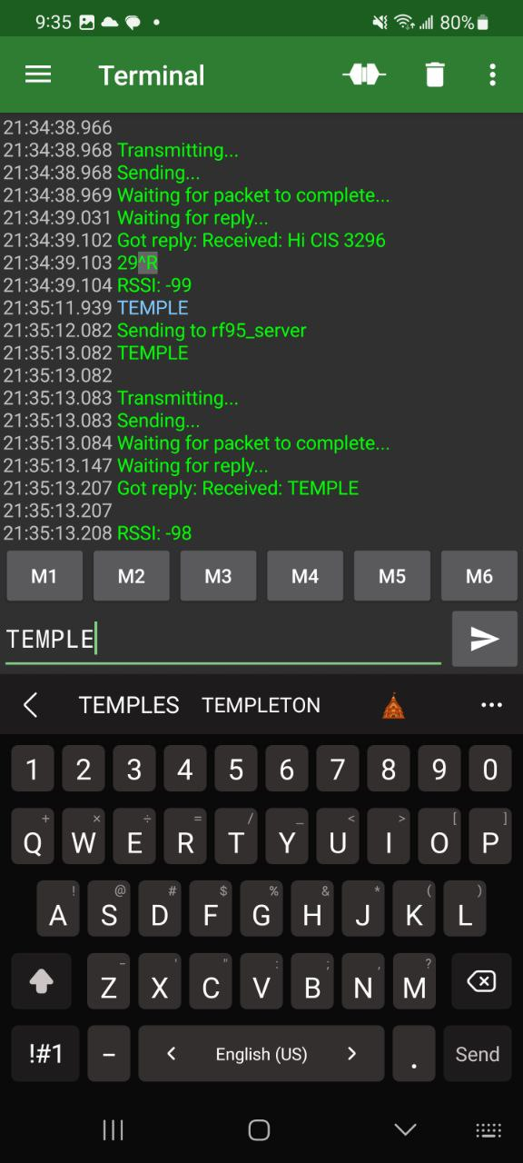

Message received from standalone LoRa module and replied.

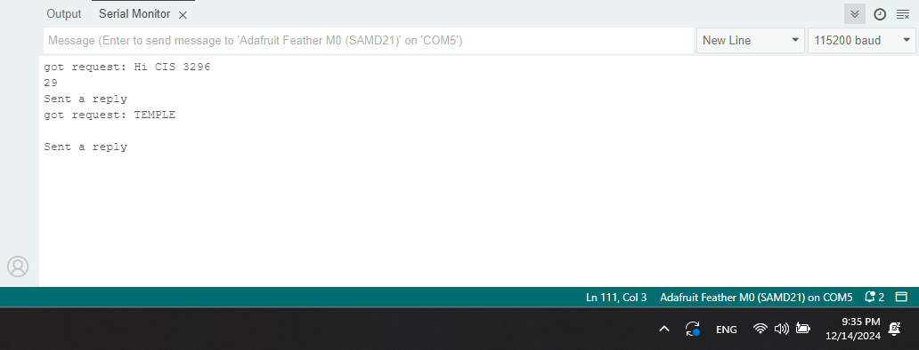

In this example, only one smartphone is used. 2nd LoRa module programmed as a standalone and reply with same message (so 2nd smartphone is not required). The 2nd board is connected to PC and is monitored via Arduino IDE. The input from the smartphone is read by the LoRa board connected to smartphone, and message is sent to the standalone module. Serial communication terminal android application is used here, but new application will be developed using Android Studio. The final product will allow 2 or more smartphones to communicate.

To test the project, user needs 2 Adafruit M0 Feather LoRa RFM95x boards, usb cables (micro-USB to USB-A, and micro-USB to your Android smartphone),

1. Connect the 1st board to PC via USB.
2. Open Arduino IDE and open the client file.
3. Extract RadioHead library zip folder, and add it to Documents/Arduino/libraries folder.
4. Compile and upload the code.
5. Disconnect the board from PC and connect it the smartphone.
6. Install serial USB terminal application in your smartphone from play store (you need to have android developer settings on, and USB debugging on), and turn on the connection with 9600 baud rate setting.
7. Connect the second board to PC via USB.
8. Open the server file in Arduino IDE, compile and upload it to the second board.
9. You can now send messages from smartphone to the board.

## Background

This application and hardware are designed to be used as a backup communication system, that can be plugged in into the smartphone, instead of being a standalone communication tool, minimizing hardware use. A custom smartphone case can hold the entire hardware. Similar products are usually dedicated to smartphones that use radio communication. Hobbyists generally build such systems without a smartphone (using simple monitor and keyboard).

## Required Resources

Adafruit M0 Feather LoRa RFM95x board (x2), micro-USB to USB-A (2x), USB-A to USB-C adapter (for connecting to smartphone, may be different), Arduino IDE, Android Studio, Adafruit and RadioHead libraries. Coding languages: C, Java, Kotlin (maybe). NO SOLDERING OR WIRING IS REQUIRED.