

**Group Report**

*COMP1640 - Enterprise Web Software Development*

**Group Name :** Group 3 – TCH2401

**Member 1 :** Nguyen Truong Giang – GCH190083

**Member 2 :** Full name –Greenwich ID

**Member 3 :** Full name –Greenwich ID

**Member 4 :** Full name –Greenwich ID

**Member 5 :** Full name –Greenwich ID

**Member 6 :** Full name –Greenwich ID

**Instructor :** MSc. Nguyen Dinh Tran Long

**Table of Contents**

❖ **General Information** 3

**1.** **Introduction** 4

**2.** **Requirement Analysis** 4

**3.** **Database** 4

**4.** **Design** 4

**5.** **Implementation** 4

**6.** **Testing** 4

**7.** **Methodology** 4

**8.** **Conclusion** 4

❖ **Bibliography** 4

**Table of Figures**

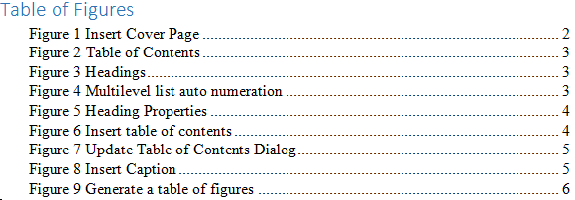

**List of Tables**

Table 1 - Project Information 3

Table 2 - Group Information 3

# **General Information**

|  |  |  |  |
| --- | --- | --- | --- |
| Group name | Group 3 | | |
| Repository URL | *GitHub/Gitlab link, etc.* | | |
| Group Board URL | *Trello/Jira link, etc.* | | |
| Web Hosting URL | [*www.mywebapp.com*](http://www.mywebapp.com) | | |
| Test accounts | *Role* | *Username* | *Password* |
| admin | admin | 123456 |
| manager | manager | 123456 |
| *…* | *…* | *…* |
| Screen cast URL | *YouTube link* | | |
| Backlog URL | *Google Docs/Sheet link* | | |
| Test plan URL | *Google Docs/Sheet link* | | |
| Front-End Technology | *ReactJS* | | |
| Back-End Technology | *ExpressJS/NodeJS* | | |
| Database | *MongoDB* | | |

Table 1 - Project Information

|  |  |
| --- | --- |
| Full Name | Role |
| Hung | Scrum Master |
| Hien | Front-end Developer |
| An | Back-end Developer |
| Giang | Business Analyst |
| Minh | UI/UX Designer |

Table 2 – Member Role

# **Introduction**

In a large university setting, gathering student writing for the annual journal can be a complex task involving many stakeholders and sensitive content. To streamline this process while ensuring security and efficiency, implementing a web-based security role-based system is indispensable. This project aims to develop a robust platform that facilitates submitting, reviewing, and publishing student contributions to the university journal. Combining role-based access control and strict security measures ensures that only authorized individuals can access, review, and manage submissions, thereby protecting the integrity of content, and security of content.

The purpose of this report is to provide an overview and justification for the development of a secure web-based role-based system for collecting student contributions to an annual university journal. The report outlines the current challenges faced in the traditional solicitation and application management process and proposes solutions to address these challenges through the implementation of digital platforms.

To identify the need for a more efficient and secure method of collecting and managing student contributions to university journals. Describe the features and functionality of the proposed web-based system, including user authentication, role-based access control, submission portals, review and feedback mechanisms, content management, and security measures. Provide a rationale for investing in the development of the proposed system, including the potential for cost savings, increased productivity, and improved publication quality. Ultimately, the report aims to convince university stakeholders, including administrators, decision-makers, and funding agencies, of the value and feasibility of adopting the proposed solution. Provide recommendations to address identified challenges and achieve desired goals.

This section provides a brief overview of the project, highlighting its objectives, key features, and expected benefits. It serves as a quick reference for stakeholders to grasp the essence of the proposal.

Here you can outline current challenges and inefficiencies in the process of collecting student contributions for the university magazine. Discuss the importance of modernizing processes and leveraging technology to effectively address these challenges.

Define the scope of the project by defining its boundaries, including the functions and features that will be included in the proposed system. Outline the main goals of the project, such as improving efficiency, enhancing collaboration, and ensuring security.

Identify and analyze key stakeholders involved in the project, including marketing managers, coordinators, administrators, students, and guests. Discuss their roles, responsibilities, and expectations in the context of the proposed system.

Provides an overview of the web-based security role-based system, highlighting its architecture, components, and functionality. Explain how the system will streamline the process of collecting, evaluating, and managing student contributions to the university journal

# **Requirement Analysis**

functional + non-functional,

use-case diagram + specification

# **Database**

database normalization,

data security,

data validation,

ERD,

class diagram,

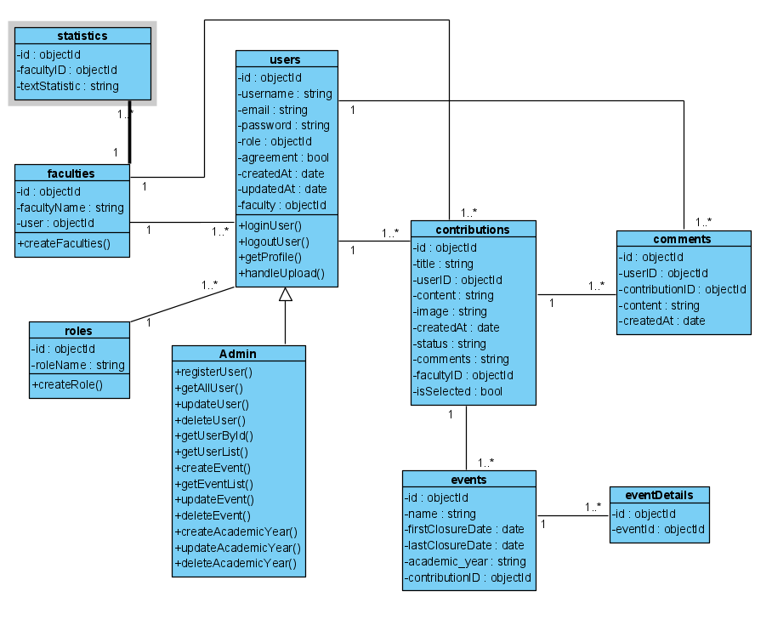

database diagram

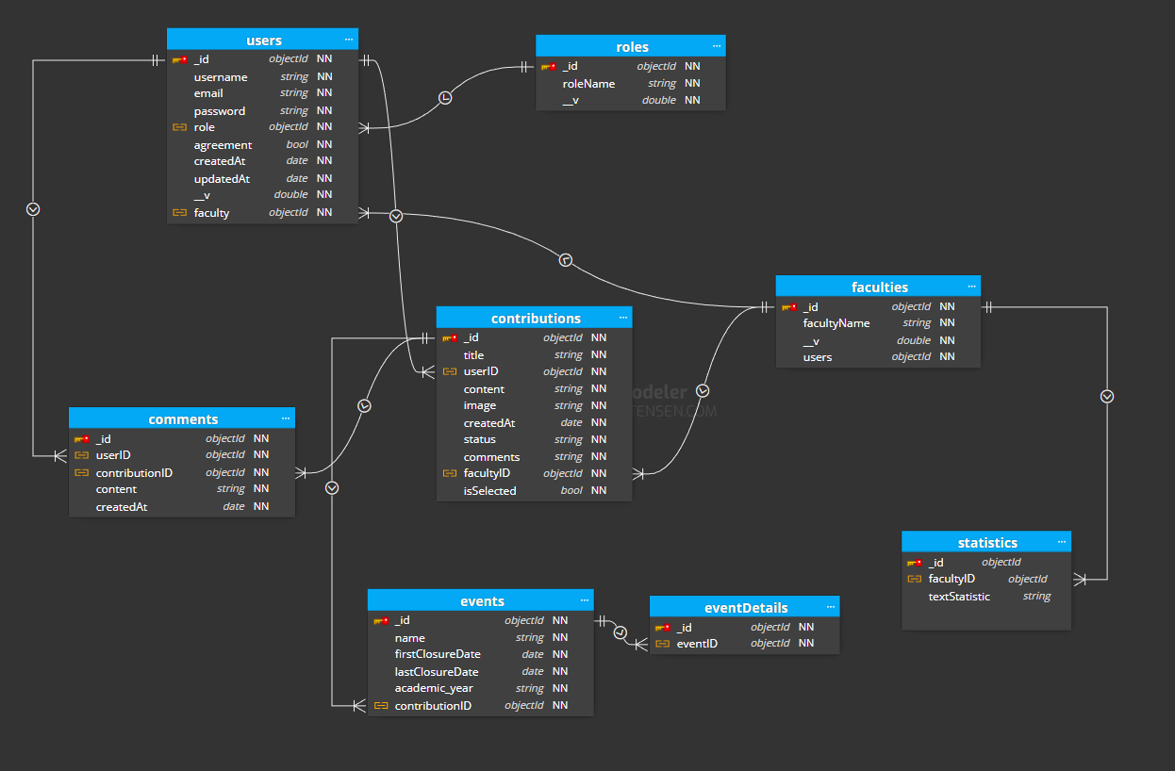

# **Design**

sitemap,

wireframes,

flowcharts,

mockup (Figma),

activity diagram,

sequence diagrams

# **Implementation**

overview about selected techniques (FE+BE+DB),

system structures ,

features introduction & explanation for outstanding/important code snippets,

final web screenshots

# **Testing**

Test overview,

Test plan,

test scenarios,

test cases,

test logs,

test evidences,

test result evaluation

# **Methodology**

user stories,

product backlog,

sprint backlogs,

burndown chart,

meeting minutes,

team challenges

# **Conclusion**

summarize have been presented in this report/what have done in this project, overall evaluation for web application/Agile methodology, future improvements

# **Bibliography**

