**VSTEP SPEAKING**

**CẤU TRÚC THI SPEAKING:**

**PART 1: Social interaction (3’)**

**PART 2: Solution discussion (4’)**

**PART 3: Topic Development (5’)**

**-----------------------------------------------**

**ĐỀ 1:**

**Part 1:**

**Now let’s talk about Leisure & Hobbies***.*

What do you like doing in your free time?

Why do you like doing it/them?

Who do you usually do it/them with? How do you feel after doing it/them?

**Part 2: Let’s talk about the holiday place**

One of your friends is planning for a holiday with his friends. He asked you for some advices about where to go: Sapa, Nha Trang or Singapore. What do you think is the best choice? Why?

**Part 3:**

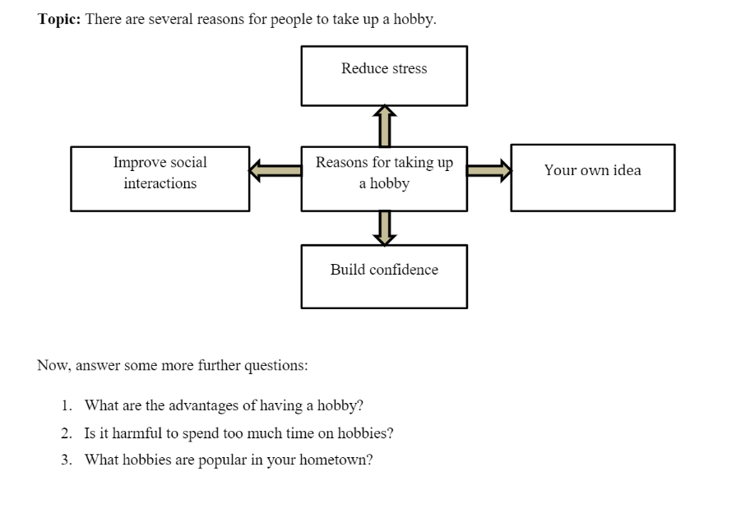

**ĐỀ 2:**

**Part 1:**

**Let’s talk about Music**

• **Do you like listening to music?** Why/ Why not?

• **What kinds of music do you like best?** Why?

• Who do you often listen to music with?

**Part 2: Let’s talk about the conference area**

Your company is considering the place to hold a 2 – 3 day conference. There are 3 options for you: a big hotel, a conference center and your company.

**Part 3:**

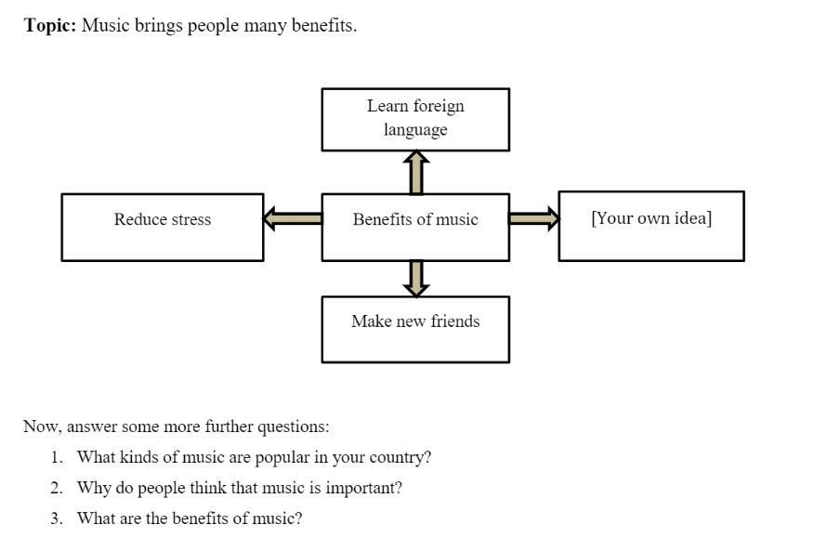

**PART 1:**

I would like to talk about …*[Chủ đề chính]*

The first question is *[Câu hỏi 1],* *giải thích*

The second question is *[Câu hỏi 2],* *giải thích*

The third question is *[Câu hỏi 3],* *giải thích*

**PART 2:**

The situation *(trường hợp)* is …*[Đọc lại đề bài, thay thế “you” thành “I”, “your” thành “my”]*

From my point of view, …*[Lựa chọn A]* is the best option because of the following reasons.

Firstly, *[Lựa chọn A]* is acceptable and suitable.

Secondly, it is *…[lý do]*

Moreover, it is practical and useful.

There are several reasons why I don’t choose other options.

Firstly, they are not useful

Secondly, they are inconvenient.

Thirdly, they are *…[lý do]*.

To sum up, if I were in that situation, I would choose *…[Lựa chọn A]* due to the above reasons.

**PART 3:**

Well, I would like to talk about this topic. It is about *[Chủ đề chính]*

First of all, the first point is *…[Ý chính số 1], …[giải thích]*

Second of all, the second point is *…[Ý chính số 2], …[giải thích]*

Third of all, the third point is *…[Ý chính số 3], ….[giải thích]*

Lastly, the fourth point is…

To sum up, we can’t deny that *…[Nhắc lại đề bài]*

Now, I will anwer follow-up questions:

1. *[Đọc câu hỏi A],* giải thích
2. *[Đọc câu hỏi B],* giải thích
3. *[Đọc câu hỏi C],* giải thích

Cách trả lời cho 1 số phần giải thích (hạn chế sử dụng với câu hỏi What):

* It’s getting more common recently.
* It's really helpful and essential for daily life.
* People should be motivated to do so.
* It can make people’s life more comfortable and meaningful.
* It is suitable for everyone, no matter their background.
* Many people can benefit from it easily.

*MẸO TRẢ LỜI SPEAKING:

1. – Who => Ai

- What => Cái gì/ Điều gì

- How => Điều này như thế nào/ Cảm thấy như thế nào

- Why => Tại sao