# Exercises

## In this exercise, you are going to create a simple yet beautiful website called blog. A screenshot of Blog is as follow (in the next page)

* Reference for CSS margin: <https://www.w3schools.com/css/css_margin.asp>
* Reference for CSS padding: <https://www.w3schools.com/css/css_padding.asp>
* Reference for CSS border: <https://www.w3schools.com/css/css_border.asp>
* Reference for CSS width and height: <https://www.w3schools.com/cssref/pr_dim_width.php>, <https://www.w3schools.com/cssref/pr_dim_height.php>

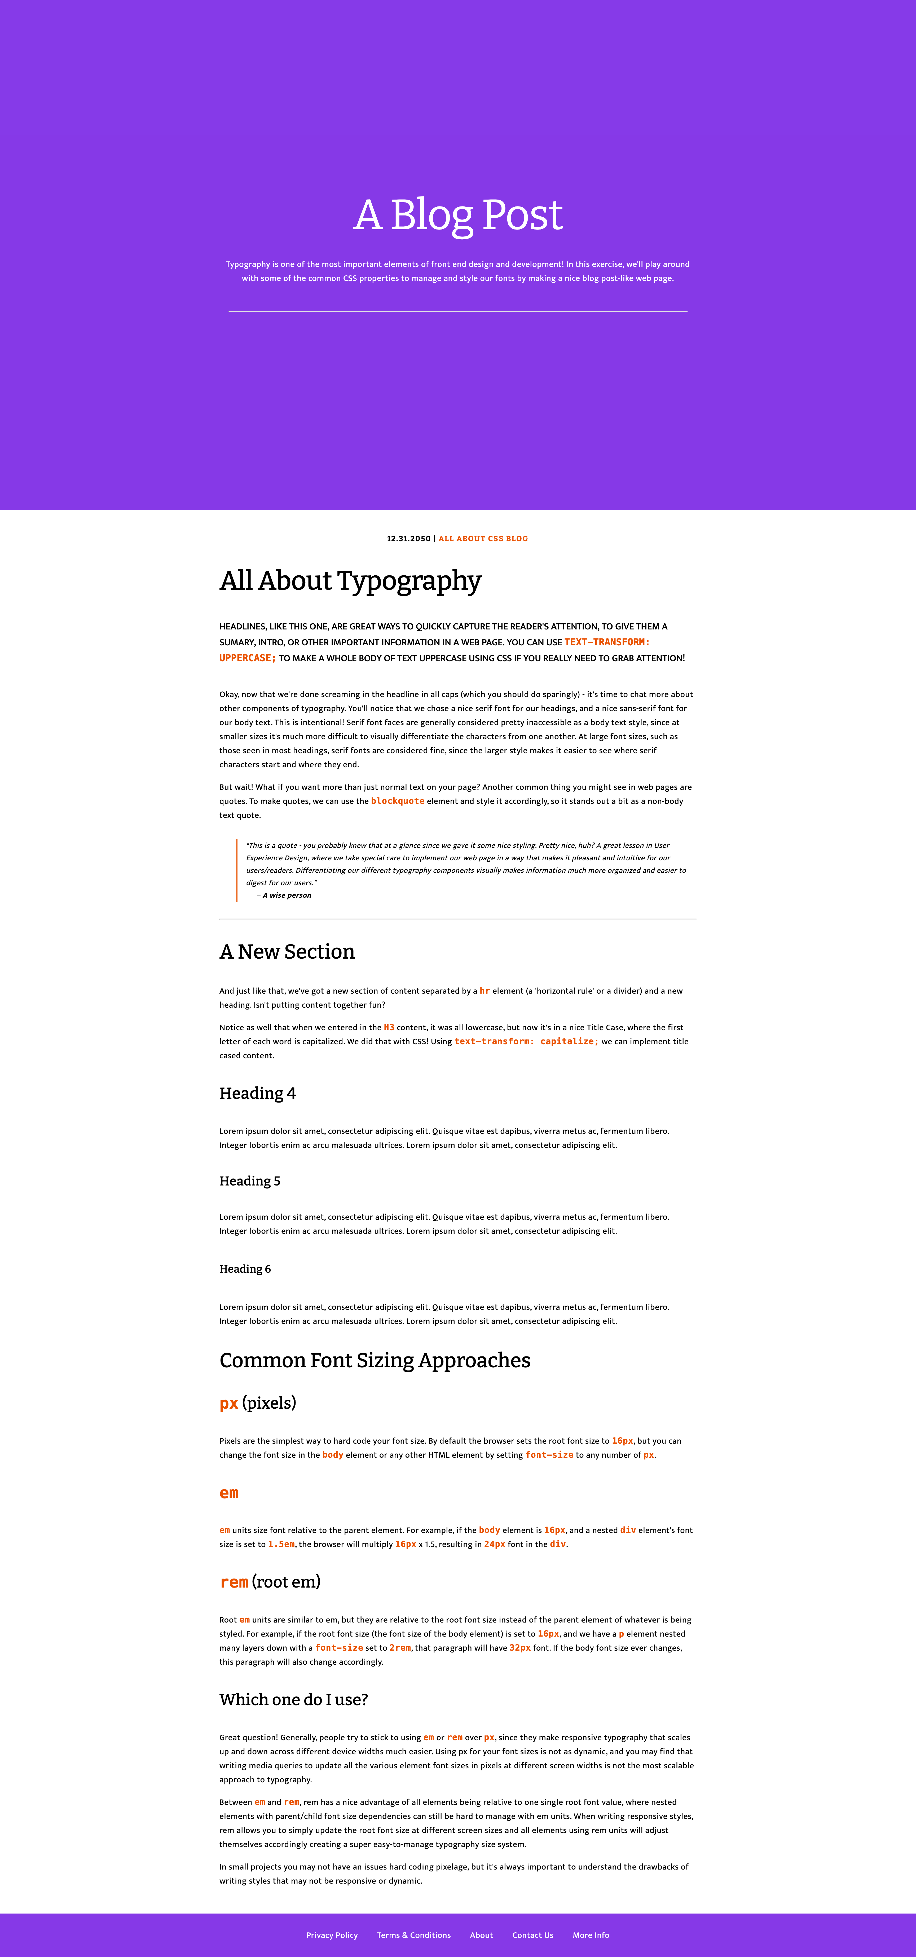

Figure 1: Sample user interface

Content for this exercise is also served in file content.txt for you to copy and paste.

Your task is to create HTML Skeleton (Div divisions) and style it using CSS. This is the higher and more advanced of the previous tutorial; I will put less CSS by using steps.

**Part 0: Preparation**

Include this link in your CSS declaration. This link will contain CSS for font family and typography

<https://fonts.googleapis.com/css2?family=Bitter:wght@300;400;500;700&family=Mukta:wght@300;400;500;700&display=swap>

The order of CSS is as follow

* Google font CSS > your CSS

**­­­Part 1: (Hero)**

Set CSS for body: margin: 0, padding 0 to reset margin and padding to default

Set margin: 0 auto for all of the Hero to set content in the middle.

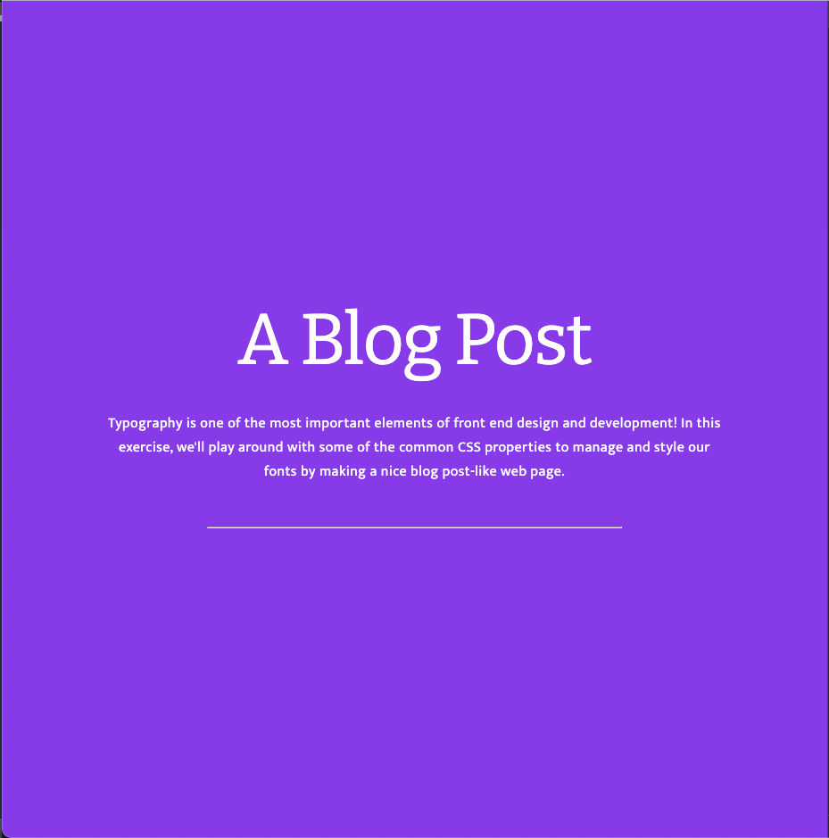

Figure 2: Hero part

**Step 1**: Create a parent container <div> call #hero, set height of div using height: 100vh

Vh means: viewport height, it takes the entire screen height as its height.

Set background color equal to #863ae8

**Step 2**: Create a new div inside hero, set CSS to the center of the screen using:

{

position: absolute;

top: 50%;

transform: translateY(-50%)

}

Make sure to put **#hero** as position: relative

**Step 3:** For title, set width is 75% and margin is 16px for top & bottom. For left and right is 0. Font family is “Bitter, serif”

**Step 4**: For content below title, format the same as Step 3

**Step 5**: For a slim line, set width to be 50%, and set margin top-bottom to 32px

**Part 2: Content - Below hero part and before footer part.**

**Step 1**: Set padding of overall content to 32px in 4 dimensions

**Step 2**: Using p class using proper class name, combined with <span> to create title of date and “All ABOUT CSS BLOG”. Put content in the center using text-align:center

Color code of “ALL ABOUT CSS BLOG” is #e95400

Font of this part is “Bitter”, font size is 14px and letter spacing is 1.5px and aligned in the center.

**Step 3:** For heading “All About Typography” using tag h2, use letter spacing to -0.5px and font size to be 50px

**Step 4**: For headlines sections, set font weight to 500, margin 40px top-bottom, and font-size to 18px

For content before quote, just use <p> as normal

**Step 5**: For quote:

Set border-left to 2px using color : #e95400

Padding left : 16px

Except margin-right to 0, other dimensions are 32px

Font size set to 14px

**Step 6**: A new section

Font size: 38px

**Step 7**: Heading 4

Font-size: 30px

Letter spacing: 0.25px

**Step 8**: Heading 5

Font size: 24px

**Step 9**: Heading 6

Font size: 16px

**Step 10**: For Common Font Sizing Approaches

Using h3 tag, similar to A New Section

**Step 11**: For px, em, rem, use <h4> heading tag, use font “Bitter, Serif”

**Step 12**: For Which one do I use, using <h4> again

**Part 3: Footer**

**Step 1**: Using background similar to Part 1

**Step 2:** Set text in the center, padding top-bottom to 28px, remove list style circle at the beginning of list.

For list item in footer, use padding 16px in left-right, for top-bottom is 0

<THE END>