**Title of the project:** SMS (Sales Management System)

**Names of members of the team:** Hana Mhira, MJ Hadi

**Project Description:**

Sales management systems are information systems. These systems are used in marketing and management. These systems integrate with the marketing information system and are often referred to as customer relationship management systems.

There are various mechanisms for issuing the invoice in the sales system. The invoice can be issued on the basis of an order for an order, a customer order, a pre-invoice, a contract, or even directly, without any preconditions, and in accordance with the terms referred to Sales system processes in the system of predicted system management. The above mechanisms for each company can be separately defined and used. There are a lot of benefits for sales person. For example: Sales person can use e-forms instead of writing reports and sales activities on the sheet. The order is saved in time. Instead of providing reports in print management, sales person can send information through the company's intranet.

**Common features of SMS software include:**

* Customers Management
* Employee Management
* Order Management
* Products Management
* Complaints Management
* Tasks Management
* Sales management
* Billing
* Reporting ( Charts, Printable)

**Technologies:**

* WPF
* LINQ
* Entity Framework
* Ribbon instead menus
* Stack Panel, Grid Splitter
* Tab Control, Toolbar, Tree View
* PDF-generation
* Printing
* Storing binary data (pictures)

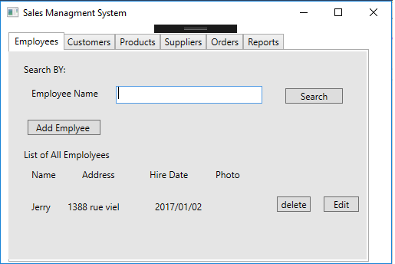

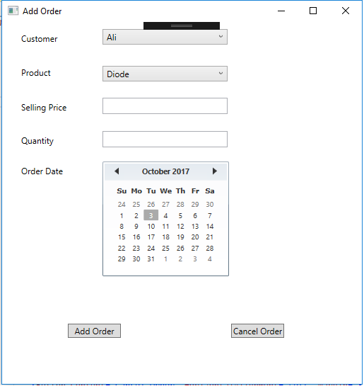

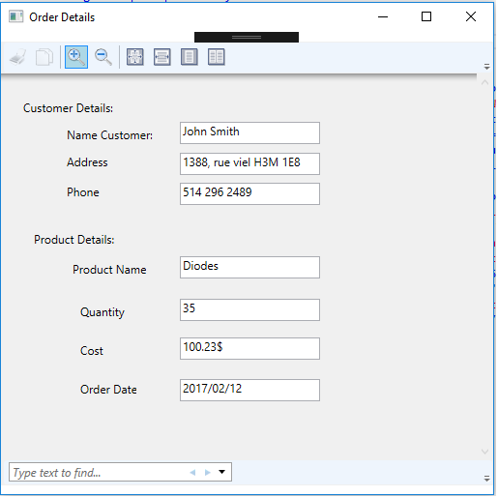

Database Design:



