**CHAPTER ONE**

**INTRODUCTION**

* 1. **BACKGROUNDOFTHESTUDY**

Human’s face reveals various information including gender, age and ethnicity. They provide important cues for many applications such as biometric authentication and intelligent human-computer interface. Recently many applications from biometrics, security control to entertainment use the information extracted from facial images that contains information about age, gender, ethnic background and emotional state. Automatic age and gender estimation from face images is one of the popular and challenging task that have different and diverse fields of applications.

Age and gender recognition has long been recognized as an important module for many computer vision applications such as human-robot interaction, visual surveillance and passive demographic data collections. Determining the age and gender of individuals from a live camera has many applications in the world of advertising. When a frame is captured, a face detection technique is employed to detect the face object. After detecting and aligning the face, the information allowing for greater facial discrimination is extracted and these data are then used to recognize the face's age and gender category

Interestingly, research has shown that age estimation and classification are affected by gender differences as well as actual age. Indeed, both facial and gender classification have been studied together as a related problem. Similarly, the two problem have been tackled simultaneously in other fields such as automatic speech recognition. Like other branches of facial analysis, automatic aging and gender classification are hindered by a host of factors including illumination variation, facial expressions, and pose variation to mention but a few. Several approaches have been documented in the literature to circumvent these problems. Facial aging can be categorized into age estimation, age progression, and age invariant face recognition (AIFR). Age estimation refers to the automatic labeling of groups or the specific ages of the individuals using information or features obtained from their faces. Age progression reconstructs the facial appearance with natural aging effects, and AIFR focuses on the ability to identify or verify people’s faces automatically, despite the effects of aging. Gender classification automatically assigns on of the two sex label (male/female) to a facial image. Studies have shown that we humans are able to differentiate between adult male and female faces with up to 95% accuracy. However, the accuracy rate reduces to just above chance when considering child faces.

**1.2 STATEMENT OF THE PROBLEM**

The task is to predicts the age and gender of a person from his facial attributes using Adience dataset which can be done with the following four components;

* The first component is facial detection; which detects the face and minimize the lighting effect.
* In the second component features (attributes) are extracted and unwanted features are removed.
* In the third component; the required features are selected.
* And the final component; (which produce the result) is a classification where the age and gender will be estimated.

Thus, two separate problems will be studied: *face recognition* and determining the corresponding *age and gender* of face objects.

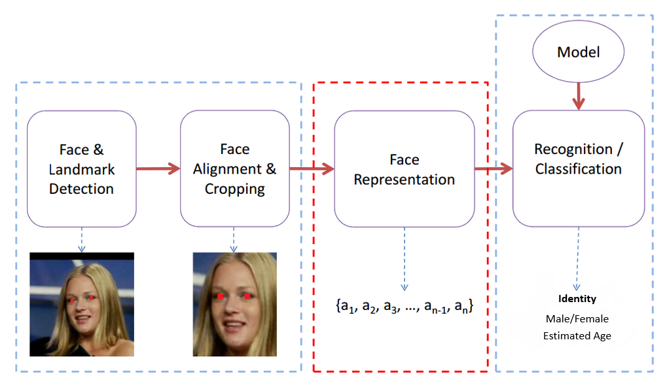

Fig. 1 Main program flow diagram

* 1. **AIM AND OBJECTIVES**

**Aim:**

In this project, we focused on face detection and recognition capabilities that will identify age and gender of a person in an image or in real time (webcam).

**Objectives:**

* To establish an image recognition system that can estimate the age and gender from a frontal facial images or real-time video captured from webcam.
* To create a python application using Open Source Computer Vision Library for python (OpenCV-python) and deep learning module to perform real-time age and gender detection.
* To detect the face in a given frame, extracts features related to the face objects and uses deep learning model to produce the result.
* To propose a methodology for the automatic detection of face and recognition of facial/pattern occurrences from sample images captured in real time.
  1. **SCOPE AND LIMITATION**

**Scope:**

This project focuses in the problem of age and gender classification of an image, and the experiment is conducted on the Adience dataset, which is designed for age/gender classification in an unconstrained environment. The Adience dataset contains 19,487images of 2,284 subjects with 8 age groups: 0-2, 4-6, 8-13, 15-20, 25-32, 38-43, 48-53 and 60-. Most age groups have around one to two thousand images except for two senior groups (only around eight hundred images each), and the 25-32 group (about five thousand images).

**Limitations:**

There will be some restrictions which includes:

* The project was not predicting with high accuracy because of limited number of training and testing data.
* Using of Classification instead of Regression because of no enough training data.
* The predicted age is grouped instead of predicting discrete value.
* The proposed system is not a fully automated system.
* The face detection is based on the frontal face only.
* As a standalone application, it does not require installation
  1. **SIGNIFICANCE OF THE STUDY**

This technology has a broad scope and the potential to make a large impact, which could be used to aid assisted vision devices for those with deteriorating or lose eye sight. Social media like Facebook could use information about age and gender of the people to better infer the context of the image and it could also be used in Human computer interaction.