FUZZY CLUSTERING  
Mohammadreza Samadi - 9531052  
Assignment3 – Report

# Introduction

Fuzzy clustering algorithms have two popular methods: FCM and HCM. In HCM (Hard C-Means) we classify data in a crisp sense so each data is a member of just one cluster. FCM (Fuzzy C-Means) is another method that classifies data in fuzzy sets. FCM algorithm has the below steps:

1. Initialize (number of clusters) and U (membership matrix).Also we select a number for m` (fuzziness parameter).
2. Calculate (*i*th cluster centers in *rth* iteration) for each step.
3. Update the membership matrix for *r*th step.
4. If *r* > *iterations* plot outputs, Else *r = r + 1* and return to step 2

In this assignment, we must implement the FCM algorithm and plot outputs with *matplotlib*.

# Output

In the following, you can see outputs of the FCM algorithm. Each test case has two plots, the first plot is input data and other is clustered data.  
In clustered data plots cluster centers are shown with red plus (+) and points that have the same color are members of the same cluster.

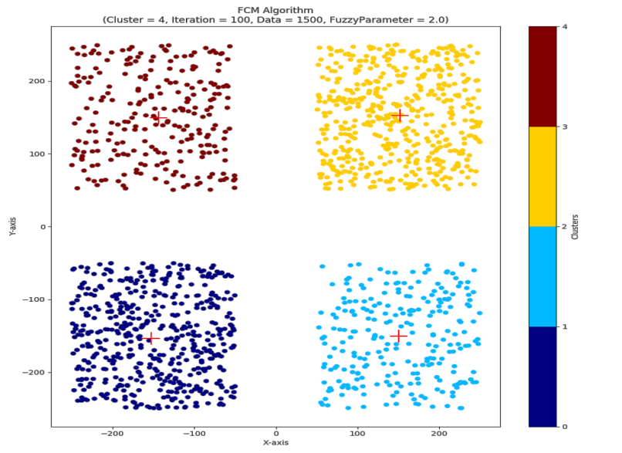

* Test case 1:

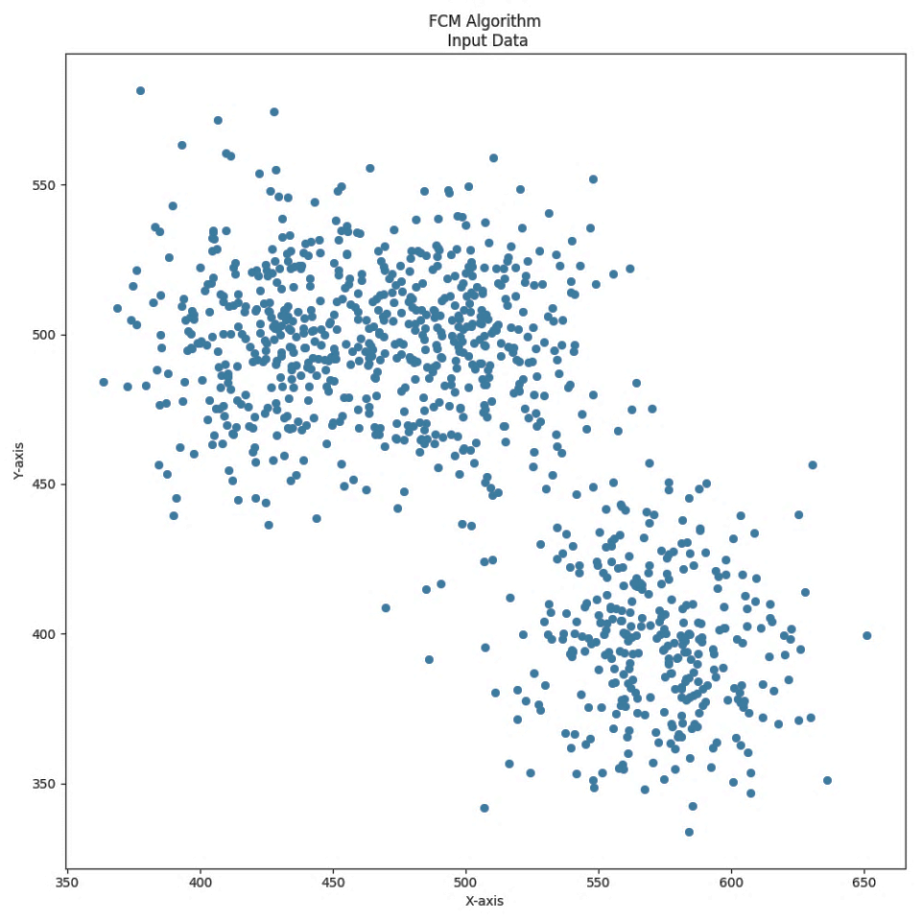 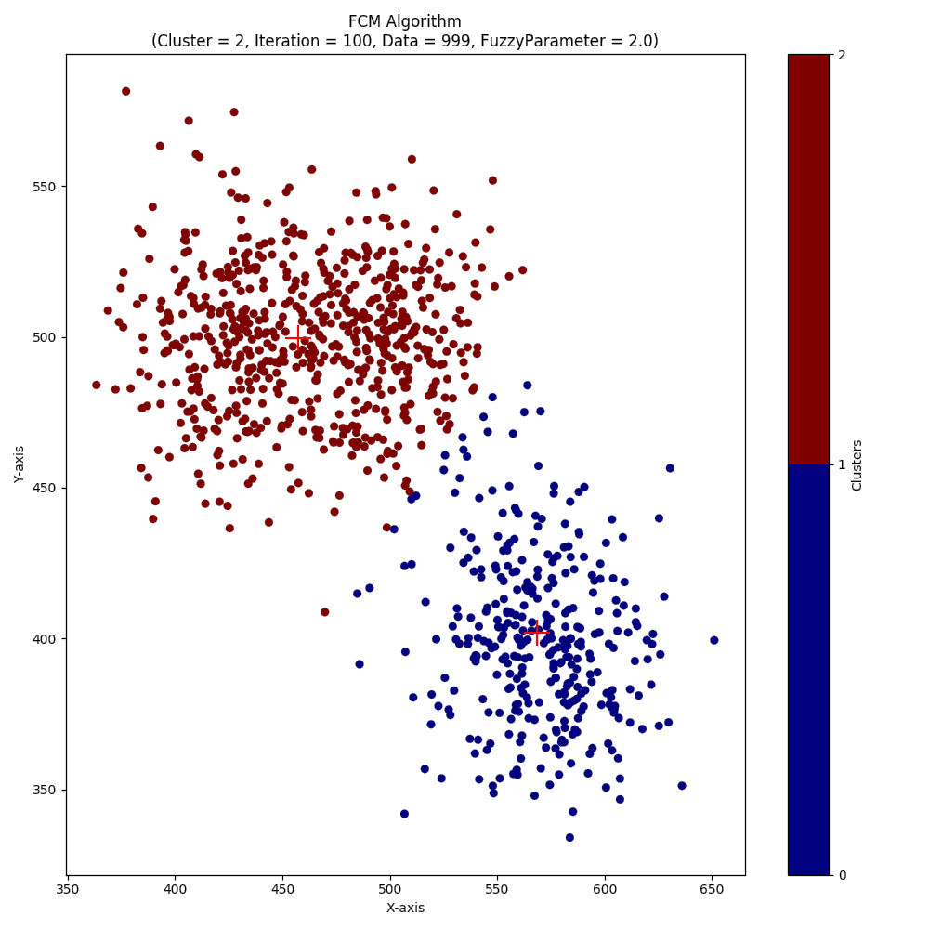

* Test case 2

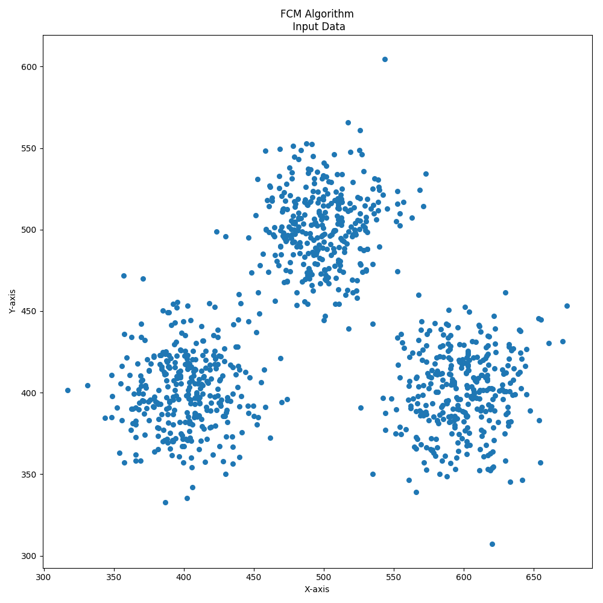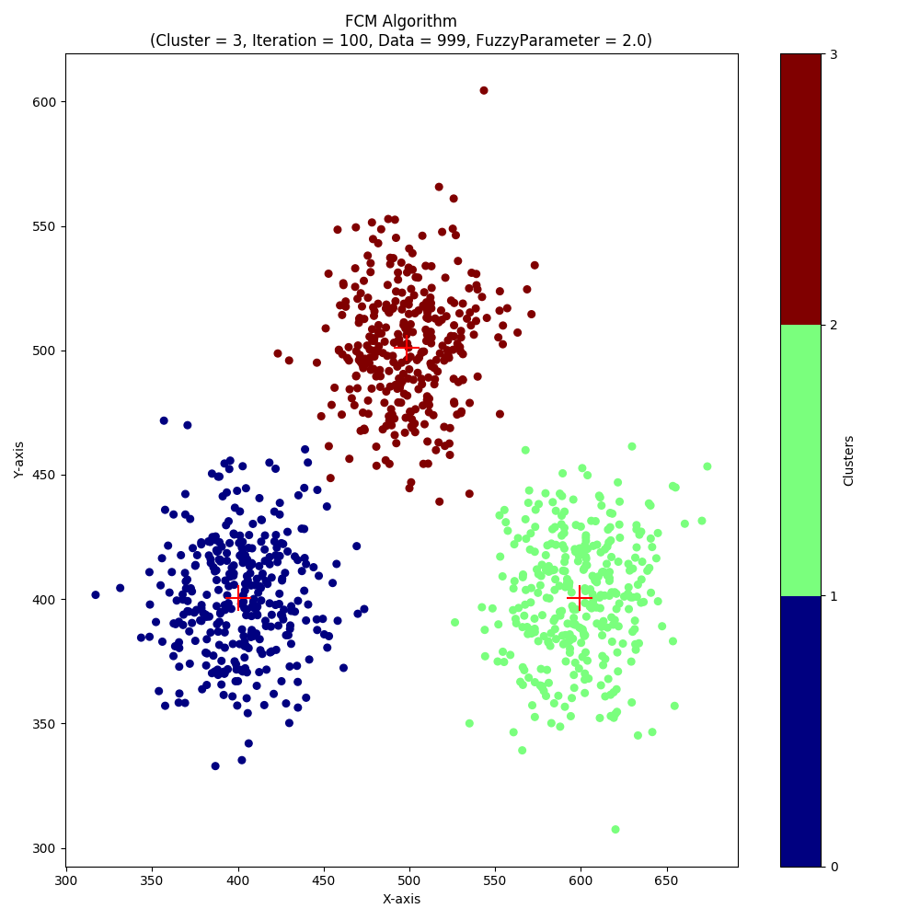

# Test case 3:

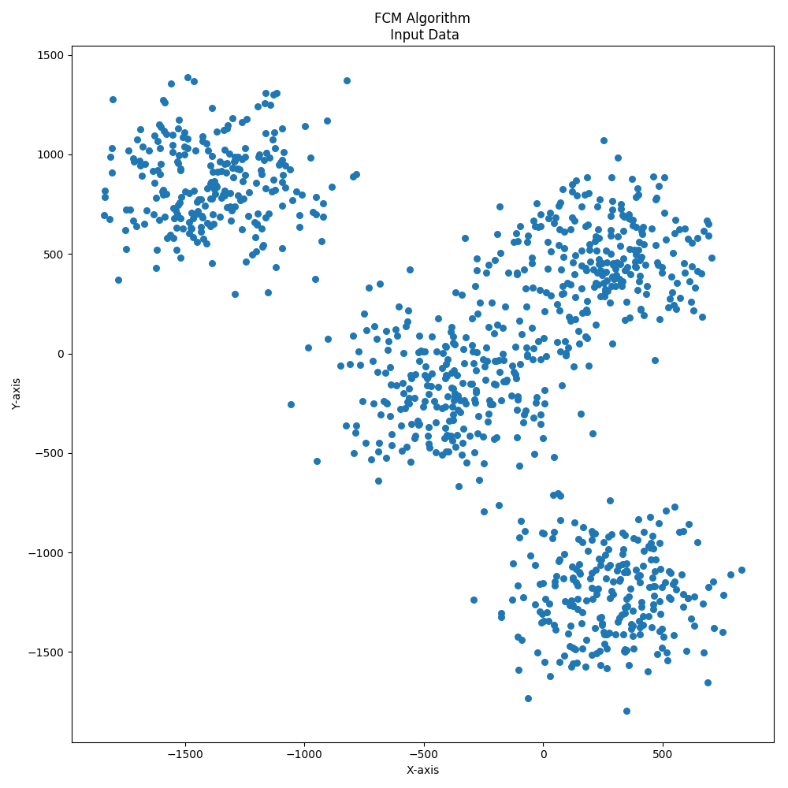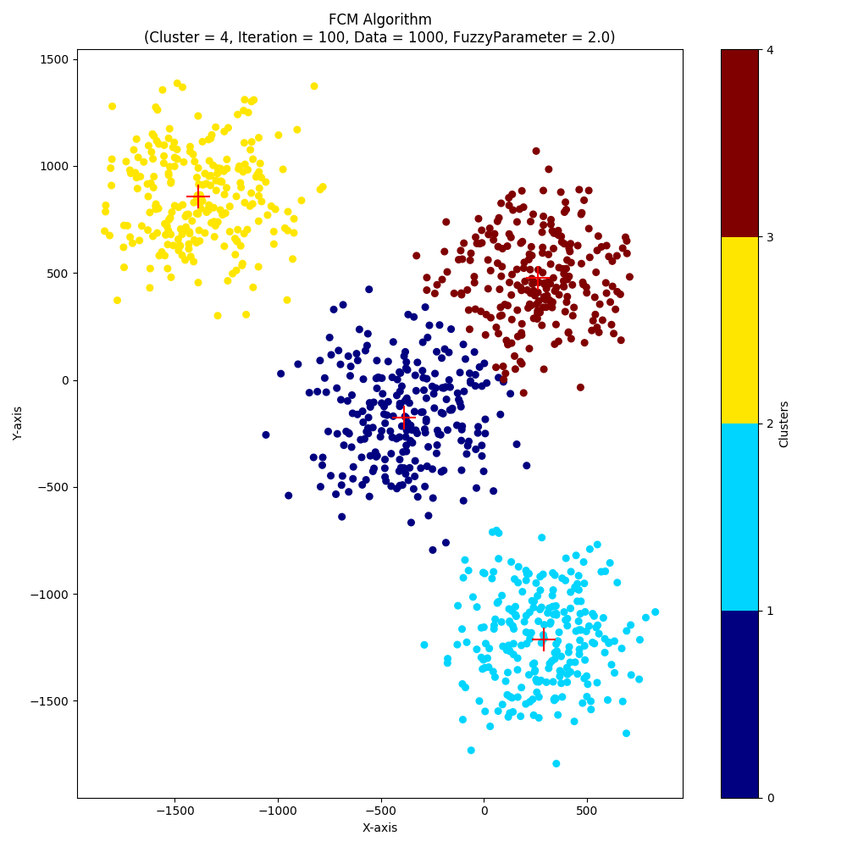

# Test case 4:

