## Introduction

The transmission of electrical energy does not usually raise as much interest as does its generation and utilization; consequently, we sometimes tend to neglect this important subject. This is unfortunate because the human and material resources involved in transmission are much greater than those employed in generation. Electrical energy is carried by conductors such as overhead transmission lines and underground cable. Although these conductors appear very ordinary, they possess important electrical properties that greatly affect the transmission of electrical energy. ….. In recent times, many important developments have come from extending innovations in the information and communications technology (ICT) field to the power engineering field. For example, the development of computers meant load flow studies could be run more efficiently allowing for much better planning of power systems. Advances in information technology and telecommunication also allowed for effective remote control of a power system's switchgear and generators. It is highly flexible in use as it can be converted to any desired form like mechanical, thermal, light, chemical etc. An electrical power system is made up of many components connected together to form a large, complex system that is capable of generating, transmitting and distributing electrical energy over large areas.

The electric power system is defined as a large electric network that consists of three major components: generation, a high voltage transmission grid, and a distribution system. The high voltage transmission system links the generators to substations, which supply power to the user through the distribution system

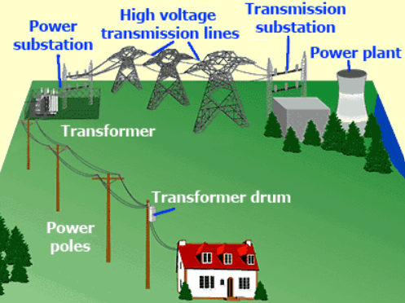

* Generation

In generating station the fuel (coal, water, nuclear energy, etc.) is converted into electrical energy. The electrical power is generated in the range of 11kV to 25kV, which is step-up for long distance transmission. The power plant of the generating substation is mainly classified into three types, i.e., thermal power plant, hydropower plant and nuclear power plant. The generator and the transformer are the main components of the generating station. The generator converts the mechanical energy into electrical energy. The mechanical energy comes from the burning of coal, gas and nuclear fuel, gas turbines, or occasionally the internal combustion engine. The transformer transfers the power with very high efficiency from one level to another. The power transfer from the secondary is approximately equal to the primary except for losses in the transformer. The step-up transformer will reduce losses in the line which makes the transmission of power over long distances

* Transmission

The transmission substation carries the overhead lines which transfer the generated electrical energy from generation to the distribution substations. It only supplies the large bulk of power to bulk power substations or very big consumers.

The transmission lines mainly perform the two functions

1. It transports the energy from generating stations to bulk receiving stations.
2. It interconnects the two or more generating stations.

The neighbouring substations are also interconnected through the transmission lines. The transmission voltage is operating at more than 66kv and is standardised at 69kv, 115KV, 138KV, 161KV, 230KV, 345KV, 500KV, and 765KV, line-to-line. The transmission line above 230KV is usually referred to as extra high voltage (EHV). The high voltage line is terminated in substations which are called high voltage substations, receiving substations or primary substations. In high voltage substation, the voltage is step-down to a suitable value for the next part of flow toward the load. The very large industrial consumers may be served directly to the transmission system

Sub-transmission Substation

The portion of the transmission system that connects the high voltage substations through the step-down transformer to the distribution substations is called the sub-transmission system. The sub-transmission voltage level ranges from 90 to 138KV. The subtransmission system directly serves some large industries. The capacitor and reactor are located in the substations for maintaining the transmission line voltage. The operation of the sub-transmission system is similar to that of a distribution system. Its differ from a distribution system in the following manner.

1. A sub-transmission system has a higher voltage level than a distribution system.

2. It supplies only bigger loads.

3. It supplies only a few substations as compared to a distribution system which supplies some loads.

* Distribution

The component of an electrical power system connecting all the consumers in an area to the bulk power sources is called a distribution system . The bulk power stations are connected to the generating substations by transmission lines. They feed some substations which are usually situated at convenient points near the load centres . The substations distribute the power to the domestic, commercial and relatively small consumers. The consumers require large blocks of power which are usually supplied at sub-transmission or even transmission system

In the following we concern for transmission of power and transmission line design so to do that we must design the different parameters of the T.L like (transmission voltage, conductor type, number of circuits, and number of bundles per phase) also we should satisfied some constrains( electric, mechanical, environmental and economical constraints)

Electric constrains

Includes stability, reliability, thermal capacity, voltage profile, corona and over voltages

Here we should calculate the efficiency and voltage regulation of the system

Efficiency = receiving end power (PR) / sending end power (Ps)

Voltage regulation: is the rise in voltage at the receiving end expressed in percent of full-load voltage

Ԑ =( |𝑣𝑠 | − |𝑣𝑅 @𝐹𝐿|)/ |𝑣𝑅 @𝐹𝐿|

Where at no load condition VRnl = Vs

Environmental constrains

These constraints guarantee the protection of the health of the people surrounding the transmission line if it passes near a living area

Mechanical constraints

The different forces existing on the conductors (string and the tower)

Economical constrains

The economical constrains is that we should achieve all of the previous constrains but by using the minimum cost possible

Here we will design the transmission line according to electrical constrains only so we will focus on designing of transmission line parameters such ( material of transmission line and calculations of the efficiency, voltage regulation, power factor at receiving end, current at sending / receiving end and line resistance / impedance / capacitance / inductance )

If our design don’t achieve all of the requirements and all the constrains we will try another design by change some parameters (voltage ,conductor material , number of bundles or circuits per phase ) until we find the best design that achieve all the requirements (the best performance , minimum cost , …)

* Transmission line parameters

The efficiency of the transmission depends on the line parameters ( resistance , inductance, capacitance, and conduction transformation)

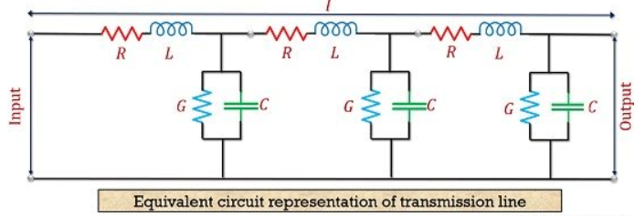

1. Resistance

**R = ρ*L/a**

So it depend on the material of the conductor of the transmission line and the cross sectional area of it and its unit is ohms per unit length of the conductor. It represent an important parameter to design where it affects on The efficiency of the transmission by causing losses

P loss = I2R

1. Inductance

The change of current in the transmission line leads to the generation of emf in the circuit, as a result of changing the magnetic flux. This emf resists the flow of current. The magnitude of emf depends on the rate of flux change

1. Conductance

Air acts as and dielectric medium between the conductors, and some current flows in this dielectric medium due to dielectric defects when alternating voltage is applied. The leakage of this current depends on pollution and the condition of the atmosphere.

1. Capacitance

Capacitance between the conductors of a two-wire line is defined as the charge on the conductors per unit of potential difference between them

C = q/ V (F/m)

This capacitor stores electrical energy or increases the capacitance of the line Capacitance is negligible in short transmission lines but in long transmission, it is the most important parameter. As it affects the efficiency, voltage regulation, power factor and stability of the system