
August 13, 2026

University of Sciences and Arts in Lebanon
Faculty of Sciences and Arts

UniConnect: An Integration-First Multi-University Digital Services Platform

Computer Science Final Year Project – Computing

Mohamad Sabbagh – 1123206 & Mohamad Ali Rida – 1122824
Supervisor: Zahraa Sleem

Abstract
Universities give students identity, courses, and grades through a Student Information System, but rarely provide the everyday services that surround campus life — coordinating study groups, sharing rides, verifying attendance, running clubs, or matching students to internships. Each university that wants these services must either build them from scratch or adopt a vendor tool that assumes ownership of academic data it should never need to touch. UniConnect addresses this by acting as an integration-first layer above a university's existing systems rather than a replacement for them. A single adapter interface, IUniversityProvider, is the only contract UniConnect depends on; each university's own API is plugged in behind it, so identity, enrolment, and coursework remain the university's system of record. On top of this layer, UniConnect delivers six student-facing services — Smart Attendance, Study Groups, Ride Sharing, Clubs, Internship Matching, and Complaints and Ticketing — together with three cross-cutting platform services (Notifications, Reporting, and Audit Logging) that every module relies on, all delivered through a shared ASP.NET Core backend consumed by both a web portal and a native .NET MAUI mobile application. The platform was built and tested against the project's own simulated university, then validated end-to-end against a real partner university's live production API, confirming that the adapter pattern holds up outside a controlled test environment. This report documents the platform's requirements, design, and implementation, and reflects on the practical challenges of building a system whose correctness depends on integrating cleanly with infrastructure the project does not control.

Acknowledgements
We are grateful to the Faculty of Sciences and Arts at the University of Sciences and Arts in Lebanon for the opportunity to undertake this project, and to the teaching staff whose courses gave us the foundation it was built on.
We are equally grateful to Dr Yasser Fadlallah, whose guidance and professional advice shaped our approach throughout the project, and whose help in obtaining approval to use the university's API is what made the integration work described in this report possible.
We would like to thank our supervisor, Zahraa Sleem, for her guidance throughout this project, and for the feedback that shaped both the direction of the work and this report.
We also thank the team at our partner university for granting access to their production API and for answering our questions about its behaviour. Their willingness to engage with an external student project is what allowed the integration approach to be tested against a real system rather than only against simulated data.

Table of Contents
Section | Page
Abstract | 2
Acknowledgements | 3
List of Abbreviations | 7
1 Introduction | 9
1.1 Background | 9
1.2 Objective | 9
1.3 Scope | 9
1.4 Methodology | 10
1.5 Limitations | 10
2 Related Research | 11
2.1 Similar Existing Products | 11
2.2 Project’s Added Value | 11
3 Problem Analysis | 12
3.1 Project Description | 12
3.2 Business Requirements Overview | 12
3.3 Use Cases | 12
4 Design | 14
4.1 Data Modeling | 14
4.2 Data Flow Diagrams | 15
4.3 User Interface Design | 18
5 Development | 21
6 Testing and Evaluation | 21
7 Ethics and Data Protection | 22
8 Challenges | 22
9 Future Work | 23
10 Conclusion | 24
11 Bibliography | 24

Table of Figures
Figure | Page
Figure 1 — Fully-attributed core entities of the UniConnect data model | 15
Figure 2 — Context Data Flow Diagram | 16
Figure 3 — Level 0 Data Flow Diagram | 17
Figure 4 — Level 2 Data Flow Diagram — Smart Attendance | 18
Figure 5 — Web portal — Home dashboard | 19
Figure 6 — Mobile app — Home tab | 19
Figure 7 — Web portal — Smart Attendance | 20
Figure 8 — Mobile app — Attendance check-in | 20

List of Abbreviations
Abbreviation | Expansion
API | Application Programming Interface
ASP.NET | Active Server Pages .NET
CV | Curriculum Vitae
DFD | Data Flow Diagram
DPIA | Data Protection Impact Assessment
EF Core | Entity Framework Core
GPS | Global Positioning System
HTTP | Hypertext Transfer Protocol
JSON | JavaScript Object Notation
JWT | JSON Web Token
LMS | Learning Management System
MAUI | Multi-platform App UI
MVC | Model-View-Controller
QR | Quick Response code
RFC | Request for Comments
RSVP | Repondez s'il vous plait
SIS | Student Information System
SMS | Short Message Service
SQL | Structured Query Language
SQLite | Embedded SQL database engine
SignalR | ASP.NET Core real-time messaging library
TF-IDF | Term Frequency-Inverse Document Frequency
TOTP | Time-based One-Time Password
URI | Uniform Resource Identifier
UTC | Coordinated Universal Time

1 Introduction

1.1 Background
Most universities operate a Student Information System (SIS) and a Learning Management System (LMS) to manage identity, enrolment, coursework, and grades. These systems are deliberately conservative: they are the institution's system of record, and universities are rightly reluctant to let a third-party project write to them or depend on undocumented internals. This leaves a real gap between what an SIS/LMS provides and what students actually need day to day — finding a study partner for a specific course, coordinating a ride to campus, proving attendance without a manual roll call, discovering an internship that matches their actual coursework, or raising a complaint with the right department and tracking its resolution. Where these needs are met at all, they are usually met by generic, non-academic tools (WhatsApp groups, ride-hailing apps, spreadsheets) that have no awareness of a student's enrolment, course schedule, or university identity, and therefore cannot enforce the basic guarantees — “only classmates in this course can join this group”, “only an enrolled student can be marked present” — that make these services trustworthy in an academic context.

1.2 Objective
The objective of UniConnect is to design and build a platform that delivers these missing student-life services without requiring a university to migrate data, change its existing SIS, or grant UniConnect write access to academic records. Concretely, the project set out to: (1) define a single, stable integration contract that any university's academic data can be read through; (2) build six student-facing services, and the three cross-cutting platform services they share, on top of that contract, each verified against real enrolment and identity data rather than self-reported information; (3) ship both a web portal and a native mobile client from one shared backend; and (4) prove the integration approach against a real external university's production API, not only against simulated data.

1.3 Scope
In scope: account activation and role resolution against a university's own identity data; per-university enablement and configuration of each service; the six student-facing services listed in the objective, each with real-time features (chat, live tracking, notifications) where appropriate; a role-based web portal for administrators, department staff, and company users; a native mobile application, scoped to students only, covering Smart Attendance, Study Groups, and Internships as full modules, alongside a Home dashboard, a Profile screen, and Notifications; and a working integration against one real partner university's live API, alongside the project's own simulated university used for the remaining test tenants. Out of scope: UniConnect does not create, edit, or store courses, enrolments, or grades — that data is always read live from the university's own system and never duplicated as the source of truth; it does not replace an SIS or LMS; and mobile coverage of Rides, Clubs, and Complaints, along with a live SignalR layer for the mobile client, were identified as a deliberate second phase and are documented under Future Work rather than claimed as complete.

1.4 Methodology
The backend is an ASP.NET Core MVC application (C#) with Entity Framework Core over SQL Server, exposing both server-rendered Razor views for the web portal and a JSON API (secured with JWT bearer tokens) for the mobile client, alongside cookie-based authentication for the web session. Real-time features (chat, live notifications, ride tracking) are implemented with SignalR. The mobile client is built with .NET MAUI, targeting Android and Windows. All access to academic data — students, courses, enrolments, instructors, staff — goes through one adapter interface, IUniversityProvider, so the rest of the application never knows or cares whether it is talking to the project's own simulated university or a real partner institution's live API. The internship-matching feature uses a TF-IDF (term frequency–inverse document frequency) and cosine-similarity model over a student's skills, completed coursework, and stated interests against each posting's requirements. Development proceeded iteratively, module by module, with an automated test suite (xUnit, against a real relational SQLite database rather than an in-memory provider, so that unique-index and foreign-key constraints are actually exercised) built alongside the features it covers.

1.5 Limitations
The project was affected by the loss of two months of prior work when access to an earlier development account was lost, requiring the codebase and design documentation to be reconstructed from local backups. Time constraints meant the mobile client's real-time (SignalR) layer, and mobile coverage of the Rides, Clubs, and Complaints modules, were not completed and are documented as future work rather than attempted incompletely. Integration with the real partner university surfaced genuine, external limitations outside the project's control: its API has no endpoint for retrieving a full student list, no instructor or staff directory, and returns a derived academic-standing field that its own team has not yet finalised — each of these was confirmed directly against the partner's own API documentation and formally raised with them rather than worked around silently.

2 Related Research

2.1 Similar Existing Products
No single existing product covers the same ground as UniConnect, but each of its services has established comparables. Learning Management Systems such as Canvas [8] and Blackboard [9] centralise coursework and grading but offer no ride-sharing, club management, or internship matching, and their attendance features typically rely on a single factor (a code or link) with no location or device verification. General-purpose messaging apps (WhatsApp, Discord) are commonly repurposed for study groups, but have no awareness of course enrolment, so anyone with an invite link can join regardless of whether they are actually taking the course. Commercial ride-hailing apps solve transportation but are not campus-aware and were not designed for the trust model of “only people from my own university”. Career platforms such as LinkedIn [10] and Indeed [11] offer far larger job pools but match on self-reported skills and free-text profiles rather than a student's actual completed coursework, and have no institutional relationship with any specific university's career-services office. Card-based or barcode attendance systems are common in industry but generally check only one factor — a scanned code — leaving them vulnerable to a student sharing a screenshot with a classmate who is not physically present.

2.2 Project’s Added Value
UniConnect's contribution is not any single service in isolation, but the combination of nine previously-siloed functions behind one identity and one adapter contract, so every service can trust the same verified enrolment and identity data instead of re-implementing its own checks. Three specific design choices go beyond what the reviewed comparables offer. First, Smart Attendance combines a time-bound QR token, GPS proximity to the classroom, and device-fingerprint reuse detection, rather than relying on a single factor. Second, internship matching scores a student against a posting using their actual completed coursework and declared skills through TF-IDF and cosine similarity [6], rather than free-text self-reporting alone. Third, and most significantly from an architectural standpoint, the adapter pattern (IUniversityProvider) means a new university can be onboarded by implementing one interface against its own API, with zero changes to any of the services built on top of it — a claim this project tested directly, validating it against a real partner university's live production API rather than only against the project's own simulated data.

3 Problem Analysis

3.1 Project Description
UniConnect is organised around a small Core Platform (identity linking, role resolution, per-university service configuration) and nine services built on top of it: six student-facing services that a university can enable or disable independently, and three cross-cutting services that every module consumes rather than re-implementing. The six student-facing services are as follows. Smart Attendance lets an instructor open a time-bound session and students check in via QR scan or manual token entry, verified against GPS location, enrolment, and device history. Study Groups lets enrolled students create or join course-scoped groups with real-time chat. Ride Sharing lets driver-students offer seats and other students request them, tracked on a live map. Clubs and Organizations supports structured membership roles, announcements, and events with RSVP. Internship Matching scores postings against a student's profile and completed coursework. Complaints and Ticketing routes student requests to the correct department and tracks every response until resolution. The three cross-cutting services are Notifications, Reporting, and Audit Logging; these are shared infrastructure rather than per-university options, and are therefore not exposed in the service catalogue that administrators enable and disable.

3.2 Business Requirements Overview
Functionally, the system must: verify a registrant's identity against the university's own record before activating an account; enforce course enrolment before allowing a student to join a course-scoped study group or be marked present in an attendance session; let a university enable, disable, and configure each service independently; and keep every service's data isolated per university even when two universities share the same database. Non-functionally, the system must remain correct when a university's external API is temporarily unavailable (serving cached data rather than failing outright); must not let one university's users see another university's data under any circumstances; must support real-time delivery for chat, notifications, and live tracking; and must degrade gracefully — a slow or malformed response from a university's own API should produce a clear error, not a system-wide failure.

3.3 Use Cases
Use cases were documented across the six student-facing services; the table below summarises five representative ones spanning identity verification, real-time collaboration, and cross-service notification.
ID | Actor | Description | Outcome
UC-01 | Student | Register using University ID and registrar email; the system verifies both against the university's own record before an account is created. | A confirmed account exists only for a genuine, currently-enrolled student.
UC-04 | Student | Submit attendance by scanning a QR code or entering its token manually; the system checks token validity, time window, GPS proximity to the classroom, and course enrolment. | Attendance is recorded as Present or Late, or rejected with a specific reason (expired token, out of range, not enrolled).
UC-09 | Student | Create or join a study group for a course the student is enrolled in; enrolment is verified live through the adapter before the request succeeds. | The student is added to a group scoped to a course they can actually prove they are taking.
UC-13 | Driver Student | Offer a ride with a departure point, destination, and available seats; other students request a seat, which the driver accepts or rejects. | Seats decrement automatically on acceptance and restore on cancellation, with the ride status updated in real time.
UC-18 | Student / Staff | A student submits a complaint to a department; staff respond and change its status; every update notifies the student. | A fully auditable ticket thread exists from submission through resolution.

4 Design

4.1 Data Modeling
- Context Data Model: At context level, UniConnect's own database holds only what it must own — accounts, university and service configuration, and each service's own records (study groups, rides, tickets, club memberships, internship applications, attendance records, notifications, audit log). Academic data — students, courses, enrolments, instructors, and staff — sits outside this boundary, on the university's own system, and is read through the adapter rather than owned by UniConnect. A small, university-scoped cache of that academic data exists locally, but it is explicitly a cache, not a system of record: it is refreshed by a background sync job and is never the final authority on whether a student is actually enrolled in a course.
- Key-Base Data Model: The key entities are University (Code, Name, ApiBaseUrl, ApiStyle), ApplicationUser (Id, UniversityId, UniversityCode, FullName, Role), Course (UniversityCode + CourseCode as a composite key, so two universities may each have their own “CSC301” without collision), StudyGroup, Ride, Ticket, ClubMembership, InternshipApplication, AttendanceSession, and AttendanceRecord. Every service-level entity carries a UniversityCode foreign key, which is what makes per-university data isolation enforceable at the database level rather than only in application logic.
- Fully attributed Data Model: The fully-attributed model adds the constraints that give each entity its real behaviour: a unique index on (AttendanceSessionId, UserId) prevents duplicate attendance submissions; a composite primary key of (UniversityCode, CourseCode) on Course allows safe multi-tenancy; optimistic-concurrency row-version columns on Ride and StudyGroup prevent two simultaneous requests from double-booking the last seat or exceeding a group's capacity; and a unique constraint on (InternshipId, StudentId) for applications prevents a student from applying to the same posting twice. The complete model spans thirty-seven tables and is included as the figure below.
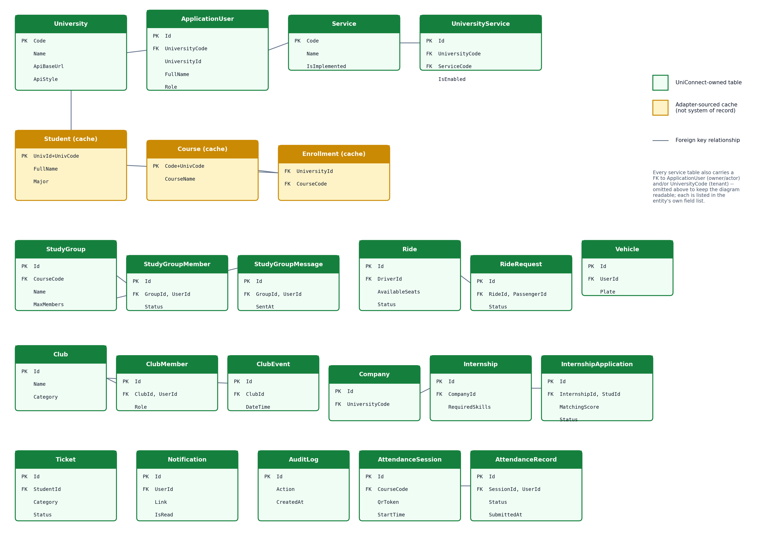
Figure 1: Fully-attributed core entities of the UniConnect data model

4.2 Data Flow Diagrams
- Context Data Flow Diagram: At context level, three external entities interact with UniConnect: the Student/Instructor/Staff user (via web browser or the mobile app), the Administrator/Company user (via web portal only), and each University's own external API, which UniConnect reads from but never writes to. All user-facing traffic flows through the ASP.NET Core backend, which is the only component with direct access to UniConnect's own database.
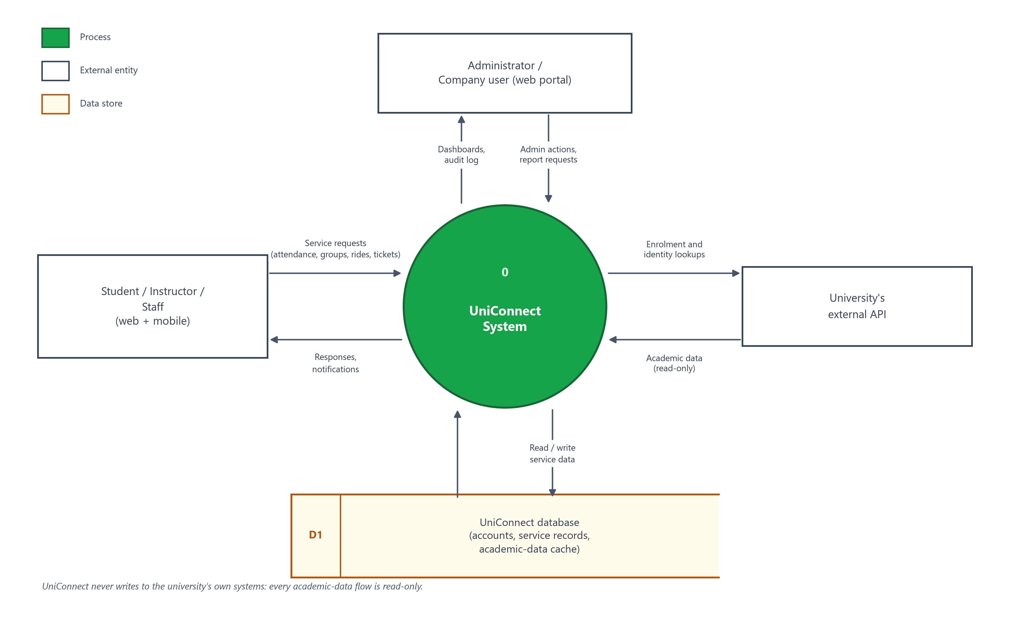
Figure 2: Context Data Flow Diagram

- Level 0 Data Flow Diagram: At level 0, the backend decomposes into the Core Platform (identity, role resolution, service configuration), the Adapter layer (IUniversityProvider, resolved per university to either the simulated or real-partner implementation), and the nine service modules, each reading academic data through the adapter and writing only to its own tables. A background Sync process periodically refreshes the local academic-data cache from each university's external API where that API's shape supports it.
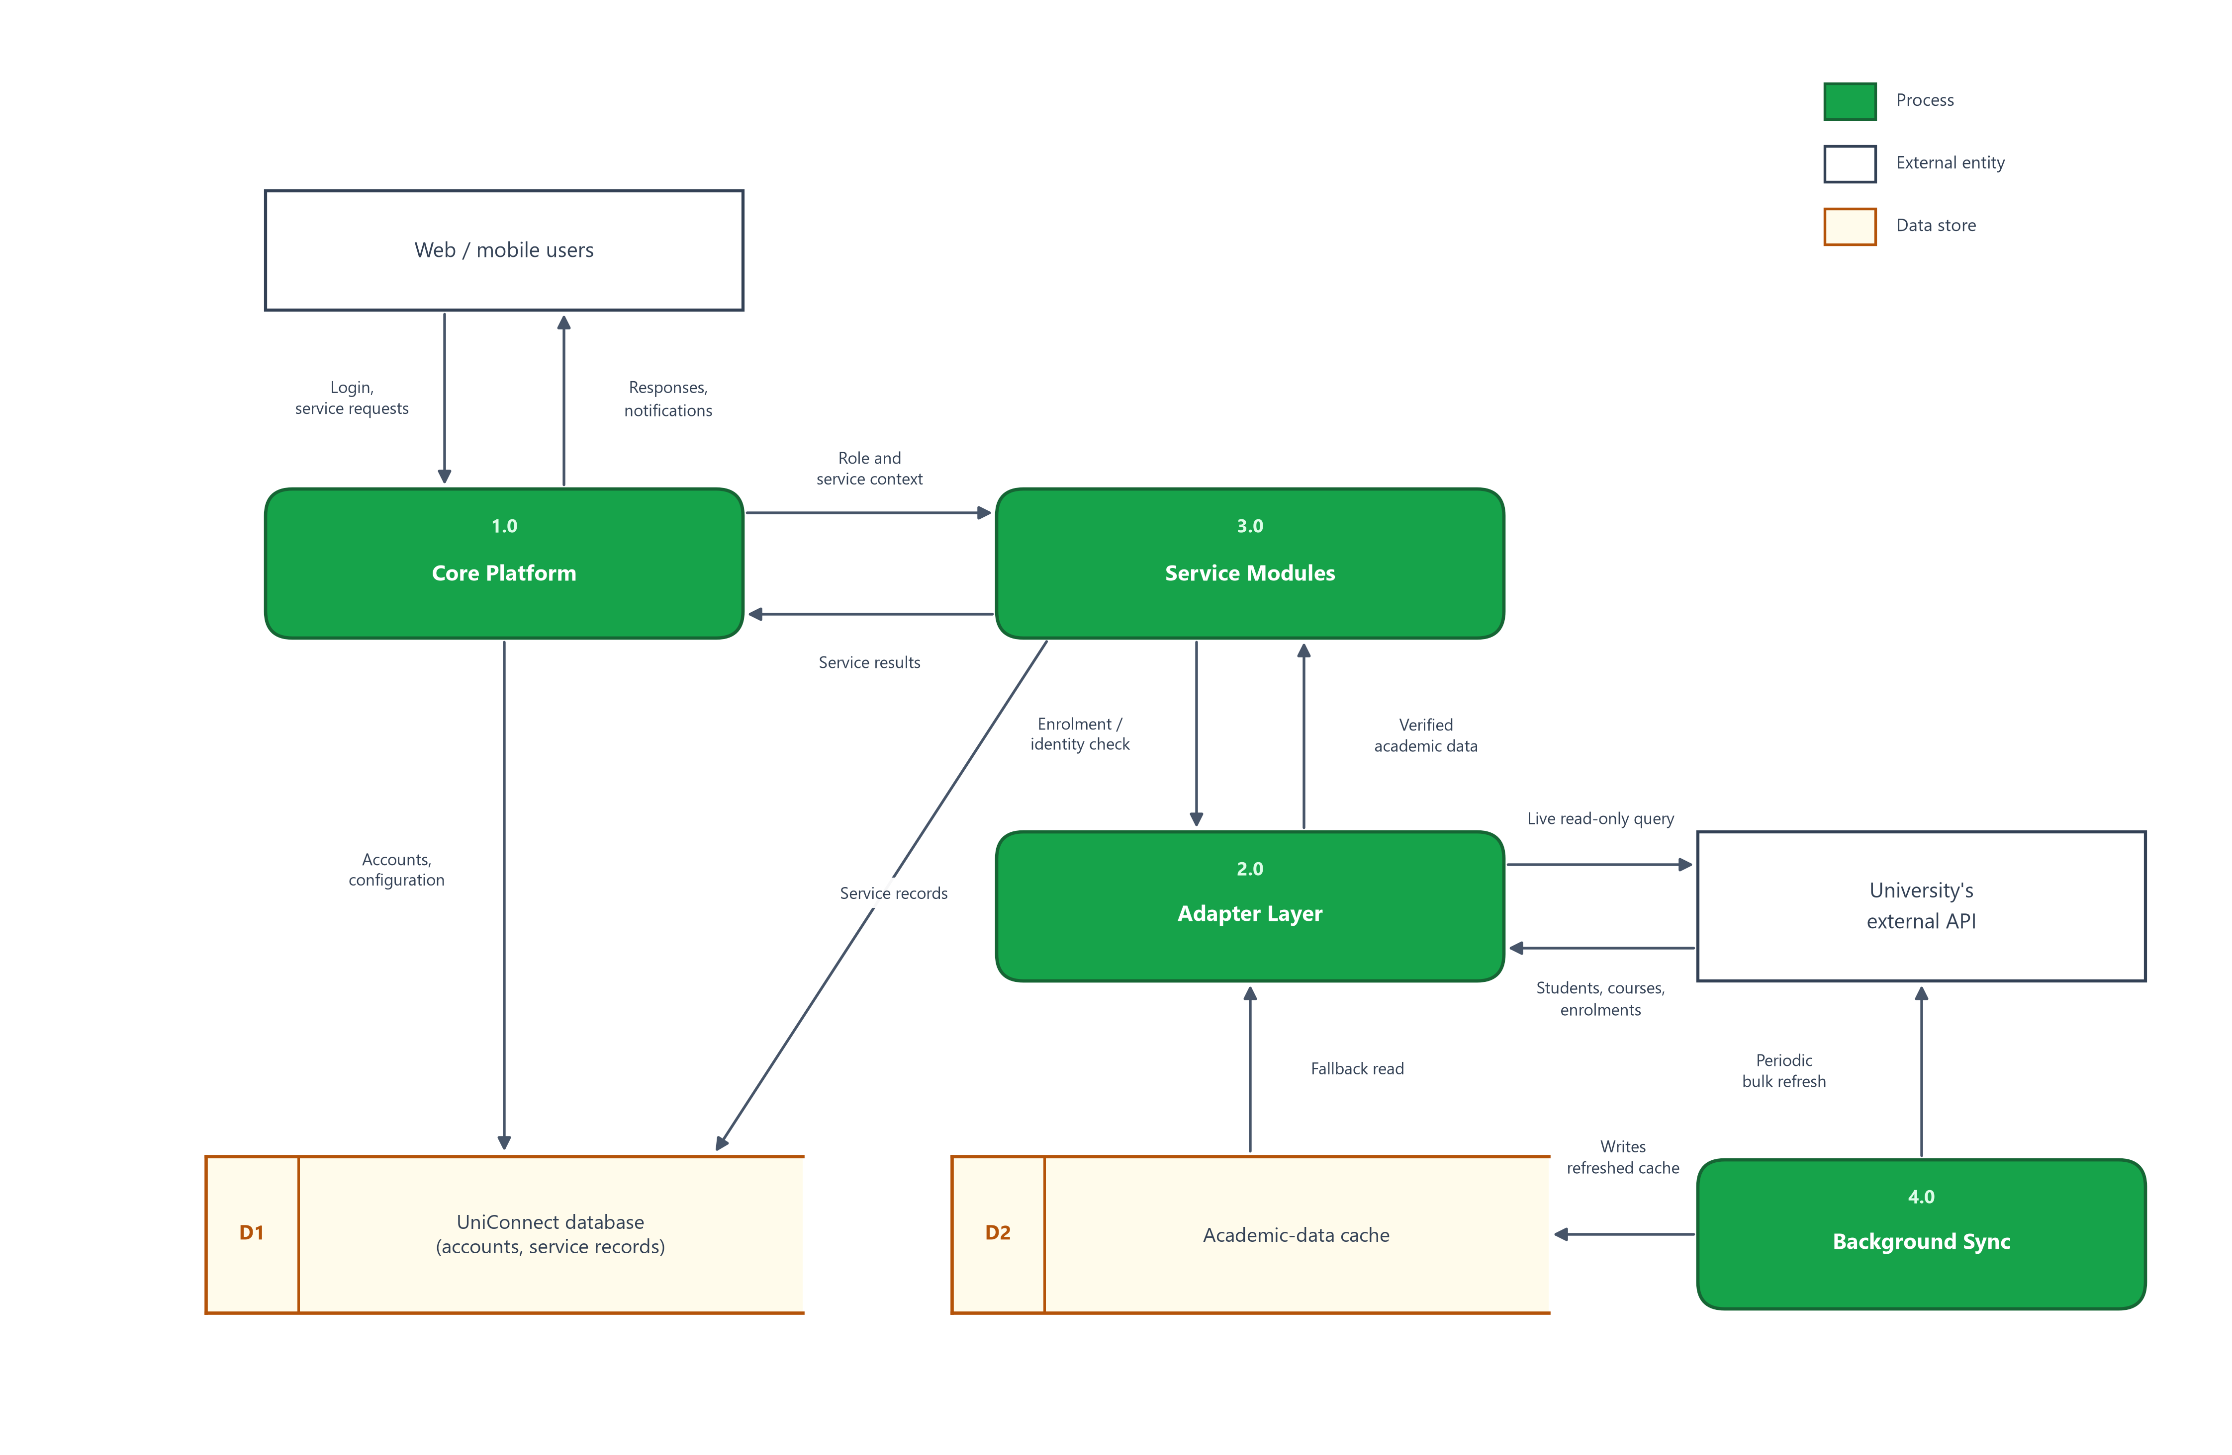
Figure 3: Level 0 Data Flow Diagram

- Level 2 Data Flow Diagram: At the next level of detail, the Smart Attendance process, for example, decomposes into session creation (instructor-initiated, generates a time-bound QR token), submission validation (checks token validity, time window, GPS radius, enrolment via the adapter, and duplicate/device-reuse detection), and result aggregation (marks Present/Late/Absent and notifies the student). Each of the other eight services follows the same shape: a write path that validates against live or cached academic data before touching UniConnect's own tables, and a read path that serves the web portal, the mobile app, or both.
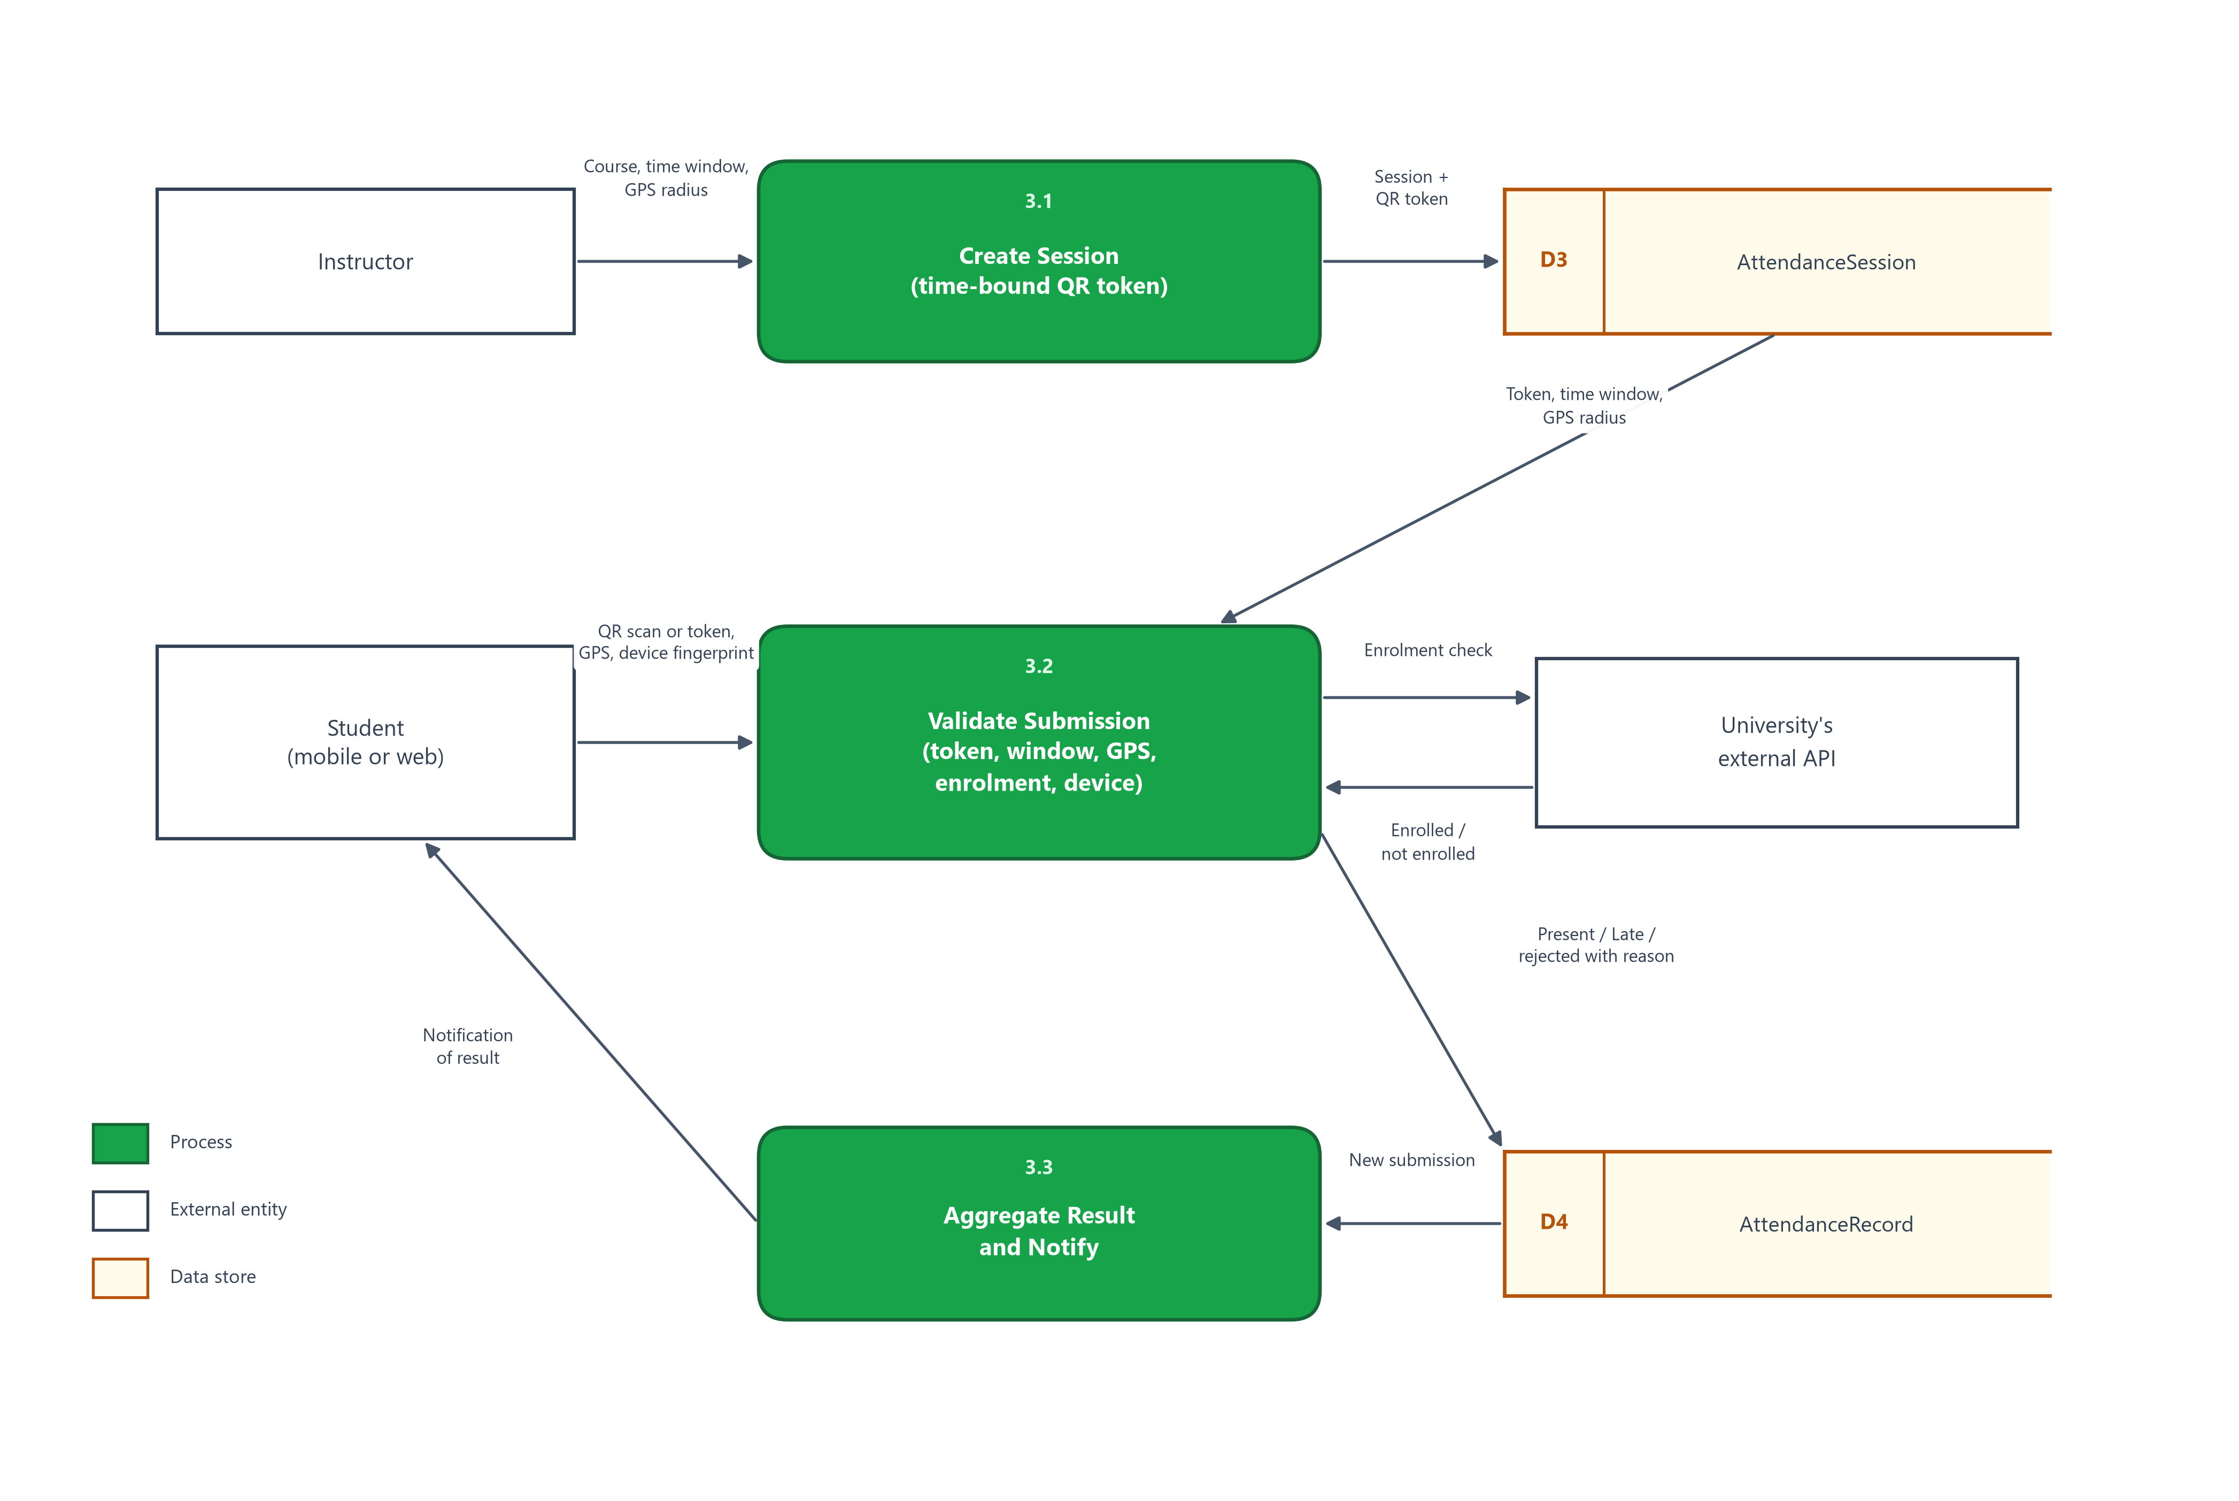
Figure 4: Level 2 Data Flow Diagram — Smart Attendance

4.3 User Interface Design
The web portal follows a conventional top-navigation layout for the student-facing pages and a sidebar layout for the administrative portal, styled with a consistent design system (a single primary green, #16a34a, plus a small set of derived tints and a shared card/pill/badge vocabulary) so that every module reads as part of one product rather than a set of independently-styled screens. The mobile client follows a native, mobile-first pattern deliberately distinct from the web's layout — a bottom tab bar for primary navigation across Home, Study Groups, Internships, Smart Attendance, and Profile; card-based lists; and platform-native controls. It shares the web's palette family, iconography and copy, but deliberately does not reuse its primary colour: the mobile client is built on a brand gradient (#108548 to #0a5d32) with #0f7a46 for text and icons, because a single flat green that reads well against a wide desktop layout reads as a slab when it fills a phone-width header. The intent is that the two clients feel like the same product expressed through two different platforms' conventions, rather than one being a literal clone of the other. Screens from both clients are included as the figures below.
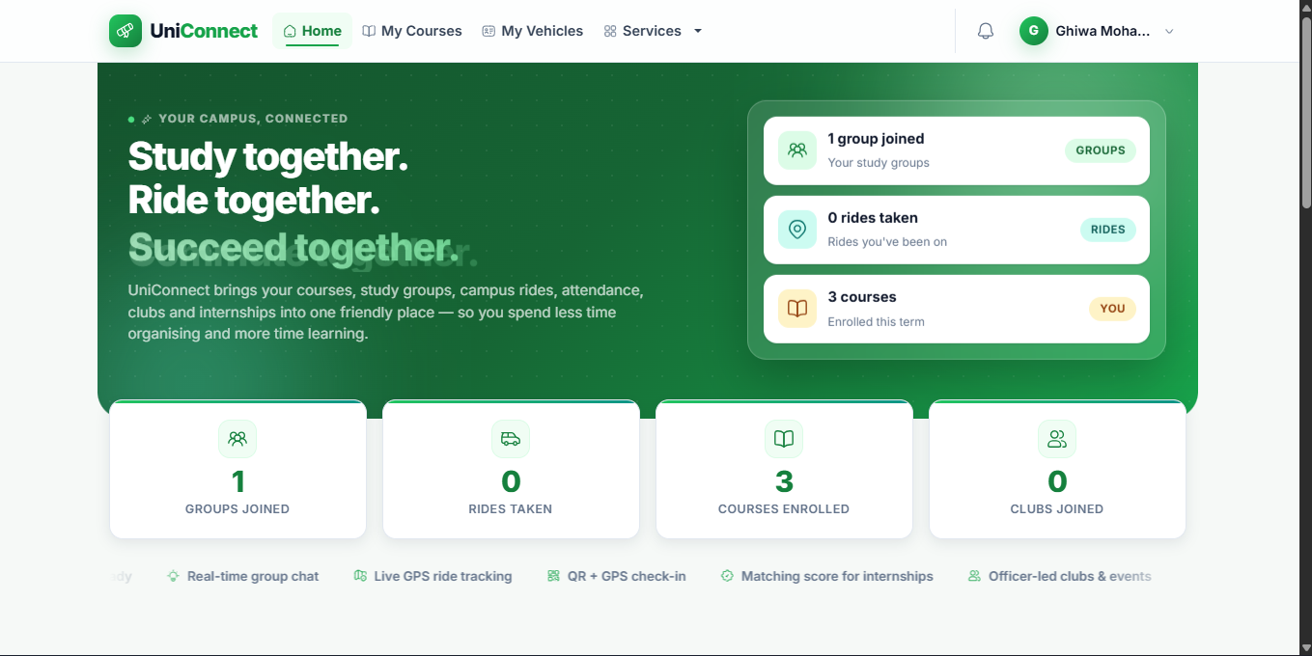
Figure 5: Web portal — Home dashboard

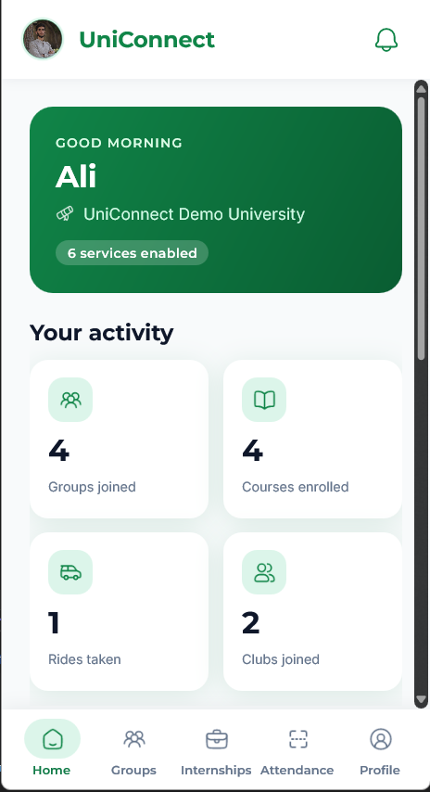
Figure 6: Mobile app — Home tab

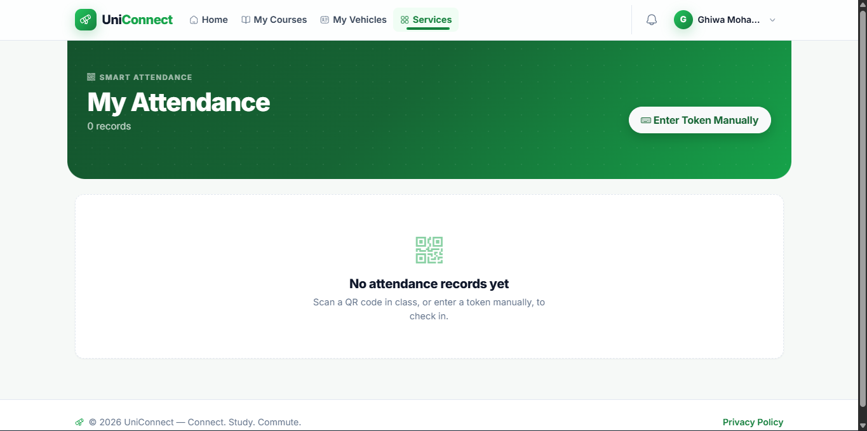
Figure 7: Web portal — Smart Attendance

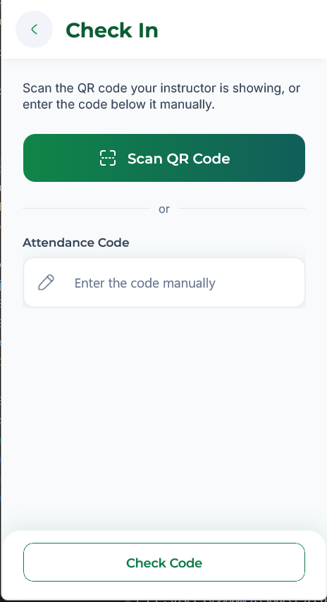
Figure 8: Mobile app — Attendance check-in

5 Development
Implementation proceeded module by module, each following the same pattern: an EF Core migration for the module's own tables, a controller (and, for modules consumed by the mobile app, a parallel JSON API controller) that delegates its business rules to a shared service so the web and mobile clients can never silently disagree about a rule, and a Razor or MAUI view on top. Counting hand-written C# only — excluding generated EF Core migrations, designer files, and build output — the server application comprises roughly 16,900 lines across 27 controllers exposing 172 actions, 21 services, 6 SignalR hubs, and 6 background hosted services, over a schema of 37 tables built by 33 EF Core migrations. The .NET MAUI client adds a further 5,800 lines, and the automated test project a further 6,000, for roughly 28,700 lines of hand-written C# in total. Authentication is cookie-based for the web session and JWT-bearer for the mobile API, both issued by the same underlying ASP.NET Core Identity store, so a student has exactly one account regardless of which client they use. The adapter layer was implemented twice in practice: a RealApiUniversityProvider matching the project's own simulated university's API shape, and a second, independent UmsApiUniversityProvider written specifically to match a real partner university's genuinely different API — different field names, nested course-section data, and no bulk student-listing endpoint — proving that a new, unanticipated API shape can be supported by adding one class rather than modifying the services that depend on the interface. The mobile client targets Android and Windows from a single .NET MAUI codebase, with platform-specific handling isolated to the small number of places — secure token storage, development-certificate trust, native input-chrome removal — where the two platforms genuinely differ.

6 Testing and Evaluation
Testing used xUnit against a real, file-backed SQLite database rather than EF Core's in-memory provider. This distinction matters more than it appears: the in-memory provider does not enforce unique indexes or foreign-key constraints, so a test suite built on it silently passes for exactly the defects most likely to reach production — a duplicate attendance submission, an application to the same internship twice, an orphaned membership row. Running against a real relational engine means those constraints are exercised the same way they would be against SQL Server. At the time of writing the suite contains 271 passing tests, organised around the rules that carry the most risk: attendance submission validation (token expiry, time window, GPS radius, enrolment, and duplicate or device-reuse detection), matching-score computation, study-group membership and capacity rules, and per-university service gating.
Evaluated against the objectives set out in Section 1.2, the results support three of the four directly. The integration contract (objective 1) and the adapter's substitutability (objective 4) are evidenced by the second provider implementation: a real partner university with different field names, a nested course-section shape, and no bulk student-listing endpoint was supported by adding one class, with no change to any service built on the interface. The shared-backend claim (objective 3) is evidenced by the web and mobile clients consuming the same services and the same Identity store, with business rules held in a shared service layer rather than duplicated per client. Objective 2 — every service verified against real enrolment and identity data — holds for the services covered by the test suite and by the live partner integration, but is not uniformly evidenced across all nine: the modules without mobile coverage were exercised manually through the web portal rather than under automated test.
Three gaps in the evaluation are worth stating plainly. First, the test suite's later planned phases — end-to-end tests through a real HTTP pipeline, and a formal authorization matrix asserting that each role can reach exactly the endpoints it should — were scoped but not started, so authorization is currently evidenced by code review rather than by test. Second, no usability or user-acceptance evaluation was carried out with real students; the interface decisions in Section 4.3 rest on convention and on the design system's internal consistency, not on measured task success. Third, the system has not been load-tested, so the non-functional requirement concerning graceful degradation under a slow university API is demonstrated by construction (timeouts and a cached-data fallback) rather than by measurement. Each is recorded in Section 9 as future work rather than presented as complete.

7 Ethics and Data Protection
UniConnect processes a considerable amount of personal data, and the attendance module in particular goes further than most student software: it records where a student physically was at a given time. The personal data held falls into three groups. Identity data (full name, university identifier, institutional email) originates from the university's own record and is read through the adapter rather than collected independently. Data the student supplies directly includes a phone number, an optional profile picture, uploaded CVs for internship applications, ticket attachments, and chat messages. Data generated by using the system includes attendance records with the GPS coordinates and device fingerprint captured at check-in, ride pick-up and drop-off locations, and an audit log of administrative actions.
Three design decisions limit the exposure this creates. Data minimisation is enforced architecturally: academic data is read live through the adapter and never adopted as UniConnect's own record, so the platform holds no copy of grades or transcripts, and the local academic cache is explicitly a cache that a background job refreshes rather than a second source of truth. Tenant isolation is enforced at the database level rather than only in application logic — every service-level entity carries a UniversityCode foreign key — so one university's staff cannot reach another's data even though both share a database. The adapter is read-only by construction: UniConnect never writes to a university's systems, so a defect in the platform cannot corrupt an institutional record.
Several obligations are acknowledged rather than met, and are recorded here rather than left implicit. The system has no formal data-retention or erasure policy: attendance records, GPS coordinates, and uploaded documents persist indefinitely, and there is no self-service route for a student to export or delete their own data. Uploaded files are stored on the application's own filesystem under non-guessable names rather than in object storage with per-object access control, which protects against enumeration but not against direct filesystem access. Disclosure at the point of collection is uneven: both clients tell the student that their location is being checked against the classroom, but the device fingerprint is gathered without being surfaced in the interface at all, and neither is covered by a separate consent record. No formal data-protection impact assessment was carried out. Any real deployment should treat these as prerequisites rather than enhancements, and they are listed as such in Section 9.

8 Challenges
The most disruptive challenge was losing access to an earlier development account, along with two months of accumulated code and design documentation; recovery required reconstructing the project from local backups and re-establishing a full understanding of the existing codebase before any new work could safely proceed. A recurring technical challenge was time-zone handling: attendance session times are deliberately stored as local time rather than UTC (to match how instructors set them), and one background service that compared this local value against DateTime.UtcNow caused sessions to close hours late — a defect caught by direct code review rather than by observed failure, since the delay was easy to miss in day-to-day testing. Integrating with the real partner university surfaced constraints no amount of internal testing could have revealed: field names that did not match the project's own simulated API, a nested course/section data shape the original adapter had not anticipated, and two genuinely missing capabilities (a bulk student list, an instructor/staff directory) that were confirmed against the partner's own documentation and formally raised with them rather than worked around. On the mobile side, reconciling two independently-built MAUI codebases — developed in parallel by different team members after a synchronisation gap left one without the other's work — required a full architectural review before new features could be added safely, since the two implementations had converged on different, individually reasonable but mutually incompatible navigation patterns.

9 Future Work
The most immediate follow-on work is completing the mobile client's live layer — SignalR-backed chat, live ride tracking, and instant notification push — to match the real-time behaviour already present on the web portal. Mobile coverage should also extend to Ride Sharing, Clubs, and Complaints, and the planned “My Activity” cross-module view needs a dedicated backend endpoint rather than being assembled ad hoc per screen. A second priority is two-factor authentication. UniConnect holds verified university identity and, through Smart Attendance, a record of where a student physically was, so a compromised password is a more serious event here than in a general-purpose application. The intended design is time-based one-time passwords (TOTP, RFC 6238 [12]), which work offline and require no SMS gateway or per-message cost. Enrolment is the step most often got wrong: rather than asking the student to transcribe a long shared secret by hand, the server will render the standard otpauth:// provisioning URI as a QR code that the student scans once with their authenticator application, so the secret is transferred without ever being typed. Both halves of this already exist in the codebase and would be reused rather than rebuilt — QR rendering from the instructor's attendance-session screen, and the ZXing-based scanner from the mobile client's check-in flow — which is a direct dividend of the shared-service structure described in Section 5. On the integration side, closing the two open items with the partner university (an instructor/staff directory, and either a bulk student-listing endpoint or a documented workaround) would let instructor self-registration and full local caching work against their real system the same way they already do against the project's own simulated university. Finally, the automated test suite's later phases — full end-to-end integration tests through a real HTTP pipeline and a formal authorization matrix — were scoped but not yet started, and would meaningfully increase confidence ahead of any real deployment.

10 Conclusion
UniConnect demonstrates that a meaningful set of student-life services — attendance, study groups, ride sharing, clubs, internship matching, and support ticketing — can be delivered as one coherent platform without requiring a university to give up ownership of its academic data. The adapter-first architecture was not merely a design intention: it was tested against a real, independently-run university API with a genuinely different data shape than the project's own, and required adding one new class rather than modifying any of the services built on top of it. The finished system spans a full web portal, a native mobile application sharing the same backend and identity, and an automated suite of 271 tests exercising its core business rules against a real relational database. The project's main limitations — an incomplete mobile client, an unstarted end-to-end and authorization test phase, and two capabilities genuinely missing from the real partner university's own API — are documented rather than hidden, and represent the clearest, most concrete next steps for the platform.

11 Bibliography
[1] Microsoft, “ASP.NET Core documentation,” Microsoft Learn. [Online]. Available: https://learn.microsoft.com/aspnet/core/
[2] Microsoft, “Overview of Entity Framework Core,” Microsoft Learn. [Online]. Available: https://learn.microsoft.com/ef/core/
[3] Microsoft, “.NET MAUI documentation,” Microsoft Learn. [Online]. Available: https://learn.microsoft.com/dotnet/maui/
[4] Microsoft, “ASP.NET Core SignalR overview,” Microsoft Learn. [Online]. Available: https://learn.microsoft.com/aspnet/core/signalr/introduction
[5] Microsoft, “Introduction to Identity on ASP.NET Core,” Microsoft Learn. [Online]. Available: https://learn.microsoft.com/aspnet/core/security/authentication/identity
[6] G. Salton and C. Buckley, “Term-weighting approaches in automatic text retrieval,” Information Processing & Management, vol. 24, no. 5, pp. 513–523, 1988.
[7] E. Gamma, R. Helm, R. Johnson, and J. Vlissides, Design Patterns: Elements of Reusable Object-Oriented Software. Reading, MA: Addison-Wesley, 1994.
[8] Instructure, “Canvas LMS,” Instructure. [Online]. Available: https://www.instructure.com/canvas
[9] Anthology, “Blackboard Learn,” Anthology. [Online]. Available: https://www.anthology.com/products/teaching-and-learning/learning-effectiveness/blackboard-learn
[10] LinkedIn Corporation, “LinkedIn Jobs.” [Online]. Available: https://www.linkedin.com/jobs/
[11] Indeed, “Indeed Job Search.” [Online]. Available: https://www.indeed.com/
[12] D. M’Raihi, S. Machani, M. Pei, and J. Rydell, “TOTP: Time-Based One-Time Password Algorithm,” RFC 6238, Internet Engineering Task Force, May 2011. [Online]. Available: https://www.rfc-editor.org/rfc/rfc6238
[13] Microsoft, “Architectural approaches for multitenancy,” Azure Architecture Center. [Online]. Available: https://learn.microsoft.com/azure/architecture/guide/multitenant/overview

