ITMO University
Python Programming Course

Laboratory Work 2
Airport Data Analysis with NumPy and pandas
Report
Student Септанугрохо Мухаммад Арис
ISU number 512260
Group P3121
2026

1 Objective and data preparation
The airport catalog from Lab 1 was analyzed in analysis.ipynb using NumPy, pandas and Matplotlib. The work compares missing-value imputation and duplicate removal, verifies manual statistics, investigates logical filters and operation order, and describes airport types and within-group deviations. The notebook contains executed results and four plots.
Characteristic | Value
Number of records | 8 000
X | elevation_ft — elevation in feet
G | kind — airport type
Observed and missing X | 6 550 / 1 450
Random seed | 42

Heights are converted with to_numeric(errors='coerce'). Empty cells and null markers become missing rather than zero. Explicit missing markers preserve the country code NA. Missing group labels are collected under Неизвестно. Statistical calculations exclude missing X. The original DataFrame is preserved; the imputation and duplication experiments use independent copies.

2 Missing value experiment
A seeded generator selects 655 of the 6,550 known heights without replacement. Their indices and true values are retained only for evaluation. All three methods fill the same damaged table independently. Mean, median and per-type medians are calculated after removal; a group without an observed height falls back to the global observed median. Original missing heights are not included in evaluation.
MAE = mean(abs(restored - true))
MSE = mean((restored - true) ** 2)
Method | MAE in feet | MSE in square feet
Global mean | 1136.78 | 2595470.66
Global median | 993.73 | 2847967.11
Group median | 981.19 | 2866265.57

Group median gives the lowest MAE, while global mean gives the lowest MSE. Squaring gives large errors in the upper elevation tail much greater influence. MAE and MSE have different units and cannot be compared directly by magnitude. Group information helps absolute error here, but does not reconstruct an individual airport's geography.

3 Duplicate removal
Exactly 400 randomly selected rows, or 5% of the original catalog, are appended as exact copies. Three independent copies of the augmented table are deduplicated by all columns, by id, and by country. The first occurrence is kept. Comparing country demonstrates why a shared descriptive attribute is not necessarily an identity key.
Stage | Rows | Mean X in feet
Before adding copies | 8000 | 1302.38
After adding copies | 8400 | 1301.26
All-column deduplication | 8000 | 1302.38
ID deduplication | 8000 | 1302.38
Country deduplication | 193 | 1225.96

The baseline contains unique IDs and no exact duplicates. The first two methods therefore restore the original 8,000 rows and mean. Country removal leaves 193 rows and deletes real airports with distinct IDs. The notebook displays such examples. Adding copies changes the mean slightly because the copied subset does not have to share the overall mean.

4 Manual descriptive statistics
After excluding missing values, loops, sorting and arithmetic calculate the range, mean, median, variance and standard deviation. For even N, the median averages the two central sorted values. Variance divides the sum of squared deviations by N. NumPy and pandas comparisons use ddof=0, and all results agree within floating-point tolerance.
Statistic | Value
Range | 15187.00
Mean | 1302.38
Median | 730.00
Population variance | 2755656.71
Standard deviation | 1660.02

The mean of 1,302.38 feet exceeds the median of 730 feet, consistent with the long high-elevation tail. pandas normally uses N−1 for variance, so its default would not match the assignment formula. Variance is in square feet; the other statistics above are in feet.

5 Logical filters and operation order
The selected types are small_airport and medium_airport; the elevation threshold is 500 feet. AND requires both type membership and elevation above the threshold. OR requires either condition. AND selects 2,456 rows; OR selects 5,814; 3,358 occur only in OR. Missing X never satisfies the height condition, but the row may enter OR through its type.
Filtering before nlargest(5) selects the five highest eligible airports. Applying nlargest(5) to the complete table first can discard eligible airports before filtering. The two orders give different results in this dataset and are not interchangeable in general.

6 Group summaries
Type | Rows | Share | Missing X | Mean X
small_airport | 3949 | 49.362% | 480 | 1354.52
heliport | 2194 | 27.425% | 659 | 1307.07
closed | 1274 | 15.925% | 270 | 1275.12
medium_airport | 364 | 4.550% | 18 | 1079.70
large_airport | 113 | 1.413% | 0 | 922.68
seaplane_base | 100 | 1.250% | 23 | 699.38
balloonport | 6 | 0.075% | 0 | 2249.50

Group size counts all rows, including missing heights. Means and medians omit missing X; shares use all 8,000 rows. Small airports dominate with 3,949 objects, while balloonports contain only six. Groups are sorted by descending size and the largest horizontal bar is placed at the top.
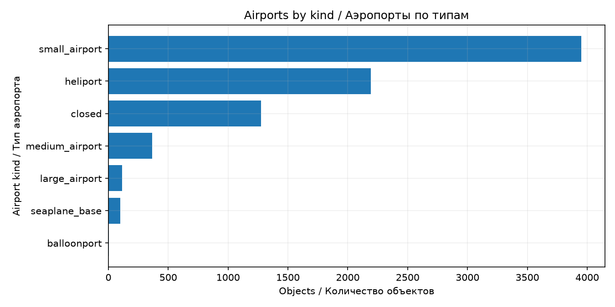
Figure 1 Number of airports by type

7 Comparing an object with its group
A many-to-one join attaches group_count and group_mean to each original row. Validation and assertions preserve the count of 8,000 and the source index. delta = elevation_ft − group_mean compares an airport with its own type; a missing height produces a missing delta. Both figures use the same first 100 rows with known X.
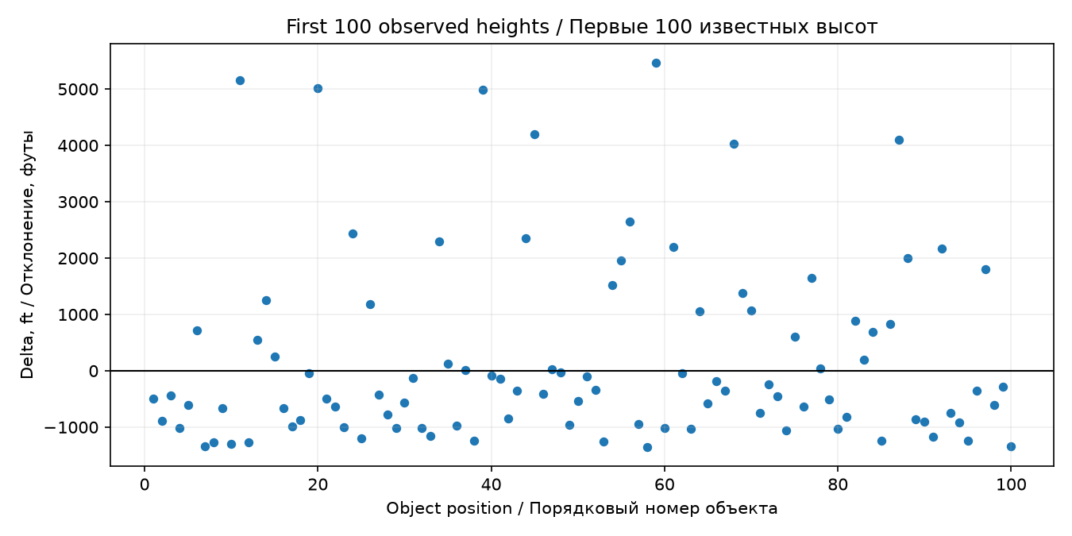
Figure 2 Deviations in the original object order
Points above zero have greater elevation than their type's mean; points below zero have smaller elevation. The second plot sorts these same objects by delta and assigns new evenly spaced positions from 1 to 100, so the line cannot decrease.
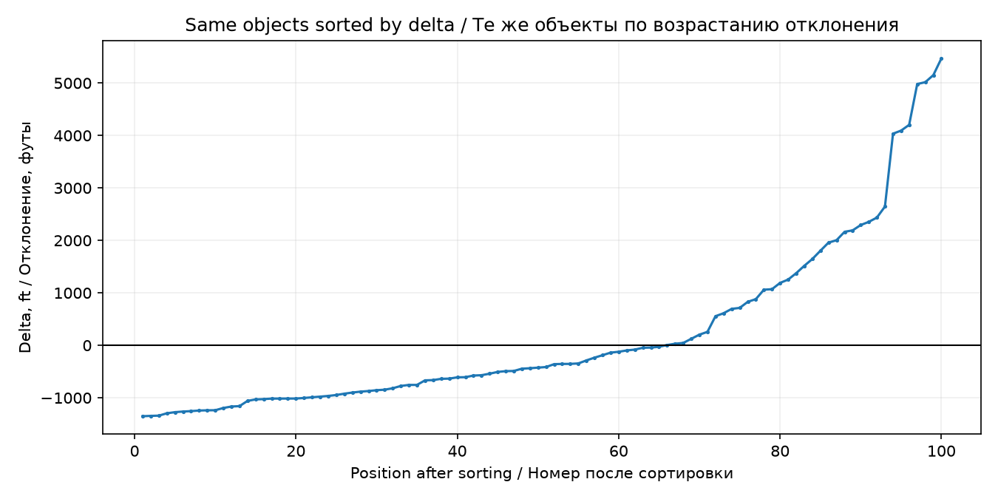
Figure 3 The same deviations in increasing order

8 Quantiles and boxplots
The elevation quartiles are Q1 = 207.25, Q2 = 730.00 and Q3 = 1,630.00 feet. Q2 equals the median; Q1–Q3 contains the central half of the distribution. Boxplots are constructed for the five groups with the largest row counts, excluding missing heights inside each group.
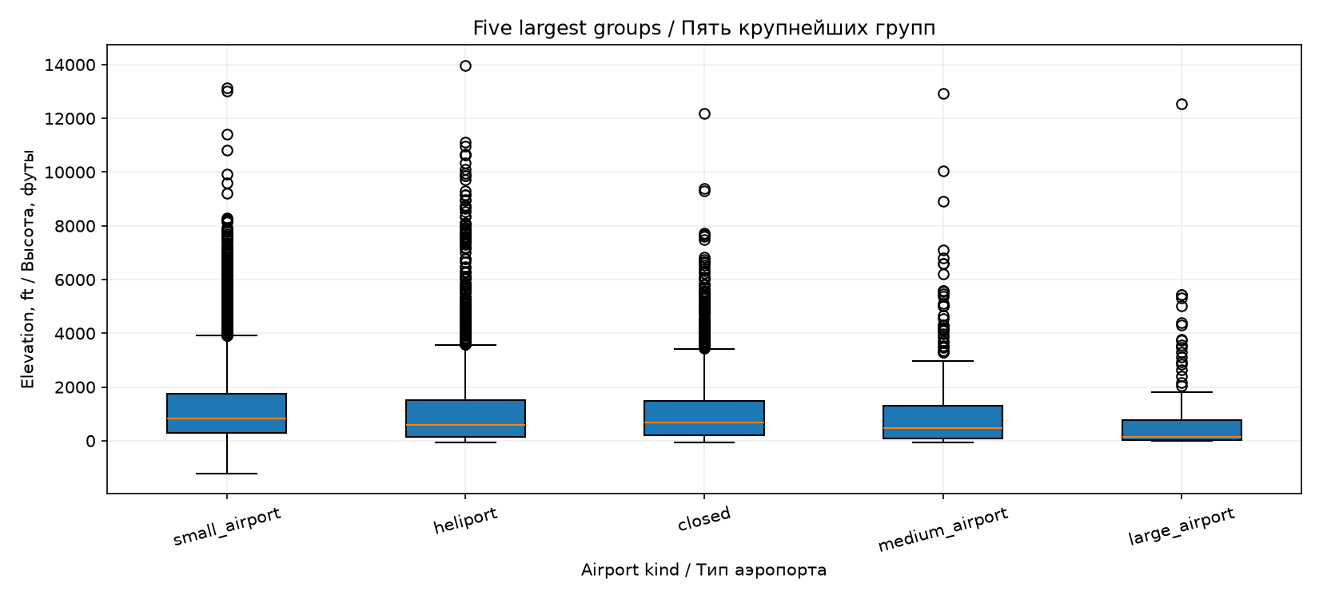
Figure 4 Elevation distributions for the five largest types
Among these groups, small_airport has the highest median (830 feet), largest IQR (1,442 feet) and largest range (14,330 feet). large_airport has the lowest median (140 feet) and smallest IQR (716 feet). Points beyond the whiskers are statistical outliers, not automatically invalid observations. Negative elevations can also be valid.

9 Verification and conclusion
The notebook was executed from a fresh kernel. Assertions check numeric data, unchanged observed values after filling, duplicate counts, manual statistics, AND being a subset of OR, group totals, preserved rows after the join, identical membership of the delta samples, increasing sorted deltas and the unchanged original table. Detailed results are saved in results/summary.json and the two CSV summary tables.
The experiments show that the preferred imputation depends on the error metric, while duplicate removal depends on a meaningful identity key. Logical operators and operation order change the selected population. Group summaries and robust distribution measures give context that an overall mean alone cannot provide.

