ITMO University
Python Programming Course

Laboratory Work 3
A Small Neural Network Library with NumPy
Report
Student Септанугрохо Мухаммад Арис
ISU number 512260
Group P3121
2026

1 Objective and implementation
A modular neural-network library was implemented using NumPy and manual backpropagation. tutorial.ipynb contains the complete code, explanations, examples and executed MNIST experiment. Its writefile cells save the implementation into separate minitorch modules. The resulting 784–32–10 network reaches 89.51% accuracy on the independent 10,000-image test set.

2 Class design
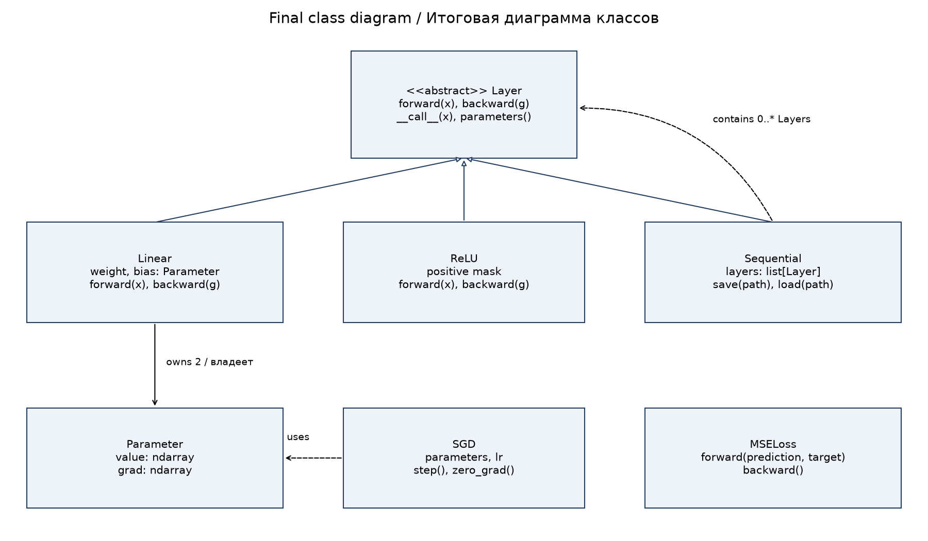
Figure 1 Final class diagram
Class | Responsibility
Parameter | Owns a value array and an equally shaped gradient
Layer | Abstract forward, backward and common calling interface
Linear, ReLU | Affine transformation and nonlinearity
Sequential | Nested layer composition and model persistence
MSELoss, SGD | Measure error and update existing parameters

Inheritance gives layers the same interface; composition builds models, including nested Sequential containers. parameters() returns the original Parameter objects in layer order, so SGD updates the same arrays used by forward. The initial diagram in notebook section 1 retains these responsibilities in the final design.

3 Forward and backward computation
Inputs are nonempty two-dimensional arrays: rows represent objects and columns represent features. A Linear layer stores W with shape (input_features, output_features) and b with shape (output_features,). Bias broadcasts across rows. Both arrays start with small random values around zero; one seeded generator makes initialization reproducible.
Operation | Formula
Linear forward | Y = XW + b
Linear input gradient | G_X = G Wᵀ
Linear weight gradient | G_W = Xᵀ G
Linear bias gradient | G_b = sum(G, axis=0)
ReLU forward / backward | Y = max(0, X); G_X = G · [X > 0]
MSELoss | L = sum((prediction − target)²) / (n k)
MSE prediction gradient | G_prediction = 2 (prediction − target) / (n k)

G is the gradient received from the next layer in reverse order. Linear caches its input to compute parameter derivatives. ReLU caches a positive-input mask, has no trainable parameters and chooses derivative zero at zero. Sequential traverses layers forward for prediction and in reverse for backpropagation, implementing the chain rule.
MSE averages over n objects and k outputs, and returns one number. Exact target/prediction shape equality prevents unintended broadcasting. The factor 1/(n k) is already included in the loss derivative and must not be applied again in Linear. Numerical central differences verify analytical derivatives for every weight, bias and input coordinate in the test model.

4 Optimization and training loop
zero_grad()
prediction = model(x_batch)
loss = criterion(prediction, target_batch)
model.backward(criterion.backward())
optimizer.step()
parameter.value -= learning_rate * parameter.grad
Gradients accumulate through +=, so zero_grad clears them before each batch. SGD uses a positive finite learning rate and works independently of layer types. One index permutation shuffles inputs and targets together each epoch. The final incomplete batch is included. Epoch loss is sum(batch_loss × actual_batch_size) / N, preventing a short batch from receiving excess weight.

5 MNIST experiment
fetch_openml obtains mnist_784 version 1. scikit-learn is used only for data loading; NumPy performs all network computation. The liac-arff parser avoids a numeric-category compatibility issue in the default pandas parser without changing the dataset. The first 60,000 images train the model; the last 10,000 are used only for evaluation. Test data never updates parameters or selects hyperparameters.
Setting | Value
Input and target | 784 float32 pixels / 255; 10 one-hot outputs
Architecture | Linear(784, 32) → ReLU → Linear(32, 10)
Trainable values | 784 × 32 + 32 + 32 × 10 + 10 = 25 450
Loss and optimizer | MSELoss; SGD; lr = 0.05
Epochs and batch size | 10 epochs; batch 128; final batch 96
Initialization and shuffle seed | 42

Every 28 × 28 image is flattened into 784 values. Pixel scaling gives values in [0, 1], and one-hot encoding places one at the correct digit's output. Predictions are argmax over ten scores; these scores are not probabilities and need not sum to one.
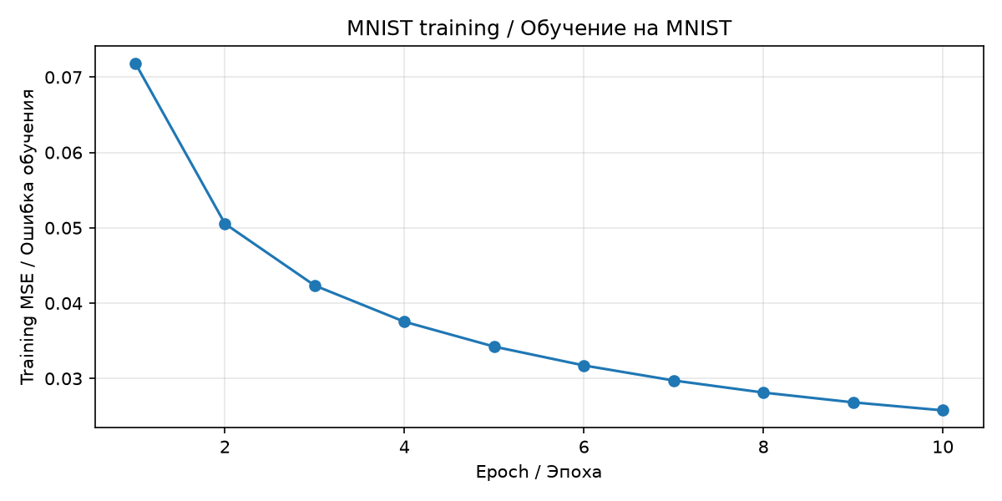
Figure 2 Sample-weighted training MSE by epoch
The training-history loss decreases from 0.071865 to 0.025767. It averages batch losses measured at changing weights during an epoch. It therefore differs from a separate full-dataset loss evaluated at the final epoch weights.

6 Test metrics and predictions
Metric | Measured value
Test accuracy before training | 5.71%
Test accuracy after training | 89.51%
Correct test predictions | 8 951 / 10 000
Final test MSE | 0.024392
Maximum score difference after reload | 0.0

Accuracy counts correct argmax decisions, while MSE measures numerical error against the one-hot vectors. These metrics need not change in the same way. A random initial model need not have exactly 10% accuracy because its decisions are not uniformly random labels.
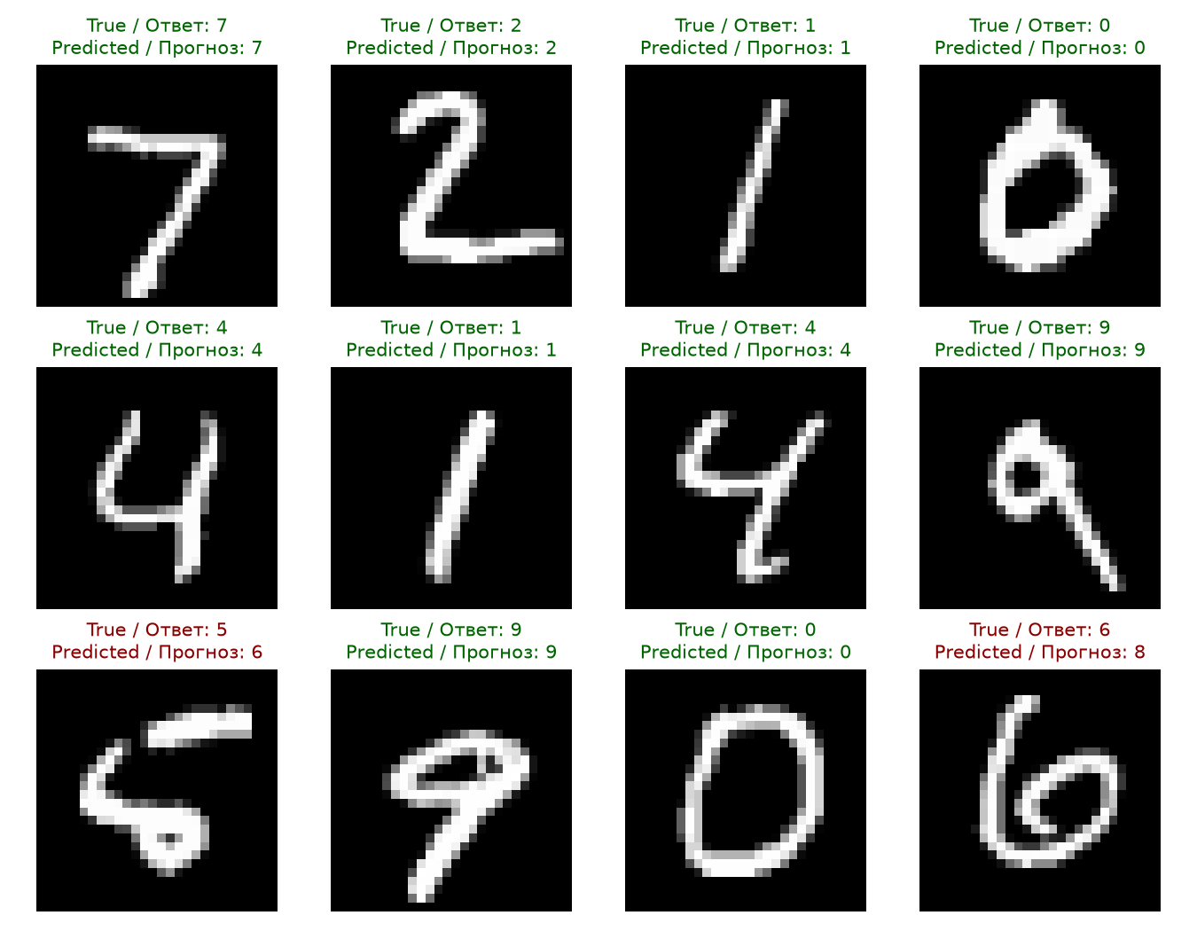
Figure 3 Predictions for the first twelve test images
The examples are the first twelve test images, without selecting only successful cases. Correct and incorrect predictions are included: for example, a 5 is predicted as 6 and a 6 as 8. Raw metrics, the full confusion matrix and per-digit accuracy are stored in results/metrics.json.

7 Error analysis and model persistence
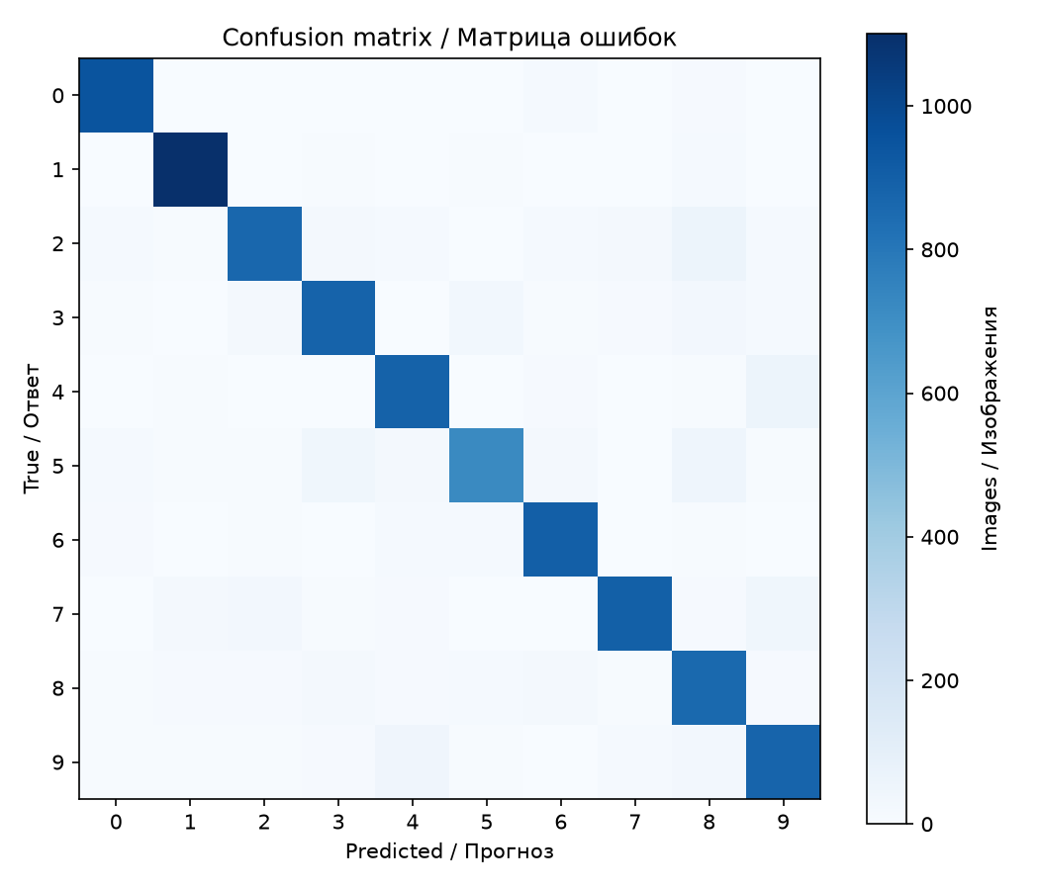
Figure 4 Confusion matrix on the independent test set
Rows represent true digits and columns represent predictions. The diagonal contains correct decisions; an off-diagonal cell counts a particular confusion. The saved per-digit results show approximately 97.00% accuracy for digit 1 and 80.83% for digit 5, so recognition quality is not uniform across classes.
Sequential.save stores a versioned JSON architecture and numeric parameter arrays in model.npz. Loading uses allow_pickle=False, reconstructs nested layers and restores values; gradients and caches reset. Exact equality of all 10,000 test output vectors is verified using the same evaluation batch size. The maximum absolute difference is zero.

8 Verification and conclusion
Six automated tests check known forward values, nested parameter identity, central-difference gradients, accumulation and SGD, ReLU and MSE, invalid shapes and call order, nested persistence, successful regression learning and weighted short batches. The notebook was executed from a fresh kernel. Each layer caches one forward pass, so distinct layer instances must be used at different model positions; shared-layer graphs and general automatic differentiation are outside the implementation.
The library demonstrates separation of responsibilities, polymorphic layer interfaces, nested composition and manual application of the chain rule. Its measured MNIST improvement from 5.71% to 89.51% and exact reload equality confirm that training and persistence work together.

