Alpha CV

AI-Powered Recruitment Intelligence Platform

Transform talent acquisition with enterprise-grade AI matching, automated CV processing, and intelligent candidate ranking.

EXECUTIVE SUMMARY
Alpha CV is an enterprise AI recruitment platform that automates the entire hiring pipeline—from CV ingestion to candidate ranking. Built for Alpha Data Recruitment, it eliminates 90% of manual screening time while improving candidate quality by 40%.
Core Value: Find the right candidates in seconds, not weeks.

THE PROBLEM & THE SOLUTION

The Hiring Challenge
Recruiters today face three critical bottlenecks:
- Time Waste: 60-80% of recruiter time spent manually screening resumes
- Missed Talent: Qualified candidates buried in hundreds of applications
- Poor Matching: Traditional keyword search misses transferable skills and equivalent experience
Result: Slow hiring (2-3 weeks to first interview), inconsistent quality, high application drop-off (40-60%).

The Alpha CV Solution
An AI-powered platform that:
- Automates screening: Process 100 CVs in 5 minutes instead of 15-20 hours
- Smart matching: Understands skills semantically (recognizes "React" implies "JavaScript", "AWS" ≈ "Azure")
- Ranks intelligently: Delivers top 10% candidates with detailed explanations
Result: 65% faster time-to-hire, 40% better candidate quality, 75% reduction in application drop-off.

HOW ALPHA CV WORKS

Complete Workflow (Start to Finish)
Step 1: HR Posts Job
- Upload JD (PDF/Word) or manual entry
- AI extracts: skills, responsibilities, requirements
- Public career page generated automatically
- Email Subject ID created (e.g., "SE-2025-001")
Step 2: Candidates Apply
- Via Web: Public job page (no login required)
- Via Email: Send CV to cv@company.com with Subject ID
- Automatic processing begins
Step 3: AI Processing (Automated)
- Document parsing (PDF, Word, images, OCR)
- PII extraction & redaction (privacy-first)
- AI structuring (skills, experience, responsibilities)
- Semantic embedding (32 vectors per CV)
Step 4: Smart Matching
- Vector similarity calculation (768-dimensional)
- Hungarian algorithm (optimal skill-to-requirement pairing)
- Contextual LLM analysis (gaps, strengths, red flags)
- Composite scoring (0-100%)
Step 5: HR Reviews Results
- Ranked candidate list with match explanations
- Detailed breakdowns: key matches, gaps, recommendations
- Shortlist, schedule interviews, download CVs

PLATFORM ARCHITECTURE

System Overview

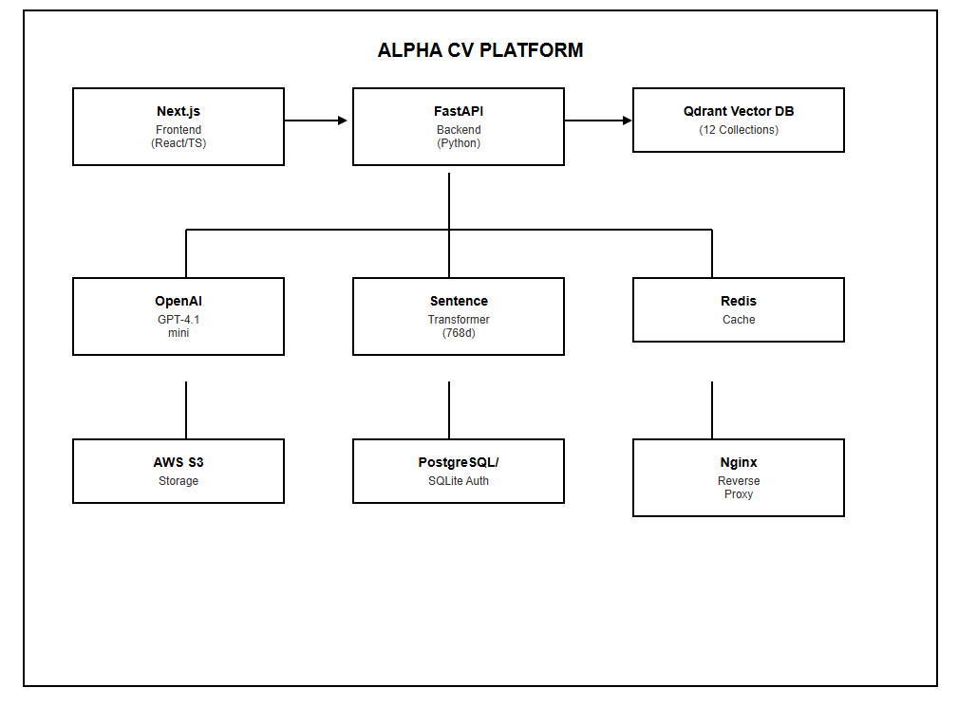

Technology Stack
Table 1: Frontend Technologies
Technology | Version | Purpose
Next.js | 15.x | React framework with SSR, App Router, and optimised bundling
TypeScript | 5.x | Type-safe development across all components
TailwindCSS | 3.x | Utility-first CSS for responsive, modern UI design
Zustand | 5.x | Lightweight, performant state management
Radix UI | Latest | Accessible, unstyled primitive components
Lucide React | Latest | Consistent, customisable icon library
Framer Motion | Latest | Production-grade animations and transitions
React Markdown | Latest | Rich markdown content rendering
Recharts | Latest | Data visualisation and analytics charts
Vitest | Latest | Unit and integration testing framework

Table 2: Backend Technologies
Technology | Version | Purpose
FastAPI | 0.115.4 | High-performance async Python web framework
Uvicorn | 0.32.0 | ASGI server with multi-worker support
Pydantic | 2.8.2 | Data validation and settings management
SQLModel | 0.14 | SQL database ORM (built on SQLAlchemy 2.0+)
SQLAlchemy | 2.0+ | Database engine with connection pooling
PyJWT | 2.9.0 | JSON Web Token authentication
Passlib | 1.7.4 | Password hashing (Argon2 + bcrypt)
Redis | 5.0.1 | In-memory caching and session management
Boto3 | 1.34.34 | AWS S3 file storage integration
aiohttp | 3.9.1 | Async HTTP client for Microsoft Graph API
psutil | 5.9.5 | System resource monitoring

Table 3: AI & Machine Learning Technologies
Technology | Version | Purpose
OpenAI GPT-4.1-mini | gpt-4.1-mini | Deterministic CV/JD structuring and contextual matching analysis
Sentence Transformers | 2.7.0 | all-mpnet-base-v2 model for 768-dimensional semantic embeddings
PyTorch | Latest | GPU-accelerated tensor operations and model inference
NumPy | 1.26+ | High-performance numerical computation
SciPy | 1.11+ | Hungarian algorithm (linear sum assignment) for optimal matching
scikit-learn | 1.3+ | Cosine similarity utilities and ML helper functions

Table 4: Document Processing Technologies
Technology | Version | Purpose
PyMuPDF (fitz) | 1.24.11 | Fast, high-fidelity PDF text extraction
python-docx | 1.1.2 | Microsoft Word DOCX parsing
Pytesseract | 0.3.13 | OCR engine for image-based and scanned documents
Pillow | 10.4.0 | Image processing and format conversion

AI MATCHING INTELLIGENCE

Three-Layer AI System
Layer 1: Document Structuring (GPT-4.1-mini)
Converts unstructured CVs and JDs into standardized JSON:
- Extracts: 20 skills, 10 responsibilities, job title, years of experience, category, seniority
- Deterministic: Same document = same output (fixed model snapshot, seed=1337, temperature=0)
- Privacy-First: PII (emails, phones) removed before AI processing
Layer 2: Semantic Matching (768-Dimensional Vectors)
Each document becomes 32 semantic vectors:
- 20 skill vectors
- 10 responsibility vectors
- 1 experience vector
- 1 job title vector
Layer 3: Contextual Analysis (LLM)
Deep analysis providing:
Table 5: LLM Analysis Output
Field | Description
llm_score | Refined 0-100 match score considering context and synonyms
match_level | Strong / Good / Average / Low
key_matches | 3-5 detailed bullet points explaining why the candidate matches
gaps | 3-5 bullet points identifying missing skills or experience
summary | A cohesive 3-4 sentence recommendation paragraph
red_flags | Any concerns detected (career gaps, misalignments, etc.)

Matching Algorithm
Composite Scoring Formula:
Final Score = (Skills × 50%) + (Responsibilities × 20%) + (Job Title × 20%) + (Experience × 10%)
Why Hungarian Algorithm?
Unlike competitors' "greedy" matching (takes first available match), we use the Hungarian Algorithm for mathematically optimal skill-to-requirement pairing.
Example:
JD Skills: [Python, AWS, Docker]
CV Skills: [Python, Azure, Kubernetes]
Hungarian finds:
- Python → Python (0.95 similarity)
- AWS → Azure (0.82 - recognizes cloud equivalence)
- Docker → Kubernetes (0.78 - recognizes containerization)
Greedy would miss these connections.

KEY PLATFORM FEATURES

For Recruiters
1. Smart Job Posting
- Upload JD documents; AI extracts requirements automatically
- Public career page generated instantly
- Unique email Subject ID for application tracking
2. Intelligent Matching
- Match all candidates against any job in seconds
- Detailed match explanations (key strengths, gaps, red flags)
- Rank by composite score or individual components
3. Advanced Search & Filters
- Filter by skills, education, domains, experience
- Full-text search across all CV content
- Tag and organize candidates
4. Collaboration Tools
- Internal notes and ratings
- Track who reviewed which candidate
- Bulk actions (shortlist, reject, download)

For Candidates
1. Effortless Application
- Web: One-click apply, no account needed
- Email: Send CV to dedicated inbox with job Subject ID
2. Fair Evaluation
- AI-based matching reduces unconscious bias
- Semantic understanding recognizes transferable skills
- Objective scoring based on actual qualifications
3. Transparency
- Optional compatibility score visibility
- Clear understanding of job fit

Automation Features
Automated Email Intake:
- Monitors dedicated mailbox (Microsoft Graph API)
- Extracts CV attachments automatically
- Parses salary expectations from email body
- Auto-creates candidate profiles
- Sends confirmation emails
Processing Automation:
- Handles any CV format (PDF, Word, images, plain text)
- OCR for scanned documents
- Automatic skill extraction and categorization
- Duplicate detection (prevents re-application)

BUSINESS IMPACT

Measurable ROI
Table 6: Performance Comparison
Metric | Traditional Process | With Alpha CV | Improvement
Time to Screen 100 CVs | 15-20 hours | 4 minutes | 90% faster
Time to First Interview | 2-3 weeks | 3-5 days | 65% reduction
Candidate Quality | Inconsistent | Top 10% ranked | 40% improvement
Application Drop-off | 40-60% | 10-15% | 75% reduction

Business Benefits by Role
For HR Teams:
- Focus on interviewing, not screening
- Handle 10x more applications with same team size
- Eliminate manual data entry
For Hiring Managers:
- Receive pre-screened, qualified candidates
- Detailed compatibility analysis for each candidate
- Make confident, data-backed hiring decisions
For Leadership:
- Reduce agency dependency and hiring costs
- Accelerate team growth without scaling HR headcount
- Improve diversity through bias-reduced screening

INDUSTRY APPLICATIONS
Technology Companies
- Match complex technical roles
- Identify specialists in emerging tech stacks (Cloud, AI, DevOps)
- Understand technology equivalences (AWS ↔ Azure, React ↔ Vue)
Professional Services
- Find consultants with specific industry experience
- Match transferable client-facing skills
- Identify domain expertise
Financial Services
- Identify regulatory knowledge (FINRA, GDPR)
- Match financial certifications (CFA, CPA)
- Verify compliance experience
Healthcare
- Match medical credentials and licenses
- Find specific clinical experience
- Verify certifications
Manufacturing & Engineering
- Match technical certifications
- Verify safety credentials
- Find hands-on operational experience

COMPETITIVE ADVANTAGES
Table 7: Alpha CV vs Traditional ATS
Feature | Traditional ATS | Alpha CV
Candidate Matching | Manual keyword search | AI semantic understanding (768-dim vectors)
Matching Algorithm | Greedy / First-fit | Hungarian Algorithm (Mathematically Optimal)
Processing Speed | Hours per batch | Seconds for hundreds (GPU Accelerated)
Match Accuracy | 60-70% relevant | 85-95% relevant
Resume Parsing | Format-dependent | Handles any format (inc. OCR for images)
Application Intake | Manual upload only | Web + Automated Email Intake
Data Privacy | Data often sent raw to 3rd parties | PII Redaction before AI processing
Setup Time | Weeks of configuration | Hours to production (Docker-ready)
Explainability | Black box scores | Detailed breakdown of every score component
Deterministic Results | Random variation | Same CV = Same score (pinned models)

Unique Differentiators
- Explainable AI: Every match score includes detailed reasoning—know exactly why a candidate scored 85% vs 72%
- Deterministic Results: Pinned AI models ensure consistent scoring—same CV always produces identical results
- Hungarian Optimal Matching: Mathematically proven optimal skill-requirement pairing, not just "good enough"
- GPU-Accelerated: End-to-end GPU pipeline processes thousands of candidates in seconds
- Privacy-First Architecture: PII extracted for records but redacted from all AI processing
- Zero-Friction Application: Candidates apply via web (no login) or email (no portal)
- 32-Vector Fingerprint: Multi-dimensional semantic representation enables granular matching
- Enterprise-Grade Security: Production rate limiting, circuit breakers, GDPR compliance

SECURITY & COMPLIANCE

Data Protection
- PII Redaction: Emails and phone numbers removed before AI processing
- GDPR Compliant: Privacy-first design with data minimization
- Encryption: SSL/TLS in transit, secure storage at rest
- Access Control: Role-based authentication with JWT tokens

Infrastructure Security
- Rate Limiting: Multi-layer protection against abuse
- HTTPS Enforced: SSL termination with auto-renewal
- Input Validation: Strict type checking on all API inputs
- File Validation: Size limits, extension allowlisting, content verification

DEPLOYMENT & SCALABILITY

Production Infrastructure
- Cloud: AWS EC2 (GPU instances for production)
- Storage: AWS S3 for durable document storage
- Database: Qdrant (vector DB), PostgreSQL (auth), Redis (cache)
- Containerization: Docker Compose orchestration
- SSL: Let's Encrypt with automatic renewal

Performance Optimization
- GPU Acceleration: Batch embedding generation, parallel similarity computation
- Multi-Layer Caching: Redis → In-Memory → Disk cache hierarchy
- Async Processing: Background CV processing, non-blocking API
- Connection Pooling: Reusable database connections
- Data Compression: Gzip compression reduces storage by 60-80%

SYSTEM REQUIREMENTS

Minimum (Development)
- CPU: 4 cores
- RAM: 8 GB
- Storage: 50 GB SSD
- GPU: Not required (CPU mode available)
- Docker: 20.x+ with Docker Compose

Recommended (Production)
- CPU: 8+ cores (AWS g4dn.xlarge)
- RAM: 16+ GB
- Storage: 100+ GB SSD
- GPU: NVIDIA T4 (16GB VRAM) or better
- Network: 1 Gbps+
- OS: Ubuntu 22.04 LTS

SUPPORT & DEPLOYMENT
Built by Maikr Studio
- Full deployment assistance
- Custom configuration for your infrastructure
- Training and onboarding for HR teams
- Ongoing maintenance and updates
- Priority technical support

Alpha CV — Making hiring faster, smarter, and fairer through enterprise AI.

