

1001

**أضحية**



IBRAHIM JADHEEDH AHMED

44510

Sheep





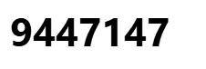

Chad



1002

**أضحية**



IBRAHIM JADHEEDH AHMED

44510

Sheep





Chad



1003

**أضحية**



IBRAHIM JADHEEDH AHMED

44510

Sheep





Chad



1004

**أضحية**



IBRAHIM JADHEEDH AHMED

44510

Sheep





Chad