**PROJECT REPORT**

**Finished by : Eng / Mahmoud Mohamed Ahmed Hussain**

**E-mail : mahmoud.mohamed002@outlook.com**

In the project I have created an amazon e-commerce database system which fulfils basic functional requirements for an e-commerce website. The database system fulfils the following functional requirements -

1. **A user can register**– A user can be a buyer or a seller
2. **A user can place order**- each order contains multiple products.
3. **A seller can add products**- this contains the details of a product.
4. **A buyer can give review**- a user can write reviews about a product.
5. **A user can add products to a Wishlist**- user can store the products which they like but not yet ready to buy
6. **A user can add products to a shopping cart**- users add to the shopping cart the products they want to buy.
7. **Product can be of multiple category**- it defines the category of a product like clothing, electronics etc
8. **Product can be carried by different carrier**- the shipping service through which a product can be shipped.
9. **A user can have multiple address and contact details**- users address and phone number saved in the account
10. **A user can have multiple Card info**- users saved card in the account
11. **A buyer can add images to its review**- each review can have images associated with it
12. **A seller can add images to its product** - each product can have multiple images associated with it, so taken in separate table.

# RELATIONSHIPS

1. **User-contact_details:** each user can have multiple contact details saved, while each contact detail will have only 1 user linked. Thus, cardinality is 1: N
2. **Buyer-card_info:** each buyer can have many cards, while each card is associated with 1 buyer. Thus, cardinality is 1: N
3. **Buyer-order:** buyer places order. A buyer can place many orders, while each order is linked with only 1 buyer. Thus, cardinality is 1: N
4. **Order-product:** each order can contain many products, and each product can come in many orders. Thus, cardinality is M: N
5. **Seller-product:** seller sells products. Each seller can sell many products, while each product has only 1 seller. Thus, cardinality is 1: N
6. **Buyer-reviews:** buyer can write a review. Each buyer can write multiple reviews, while each review has only 1 buyer. Thus, cardinality is 1: N
7. **Review-products:** each review is for 1 product while each product can have many reviews. Thus, cardinality is 1: N
8. **Buyer-wishlist:** each buyer can have only 1 Wishlist, and each Wishlist has 1 buyer. Thus, cardinality is 1:1.
9. **Buyer- shopping cart:** each buyer has only 1 shopping cart while each shopping cart is associated with 1 buyer. Thus, cardinality is 1:1.
10. **Wishlist-product:** each Wishlist contains many products, and each product can be in many wish lists. Thus, cardinality is N:M
11. **Shopping_cart-product:** each cart contains many products, and each product can be in many carts. Thus, cardinality is N:M
12. **Product-category:** each product has only 1 category while each category has many products. Thus, cardinality is 1: N
13. **Product-carrier:** each product is shipped by 1 carrier, while each carrier ships many products.
14. **Review-review_images:** each review has many review images while each review image is linked with 1 review. Thus, cardinality is 1: N
15. **Product-product_images:** each product has many product images while each product image is linked with 1 product. Thus, cardinality is 1: N
16. **Order-card_info:** each order has a card linked with it, while each card can be used for many orders. Thus, cardinality is 1: N
17. **Order-contact details:** each order has 1 contact detail (address, phone), while each contact detail is linked with multiple orders. Thus, cardinality is 1: N
    * Number 1:1 relationship = 2
    * Number of N: M relationships = 3
    * Number of 1: N relationships = 12
    * Total Relationships = 17

# ENTITY RELATION DIAGRAM

**IMAGE URL:** [https://drive.google.com/drive/folders/1Z5GZC-](https://drive.google.com/drive/folders/1Z5GZC-_1xq8R5TdcaSBOElE96McfDIa7?usp=sharing)

[_1xq8R5TdcaSBOElE96McfDIa7?usp=sharing](https://drive.google.com/drive/folders/1Z5GZC-_1xq8R5TdcaSBOElE96McfDIa7?usp=sharing)

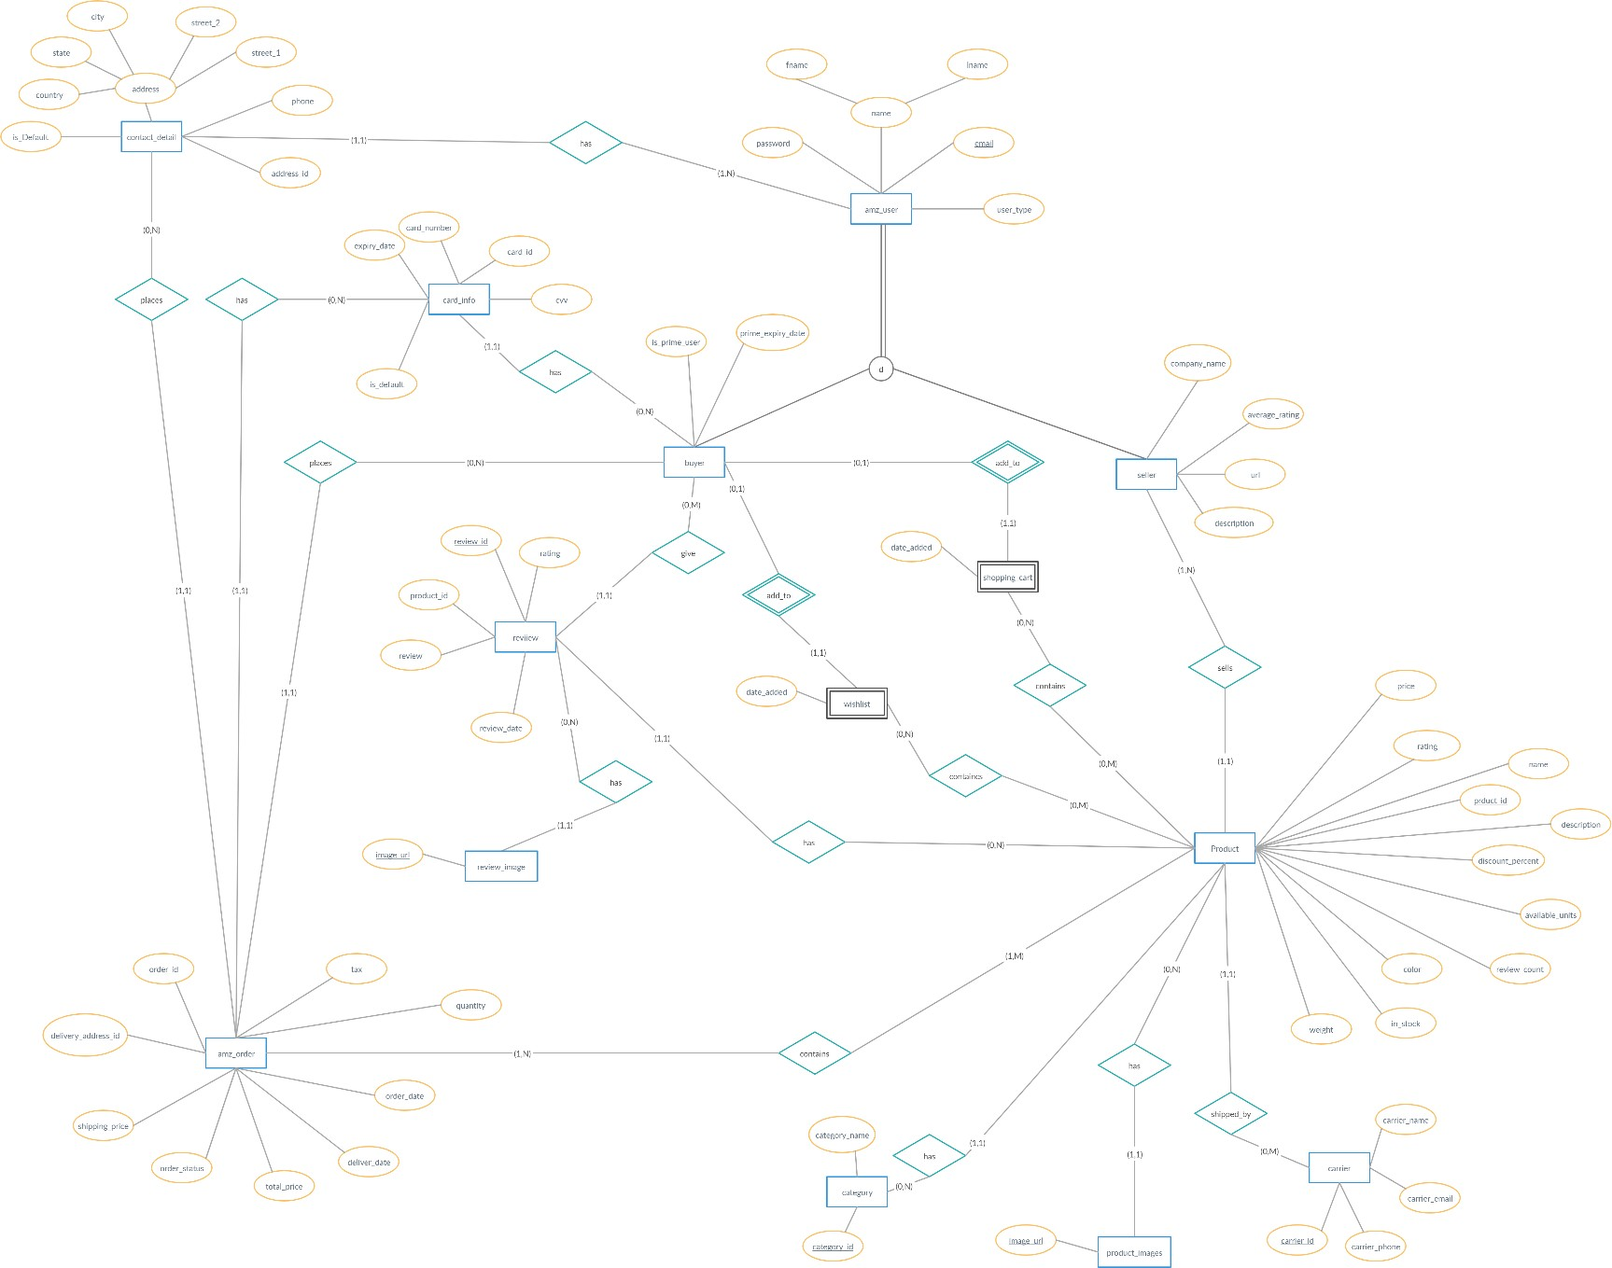

**Fig 1.0** Amazon’s Entity Relation diagram (big picture)

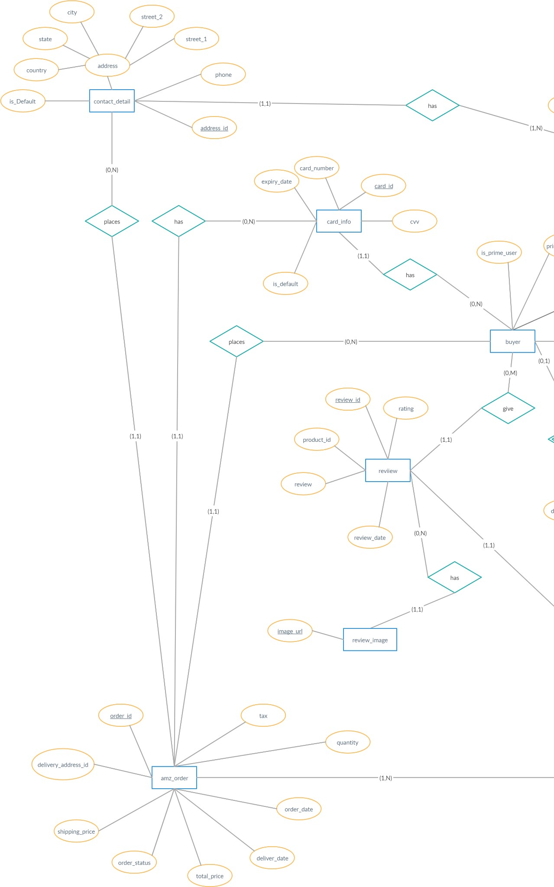

**Fig 1.1** Amazon’s Entity Relation diagram (left portion)

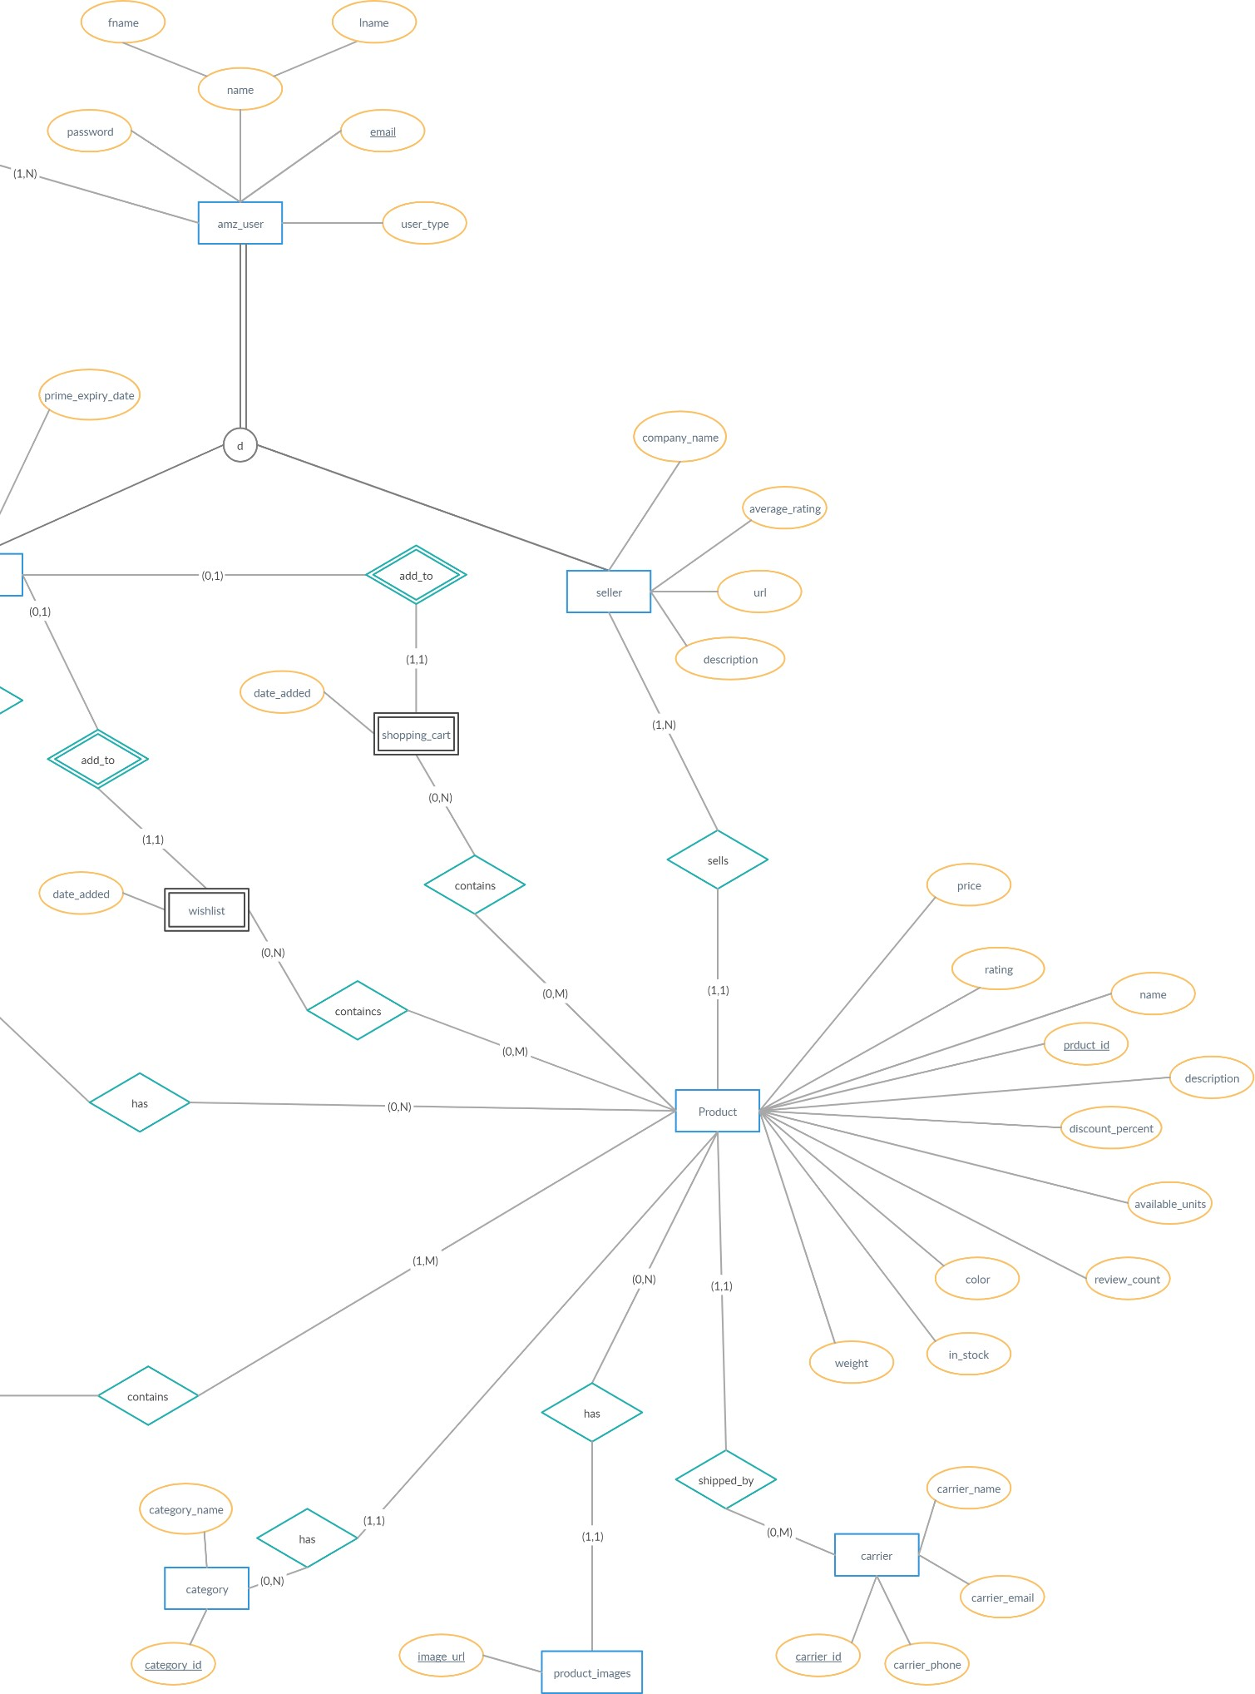

**Fig 1.2** Amazon’s Entity Relation diagram (right portion)

# RELATIONAL SCHEMA

To map ER diagram into a relational schema, we considered the following mapping rules.

For each 1: 1 binary relationship, in the total participation entity add the primary key of the other entity as the foreign key.

For 1: N binary relationship, add to the entity on the N side the primary key of the other entity as the foreign key.

For M: N binary relationship, make a new entity with foreign key as the primary key of the two participating entities. Their combination forms the new primary key.

* In buyer table we have user_id as foreign key.
* In seller table we have user_id as foreign key.
* In product table we have seller_id, carrier_id and category_id as foreign keys.
* In order table we have buyer_id as foreign key.
* In card_info we have buyer_id as foreign key.
* In reviews we have buyer_id, product_id as foreign keys.
* In wishlist we have buyer_id as foreign key.
* In shopping cart we have buyer_id as foreign key.
* In contact_details we have user_id as foreign key.
* In review_images we have review_id as foreign key.
* In product_images we have product_id as foreign key.
* We make a new table name product_wishlist which as product_id and wishlist_id as foreign key.
* We make a new table name product_shopping_cart which as product_id and buyer_id as foreign key.
* We make a new table name product_order which as product_id and order_id as foreign key.

After converting the ER Model of our system into relational tables by following the strict guidelines of mapping, we analysed and confirmed that **the resultant tables do not violate any conditions of 3NF normal form**. Thus, the resultant relational tables formed are already in a 3NF normalised form.

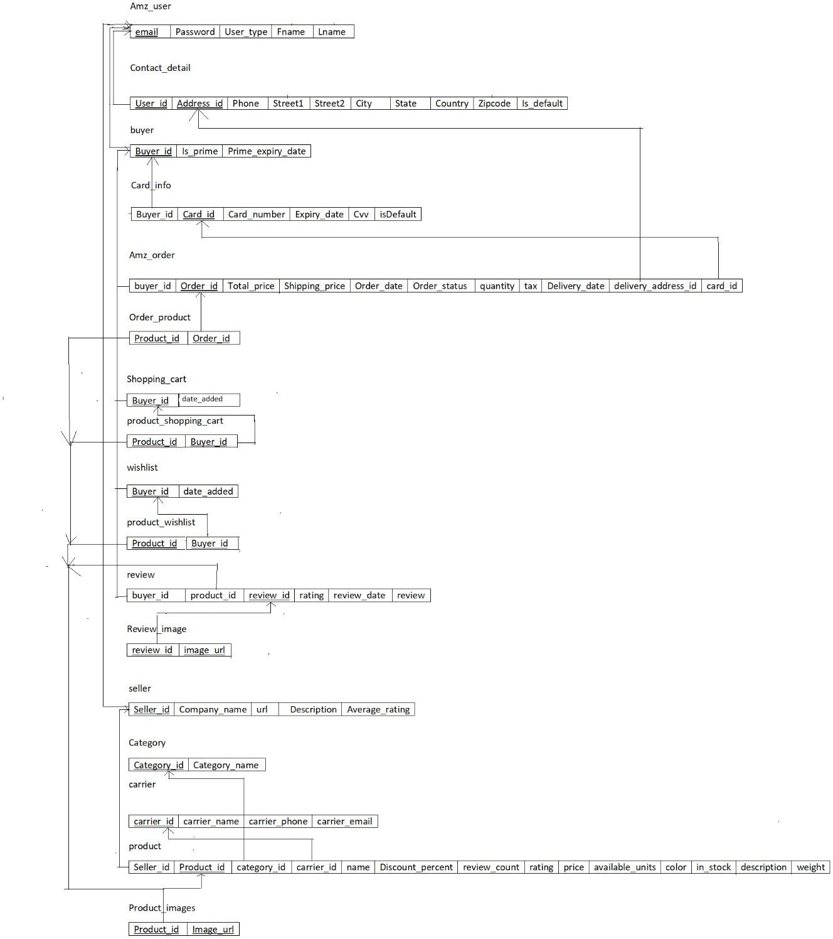

**Fig 2** Relational Tables

# SIGNIFICANT PROCEDURES

1. **Register buyer:** invoked by buyer responsible for
   1. registering user given email, fname, lname and password.
   2. registering the buyer itself setting its prime membership as false by default and prime member expiry date as Null.
2. **Register seller** has 2 responsibilities
   1. registering user given email, fname, lname and password.
   2. registering the seller itself given company name, url, description, setting its average rating as

2.5 default.

1. **Place order:** Given a buyer id, place order is responsible for the following –
   1. To iterate over the shopping cart of a particular buyer and remove each item from buyer’s cart.
   2. While removing each product, sum up the price of each product to the total price for the order.
   3. If the user is **“prime user”** do not include shipping charges for that order.
   4. Fetch the default address set by the buyer from the list of addresses for that buyer from the contact_details tables.
   5. Fetch the default card details set by the buyer from the list of card details for that buyer from the card_info table.
   6. To make sure not to include certain products from the shopping car in the order table who’s

available unity is zero (in_stock bit is set to 0).

* 1. To add an entry in the order table, containing details of the invoice (total price, total quantity of products in order, tax, shipping charge, card_details used for the order, delivery contact details used for the order)
  2. To invokes a trigger responsible for updating the available_units of each product being bought in that order.

1. **Give review:** A buyer can add a review by providing product_id, buyer_id, review, rating, and image_url (if any). It adds a review in the review table and image of it in the image table. After execution It invokes two triggers.
   1. update_product_rating
   2. updte_seller_rating.
2. **Add_contact_details:** adds details about address and the user’s number. A user can add multiple contact details and can set a single to contact_details to be used by default.
3. **Add_card_info:** add cards information like card number, expiry_date etc. A user can add mupltiple card details and can set a single to card_info to be used by default.
4. **Add_prodcut:** adds a product sold a by a seller. It also asks for the image URL if any, A seller can upload multiple images for a product.
5. **Add_to_shopping_cart:** adds a product in the shopping cart for a buyer, given the buyer Id
6. **Add_to_wishlist:** adds a product to the wishlist of a buyer, given the buyer id.
7. **Update_membership:** update users prime membership information.
8. **Cancel_membership:** cancel user’s prime membership
9. **Populate_product_categories:** adds all the available categories of product in it
10. **Populate_carrier_categories:** adds all the available carrier serviced responsible for delivering products.

# IMPORTANT TRIGGERS

1. **Update available units:**
   * Trigger is invoked whenever a user places an order. “**Update available units”** is responsible for updating the value of available units for each product in the product table that is being ordered by a buyer.
   * The procedures iterate over all the entries of order_product table for a specific order and iteratively updates each products quantity in the product table.
   * If the quantity reaches 0, the product is marked as out of stock, setting its in_stock value as 0.
2. **Update_product_rating:**
   * It is responsible for updating the rating of a product every time a buyer gives a review by averaging the earlier rating with this buyers rating.
   * It also updates the count of rating given for that particular product.
3. **Update_seller_rating**
   * It is responsible for updating the rating of a seller every time a buyer gives a review to a product by averaging the earlier rating with this buyers rating.
4. **Remove_products_from_cart**
   * After placing an order by a buyer, the trigger is responsible for removing all the ordered products from the shopping cart of that particular buyer.

# PROJECT IMPLEMTATION AND RESULTS

1. seller table registering the seller,



1. buyer table registering the buyer

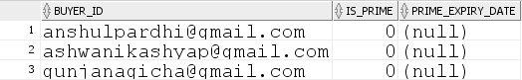

1. updating the buyer’s membership as prime user

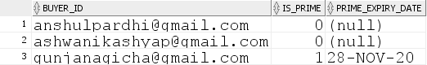

1. contact_info table after adding contact details by a buyer



1. card_info table after adding card details for the payment by a buyer

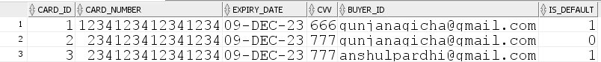

1. product, product image table after uploading products by a seller on the amazon db

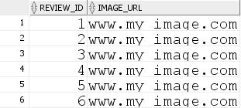

1. wishlist, product_wishlist table after adding items to wishlist by a user

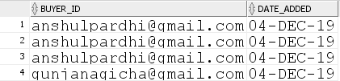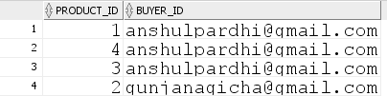

1. shopping cart, product_shopping table after adding products to shopping cart by a buyer

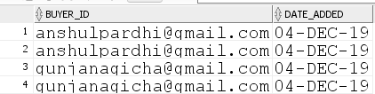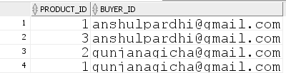

1. Multiple resultant tables after placing the order,
   * Order table, order product tables (shipping charge is set to zero if user is prime)

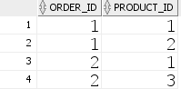

* + Reduce the product’s quantity. (if reached zero, set as out of stock)



* + Results of trigger after removing bought products from the shopping cart (empty cart)



1. Multiple tables are updated after giving a review
   * Review table, product_review, review image

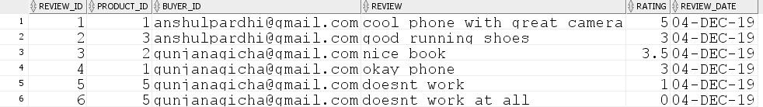

* + Updated product rating based on the given review





* + Updated seller rating based on review





# SQL CODE FOR THE AMAZON DB SYSTEM

**SOURCE CODE:** [https://drive.google.com/drive/folders/1Z5GZC-](https://drive.google.com/drive/folders/1Z5GZC-_1xq8R5TdcaSBOElE96McfDIa7?usp=sharing)

[_1xq8R5TdcaSBOElE96McfDIa7?usp=sharing](https://drive.google.com/drive/folders/1Z5GZC-_1xq8R5TdcaSBOElE96McfDIa7?usp=sharing)

# Code to create tables and apply contraints

CREATE TABLE amz_user (

email VARCHAR(255) PRIMARY KEY, fname VARCHAR(255) NOT NULL, lname VARCHAR(255),

password VARCHAR(30) NOT NULL,

user_type NUMBER(1) NOT NULL

);

CREATE TABLE contact_detail (

user_id VARCHAR(255) NOT NULL,

address_id INTEGER PRIMARY KEY, street1 VARCHAR(255) NOT NULL, street2 VARCHAR(255),

city VARCHAR(50) NOT NULL, state VARCHAR(50) NOT NULL, country VARCHAR(50) NOT NULL, zipcode NUMBER(5) NOT NULL, phone VARCHAR(20) NOT NULL,

is_default NUMBER(1) DEFAULT 0

);

CREATE TABLE card_info (

card_id INTEGER PRIMARY KEY,

card_number NUMBER(16) NOT NULL, expiry_date DATE NOT NULL,

cvv NUMBER(3) NOT NULL,

buyer_id VARCHAR(255) NOT NULL,

is_default NUMBER(1)

);

CREATE TABLE buyer (

buyer_id VARCHAR(255) PRIMARY KEY,

is_prime NUMBER(1) DEFAULT 0, prime_expiry_date DATE

);

CREATE TABLE seller (

seller_id VARCHAR(255) PRIMARY KEY,

company_name VARCHAR(255) NOT NULL, url VARCHAR(255),

description VARCHAR(255), average_rating NUMBER(2, 1) DEFAULT 2.5, rating_count NUMBER DEFAULT 0

);

CREATE TABLE category (

category_id INTEGER PRIMARY KEY, category_name VARCHAR(255) NOT NULL

);

CREATE TABLE product (

product_id INTEGER PRIMARY KEY, name VARCHAR(255) NOT NULL,

seller_id VARCHAR(255) NOT NULL, price NUMBER(10, 2) NOT NULL,

rating NUMBER(2, 1), review_count INTEGER, category_id INTEGER, description VARCHAR(255), discount_percent NUMBER(4, 2), available_units INTEGER,

color VARCHAR(30),

in_stock NUMBER(1),

weight NUMBER(10, 2),

carrier_id INTEGER

);

CREATE TABLE product_image ( product_id INTEGER, image_url VARCHAR(255),

PRIMARY KEY ( product_id, image_url )

);

CREATE TABLE shopping_cart ( buyer_id VARCHAR(255), date_added DATE

);

CREATE TABLE product_shoppingcart ( product_id INTEGER,

buyer_id VARCHAR(255), PRIMARY KEY ( product_id, buyer_id )

);

CREATE TABLE wish_list ( buyer_id VARCHAR(255), date_added DATE

);

CREATE TABLE product_wishlist ( product_id INTEGER, buyer_id VARCHAR(255), PRIMARY KEY ( product_id,

buyer_id )

);

CREATE TABLE amz_order (

order_id INTEGER PRIMARY KEY, buyer_id VARCHAR(255) NOT NULL,

card_id INTEGER NOT NULL, total_price NUMBER(10, 2), order_date DATE,

tax NUMBER(4, 2) DEFAULT 10,

shipping_price NUMBER(4, 2) DEFAULT 10, delivery_address_id INTEGER,

delivery_date DATE,

order_status CHAR(1) NOT NULL, quantity INTEGER NOT NULL

);

CREATE TABLE order_product ( order_id INTEGER,

product_id INTEGER, PRIMARY KEY ( order_id,

product_id )

);

CREATE TABLE review (

review_id INTEGER PRIMARY KEY, product_id INTEGER NOT NULL, buyer_id VARCHAR(255) NOT NULL, review VARCHAR(1000),

rating NUMBER(2, 1), review_date DATE

);

CREATE TABLE review_image ( review_id INTEGER, image_url VARCHAR(255), PRIMARY KEY ( review_id,

image_url )

);

CREATE TABLE carrier (

carrier_id INTEGER PRIMARY KEY, carrier_name VARCHAR(255) NOT NULL, carrier_phone NUMBER(10) NOT NULL, carrier_email VARCHAR(255) NOT NULL

);

ALTER TABLE contact_detail

ADD CONSTRAINT contact_detail_user_id_fk FOREIGN KEY ( user_id ) REFERENCES amz_user ( email )

## ON DELETE CASCADE;

ALTER TABLE card_info

ADD CONSTRAINT card_info_buyer_id_fk FOREIGN KEY ( buyer_id ) REFERENCES buyer ( buyer_id )

## ON DELETE CASCADE;

ALTER TABLE product

ADD CONSTRAINT product_seller_id_fk FOREIGN KEY ( seller_id ) REFERENCES seller ( seller_id )

## ON DELETE CASCADE;

ALTER TABLE product

ADD CONSTRAINT product_category_id_fk FOREIGN KEY ( category_id ) REFERENCES category ( category_id )

## ON DELETE CASCADE;

ALTER TABLE product

ADD CONSTRAINT product_carrier_id_fk FOREIGN KEY ( carrier_id ) REFERENCES carrier ( carrier_id )

## ON DELETE CASCADE;

ALTER TABLE product_image

ADD CONSTRAINT product_image_product_id_fk FOREIGN KEY ( product_id ) REFERENCES product ( product_id )

## ON DELETE CASCADE;

ALTER TABLE shopping_cart

ADD CONSTRAINT shopping_cart_buyer_id_fk FOREIGN KEY ( buyer_id ) REFERENCES buyer ( buyer_id )

## ON DELETE CASCADE;

ALTER TABLE product_shoppingcart

ADD CONSTRAINT product_sc_buyer_id_fk FOREIGN KEY ( buyer_id ) REFERENCES buyer ( buyer_id )

## ON DELETE CASCADE;

ALTER TABLE product_shoppingcart

ADD CONSTRAINT product_sc_product_id_fk FOREIGN KEY ( product_id ) REFERENCES product ( product_id )

## ON DELETE CASCADE;

ALTER TABLE wish_list

ADD CONSTRAINT wishlist_buyer_id_fk FOREIGN KEY ( buyer_id ) REFERENCES buyer ( buyer_id )

## ON DELETE CASCADE;

ALTER TABLE product_wishlist

ADD CONSTRAINT product_wishlist_product_id_fk FOREIGN KEY ( product_id ) REFERENCES product ( product_id )

## ON DELETE CASCADE;

ALTER TABLE product_wishlist

ADD CONSTRAINT product_wishlist_buyer_id_fk FOREIGN KEY ( buyer_id ) REFERENCES buyer ( buyer_id )

## ON DELETE CASCADE;

ALTER TABLE amz_order

ADD CONSTRAINT order_buyer_id_fk FOREIGN KEY ( buyer_id ) REFERENCES buyer ( buyer_id )

## ON DELETE CASCADE;

ALTER TABLE amz_order

ADD CONSTRAINT order_card_id_fk FOREIGN KEY ( card_id ) REFERENCES card_info ( card_id )

## ON DELETE CASCADE;

ALTER TABLE amz_order

ADD CONSTRAINT order_delivery_address_id_fk FOREIGN KEY ( delivery_address_id ) REFERENCES contact_detail ( address_id )

## ON DELETE CASCADE;

ALTER TABLE order_product

ADD CONSTRAINT order_product_order_id_fk FOREIGN KEY ( order_id ) REFERENCES amz_order ( order_id )

## ON DELETE CASCADE;

ALTER TABLE order_product

ADD CONSTRAINT order_product_product_id_fk FOREIGN KEY ( product_id ) REFERENCES product ( product_id )

## ON DELETE CASCADE;

ALTER TABLE review

ADD CONSTRAINT review_product_id_fk FOREIGN KEY ( product_id ) REFERENCES product ( product_id )

## ON DELETE CASCADE;

ALTER TABLE review

ADD CONSTRAINT review_buyer_id_fk FOREIGN KEY ( buyer_id ) REFERENCES buyer ( buyer_id )

## ON DELETE CASCADE;

ALTER TABLE review_image

ADD CONSTRAINT review_image_review_id_fk FOREIGN KEY ( review_id ) REFERENCES review ( review_id )

ON DELETE CASCADE;

# Code for stored procedure and triggers

CREATE OR REPLACE PROCEDURE register_buyer (

email IN VARCHAR, fname IN VARCHAR, lname IN VARCHAR, password IN VARCHAR

## ) AS BEGIN

INSERT INTO amz_user VALUES ( email,

fname, lname, password, 0

);

INSERT INTO buyer VALUES (

email, 0, NULL

);

END register_buyer;

CREATE OR REPLACE PROCEDURE register_seller ( email IN VARCHAR,

fname IN VARCHAR,

lname IN VARCHAR, password IN VARCHAR, company_name IN VARCHAR, url IN VARCHAR,

description_var IN VARCHAR

## ) AS BEGIN

INSERT INTO amz_user VALUES ( email,

fname, lname, password, 1

);

INSERT INTO seller VALUES (

email,

company_name, url, description_var, 2.5,

0

);

END register_seller;

CREATE OR REPLACE PROCEDURE add_contact_details ( user_id IN VARCHAR,

address_id IN INTEGER, street1 IN VARCHAR, street2 IN VARCHAR, city IN VARCHAR,

state IN VARCHAR, country IN VARCHAR, zipcode IN NUMBER, phone IN VARCHAR

## ) AS BEGIN

INSERT INTO contact_detail VALUES ( user_id,

address_id, street1, street2, city,

state, country, zipcode, phone, 0

);

END add_contact_details;

CREATE OR REPLACE PROCEDURE set_default_contact_details ( contact_id IN INTEGER,

buyer_id IN VARCHAR

## ) AS

BEGIN

UPDATE contact_detail SET

is_default = 1 WHERE

user_id = buyer_id

AND address_id = contact_id; END set_default_contact_details;

CREATE OR REPLACE PROCEDURE add_card_info ( buyer_id IN VARCHAR,

card_id IN INTEGER, card_number IN NUMBER, expiry_date IN DATE,

cvv IN NUMBER

## ) AS BEGIN

INSERT INTO card_info VALUES ( card_id,

card_number, expiry_date, cvv,

buyer_id, 0

);

END add_card_info;

CREATE OR REPLACE PROCEDURE set_default_card_info ( card_id_var IN INTEGER,

buyer_id_var IN VARCHAR

## ) AS BEGIN

UPDATE card_info SET

is_default = 1 WHERE

buyer_id = buyer_id_var AND card_id = card_id_var;

END set_default_card_info;

CREATE OR REPLACE PROCEDURE add_product ( product_id IN INTEGER,

name IN VARCHAR,

seller_id IN VARCHAR, price IN NUMBER, category_id IN INTEGER, description IN VARCHAR, available_units IN INTEGER, color IN VARCHAR,

weight IN NUMBER, carrier_id IN INTEGER, image_url IN VARCHAR

## ) AS BEGIN

INSERT INTO product VALUES (

product_id, name, seller_id, price,

0,

0,

category_id, description, 0,

available_units, color,

1,

weight, carrier_id

);

INSERT INTO product_image VALUES ( product_id,

image_url

);

END add_product;

CREATE OR REPLACE PROCEDURE add_to_shopping_cart ( buyer_id IN VARCHAR,

product_id IN INTEGER

## ) AS BEGIN

INSERT INTO shopping_cart VALUES ( buyer_id,

sysdate

);

INSERT INTO product_shoppingcart VALUES ( product_id,

buyer_id

);

END add_to_shopping_cart;

CREATE OR REPLACE PROCEDURE add_to_wish_list ( buyer_id IN VARCHAR,

product_id IN INTEGER

## ) AS BEGIN

INSERT INTO wish_list VALUES ( buyer_id,

sysdate

);

INSERT INTO product_wishlist VALUES ( product_id,

buyer_id

);

END add_to_wish_list;

CREATE OR REPLACE PROCEDURE give_review ( review_id IN NUMBER,

product_id IN INTEGER, buyer_id IN VARCHAR, review IN VARCHAR,

rating IN NUMBER, image_url IN VARCHAR

## ) AS BEGIN

INSERT INTO review VALUES (

review_id, product_id, buyer_id, review, rating, sysdate

);

INSERT INTO review_image VALUES ( review_id,

image_url

);

END give_review;

CREATE OR REPLACE TRIGGER update_product_rating AFTER INSERT ON review

## FOR EACH ROW DECLARE

new_rating NUMBER(2, 1); review_count_old INTEGER;

## BEGIN

SELECT

review_count

INTO review_count_old FROM

product WHERE

product_id = :new.product_id;

new_rating := :new.rating; UPDATE product

## SET

rating = ( ( rating * review_count_old ) + new_rating ) / ( review_count_old + 1 ), review_count = review_count_old + 1

## WHERE

product_id = :new.product_id;

## END;

CREATE OR REPLACE TRIGGER update_seller_rating AFTER INSERT OR UPDATE OF rating ON review

## FOR EACH ROW DECLARE

new_rating NUMBER(2, 1); seller_id_to_update VARCHAR(255);

## BEGIN

new_rating := :new.rating; SELECT

seller_id

INTO seller_id_to_update FROM

product WHERE

product_id = :new.product_id;

UPDATE seller SET

average_rating = ( ( average_rating * rating_count ) + new_rating ) / ( rating_count + 1 ), rating_count = rating_count + 1

## WHERE

seller_id = seller_id_to_update; END;

CREATE OR REPLACE PROCEDURE update_membership ( buyer_id_input IN VARCHAR

## ) AS BEGIN

UPDATE buyer SET

is_prime = 1,

prime_expiry_date = add_months(DATE '2019-11-28', 12) WHERE

buyer_id = buyer_id_input; END update_membership;

CREATE OR REPLACE PROCEDURE cancel_membership ( buyer_id_input IN VARCHAR

## ) AS BEGIN

UPDATE buyer SET

is_prime = 0, prime_expiry_date = NULL

## WHERE

buyer_id = buyer_id_input; END cancel_membership;

CREATE OR REPLACE PROCEDURE place_order ( order_id IN INTEGER,

buyer_id_var IN VARCHAR

## ) AS

card_id_var INTEGER; address_id_var INTEGER; total_price_var NUMBER := 0; curr_price_var NUMBER; total_qty_var NUMBER := 0; available_units_var NUMBER(1); shipping_price_var NUMBER := 10; is_prime_var NUMBER := 0; CURSOR products_cur IS

## SELECT

product_id FROM

product_shoppingcart WHERE

buyer_id = buyer_id_var;

product_id_var INTEGER; BEGIN

OPEN products_cur; LOOP

FETCH products_cur INTO product_id_var;

EXIT WHEN products_cur%notfound; SELECT

price, available_units

## INTO

curr_price_var, available_units_var

## FROM

product WHERE

product_id = product_id_var;

IF available_units_var > 0 THEN

total_price_var := ( total_price_var + curr_price_var ); total_qty_var := total_qty_var + 1;

INSERT INTO order_product VALUES ( order_id,

product_id_var

## ); END IF;

-- DELETE FROM product_shoppingcart

-- WHERE product_id = product_id_var AND buyer_id = buyer_id_var; END LOOP;

CLOSE products_cur; SELECT

is_prime

INTO is_prime_var FROM

buyer WHERE

buyer_id = buyer_id_var;

IF is_prime_var = 1 THEN shipping_price_var := 0;

## END IF; SELECT

card_id

INTO card_id_var FROM

card_info

## WHERE

buyer_id = buyer_id_var AND is_default = 1;

## SELECT

address_id

INTO address_id_var FROM

contact_detail WHERE

user_id = buyer_id_var AND is_default = 1;

total_price_var := total_price_var + shipping_price_var + 10; INSERT INTO amz_order VALUES (

order_id, buyer_id_var, card_id_var, total_price_var, sysdate,

10,

shipping_price_var, address_id_var,

add_months(DATE '2019-11-28', 1), 'c',

total_qty_var

);

END place_order;

CREATE OR REPLACE PROCEDURE populate_product_categories AS BEGIN

INSERT INTO category VALUES ( 1,

'Electronics'

);

INSERT INTO category VALUES ( 2,

'Books'

);

INSERT INTO category VALUES ( 3,

'Clothing'

);

END populate_product_categories;

CREATE OR REPLACE PROCEDURE populate_carriers AS BEGIN

INSERT INTO carrier VALUES ( 1,

## 'DHL', 1234567890,

'DHL@gmail.com'

);

INSERT INTO carrier VALUES ( 2,

'Fedex', 1234567890,

'Fedex@gmail.com'

);

INSERT INTO carrier VALUES ( 3,

## 'UPS', 1234567890,

'UPS@gmail.com'

);

END populate_carriers;

CREATE OR REPLACE TRIGGER update_available_units AFTER INSERT ON amz_order

## FOR EACH ROW DECLARE

product_id_var INTEGER; available_units_var INTEGER; CURSOR products_cur IS SELECT

product_id FROM

order_product WHERE

order_id = :new.order_id;

## BEGIN

OPEN products_cur; LOOP

FETCH products_cur INTO product_id_var; EXIT WHEN products_cur%notfound; SELECT

available_units

INTO available_units_var FROM

product WHERE

product_id = product_id_var;

IF available_units_var >= 2 THEN UPDATE product

## SET

available_units = available_units - 1 WHERE

product_id = product_id_var;

ELSIF available_units_var = 1 THEN UPDATE product

## SET

available_units = available_units - 1, in_stock = 0

## WHERE

product_id = product_id_var; END IF;

## END LOOP;

CLOSE products_cur; END;

CREATE OR REPLACE TRIGGER remove_items_from_cart AFTER INSERT ON amz_order

## FOR EACH ROW

DECLARE BEGIN

DELETE FROM shopping_cart WHERE

buyer_id = :new.buyer_id;

DELETE FROM product_shoppingcart WHERE

buyer_id = :new.buyer_id; END;

## BEGIN

register_buyer('anshulpardhi@gmail.com', 'anshul', 'pardhi', 'abcd123'); register_buyer('ashwanikashyap@gmail.com', 'ashwani', 'kashyap', 'abcd123'); register_buyer('gunjanagicha@gmail.com', 'gunjan', 'agicha', 'abcd123');

## END;

BEGIN

register_seller('kushagradar@gmail.com', 'kushagra', 'dar', 'abcd123', 'kushagra Co and Co',

'www.kusharga.com', 'company of shoes'); register_seller('ruchisingh@gmail.com', 'ruchi', 'singh', 'abcd123', 'ruchi Co and Co',

'www.ruchi.com', 'company of metals'); register_seller('anantprakash@gmail.com', 'anant', 'prakash', 'abcd123', 'anant Co and Co',

'www.anant.com', 'company of iphones');

## END;

BEGIN

update_contact_details('anshulpardhi@gmail.com', 1, '7825 McCallum Blvd', 'Apt 007', 'Dallas',

'Texas', 'USA', 75252, 8888888888);

update_contact_details('gunjanagicha@gmail.com', 2, '7825 McCallum Blvd', 'Apt 1702', 'Dallas',

'Texas', 'USA', 75252, 8888888888);

update_contact_details('gunjanagicha@gmail.com', 3, '7825 McCallum Blvd', 'Apt 1702', 'Dallas',

'Texas', 'USA', 75252, 4692309274);

set_default_contact_details(3, 'gunjanagicha@gmail.com'); set_default_contact_details(1, 'anshulpardhi@gmail.com');

## END;

BEGIN

add_card_info('gunjanagicha@gmail.com', 1, 1234123412341234, TO_DATE('2023-12-09', 'YYYY-MM-DD'),

666);

add_card_info('gunjanagicha@gmail.com', 2, 0234123412341234, TO_DATE('2023-12-09', 'YYYY-MM-DD'),

777);

add_card_info('anshulpardhi@gmail.com', 3, 0234123412341234, TO_DATE('2023-12-09', 'YYYY-MM-DD'),

777);

set_default_card_info(1, 'gunjanagicha@gmail.com'); set_default_card_info(3, 'anshulpardhi@gmail.com');

## END;

BEGIN

populate_product_categories(); populate_carriers();

## END;

BEGIN

add_product(1, 'OnePlus 7', 'kushagradar@gmail.com', 400, 1,

'Best Phone', 2, 'Blue', 2, 2, 'bit.ly/sfdf4fg');

add_product(2, 'Harry Potter', 'kushagradar@gmail.com', 15, 2,

'Best Book', 5, 'Black', 8, 2, 'bit.ly/sfdf4fg');

add_product(3, 'Nike Shoes', 'anantprakash@gmail.com', 50, 3,

'Best shoes', 2, 'yellow', 5, 1, 'bit.ly/sfdf4fg');

add_product(4, 'I phone', 'anantprakash@gmail.com', 500, 1,

'Better than android', 3, 'Black', 2, 3, 'bit.ly/sfdf4fg');

add_product(5, 'Metal Detector', 'ruchisingh@gmail.com', 20, 1,

'Best metal detector', 4, 'Grey', 12, 2, 'bit.ly/sfdf4fg');

## END; BEGIN

add_to_wish_list('anshulpardhi@gmail.com', 1);

add_to_wish_list('anshulpardhi@gmail.com', 4);

add_to_wish_list('anshulpardhi@gmail.com', 3);

add_to_wish_list('gunjanagicha@gmail.com', 2); END;

## BEGIN

add_to_shopping_cart('anshulpardhi@gmail.com', 1);

add_to_shopping_cart('anshulpardhi@gmail.com', 3);

add_to_shopping_cart('gunjanagicha@gmail.com', 2);

add_to_shopping_cart('gunjanagicha@gmail.com', 1); END;

## BEGIN

update_membership('gunjanagicha@gmail.com'); END;

## BEGIN

place_order(1, 'gunjanagicha@gmail.com'); END;

## BEGIN

place_order(2, 'anshulpardhi@gmail.com'); END;

## BEGIN

give_review(1, 1, 'anshulpardhi@gmail.com', 'cool phone with great camera', 5, 'www.my_image.com');

give_review(2, 3, 'anshulpardhi@gmail.com', 'good running shoes', 3, 'www.my_image.com');

## END;

BEGIN

give_review(3, 2, 'gunjanagicha@gmail.com', 'nice book', 3.5, 'www.my_image.com');

## END;

BEGIN

give_review(4, 1, 'gunjanagicha@gmail.com', 'okay phone', 3, 'www.my_image.com');

## END;

BEGIN

give_review(5, 5, 'gunjanagicha@gmail.com', 'doesnt work', 1, 'www.my_image.com');

## END;

BEGIN

give_review(6, 5, 'gunjanagicha@gmail.com', 'doesnt work at all', 0, 'www.my_image.com');

END;