Arabic Clinical Named Entity Recognition Using Transformer-Based Models and IOB Labelling

Abstract
Named Entity Recognition (NER) is a fundamental task in natural language processing and plays a critical role in downstream applications such as information extraction, clinical decision support, and medical text mining. Arabic NER presents additional challenges due to complex morphology, orthographic variation, and limited annotated resources, particularly in the medical domain. In this work, we present a complete Arabic clinical NER system built on transformer-based architectures. We describe the construction and preprocessing of a medical NER dataset, including annotation selection, Arabic-specific normalization, label scheme conversion, and large language model–based data augmentation to address severe class imbalance. Multiple transformer models are fine-tuned and evaluated under a unified IOB labelling scheme. Experimental results demonstrate that CAMeL-BERT achieves the best overall performance, highlighting the importance of Arabic-specific pretraining for clinical NER.

1. Introduction
Named Entity Recognition aims to identify and classify spans of text corresponding to predefined entity types. In the medical domain, NER enables the extraction of clinically relevant information such as diseases, symptoms, medications, and procedures. While NER has achieved strong performance in English, Arabic NER remains challenging due to linguistic complexity, sparse resources, and limited domain-specific datasets.
Arabic medical text introduces additional difficulties, including rich inflectional morphology, inconsistent spelling, and the frequent occurrence of multi-token entities. Furthermore, annotated Arabic clinical corpora are scarce, and existing datasets often exhibit significant class imbalance, with non-entity tokens vastly outnumbering entity tokens. These challenges motivate the need for careful dataset preparation and the use of robust language models.
In this paper, we present a transformer-based Arabic clinical NER system trained on a carefully prepared dataset using the IOB tagging scheme. Our contributions are threefold:
- We construct a high-quality Arabic medical NER dataset through annotation selection, normalization, and label scheme alignment.
- We address severe label imbalance using large language model (LLM)–based data augmentation.
- We conduct a comparative evaluation of several state-of-the-art transformer models and identify the most effective architecture for this task.

2. Dataset Construction and Preparation
2.1 Annotation Selection
The original dataset was annotated independently by two annotators. To ensure label consistency and avoid ambiguity during training, we selected the annotations produced by the first annotator only. This decision simplified the learning process and prevented conflicting supervision signals that could negatively impact model convergence.
The resulting dataset contains two columns:
- Token: An Arabic token
- Entity Tag: the corresponding named entity label

2.2 Labelling Scheme
The original annotations followed the IOBES tagging scheme, where entity boundaries are explicitly represented. The scheme consists of:
- B (Beginning): first token of a multi-token entity
- I (Inside): inside a multi-token entity
- O (Outside): token not belonging to any entity
- E (End): final token of a multi-token entity
- S (Single): single-token entity
Since all transformer-based NER models used in this work operate on the IOB scheme, the dataset was converted as follows:
- E → I
- S → B
- B, I, O remained unchanged
This conversion ensured full compatibility with the model architectures while preserving entity boundary information in a simplified and widely adopted format.

2.3 Arabic-Specific Preprocessing
Arabic text exhibits substantial orthographic variation, which can lead to data sparsity and degraded model performance. To mitigate these issues, we applied Arabic-specific normalization steps, including:
- Removal of diacritics
- Normalization of Alef variants (آ, أ, إ → ا)
- Normalization of Yaa (ى → ي)
- Normalization of Hamza-on-waaw (ؤ → و)
- Normalization of Taa marbouta (ة → ه)
- Removal of Tatweel (ـ)
In addition, tokens were grouped into sentences using Arabic and English punctuation marks to form coherent input sequences suitable for transformer-based NER models.

2.4 Data Analysis
Exploratory data analysis revealed a pronounced class imbalance. The majority of tokens were labelled as O, while entity-related labels (B and I) accounted for a significantly smaller portion of the dataset. This imbalance is particularly problematic for medical NER, where entity spans often consist of multiple tokens and correct prediction of I-tags is crucial.
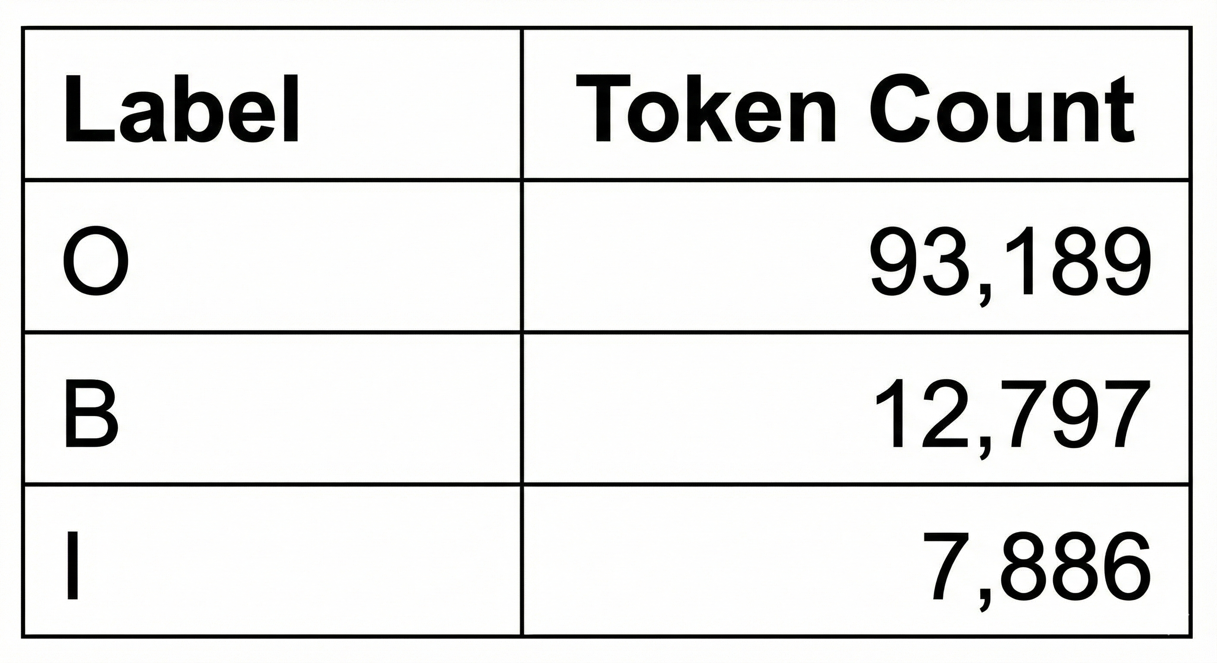Table 1 summarizes the distribution of IOB labels in the dataset, highlighting the dominance of non-entity tokens.
Further analysis at the entity-type level revealed uneven representation across medical categories.
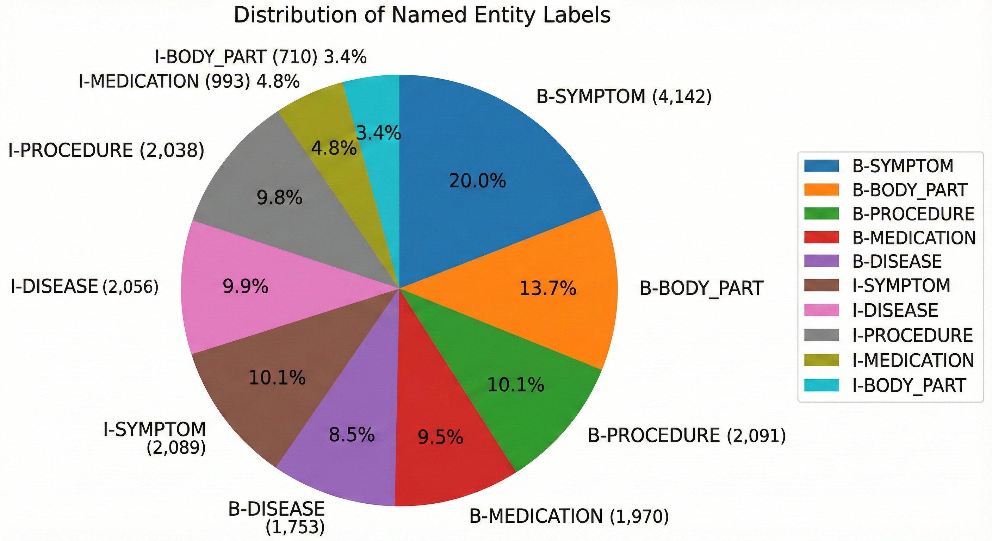
Figure 1 shows the distribution of medical entity labels, where symptom and disease entities are the most frequent, while body part and medication entities are comparatively underrepresented. This imbalance increases the difficulty of learning robust representations for rare entity types.

2.5 LLM-Based Data Augmentation
To address the imbalance between entity and non-entity tokens, we employed a large language model (Gemini) to generate additional labelled sequences. The generation process specifically focused on increasing the frequency of B and I label, thereby enriching the dataset with more entity examples and longer entity spans.
The generated data followed the same labelling rules and preprocessing pipeline as the original dataset. After validation, the generated samples were merged with the original data to form a more balanced and diverse training corpus. This augmentation strategy was designed to improve the model’s ability to detect entity boundaries, maintain correct I-tag sequences, and generalize to rare or complex medical entities.

2.6 Alternative Data Source
An additional dataset consisting of question–answer interactions between a client and a doctor was briefly explored. The intent was to use the GPT-4o API to tokenize and automatically annotate this conversational data. However, due to time and scope constraints, this approach was not pursued further and was excluded from the final experiments.

3. Model Architectures
We evaluated several transformer-based models that have demonstrated strong performance on Arabic NLP tasks:
- AraBERT
- MARBERT
- XLM-RoBERTa
- CAMeL-BERT
- QARiB
Each model was fine-tuned for token classification using the same dataset, labelling scheme, and evaluation protocol. Model-specific tokenizers were used, and labels were aligned with subword tokens using standard word-to-subword alignment techniques.

4. Experimental Setup
All models were trained using the IOB labelling scheme and evaluated at the token level. Performance was measured using Precision, Recall, and F1-score, computed over all entity labels. The dataset was split into training, validation, and test sets, and identical splits were used across all experiments to ensure fair comparison.

5. Results
5.1 Overall Performance
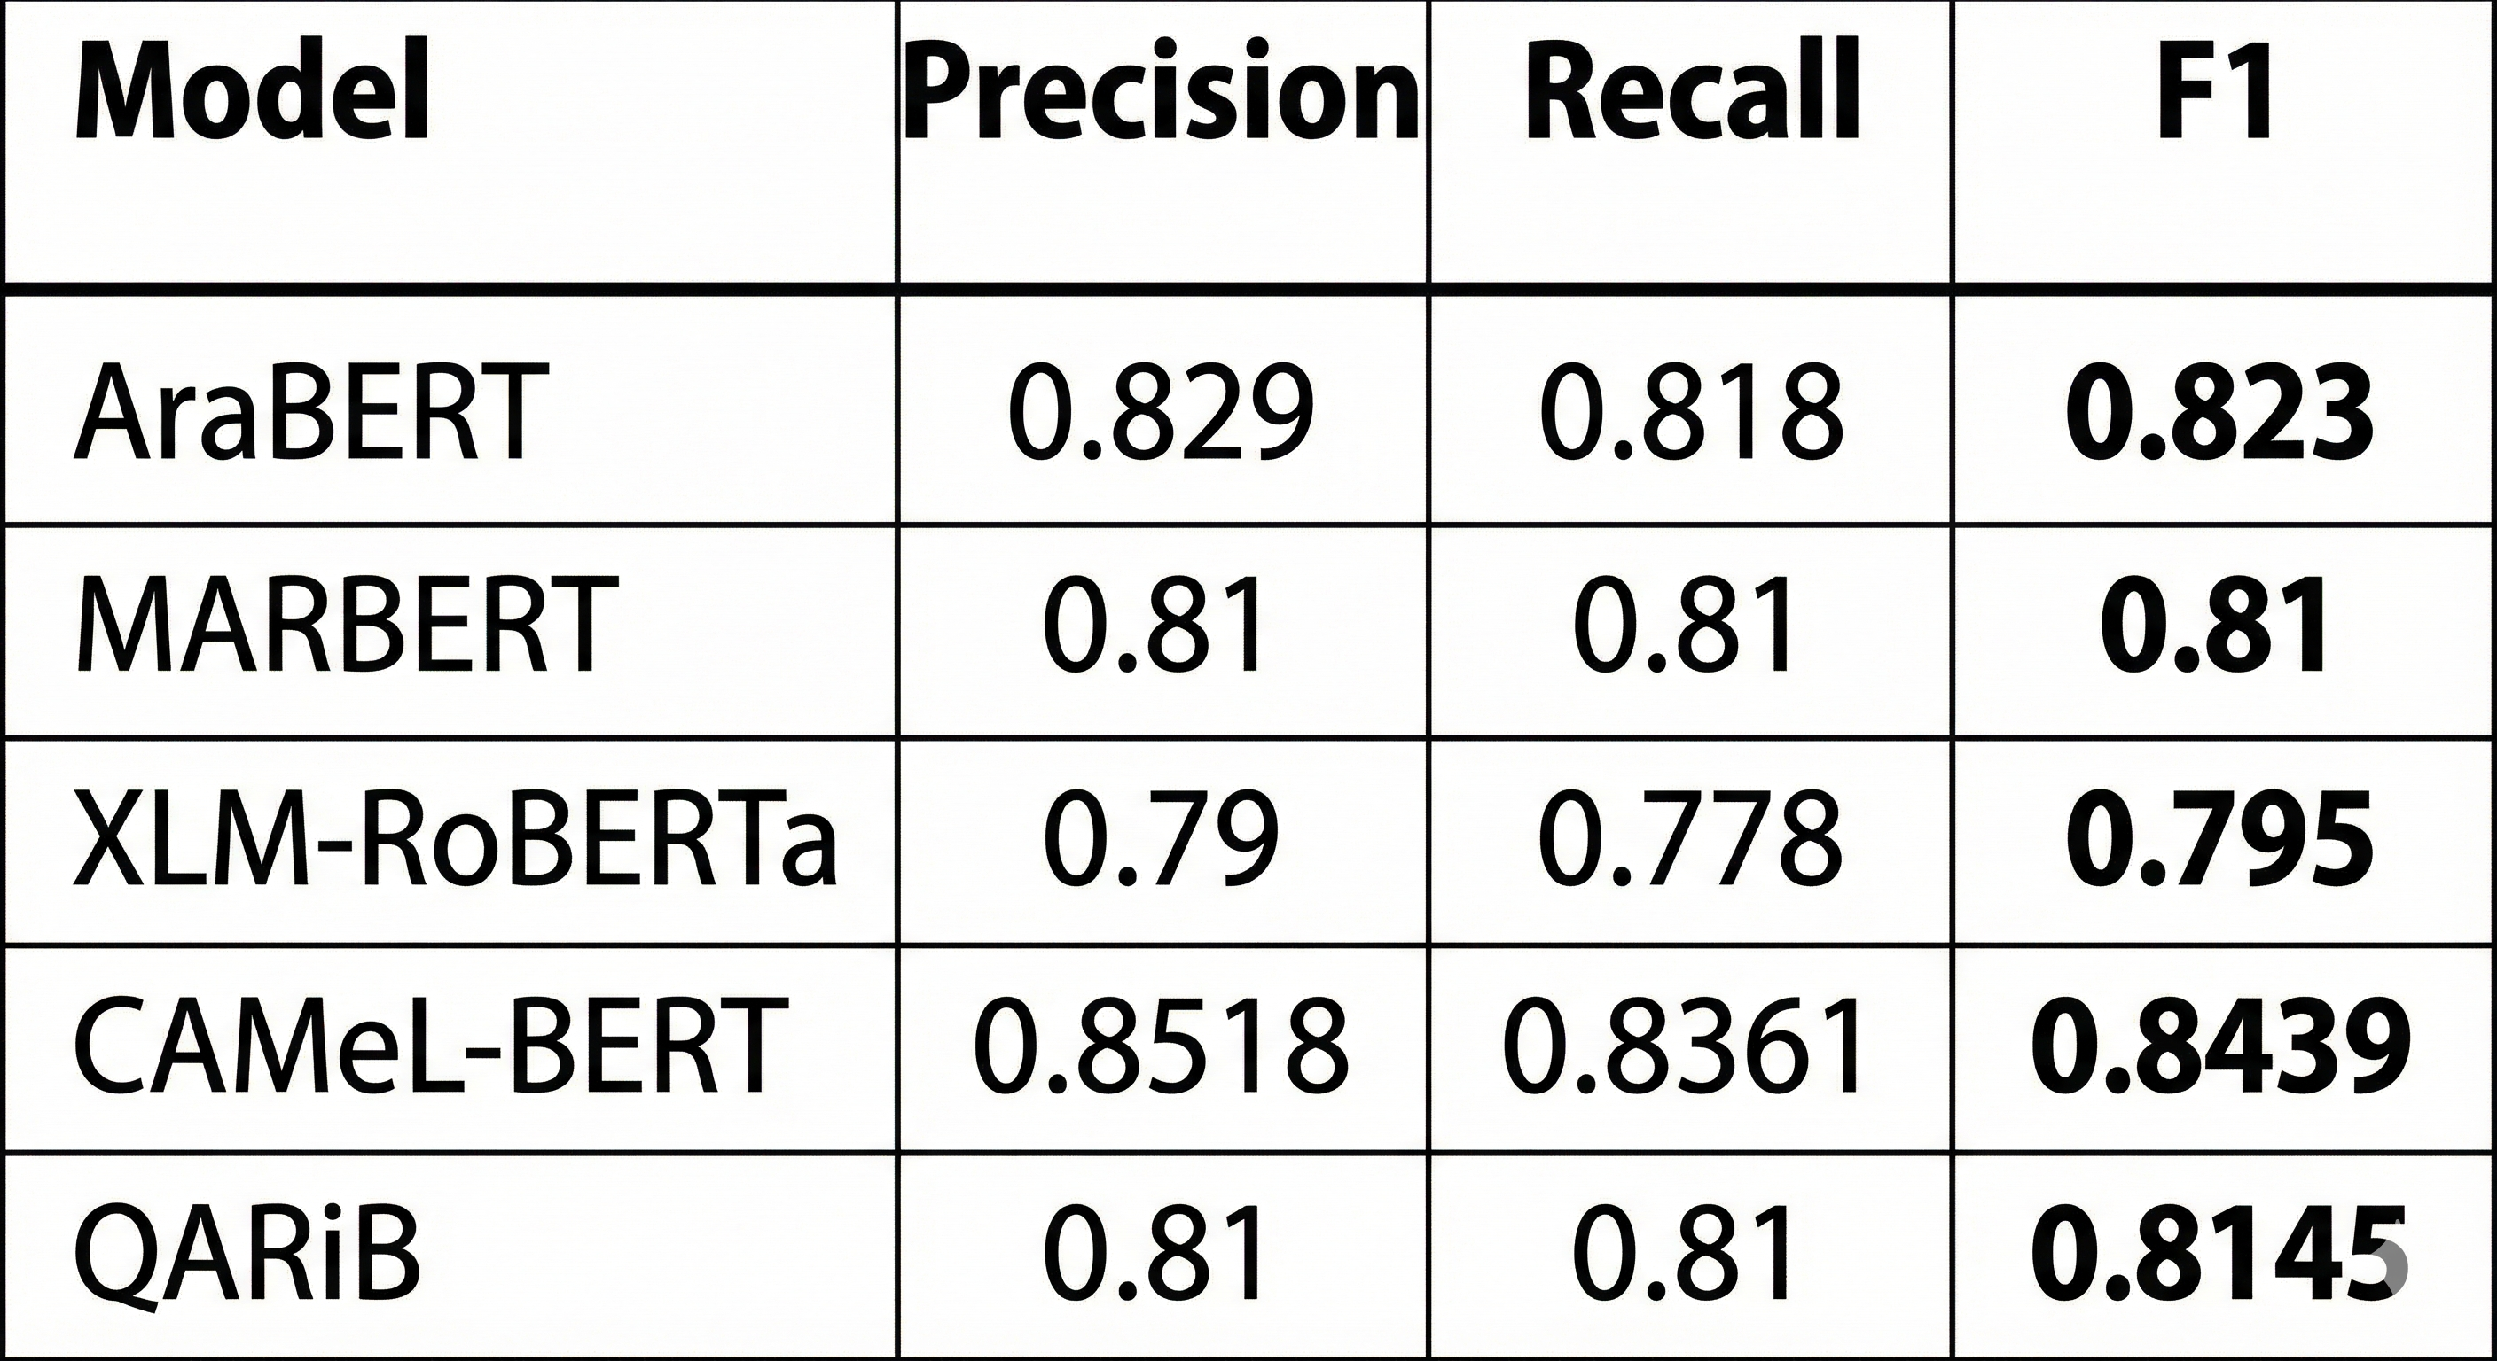
Table 2 reports the precision, recall, and F1-score for all evaluated transformer-based models.

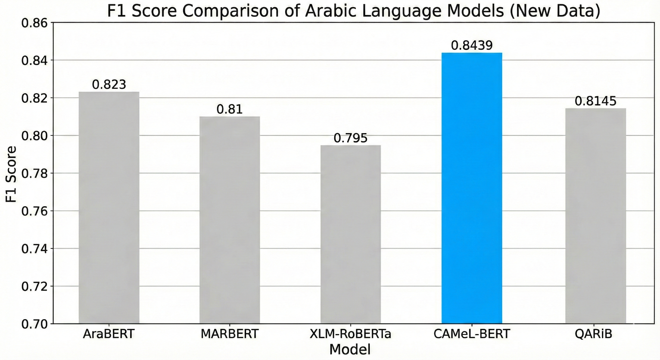Figure 2 provides a visual comparison of F1-scores across evaluated models, clearly illustrating the performance advantage of CAMeL-BERT.

5.2 Discussion
The results indicate that Arabic-specific pretraining plays a crucial role in clinical NER. Multilingual XLM-RoBERTa underperforms compared to models trained primarily on Arabic data, suggesting that language-specific representations are particularly important for capturing the morphological and syntactic properties of Arabic medical text.
Among all evaluated models, CAMeL-BERT achieves the highest F1-score. Its strong performance can be attributed to its Arabic-focused pretraining and improved handling of contextual dependencies, which is especially beneficial for maintaining correct I-tag predictions in multi-token medical entities.
5.3 Model Enhancements and Optimization
After selecting CAMeL-BERT as the best-performing base model, we conducted a set of targeted optimization experiments to improve performance and analyze training behavior. These experiments focused on hyperparameter tuning, ablation through layer freezing, and handling class imbalance.
First, we investigated the impact of learning rate selection by evaluating values of 1e-5, 2e-5, and 3e-5 while keeping all other training settings fixed. The best performance was achieved with a learning rate of 3e-5, which improved the F1-score from approximately 0.81 to 0.84, demonstrating the importance of controlled hyperparameter tuning for Arabic clinical NER.
Next, we performed an ablation study by freezing the embedding layer and early encoder layers of CAMeL-BERT and comparing this configuration against a fully fine-tuned model. Partial layer freezing resulted in a performance drop (F1 ≈ 0.83), indicating that full fine-tuning is more effective for capturing domain-specific linguistic and medical patterns in Arabic text.
Finally, to address the strong class imbalance in the dataset, we experimented with a weighted cross-entropy loss that penalizes errors on rare entity labels more heavily. This approach led to a noticeable increase in recall but also caused a reduction in precision, resulting in a lower overall F1-score. This outcome highlights a clear precision–recall trade-off when optimizing for rare entity detection.
Based on these findings, the final model configuration—referred to as CAMeL-BERT-Mix uses a learning rate of 3e-5, full fine-tuning, and a standard (unweighted) loss function. While weighted loss did not yield the best F1-score, it is retained as an analytical enhancement rather than the final model.

6. Model Selection
Based on the experimental results, CAMeL-BERT was selected as the final model for this task. Its superior performance demonstrates the effectiveness of Arabic-specific pretraining for clinical NER and justifies its use in future extensions of this work.

7. Conclusion and Future Work
In this paper, we presented a complete Arabic clinical NER system based on transformer architectures and the IOB labelling scheme. We described the construction of a high-quality dataset, addressed label imbalance using LLM-based data augmentation, and conducted a comprehensive comparison of several state-of-the-art models.
Future work will explore explicit error analysis using confusion matrices and qualitative examples, architectural enhancements such as CRF decoding layers, and expansion to additional medical entity types and datasets. Further investigation into semi-supervised and span-based approaches may also help mitigate annotation sparsity.

References
[1] J. Devlin, M. Chang, K. Lee, and K. Toutanova, “BERT: Pre-training of Deep Bidirectional Transformers for Language Understanding,” NAACL, 2019.
[2] W. Antoun, F. Baly, and H. Hajj, “AraBERT: Transformer-based Model for Arabic Language Understanding,” OSACT, 2020.
[3] M. Abdul-Mageed et al., “MARBERT: Masked Language Model Pre-training for Arabic Dialects,” ACL, 2021.
[4] N. Obeid et al., “CAMeL-BERT: Pre-trained Language Models for Arabic,” ACL, 2021.
[5] A. Alharbi et al., “QARiB: A Pretrained BERT-based Model for Arabic NLP,” 2022.
[6] N. Alshammari and S. Alanazi, “An Arabic Dataset for Disease Named Entity Recognition with Multi-Annotation Schemes,” Data, vol. 5, no. 3, p. 60, Jul. 2020, doi: 10.3390/data5030060.
[7] A. Alshahrani, et al., “Arabic Medical Named Entity Recognition Dataset,” Mendeley Data, v5, 2022. [Online]. Available: https://data.mendeley.com/datasets/mgj29ndgrk/5

