Movies: Update & Deletes
Michael Gordon
Bellevue University
Database Development and Use CSD310
Professor: Dr. Mortoza Abdullah
09/17/2026
GitHub Link

I pulled up the studio names so I could use them to find a film to add
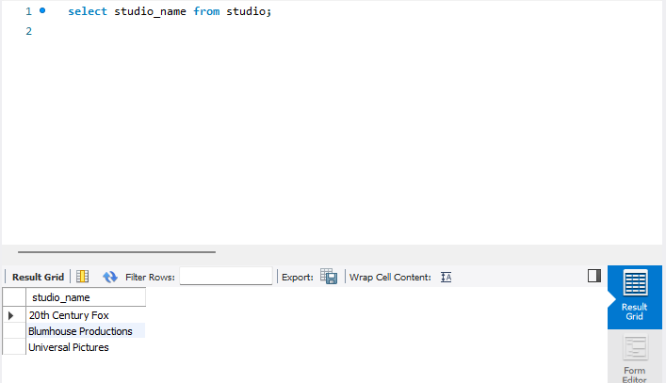
I decided to use Halloween II which is a Horror film from Universal Pictures. It was released on October 31st, 1981. The film was directed by Rick Rosenthal. This would give it a studio_id of 3 and a genre_id of 1.
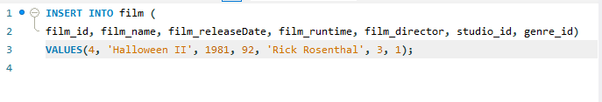
After running the INSERT INTO, I verified the data was now in the table.
